GIST, Korea National Food Cluster, and the Senior-Friendly Industry Support Center to innovate together

– Synergy effects are expected in promoting senior-friendly industries by establishing an organic cooperation system

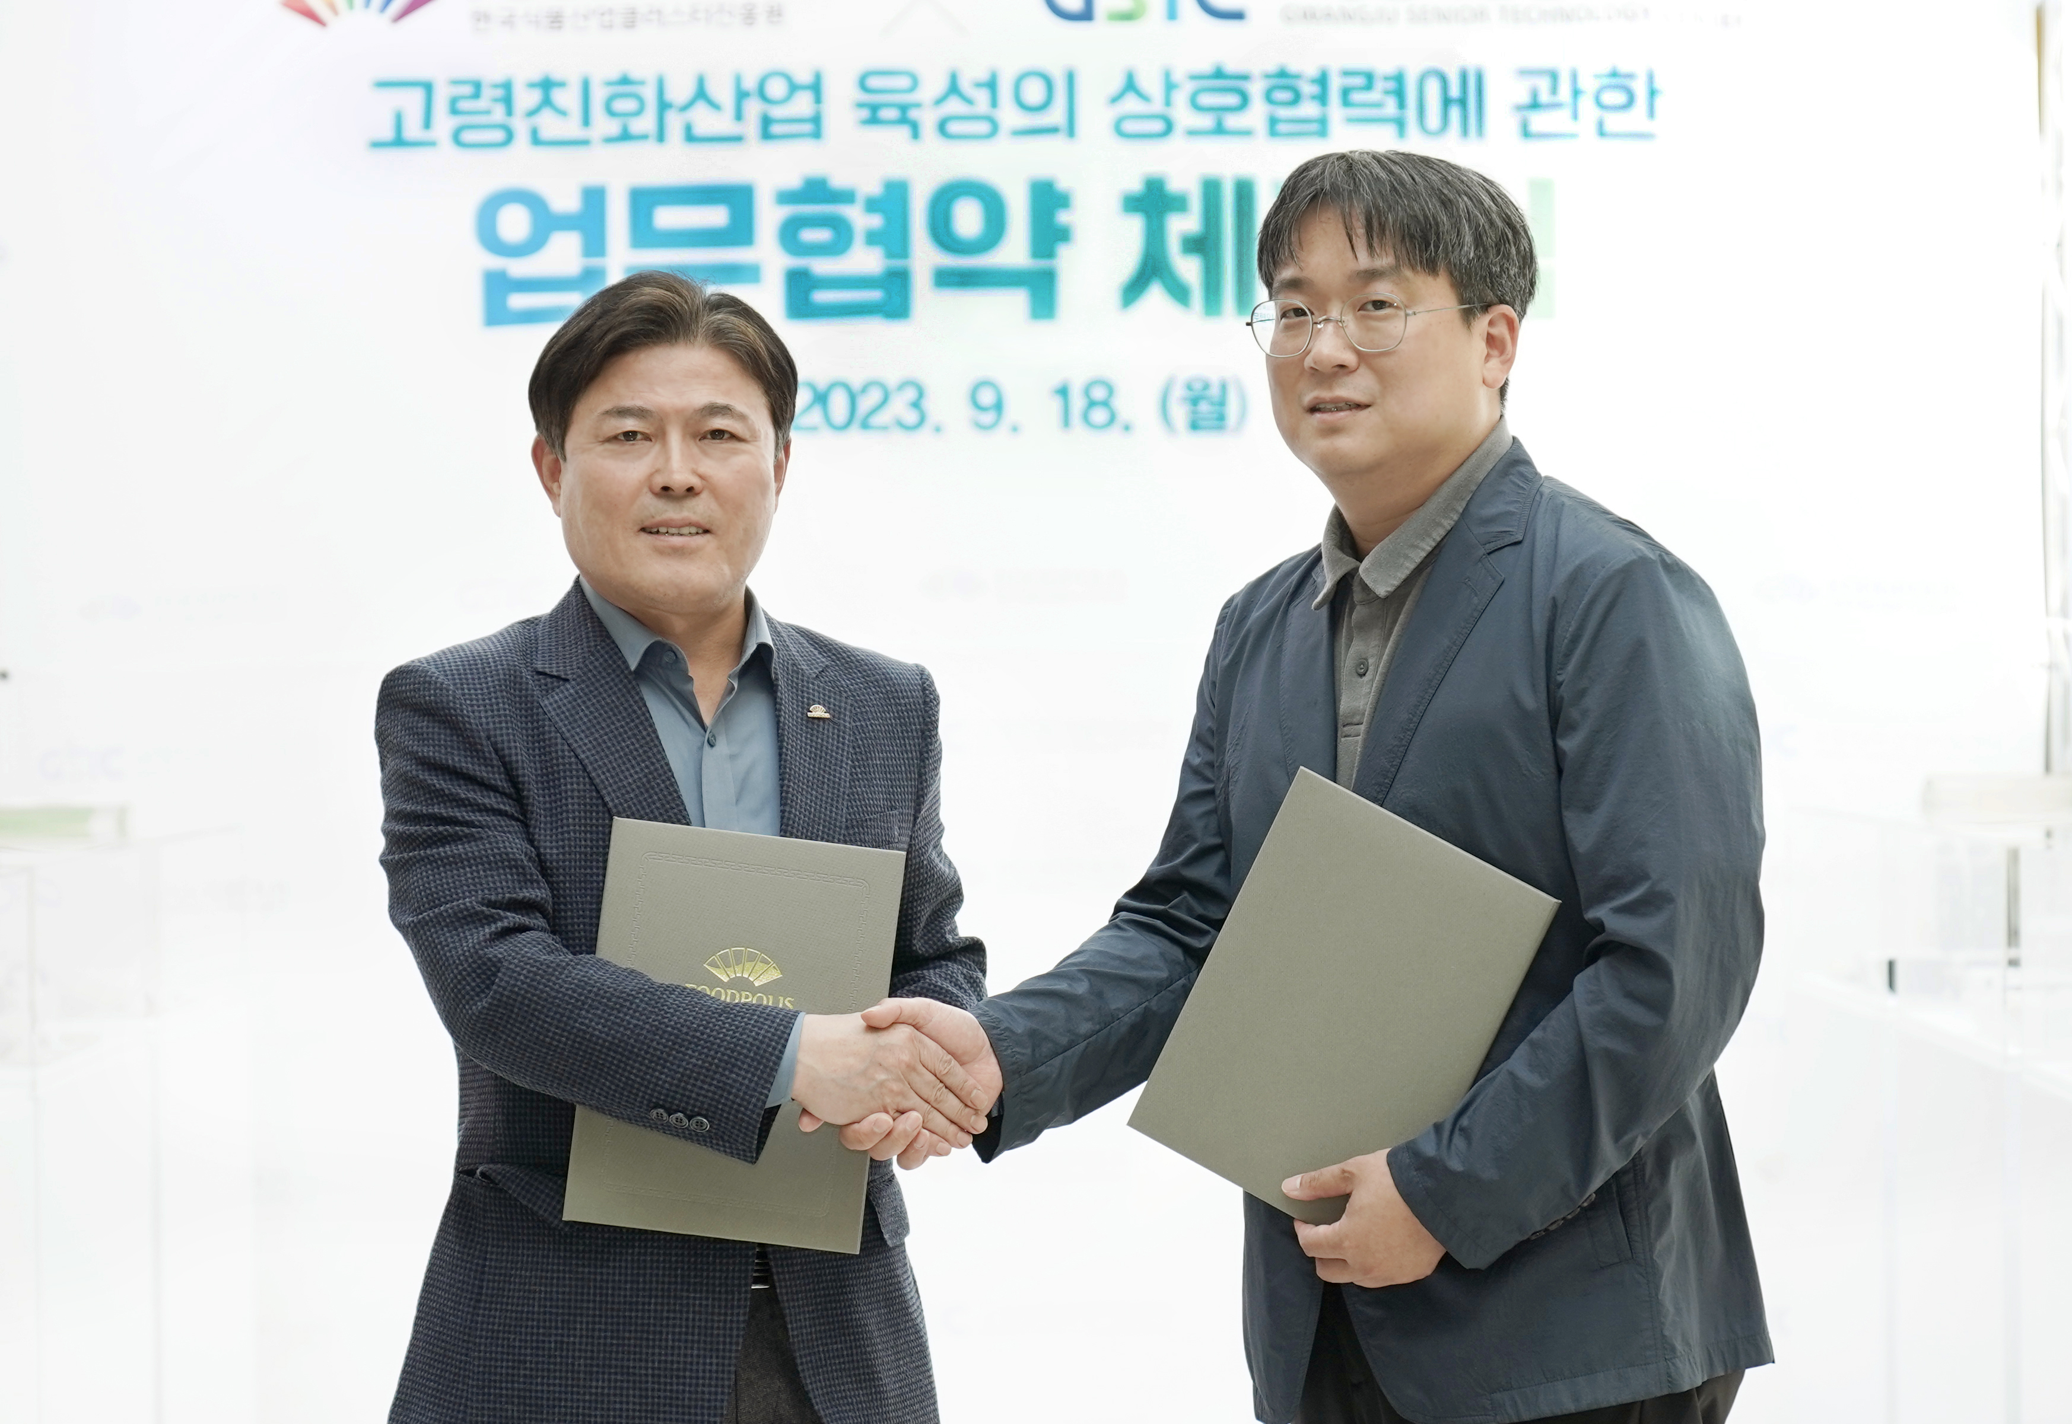▲ GIST Senior-Friendly Industry Support Center Director Chang-Myung Oh (right) and Korea National Food Cluster Chairman Young-jae Kim (left) are taking a commemorative photo after signing the ‘Business Agreement on Mutual Cooperation in Fostering Senior-Friendly Industry’.

The Gwangju Institute of Science and Technology (GIST, President Kichul Lim) Senior-Friendly Industry Support Center (Director Chang-Myung Oh, hereinafter referred to as the ‘Center’) is working with the Korea National Food Cluster (Chairman Young-jae Kim, hereinafter referred to as the ‘Food Promotion Agency’) to promote ‘age-friendly industry innovation’, and they signed a business agreement (MoU) to establish a cooperation system.

The agreement ceremony was held at the Senior-Friendly Industry Support Center located in Nam-gu on the 18th (Monday) with about 20 people in attendance, including Director Chang-Myung Oh of the Senior-Friendly Industry Support Center, Korea Food Promotion Agency Chairman Young-jae Kim, and Gwangju Metropolitan City Robotic Home Appliance Medical Industry Department Team Leader Yong-beom Park.

The agreement is expected to have a significant synergy effect in promoting the senior-friendly industry by establishing a cooperative system between the "Center" designated as the only regional senior-friendly industry innovation center in the Honam region and the "Food Promotion Agency", which has large-scale infrastructure based on fostering a national food cluster.

The two organizations signed an agreement on this day to △ conduct surveys and research needed to foster senior-friendly industries △ share infrastructure owned by institutions △ to jointly host seminars such as forums and symposiums related to senior-friendly industries and △ to cooperate and actively exchange with each other to promote senior-friendly products and revitalize their distribution.

In particular, on the day of the agreement ceremony, the infrastructure of the special exhibition zone on the first floor of the Gwangju Senior-Friendly Industry Support Center was utilized to display excellent food products from local companies and to provide 'Senior-Friendly Excellence', where about 200 regular visitors to the center could experience senior-friendly foods as a food promotion tasting event was also held.

Senior-Friendly Industry Support Center Director Chang-Myung Oh said, "Through this agreement, a cooperative network between the two organizations was formed and a foundation was laid for expanding the base of senior-friendly industries and promoting excellent products. We will continue to work harder to develop local senior-friendly industries through cooperation with related organizations in various fields."

Korea National Food Cluster Chairman Young-jae Kim said, "This agreement is significant in that it strengthens the role and function of a senior-friendly industry promotion agency ahead of entering a super-aging society. Going forward, we will strive to foster innovative growth in the domestic senior-friendly industry by actively linking and utilizing the capabilities and infrastructure of both organizations."

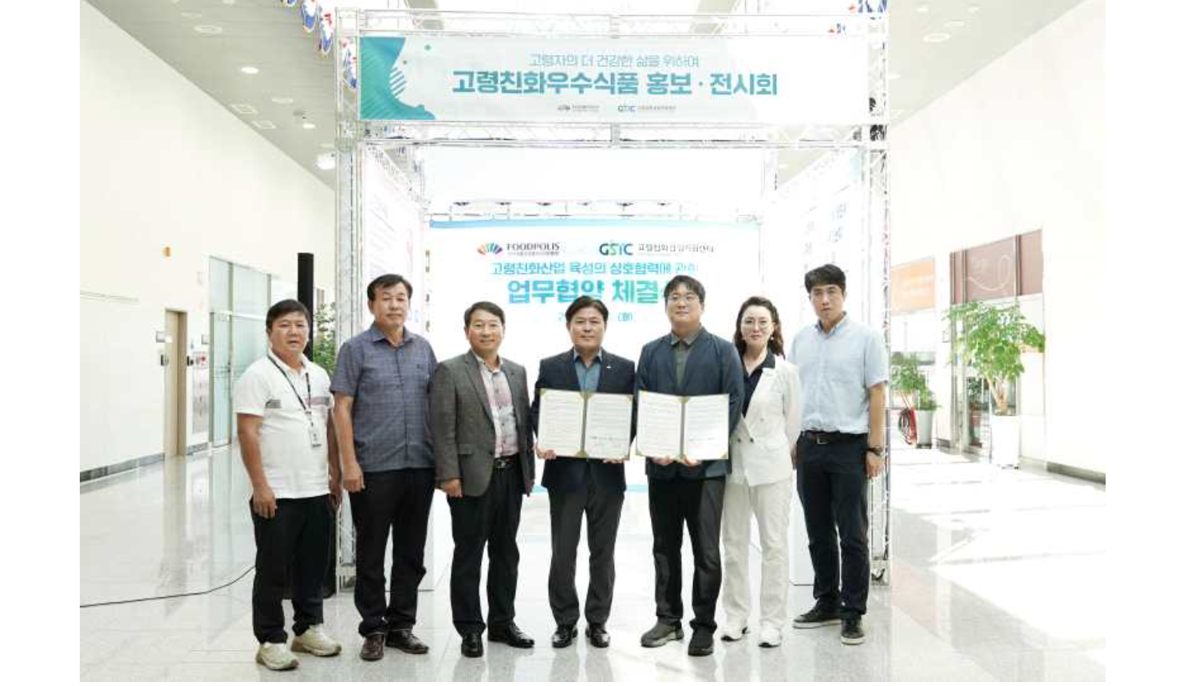▲ GIST Senior-Friendly Industry Support Center and the Korea National Food Cluster signed a business agreement (MoU) to ‘establish a promotion and cooperation system for innovation in the senior-friendly industry’ and are taking a commemorative photo. GIST Senior-Friendly Industry Support Center Director Chang-Myung Oh (third from right), Korea National Food Cluster Chairman Young-jae Kim (fourth from right), Gwangju Metropolitan City Robotic Home Appliance Medical Industry Department Team Leader Yong-beom Park (fifth from right)

Starting with the Ministry of Trade, Industry and Energy's project to build a senior-friendly product and service experience center in 2008, the center has been fostering leading senior-friendly companies. Efforts are being made to strengthen the senior-friendly industry ecosystem, such as supporting 4th Industrial Revolution research and development and establishing a digital-based usability evaluation platform.

The Korea National Food Cluster, a national food cluster development and food industry promotion agency, was designated as a senior-friendly industry support center by the Ministry of Agriculture, Food and Rural Affairs and the Ministry of Oceans and Fisheries in 2021 and is leading the domestic food industry by developing policies to promote the senior-friendly food industry, operating a designation system, supporting corporate growth, and revitalizing the market.

