GIST hosts classical music concert commemorating its 30th anniversary... 2nd free performance ‘Starlight Concert’ held

- Autumn night classical concert with string quartet ‘Quartet Noi’
- Approximately 400 people attended the first performance ‘Green Land’, adding to the excitement

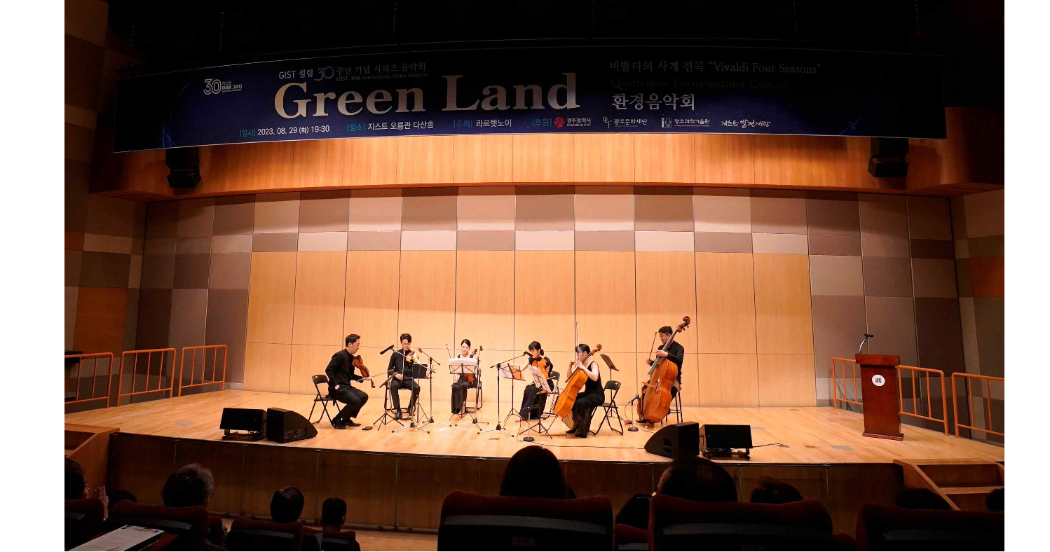▲ Classical series concert held on Tuesday, August 29th, the first performance of ‘Green Land’

In celebration of its 30th anniversary, the Gwangju Institute of Science and Technology (GIST, President Kichul Lim) will present the second performance of a classical series concert with local residents at 7:30 pm on Friday, September 15.

The first performance (Green Land) of this three-part concert series was held on Tuesday, August 29th, with about 400 people attending and received a warm response from the audience.

The theme of the second concert is ‘Starlight Concert.’ As with the first performance, all GIST members and local residents can attend, and it will be held at Dasan Hall on the second floor of Oryong Hall.

‘Quartet Noi’, which will present beautiful melodies in this concert, is a string quartet team founded in 2019 by four young musicians with the meaning of ‘new, innovative’. The cast includes first violinist Jun-seong Lee, second violinist Joon Lee, cello Ji-ho Choi, and viola Shin-ae Yang.

In addition to authentic classical music such as Mozart and Bach, about 10 songs will be performed, including the movie classic, Scent of a Woman, and drama White Tower OST. It is worth looking forward to the harmony of the characteristics of each work and the various tones.

This concert is free and can be attended without purchasing a separate ticket or making a reservation.

Meanwhile, the classical series concert prepared by GIST in commemoration of its 30th anniversary will end with ‘A Concert for Recovery and Comfort of Daily Life – Healing’ on Tuesday, November 14th.

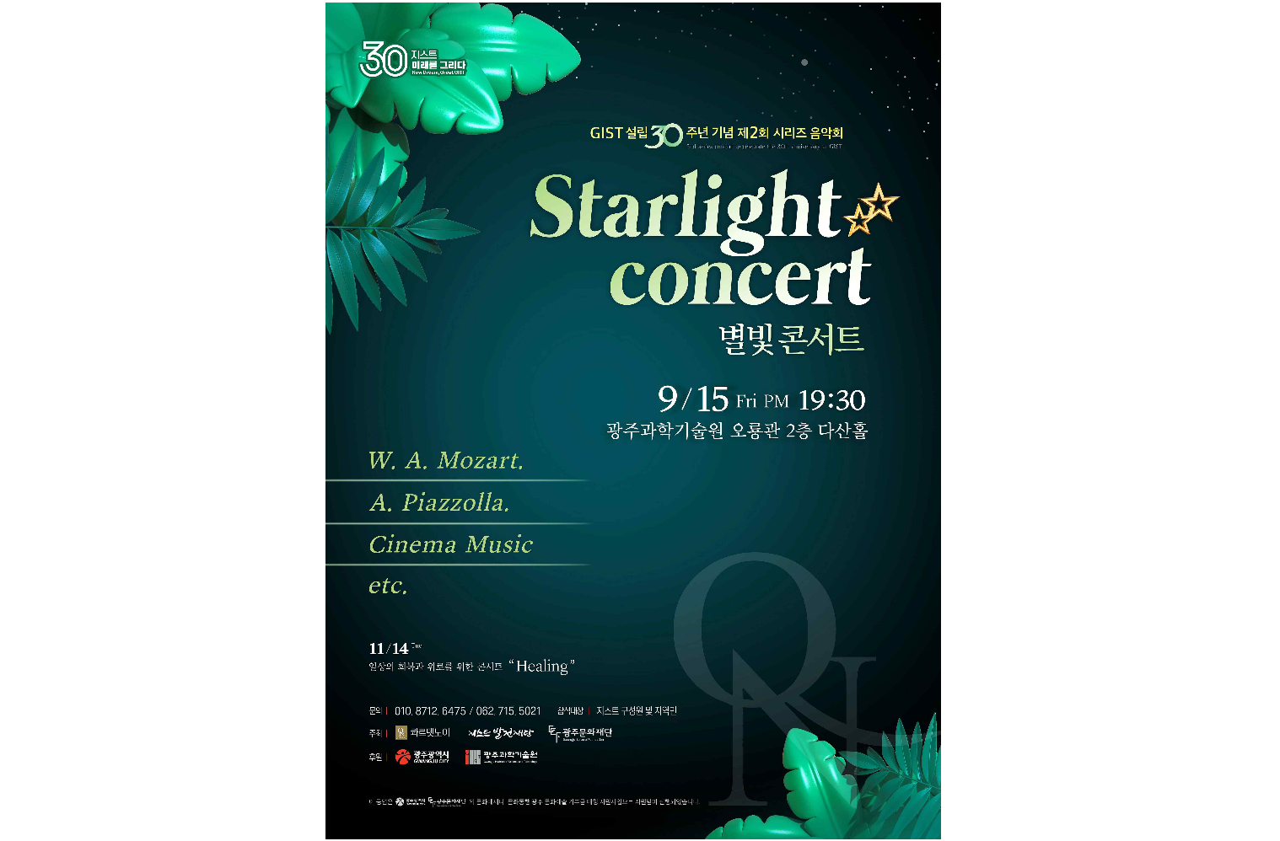▲ Poster for the 2nd ‘Starlight Concert’, a concert commemorating the 30th anniversary of GIST’s establishment



