GIST provides a venue for technological innovation in the new energy industry

- Special lectures on new energy industries such as future mobility and exhibition of innovative technology prototypes at the “Regional Innovation Cluster Industry-Academic-Research Technology Innovation Forum”

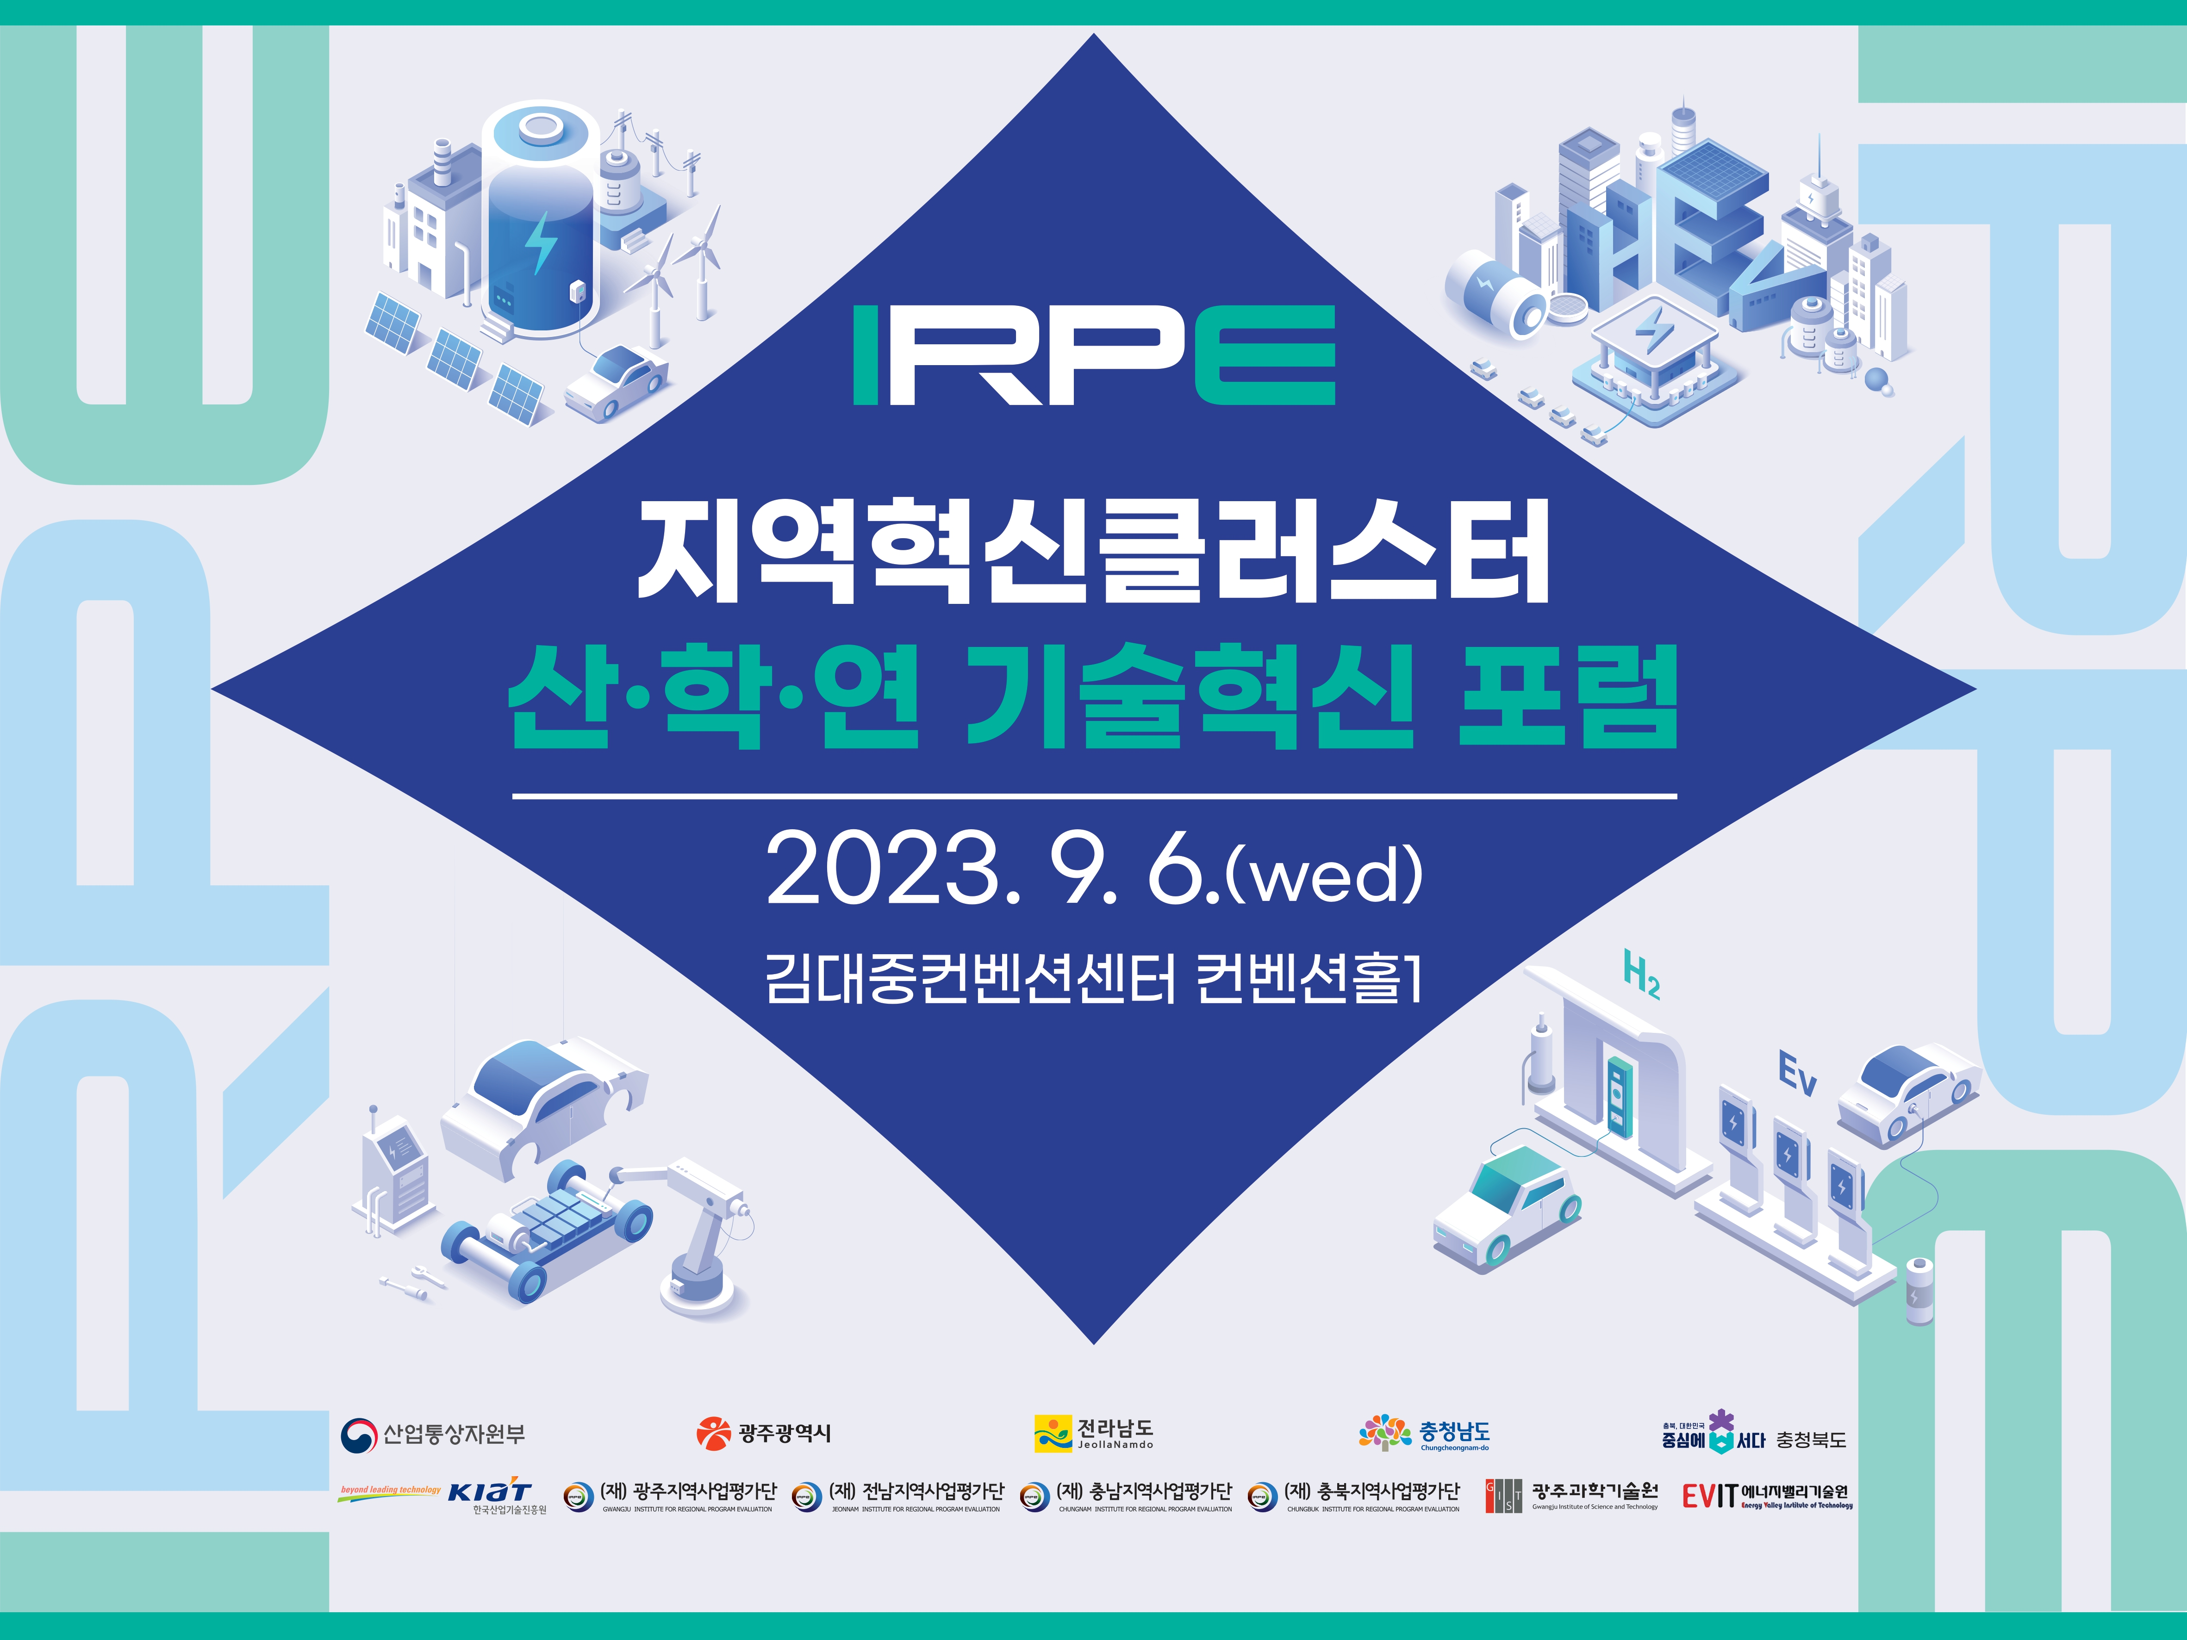▲ Regional Innovation Cluster Industry/Academia/Research Technology Innovation Forum Poster

The country's top energy field experts gathered in one place to promote cooperation in new energy industries and build a regional innovation cluster.

The Gwangju Institute of Science and Technology (GIST, President Kichul Lim) and the Energy Valley Institute of Technology (President Kwanghee Lee / Professor and Vice President for R&D) together with the Gwangju Regional Project Evaluation Team and other 200 people will host the ‘2023 Regional Innovation Cluster Energy New Industry Industry-Academia-Research Technology Innovation Forum’ for businessmen.

This forum will be held on Wednesday, September 6 as part of the ‘2023 Korea Environment & Energy Trade (KEET 2023)’ event held at the Kimdaejung Convention Center in Gwangju from September 6 to 8.

A total of 12 Korea's top energy experts, including GIST professors, Samsung SDI executives, and Korea Institute of Energy Research researchers in fields such as batteries, hydrogen, power systems, and future mobility, will lecture on changes in the technological environment and management strategies.

There will also be presentations on emerging innovative technologies and carbon neutrality, including ▲ ‘Car lightweighting and carbon neutrality’ (Korea Automobile Research Institute Center Director Hyeon-cheol Lee) ▲ ‘Large-capacity clean hydrogen production technology and distributed clean hydrogen production technology’ (Korea Institute of Industrial Technology Chief Eun-do Lee) ▲ ‘Electrode remanufacturing technology to reduce electric vehicle battery remanufacturing/recycling industry issues and carbon emissions’ (Korea Institute of Energy Research Center Director Jung-je Woo).

At this event, Energy Valley Technology Institute plans to exhibit prototypes of companies benefiting from corporate support projects, such as ‘next-generation flexible solar cell module’ and ‘supported catalyst-based water electrolysis unit cell’.

The Energy Valley Technology Institute is focusing on the 2023 Energy Valley Company R&D Innovation Capacity Strengthening Package Support Project to strengthen and promote the R&D capabilities of local companies and industry-academia-research cooperation through industry-academia cooperation in which local companies implement the technologies of GIST and regional innovation research institutes into prototypes.

Energy Valley Institute of Technology President Kwanghee Lee (GIST Vice President for R&D) said, " This event is even more meaningful in that it is an opportunity for GIST to promote local industrial development through cooperation with local innovation research institutes and companies. This is expected to be a venue for technological innovation exchange between industry, academia and research institutes to establish development strategies in the new energy industry."

Meanwhile, the GIST Energy Valley Technology Institute is an energy specialized organization for the realization of carbon neutrality and was jointly established on January 21, 2015 by Gwangju Metropolitan City, Korea Electric Power Corporation, and GIST to successfully create an energy valley and promote the development of the local energy industry.

