Chairman Ki-soo Na sponsors GIST 'Breakfast for 1,000 won'

- Decided to make a donation to give a hearty breakfast to science students

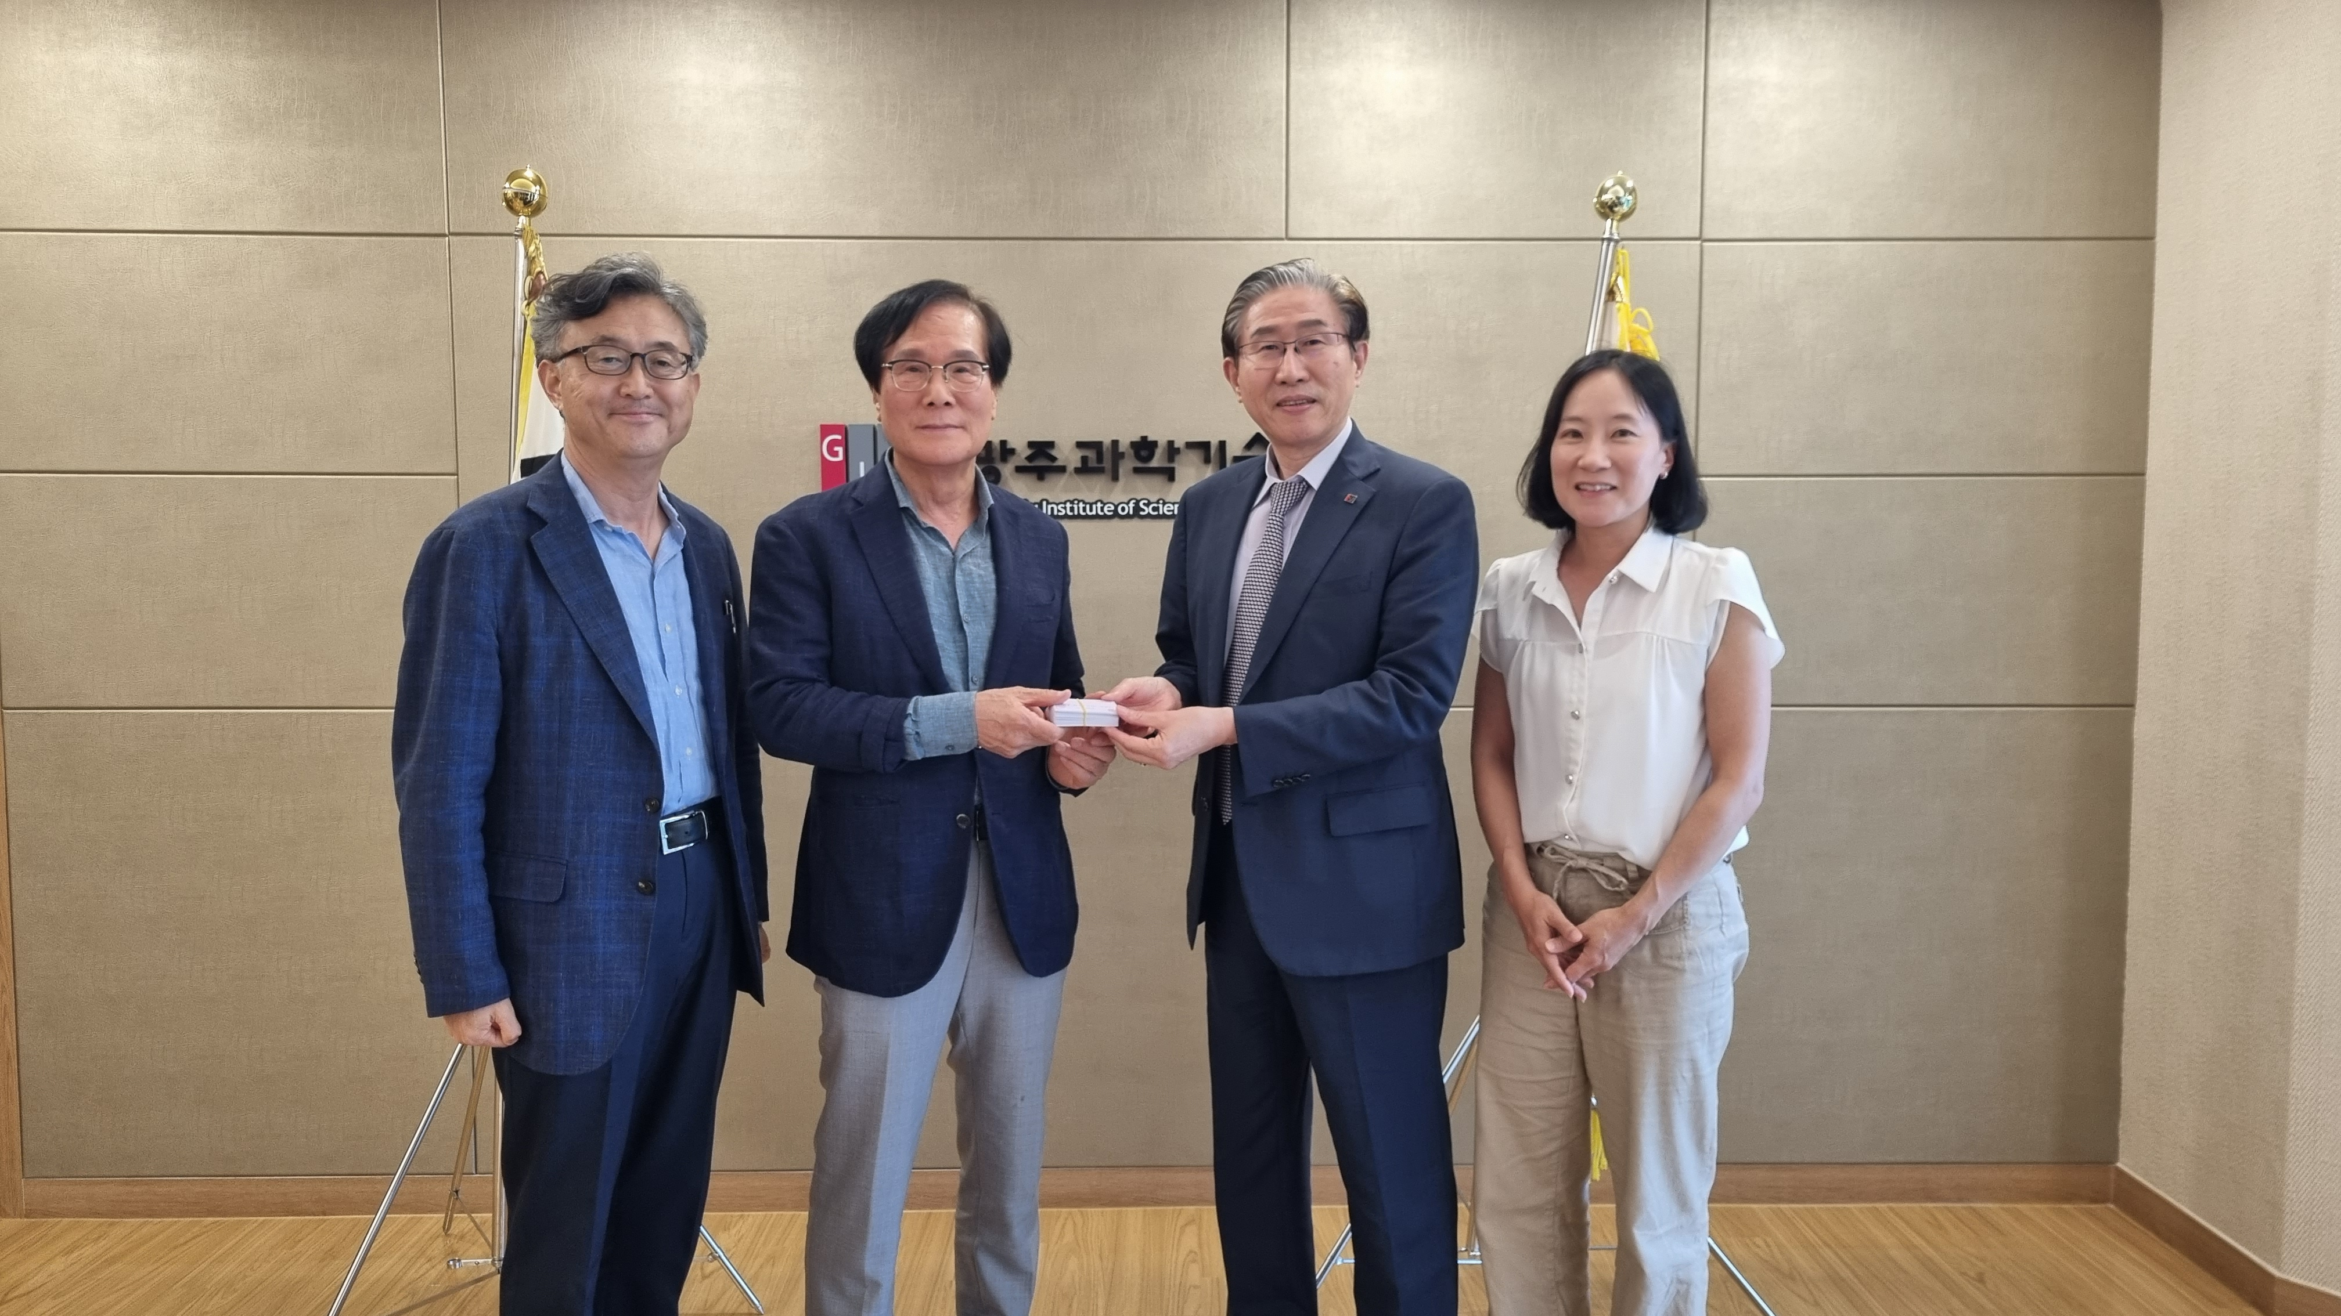▲ On the 23rd (Wednesday), Chairman Ki-soo Na is taking a commemorative photo after donating 10 million won for ‘GIST 1,000 Won Breakfast’. (From left) Vice President Kwanghee Lee, Chairman Ki-soo Na, President Kichul Lim, Student Affairs and Admissions Dean Mi-Ryoung Song

The Gwangju Institute of Science and Technology (GIST, President Kichul Lim) announced on the 23rd (Wednesday) that Gwangju Jeonnam Federation of Economic Organizations Chairman Ki-soo Na donated 10 million won to GIST’s ‘Breakfast for 1,000 Won’.

'Breakfast of 1,000 won' is a business that provides students with breakfast for just 1,000 won. GIST provides high-quality breakfasts such as rice, soup, fried rice, home-cooked side dishes, salads, and fried eggs at a unit price of KRW 5,600 (KRW 3,600 paid by the institution, KRW 1,000 by the Agriculture, Forestry and Fisheries Food Education and Culture Information Service, KRW 1,000 by students).

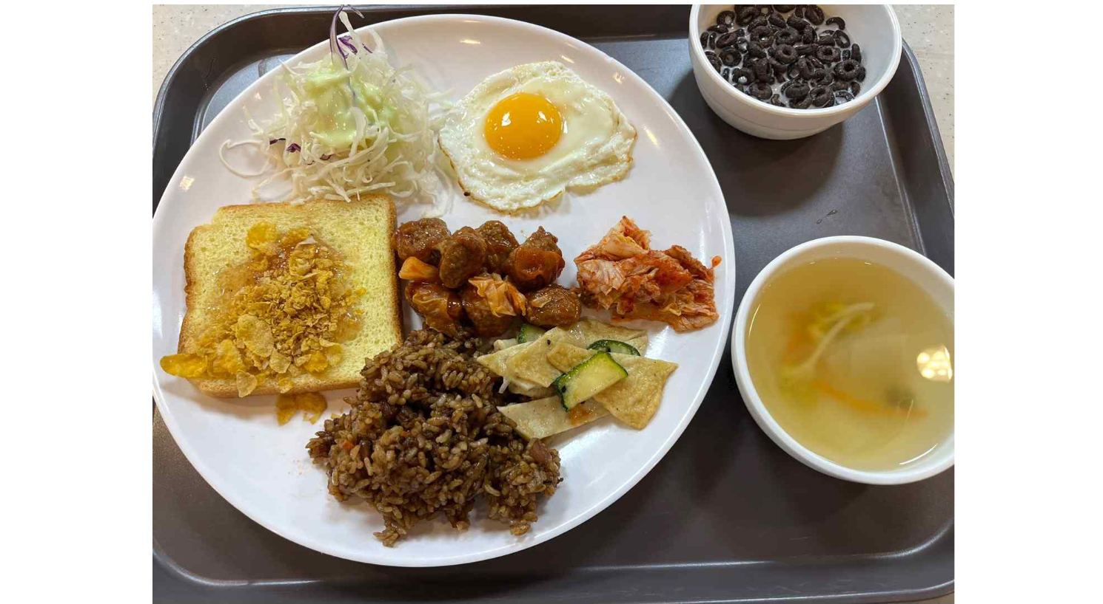▲ A picture of ‘1,000 won breakfast’ operated by GIST

The Office of Student Affairs and Admissions (Dean Mi-Ryoung Song), the department in charge of the project, has notified students of the project period from March 29 to the end of October this year. The number of breakfasters increased more than 2.5 times from the previous time, and the donation was said to have been a sweet rain while considering whether the budget could meet the promised period.

So far, about 20,000 GIST students have used 1,000 won of breakfast, and the donation is expected to provide additional breakfast for about 3,000 people and will continue until the first week of November.

Chairman Ki-soo Na said, "At the inauguration ceremony of President Kichul Lim, I heard that the scale of the program was drastically reduced as the cost was subsidized for the ‘1,000 won breakfast’ project for students. I decided to donate because I wanted to help GIST scientists eat a hearty breakfast and focus on their research."

Chairman Na is currently the chairperson of the GIST Industry-Academy Development Committee, working hard to revitalize the local economy and create jobs through industrial-academic cooperation with GIST and businesses.

President Kichul Lim said, "I am well aware of the hard work that Chairman Ki-soo Na has performed with GIST for a long time as he has been working hard to develop the institution in various ways. The donation he provided will be able to nourish the body and mind of the students."



