Development of table tennis robot and energy management system... GIST successfully completed a contest to nurture convergence specialists

- 2023 Creative Convergence Contest held... ‘SPIN’ team and ‘Electric Guard’ team won grand prizes
- Participation of 17 teams composed of Korean university students, development of innovative table tennis robots and campus energy management systems... Expected to nurture creative convergence specialists

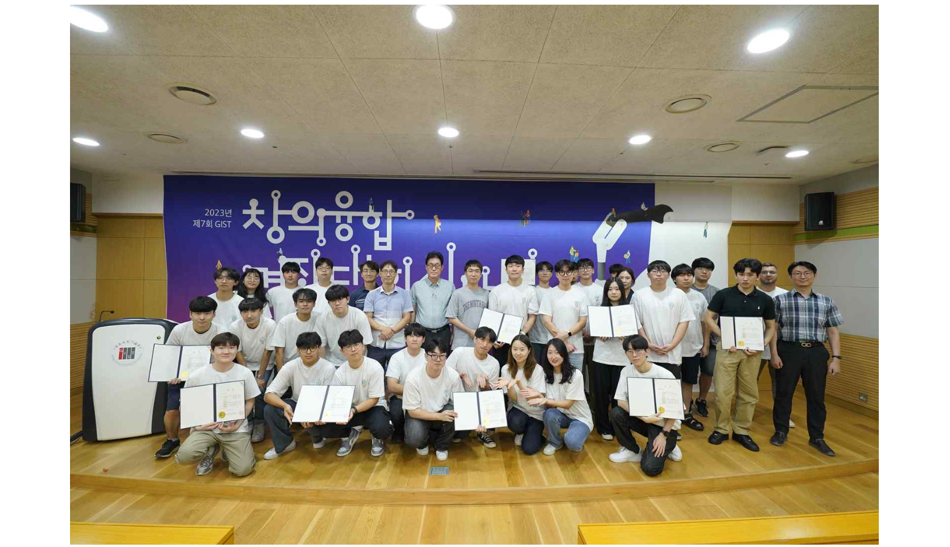▲ Participants and officials are taking a group photo at the ‘2023 Creative Convergence Contest’ award ceremony hosted by the GIST Institute of Intergrated Technology.

The Gwangju Institute of Science and Technology (GIST, President Kichul Lim) held a contest to foster students' cooperative spirit and collective creativity to strengthen practical convergence education capabilities required in the era of the 4th Industrial Revolution.

The GIST Institute of Intergrated Technology (Dean, Professor Je Ha Ryu) held the '2023 Creative Convergence Contest' (Head Professor: Professor Jung Won Yoon, Institute of Intergrated Technology), and held ▲ Table Tennis Robot Contest and ▲ Campus EMS (Energy Management System) Development Contest.

Starting with the first competition in 2017, this event, which celebrated its 7th anniversary this year, is a growth-oriented event that supports basic education including hardware, software, and artificial intelligence unique to the GIST Creative Convergence Competition beyond the framework of the existing standardized competition. By introducing a practical approach, students can develop cooperative spirit and group creativity.

In addition, professors and graduate students from the Institute of Convergence Technology acted as mentors for each team consisting of three or more people, providing practical support such as on-site guidance and advice.

This year, 51 undergraduate students from Sungkyunkwan University and Pusan National University participated in 17 teams during their summer vacation. For two months, from the end of June to the 18th of August, they devoted themselves to developing innovative table tennis robots and algorithms.

The 'Table Tennis Robot Contest' is a way to compete for the ranking of table tennis robots that reflect the unique design of the participating teams, from hardware production to AI coding. In order to compete for the ranking, a tournament was held in which a table tennis robot hit a ping-pong ball from a table tennis machine, and a table tennis match was played between the robot and a student.

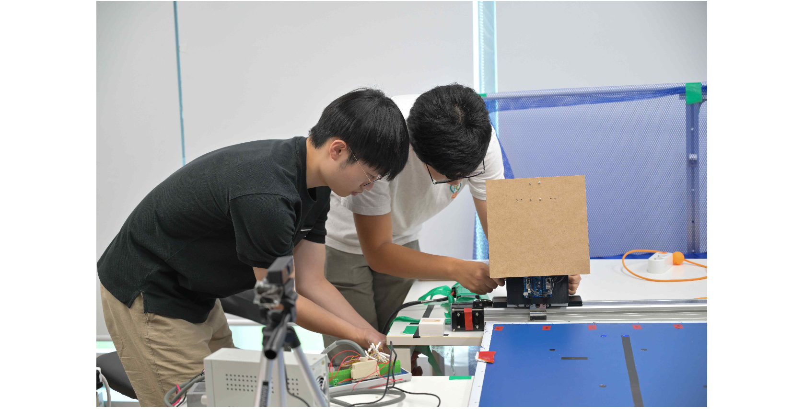▲ The Pong GPT team (encouragement award) is setting up the table tennis robot before the game.

The ‘Campus EMS Development Contest’ is a load prediction algorithm and solar power generation prediction algorithm based on data provided by the GIST Institute of Intergrated Technology. By developing an electricity rate minimization algorithm, the ranking was determined by calculating the error rate of load prediction, the error rate of solar power generation, and the electricity rate used.

The finals to select the final winners of the two tracks were held on August 18th (Friday), and the awards ceremony was held at Dasan Building in the afternoon of August 22nd (Tuesday).

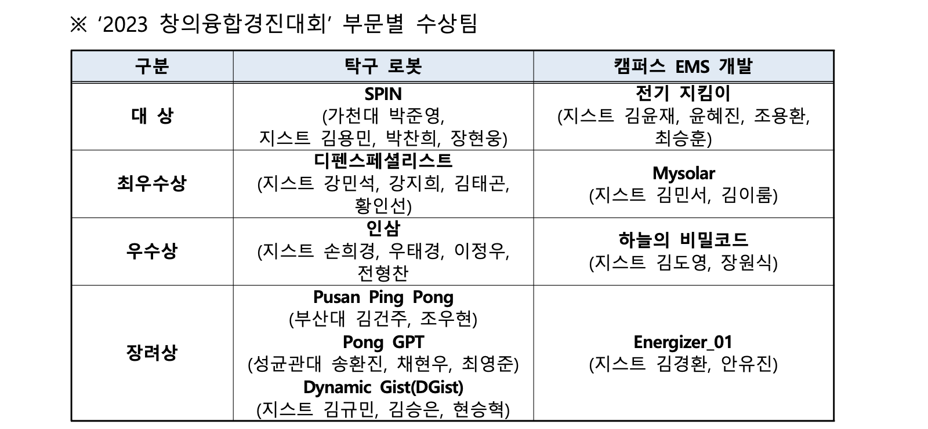The 'SPIN' team (Gachon University Park Jun-young, GIST Kim Yong-min, Park Chan-hee, Jang Hyun-woong) in the 'Table Tennis Robot Contest' category and the 'Electricity Keeper' team (GIST Kim Yoon-jae, Yoon Hye-jin, Cho Yong-hwan, Choi Seung-hun) in the 'Campus EMS Development Contest' were awarded the Grand Prize, and a certificate of merit and a prize of 2 million won were awarded to teams.

The ‘SPIN’ team, which won the grand prize, predicted the trajectory of a ping-pong ball through linear regression analysis in 3D coordinates and implemented the swing motion of the ping-pong robot using Labview and C++ programs. The ‘Electric Guardian’ team implemented an optimal algorithm using machine learning ensemble techniques, and received high marks for its understanding of the entire process, from data pre-processing to PV power generation and load prediction to ESS operation scheduling.

Graduate School of Energy Convergence Professor Yun-su Kim, who evaluated the 'campus EMS development' category, said, "It is hoped that the students who participated in the competition will be able to set new goals and gain confidence that they can actually apply it to campus EMS through various experiences by developing their own solutions that can respond to the instability of power grid operation that can occur in renewable energy and electric vehicles."

Chan-hee Park, the team leader of the ▲'SPIN' team (table tennis robot), which won the grand prize, said, "The process of implementing ideas one by one with the team members was meaningful. When I was at a loss as to where to start, I was able to successfully complete the project thanks to the professors and assistants who taught me about programming and robotics."

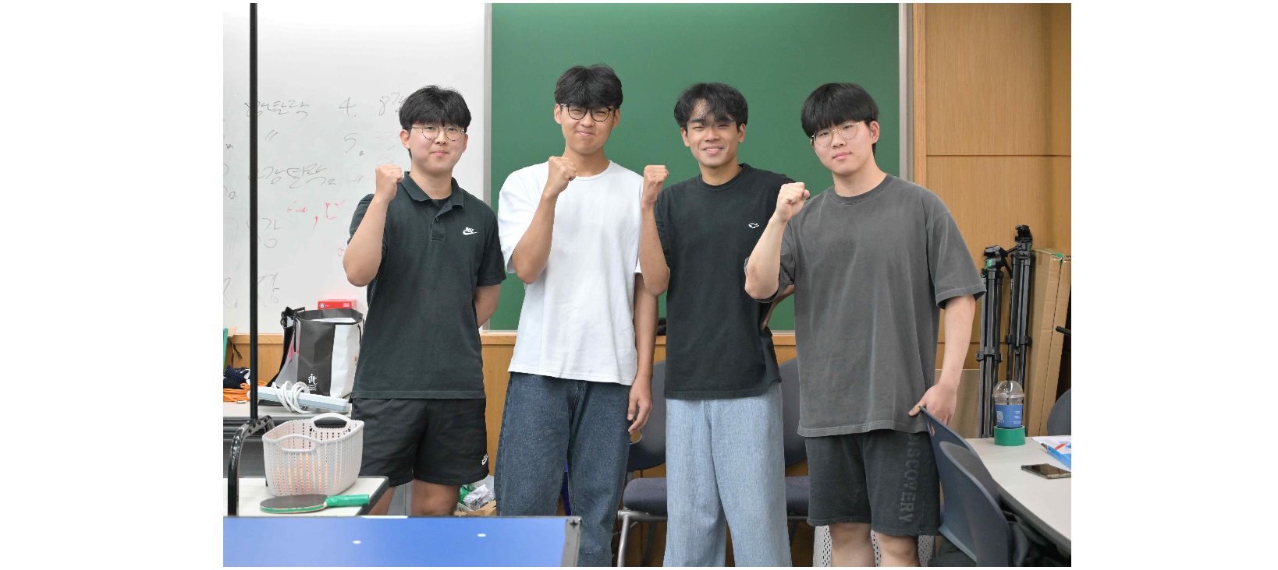▲ The SPIN team (grand prize) is strengthening its will to win ahead of the table tennis robot track finals.

▲ Yong-hwan Cho, who led the ‘Electric Keeper’ team (EMS development), said, "We are happy and grateful to be able to take a step closer to protecting the earth by challenging the campus to optimize electricity consumption while the weather lasted this summer to the point where we could feel climate change."

Professor Jung Won Yoon said, "Participation in the contest is increasing every year as it is conducted as using a convergence research topic that combines artificial intelligence and hardware (robots), which is a topic of interest to students. It is hoped that this competition will contribute to providing an experimental educational platform that nurtures convergence specialists with creativity and problem-solving skills."

