“If there is no road, we make it!” Inauguration ceremony for the 9th President Kichul Lim was held

- Appointed at the board of directors on the 4th of last month... The inauguration ceremony was held on the 16th (Wednesday)
- Suggests 3 strategies for innovation... Promise to improve university rankings and raise funds

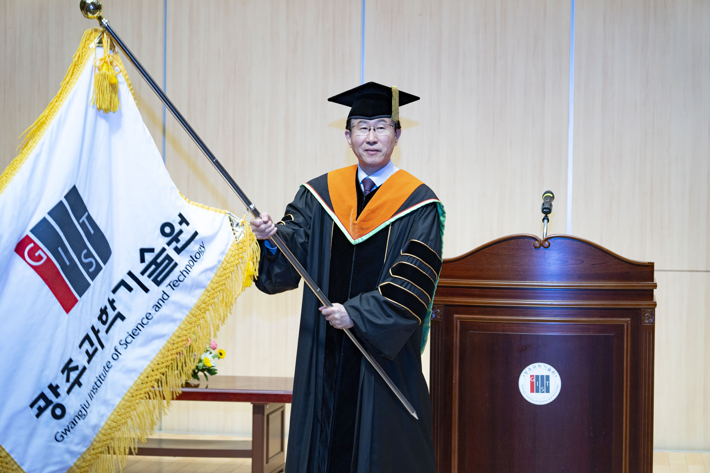▲ [Picture 1] The 9th President Kichul Lim is showing his spirit at the inauguration ceremony.

GIST (Gwangju Institute of Science and Technology) held the inauguration ceremony for Dr. Kichul Lim (68 years old, born in 1955) as the 9th president at 2:00 pm on the 16th (Wed) at GIST Oryong Dasan Hall.

Previously, the GIST board of directors (Chairman Moon-hee Han) held a board meeting on the 4th of last month and appointed Kichul Lim, former president of the Korea Institute of Science and Technology Evaluation and Planning (KISTEP), as the 9th president.

In his inaugural address, Lim, the new president, set forth his vision of becoming a “real-life science and technology central research institute” that leads the future of innovative economy together with the region.

In particular, with the GIST spirit of “Innovation, where there is no road, we make it,” the three major promotion strategies of ▴ Potential-Up, ▴ Harmony-Up, and ▴ Value-Up (3-Ups) was shared with attendees and the will to innovate was strengthened.

He is known to have laid the groundwork for innovation to be pursued for the next four years of his tenure by carrying out organizational reorganization and personnel reshuffling for a month after his appointment.

[Picture 2] President Lim delivering his inaugural address.

In particular, President Lim presents a plan to achieve a leap into the top 100 in the QS World University Rankings, establish an “AI head quarter” in Asia, and establish a GIST branch. He expressed his aspirations to encourage start-ups and expand collaboration with local companies by establishing a holding company, ‘GIST Holdings’.

In particular, he showed his will to contribute to revitalizing the local economy and attracting industries by announcing that it plans to establish a foundation for the ‘research and medical equipment industry’ in the Gwangju and Jeonnam regions by raising a development fund of KRW 20 billion.

President Lim graduated from the Department of Industrial Chemistry at Seoul National University and received a master's and doctoral degree in engineering from the same university's graduate school. He earned a master's degree in economics from Sogang University Graduate School.

He served as the head of the Planning and Coordination Office and vice president at the Science and Technology Policy Institute (STEPI), and served as the Science and Technology Secretary at the Presidential Office at the Blue House. Since then, he has been a member of the Standing Committee of the National Science and Technology Commission. He served as the 8th president of the Korea Institute of Science and Technology Planning and Evaluation, vice-president of the Korea Federation of Science and Technology Societies (Korea Federation of Science and Technology), and special professor at Korea University Graduate School of Technology Management.

The inauguration ceremony was attended former National Assembly Vice-Chairman and current president of the Korea Petroleum Association Joo-seon Park, Gwangju Metropolitan City Mayor Ki-jeong Kang, GIST Chairman Moon-hee Han, GIST Development Foundation Chairperson Hae-myeong Kim, and others attended.

Local Era Committee Chair Dong-gi Woo, KAIST President Myung-ja Kim, National Assembly member Hyeong-bae Min, National Assembly member Hyang-ja Yang, National Assembly member Hyeong-seok Lee, and National Assembly member Oh-seop Cho also congratulated President Lim on his inauguration through video messages.

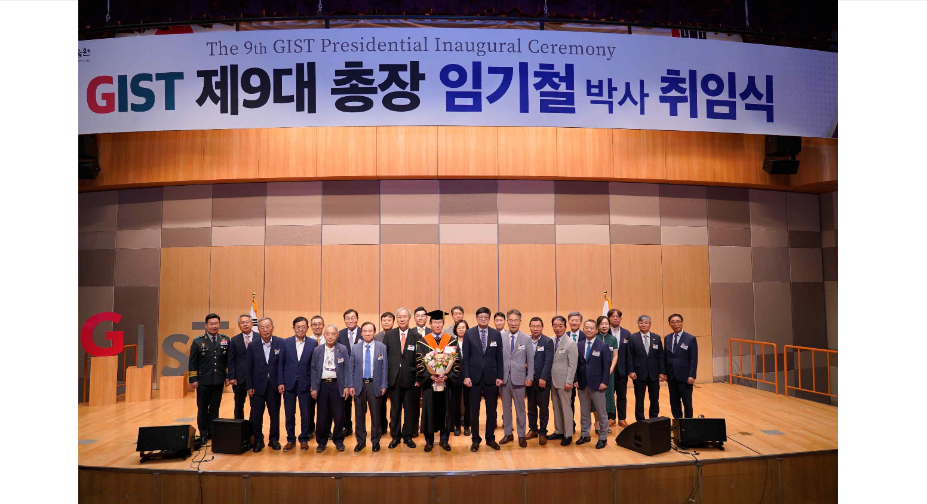[Picture 3] The 9th President of GIST Kichul Lim and guests attending the inauguration ceremony are taking a commemorative photo.

President Lim also received a lot of attention by drastically reducing the size of the inauguration ceremony and ordering the budget saved through this to be used for the '1,000 won breakfast' project.

‘Breakfast of 1,000 won’ is a project to provide high-quality breakfast to students for 1,000 won, and the budget was exhausted early due to high student participation. With the budget cuts for this inauguration ceremony, it is possible to extend the operation of the ‘1,000 won breakfast’ project until October this year.



