"GIST shares Korean IT skills in Laos" World Friends Korea IT Volunteers return home

- Conducted various social contribution activities such as IT technology and Korean culture education in Laos
- GIST Development Foundation, donated fans and school supplies to Vang Vieng Ethnic School

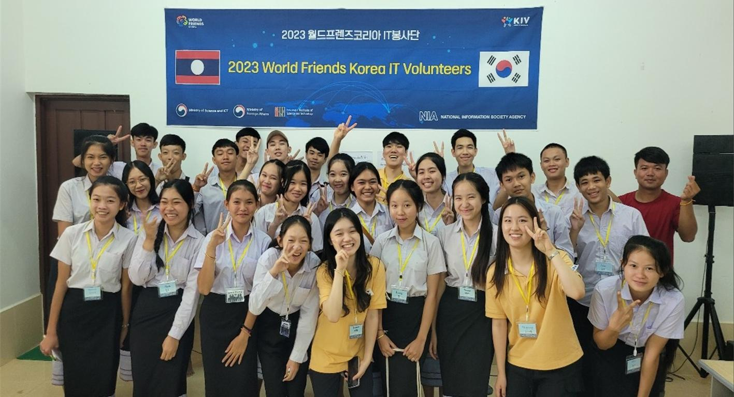▲ [Picture 1] The 2023 World Friends Korea (WFK) IT Volunteer Group visits Vang Vieng Ethnic School in Laos and takes a group photo.

GIST (Gwangju Institute of Science and Technology, President Kichul Lim) World Friends Korea IT Volunteer Group returned home on the morning of the 13th after completing a 4-week dispatch from 3 institutions in Laos from July 17th.

This volunteer group, which was jointly sent by GIST and the Korea Information Society Agency, has been been to Moldova, Panama, Bhutan, and Vietnam, starting with Vietnam in 2014.

A total of 12 students from 3 teams selected by GIST this year to volunteer at three institutions in Laos, including the Vientiane Capital Skill Development Center, Digital Government Center, and the Vangvieng Ethnic School.

The students provided not only ICT education such as programming and artificial intelligence to students and government officials, but also Korean language and Korean culture, such as K-POP, Korean food making, and traditional games.

At the Vientiane Capital Technology Development Center, the ‘Waan’ team trained 25 students and 20 civil servants. At the Digital Government Center, the ‘Laosta’ team trained 20 civil servants. At the Ethnic School in Vang Vieng, the ‘Jeongsu’ team trained 30 students.

One student participating in this program said, "From the first day, there were difficult moments such as power and internet outages, but all of the students and government officials enthusiastically participated and quickly learned Korean culture and programming language. It was an unforgettable experience in my life and I want to serve in Laos again."

Meanwhile, the GIST Development Foundation is known to have donated items worth 1 million won, such as fans and school supplies, to Vang Vieng Ethnic School students who are devoting themselves to their studies despite poor facilities.

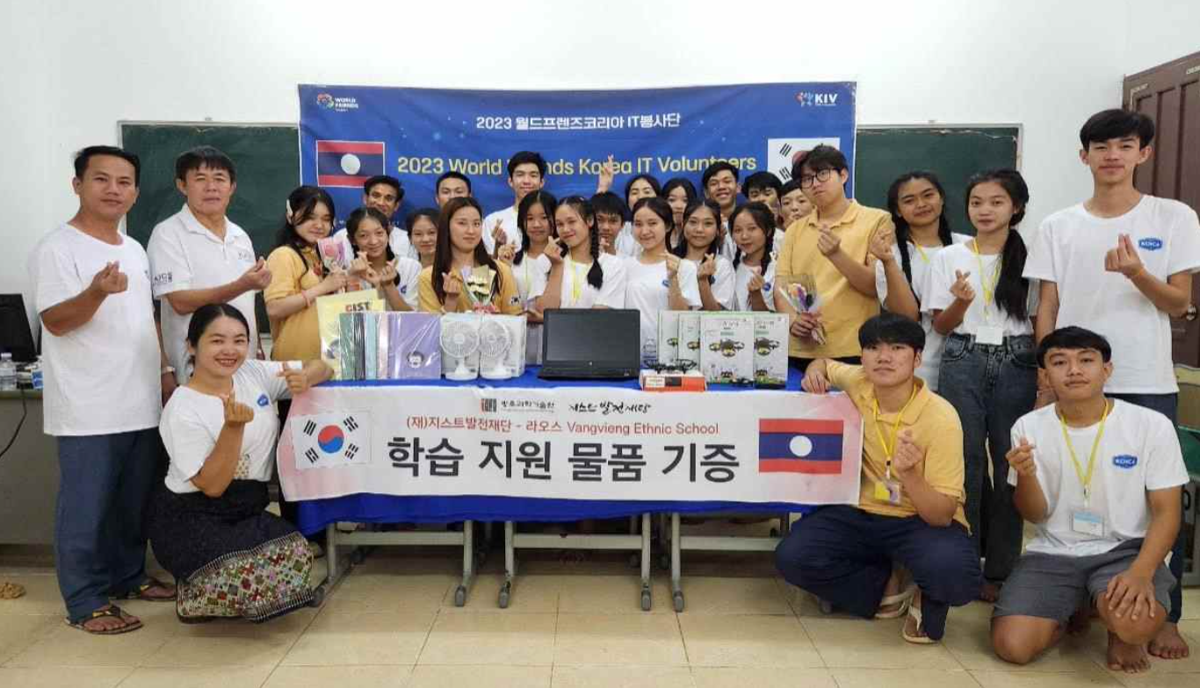[Picture 2] The GIST Development Foundation is donating learning materials to the Vang Vieng Ethnic School in Laos.

GIST Development Foundation Chairperson Haemyeong Kim said, "It is meaningful to donate to Laos, where GIST students were sent for volunteer work. We will continue to seek ways to support Laos students who need a helping hand so that they can grow into healthy members of society."

President Kichul Lim said, "We will continue to dispatch IT volunteers to many developing countries to contribute to bridging the global digital divide and spread GIST's excellent research capabilities. It is hoped that through this program, GIST and institutions in Laos will continue to exchange and maintain a close cooperative relationship, further developing bilateral relations."



