GIST held ‘Meeting with Artists’ at Oryong Art Hall

- Invitational Exhibition at Oryong Art Hall <Imagination of Infinity> Artist Yumi Song, Q&A with the audience
- President Kichul Lim and GIST Academy Alumni Association attended… “It’s in line with infinite potential”

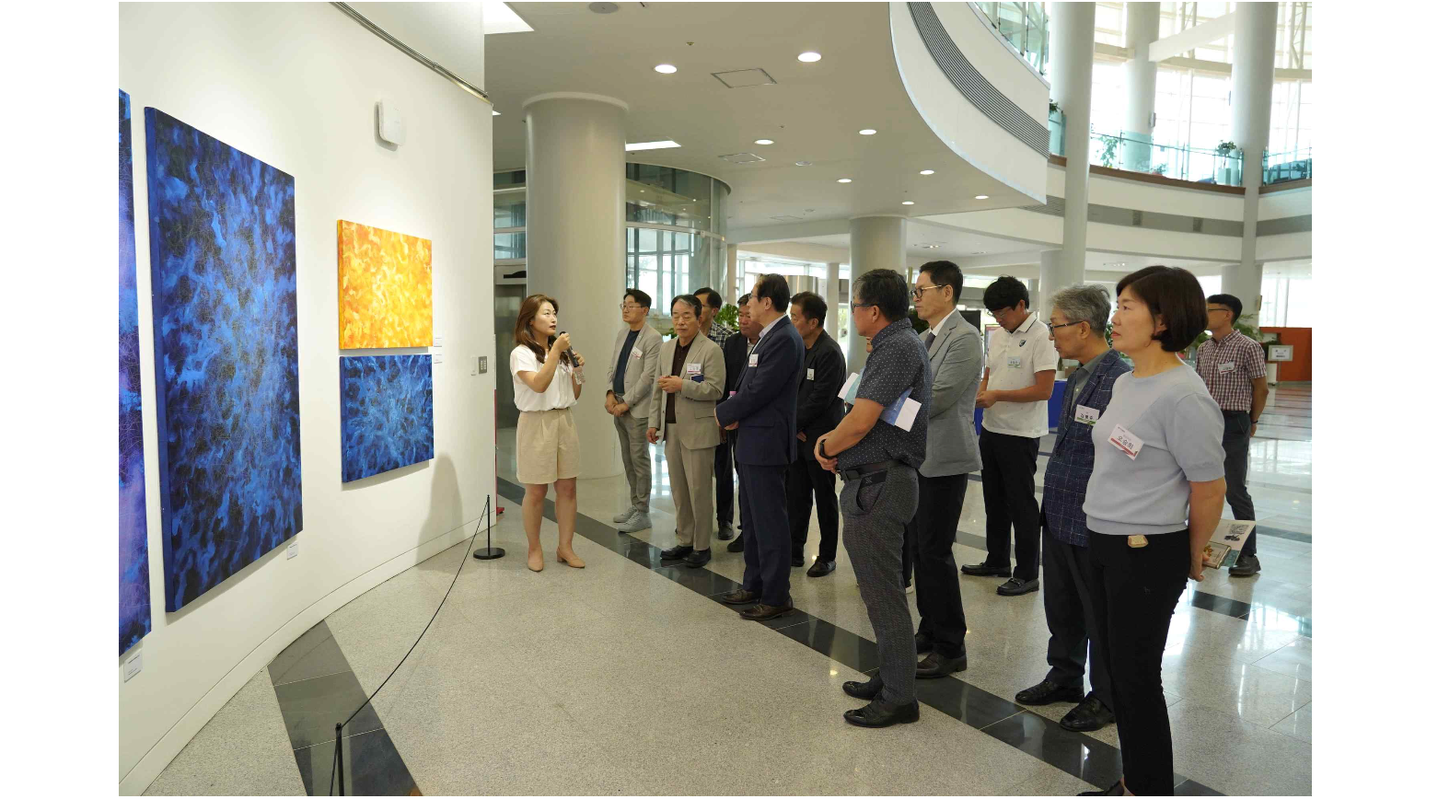▲ [Picture 1] Artist Yumi Song, the artist of the invitational exhibition, is explaining the work to the attendees.

GIST (Gwangju Institute of Science and Technology, President Kichul Lim) Academy held a 'Meeting with the Artist' to increase interest in and understanding of <Imagination of Infinity>, an invitational exhibition by Yumi Song, being held at the Oryong Art Hall.

This event, which was held recently (on the 27th of last month), was attended by President Kichul Lim, GTMBA Alumni Association President Seung-jong Na and the executive team, GIST Development Foundation Chairman Hae-myeong Kim, and others attended the invitational exhibition at Oryong Art Hall.

Artist Yumi Song, who met with the audience, is presenting 40 abstract paintings through the 3rd invitational exhibition <Imagination of Infinity> held at the Oryong Art Hall.

Artist Yumi Song explained the production process and background of the work, and then had time to share thoughts about the work through a Q&A session with the participants.

Artist Song said, "I am happy to be able to showcase and introduce my work directly to GIST members. I met a visitor who said that his work helped him select a research topic, and I hope it will continue to be a space where many visitors can receive new stimuli."

Yumi Song has been selected as the final writer of the London Art Biennale (Chelsea London) and the representative artist of the Agora Gallery (Chelsea New York), and she is an artist who has recently made her name known in Europe, participating in the group exhibition "Interconnection and Intuition" held at the Agora Gallery.

President Kichul Kim said, "The theme of the exhibition at the Oryong Art Hall, ‘Imagination of infinity’, is in line with the ‘infinite potential’ required for GIST innovation. Oryong Art Hall will serve as a source of inspiration for GIST members."

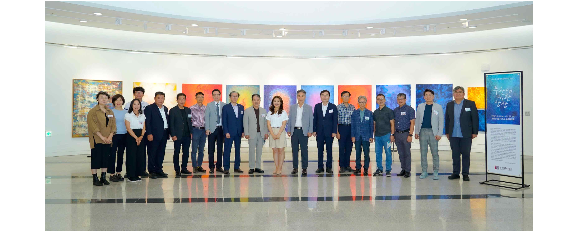[Picture 2] Participants are taking a group photo after meeting with the artist.

GIST Oryong Art Hall is an exhibition space opened by GIST to local residents and internal members to strengthen exchanges and cooperation with the local community and to provide a space for everyone to enjoy culture.

Oryong Art Hall is currently holding the 3rd Invitational Exhibition <Imagination of Infinity>, and a total of 6 exhibitions will be held by this year. Anyone can enter Oryong Hall and view the works displayed on the 1st and 2nd floors, regardless of being insiders or outsiders.

