Office of Human Rights and Legal Affairs invited ‘Gwanhyeon Blind Traditional Art Troupe’ to perform

– Inviting a professional performance group for the visually impaired to improve awareness of disabilities... Conducting Korean traditional music performances

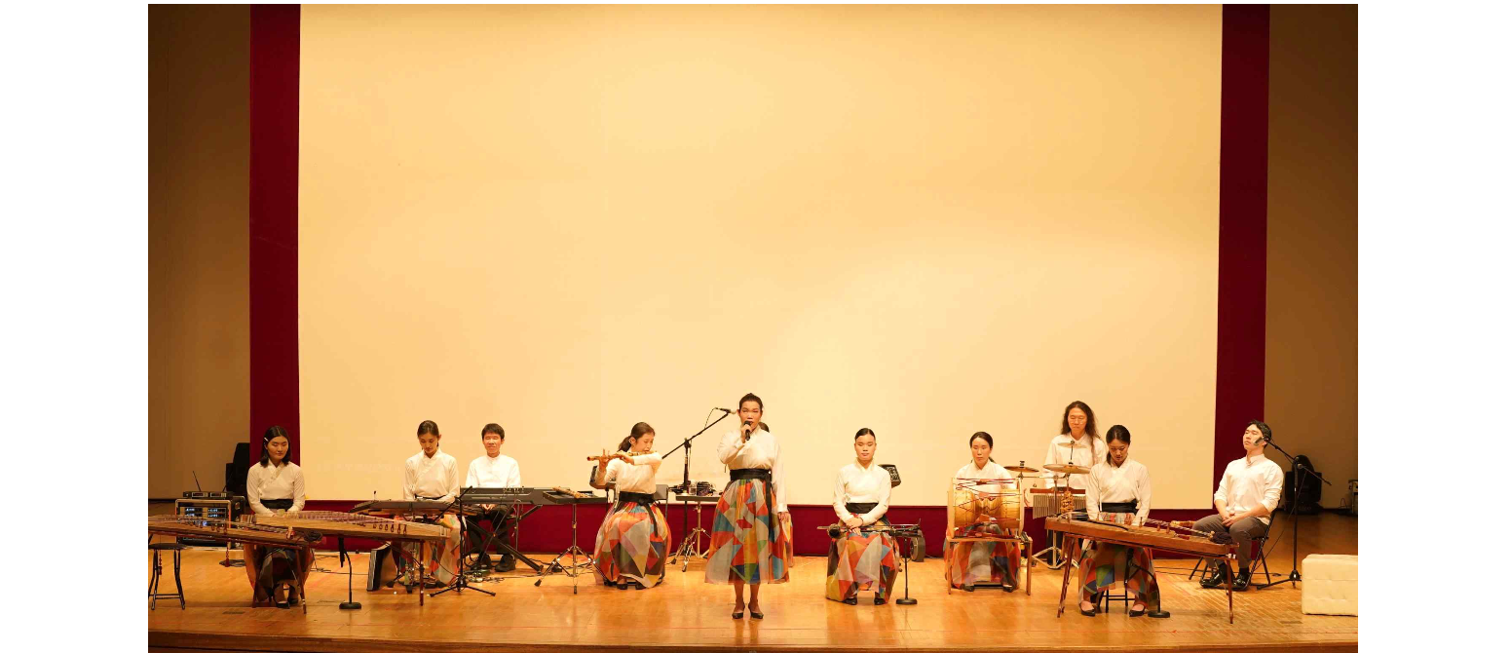▲ The Gwanhyeon Blind Traditional Art Troupe is performing at the GIST CT Art Hall.

GIST (Gwangju Institute of Science and Technology, President Kichul Lim) invited the ‘Gwanhyeon Blind Traditional Art Troupe’ to hold a concert for students and faculty to improve awareness of disabilities.

The event, held on the 11th at the CT Art Hall in the administrative building, was attended by about 180 GIST members, including President Kichuk Lim, who was newly appointed on the 7th.

The Gwanhyeon Blind Traditional Art Troupe, which gave this performance, is a performance group for the visually impaired that is actively performing at home and abroad, holding more than 100 performances every year and was invited to the Qatar World Cup.

Established in 2011, this art troupe is an organization that continues the tradition of court blind artists (Gwanhyeon) during the Joseon Dynasty. King Sejong the Great said, "There is no one who will abandon blind musicians in the world because they can hear sounds even if they cannot see."

This concert was moderated by Hyun-ah Lee, who has completed the National Intangible Cultural Property No. 41 Gasa and won the Presidential Award at the 'Onnara Korean Music Contest', and performed 'Long Live a New Thousand Years', 'Sijo Cheongsan-ri Byeokgye-su', and 'Walk', 'Cold Spring', 'The Tiger Is Coming Down', 'Sanjo Ensemble', and 'Beautiful Country'.

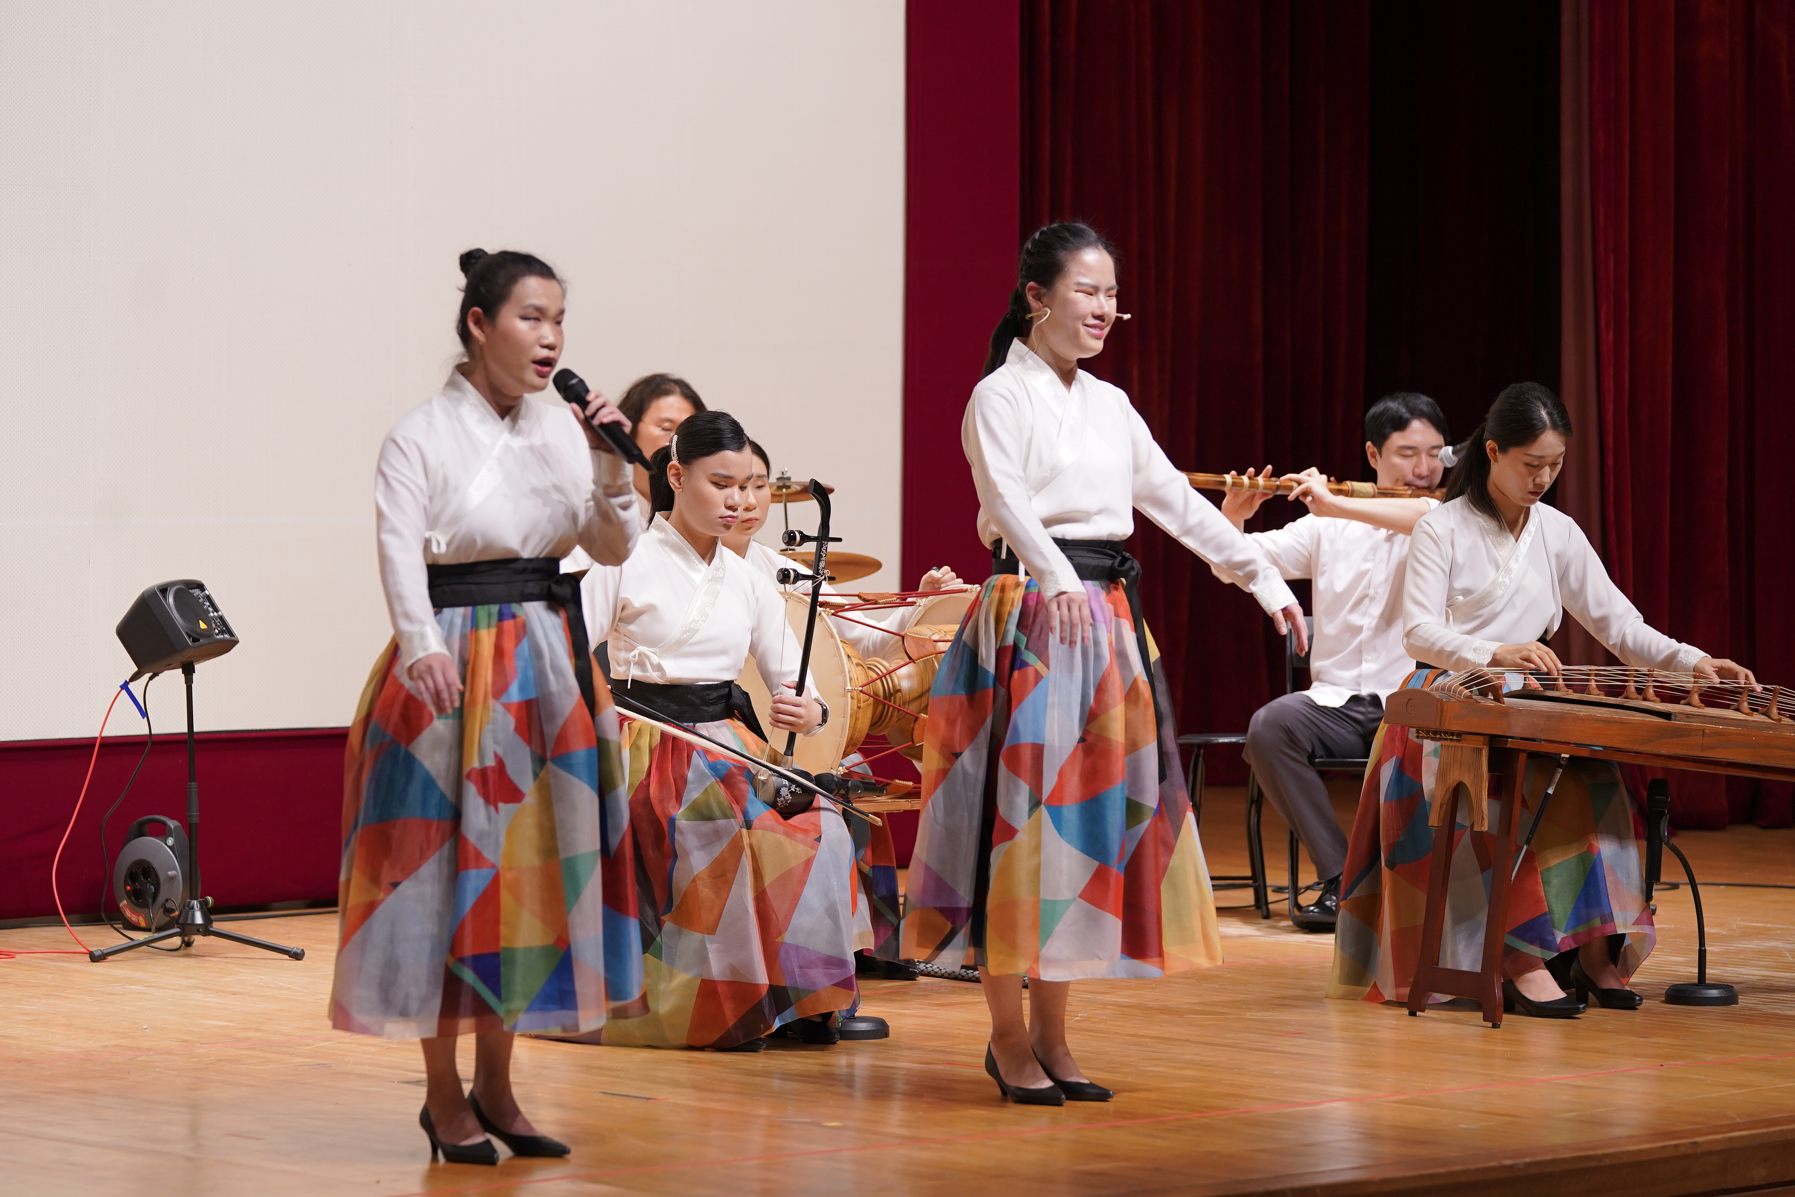▲ The Gwanhyeon Blind Traditional Art Troupe is playing the last song, ‘Beautiful Country’.

President Kichul Lim said, "I am happy to spend a meaningful time with GIST members to change the perception of disabilities. It was a heart-warming performance that moved people beyond barriers."

Meanwhile, this performance, promoted by the GIST Office of Human Rights and Legal Affairs, was held as part of the ‘Disability Awareness Improvement Education’ to create a culture of mutual understanding and empathy beyond disability and non-disability.

