"Gather students who want to start a business!" GIST Mock Startup Program Agreement Ceremony

- GIST representative start-up support program 2023 「GIST Sprint for Start-up」 started
- Held every year since 2014... Support for verification of student startup ideas without conditions for 6 months

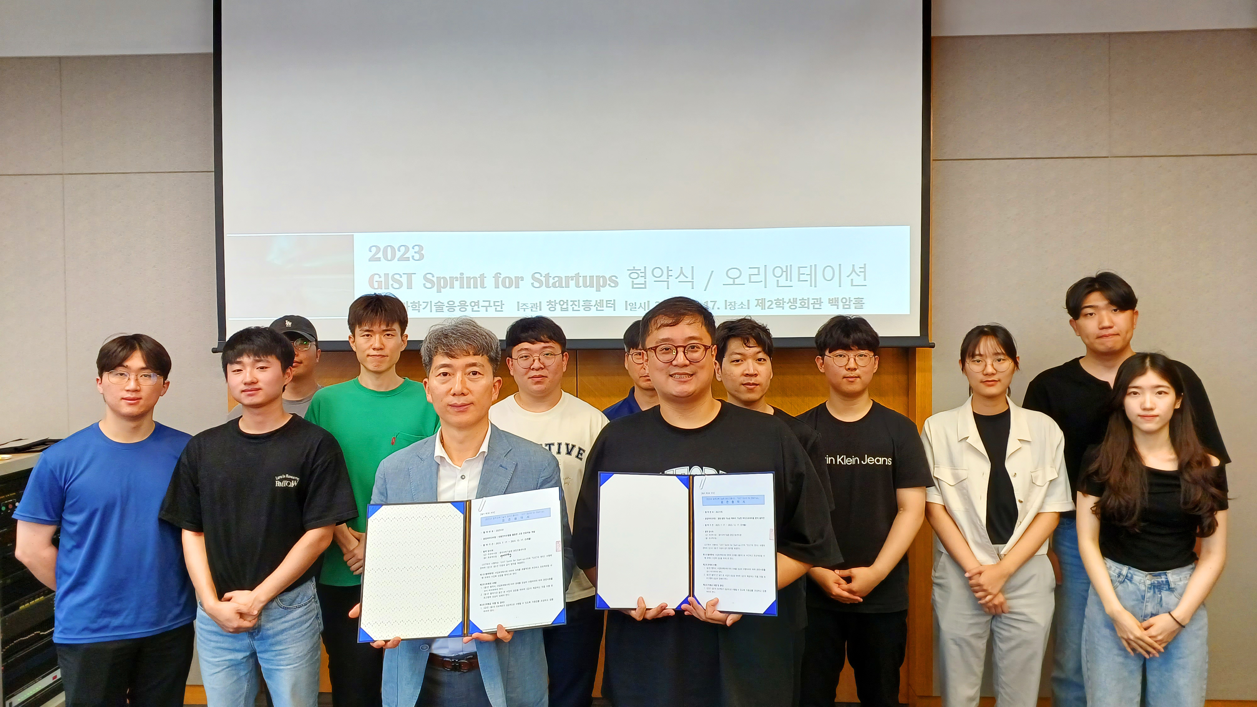▲ A group photo is being taken after holding an agreement ceremony for the ‘GIST Sprint for Startup (GSS)’ to promote a healthy start-up culture and verify various start-up ideas.

GIST’s representative start-up support program 「GIST Sprint for Startup (GSS)」, which supports students who dream of starting a business, verify start-up ideas, and explore feasibility, started the 2023 program.

GIST (Gwangju Institute of Science and Technology, President Kichul Lim) Startup Acceleration Center held an agreement ceremony and a meeting with 8 teams selected for the 「GIST Sprint for Startup」 program at the 2nd Student Union Building on the 17th (Mon) at 12:00 noon.

This program, which has been running every year since 2014, is a ‘signboard program’ of GIST’s student startup support process. After discovering entrepreneurial ideas in the 「GIST Startup Idea Contest」, the 「GIST Sprint for Startup」 proceeds with a mock start-up idea that the student actually wants to verify and increases the possibility of start-up success.

Participating teams can directly create initial products or services in the form of prototypes and even conduct market tests without the condition that they must start a business. In this process, items with a low probability of success are stopped, and items with a possibility of success are moved to the next step.

The program runs in the form of a challenge for 6 months until December, and the participating teams aim to create prototypes of verifiable early models within the period.

Participating teams are provided with a mentoring program that complements their ideas and helps commercialization, as well as consulting on design, technology, law, and marketing.

In December, when the program ends, a briefing and seminar on the final outcome will be held, and an investor meeting will also be held. Follow-up programs such as the 「Campus CEO Challenge for Student (CCS)*」 will also be conducted in connection with it.

* Campus CEO Challenge for Student (CCS): This is a practical start-up program for student start-up teams who have completed the mock start-up program and want to start a real-life start-up. Recruitment is held every March.

Among the participating teams are the teams that won at the GIST Startup Idea Contest in June ▴ First Prize (Microbiome Analysis Solution for Predicting the Predictability of Disease Development, by Yanghyun Joo, School of Materials Science and Engineering) and ▴ Excellence Prize (Ammonia Pyrolysis Catalyst, by Sungkyun Kim, School of Earth Sciences and Environmental Engineering).

In addition, artificial intelligence services such as 'correction artificial intelligence development using large language models (Student Ho-taek Joo, Institute of Integrated Technology)' and app services such as 'GIST Alumni Networking Platform App (Student Soo-yeon Shim, School of Electrical Engineering and Computer Science)' are participating and attracting attention.

Startup Acceleration Center Director Byeong-gwan Jo said, "Through this program, we plan to supplement students' entrepreneurship ideas and discover as many prospective entrepreneurship teams as possible with high potential for success. We hope to help students achieve their entrepreneurial dreams."

