GIST sends World Friends Korea IT Volunteer Group to Laos

- 12 students sent to Laos for 4 weeks from the 17th... Conducted social contribution activities such as ICT and Korean culture education

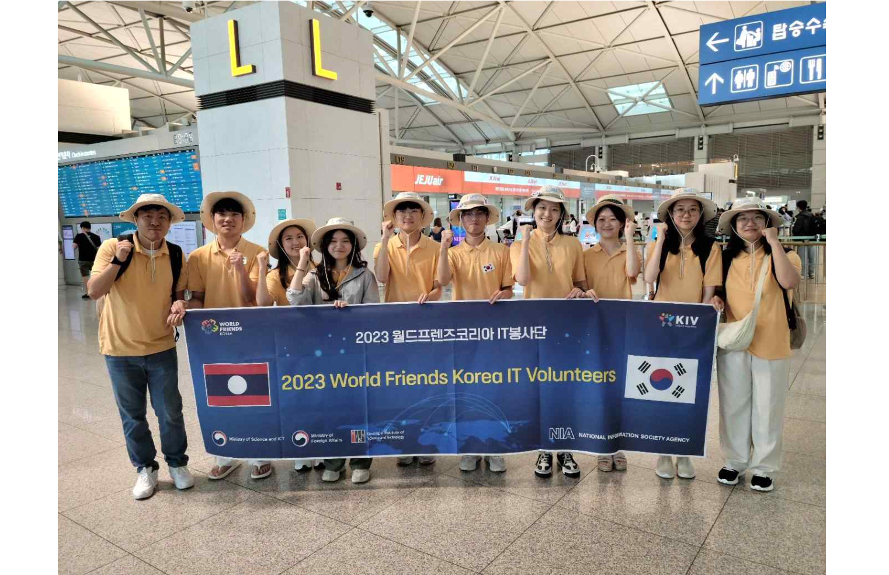▲ GIST students sent to the World Friends Korea IT Volunteer Group in 2023 are taking a group photo.

GIST (Gwangju Institute of Science and Technology, President Kichul Lim) World Friends Korea IT Volunteers will conduct volunteer activities from Monday, July 17 to Friday, August 11 to teach information and communication technology (ICT) and Korean culture at three institutions in Laos.

A total of 12 students from 3 teams selected by GIST will work for 4 weeks at three organizations: Vangvieng Ethnic School, Vientiane Capital Skill Development Center, and Digital Government Center.

Students will be taught not only ICT education such as drones, Python, and AI, but also Korean culture and Korean language, such as K-POP, Korean food making, and traditional games.

Starting with Vietnam in 2014, this volunteer group, which is jointly organized by GIST and the Korea Information Society Agency, has been sent participants to Moldova, Panama, Bhutan, and Vietnam. A total of 116 students have participated so far, including those volunteering online during the COVID-19 period.

Through this program, GIST supports students to experience educational service and grow into leaders in the field of science and technology with a spirit of volunteer service and a sound view of the country. In addition, by expanding ICT education to developing countries, it is striving to bridge the global digital divide and nurture young talent.

President Kichul Lim said, "We will continue to plan various programs utilizing the characteristics of GIST, promote the excellence of Korea's ICT technology, and contribute to strengthening the capacity of students in developing countries. We hope that our students will grow into next-generation global ICT leaders by understanding the diverse cultures of developing countries and broadening their knowledge."



