"Share the joy of science with island friends" GIST Social Contribution Group holds visiting science camp

-PIUM, the GIST social contribution group, visits Bigeum Middle School in Shinan-gun to provide science classes and career mentoring
- Held every year... Taking the lead in narrowing the gap in regional education and career through volunteering

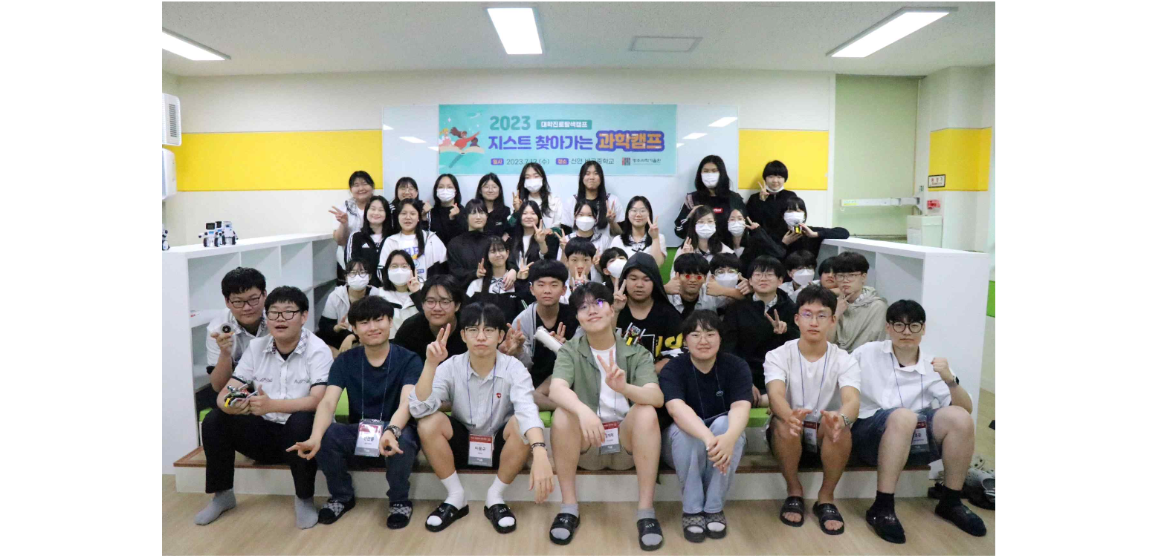▲ [Picture 1] Commemorative photos with students: The GIST social contribution group ‘PIUM’ visits Bigeum Middle School in Sinan to hold the <Visiting Science Camp>.

GIST (Gwangju Institute of Science and Technology, President Kichul Lim) social contribution group ‘PIUM’ visited Bigeum Middle School in Bigeumdo, Shinan-gun, Jeollanam-do for two days on the 12th and 13th to hold the <GIST Visiting Science Camp>, a knowledge sharing social contribution activity.

‘PIUM’, a social contribution group composed of GIST students, is being operated to contribute to narrowing the educational gap by providing various science classes and experiential programs to teenagers in underprivileged areas in an easy and interesting way.

<GIST Visiting Science Camp>, which has been running for 3 years now, is one of PIUM's representative social contribution programs. It is a program that directly visits middle schools in underserved areas such as islands and remote areas in Gwangju and Jeonnam to provide interesting and diverse science classes, experience programs, and career mentoring.

This year's visiting science camp was held for 2 days and 1 night for 34 students in the 3rd year of Bigeum Middle School in Shinan-gun. In this camp, ▴ understanding car brakes (mechanical engineering) ▴ blood type determination and centrifugal separation technology (life science/appropriate technology) ▴ making eco-friendly water bottles (earth/environment) ▴ understanding autonomous vehicles (AI/mechanics field) and other interesting topics were taught.

In particular, the mentor group of GIST students who participated in the camp drew attention and response from the students of Bigeum Middle School by preparing classes on topics covering the core fields of the future high-tech industry, such as ‘obstacle avoidance self-driving car kit’ and ‘making car brake kit’.

GIST School of Mechanical Engineering Professor Solkeun Jee also visited Bigeum Middle School and gave a special lecture and career mentoring on the theme of ‘Fluid Mechanics, Airplanes, and Bigeumdo’.

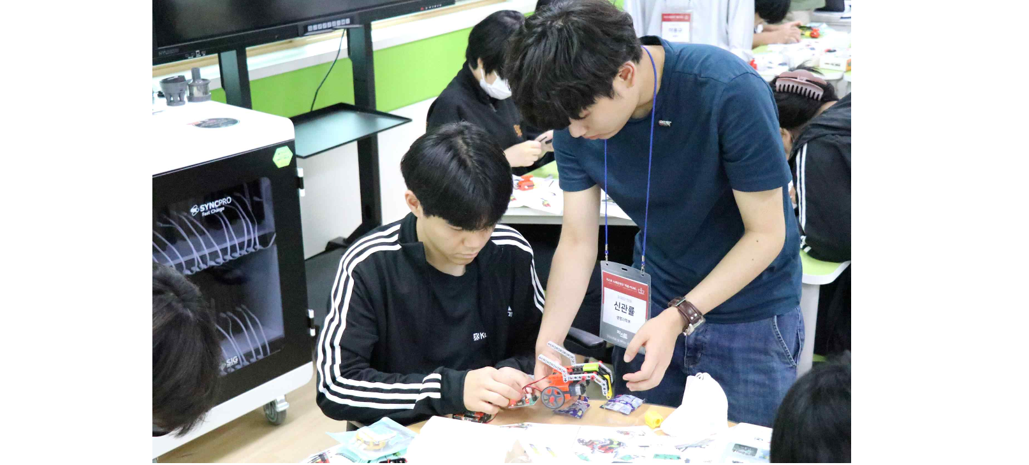[Picture 2] At the <Visiting Science Camp> hosted by GIST Social Contribution Group ‘PIUM’, Bigeum Middle School students are making an obstacle-avoiding self-driving car.

One of the bigeum students who participated in the science camp said, "Originally, I was not interested in science because I thought it was boring, but I think I was able to approach science happily through this science camp. I thought that I would like to study science with interest in the future."

Meanwhile, in addition to the <Visiting Science Camp>, which is held three times* this year, the social contribution group 'PIUM' also holds ▴ online mentoring (online learning/career mentoring) ▴ AI dream tree camp (offline experiential AI education program) ▴ and are actively carrying out knowledge-sharing volunteer work through science camps with GIST (science camps held at the GIST campus).

* Bigeum Middle School in Sinan-gun, Jeonnam, Anyang Middle School in Jangheung-gun, Jeonnam, Hadang Middle School in Mokpo-si, Jeonnam

Thanks to these various knowledge sharing program activities of ‘PIUM’, GIST was selected as an operating institution for the ‘University Career Exploration Camp Project’ hosted by the Ministry of Education and the Korea Foundation for the Creativity of Science for three consecutive years from 2021.

President Kichul Lim said, "Through GIST's social contribution projects, we aim to bridge the educational gap in the local community and lay the groundwork for nurturing future scientific talents. Celebrating the 30th anniversary this year, we will further expand our social contribution activities and strive to provide better educational opportunities to science aspirants in underprivileged areas."

