GIST Climate Change Academy held the opening ceremony of the 6th Alumni Association

– Held on the 14th (Wednesday)... Expectations for the exchange of key human resources to lead the local climate industry

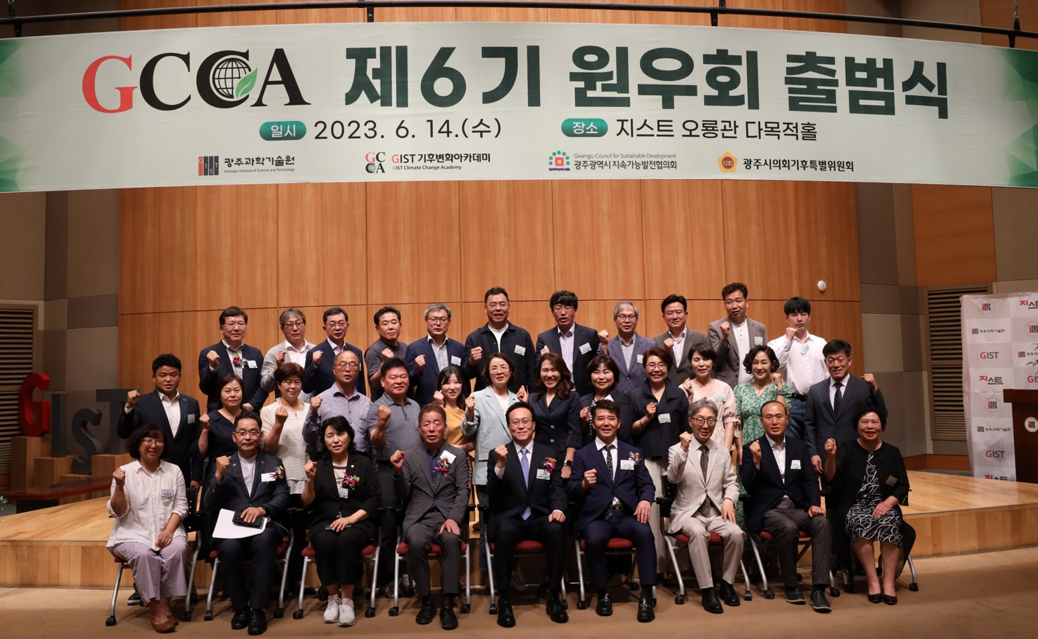▲ Participants are taking commemorative photos after the opening ceremony of the 6th Alumni Association of GIST Climate Change Academy.

GIST (Gwangju Institute of Science and Technology, Acting President Raekil Park) Climate Change Academy (GCCA) held the 6th Opening Ceremony at GIST Oryong Hall on the 14th (Wednesday).

The event was attended by College Dean Chung-Hee Cho, the 5th Climate Change Academy Alumni President Seok-jong Kim, chairman of South Foods, and the 6th Wonwoo Chairman Jeong-chul Kim (CEO of Gongilgong Power Telecom Co., Ltd.) and about 40 students and alumni of the 6th class attended and celebrated the launch.

In his inaugural address, Alumni Chairman Jeong-chul Kim said, "Based on the solid capabilities and potential that GIST Climate Change Academy has accumulated over the years, the 6th Alumni Association will become the best Alumni Association in harmony among alumni. I will do my best as the chairman to lead the climate industry and create synergy with the local community."

College Dean Chung-Hee Cho said, "It is very meaningful to operate the 6th course with leaders and opinion leaders from various fields leading Gwangju and Jeonnam. We will continue to work harder for the development of GIST and the Climate Change Academy."

Seok-jong Kim, chairman of South Foods, said, "As the 5th Alumni Chairman, I sincerely congratulate the launch of the 6th Alumni Association. Based on the expertise gained through the Climate Change Academy, we hope that they will be reborn as key talents who will lead the local climate industry and economic development."

The GIST Climate Change Academy provides training courses to raise awareness of the global climate crisis and enhance expertise in the climate industry for CEOs of companies and executives and staff of related organizations who are interested in climate change and provides a venue for close exchanges. It promotes technology transfer and industry-academia cooperation.

In particular, it visit overseas sites where we can feel the climate crisis, understand the seriousness of climate change, and provide substantial programs such as expanding exchanges through breakfast forums and various seminars.

Since its opening in 2016, a total of 180 alumni have been produced, and they play a major role in responding to the climate crisis as leaders in leading the local climate industry. Classes at the Climate Management Academy are held every Wednesday at 7pm.

The 6th executive team and executive team are as follows.

△ Chairman Kim Jeong-cheol, CEO of Gongilgong Power Telecom △ Auditor Soon-hee Lee, CEO of City Landscaping, Gil-ho Jeong, Head of Income Tax Department at Mine Tax Office △ Senior Vice Chairman Byung-chul Lee, President of Daewoong S&T △ Standing Vice Chairman Lee Geum-ja, CEO of Shin Wang-il Farming Association, Jo Jong-ryul Co., Ltd. Farm Solar CEO △ Secretary General Kwon Pil-joon, CEO of Innotop Co., Ltd., Yoo Ae-ri, director of Korea Mold & Mold Components Co., Ltd. △ Subcommittee Chairperson, Kim Seon-hak, CEO of Haewon Co., Ltd. △ Subcommittee Chairperson, Park Bok-young, CEO of Coway’s Gwangju Central Agency △ Education Chairperson, Jeon Tae-ho Gwangju National Science Museum Acting Director △ Finance Director Jung Woo-gang, Woori Bank Branch Manager △ Public Relations Director Seo Mi-bok CEO of HP Hewlett-Packard Advanced Digital.



