Is there a cure for senile sarcopenia... GIST signs technology transfer agreement with Pluto Co., Ltd.

- New drug candidate package for the treatment of senile sarcopenia... Technology transfer to Pluto Co., Ltd.
- Rediscovered in liver medicine... Expected to develop an oral sarcopenia treatment rather than an injection

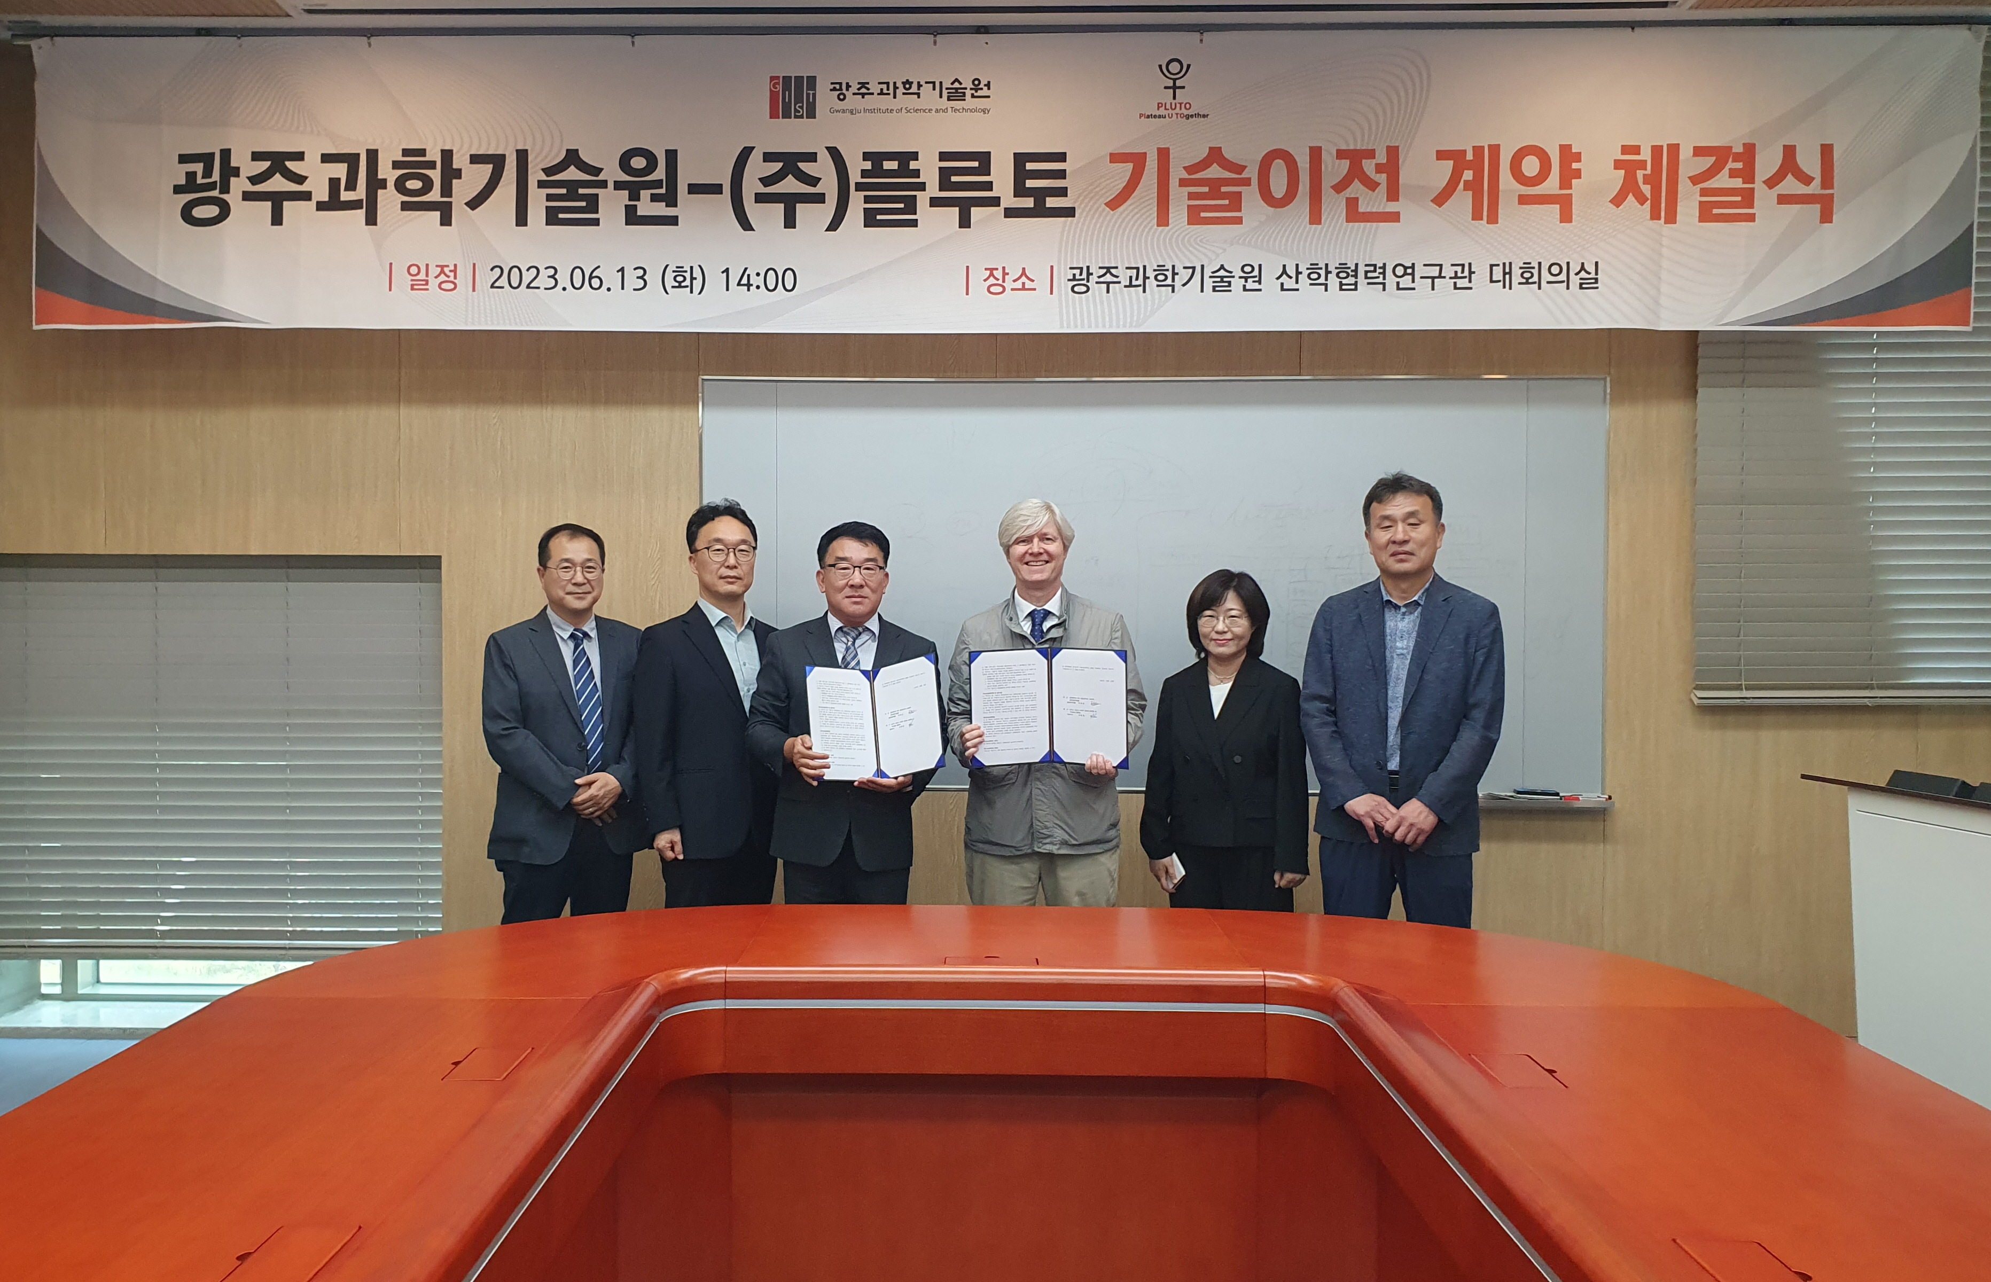▲ Participants are taking commemorative photos after the technology transfer agreement ceremony. (From left) Pluto Co., Ltd. Managing Director Kwang-Sik Yoon, Managing Director Bong-Sang Lee, CEO Hong-Yeol Jeon, GIST School of Life Sciences Professor Darren Williams, Research Professor Da-Woon Jung, Technology Commercialization Center Director Hee-gon Moon

GIST (Gwangju Institute of Science and Technology, Acting President Raekil Park) Professor Darren Williams' team developed new drug candidates that can treat 'senile sarcopenia', which causes abnormal muscle loss, and transferred the technology to Pluto Co., Ltd.

The signing ceremony was attended by GIST School of Life Sciences Professor Darren Williams, Technology Commercialization Center Director Hee-gon Moon, and Pluto CEO Hong-Yeol Jeon. It was held on the 13th (Tuesday) in the conference room of the GIST Industry-University Cooperation Research Center, with key officials including managing director Bong-sang Lee in attendance.

Senile sarcopenia is caused by an abnormal decrease in muscle mass and strength with aging. It is a disease that increases the risk of death as well as cardiovascular disease, but the development of new drugs is urgently needed as there is no approved treatment worldwide.

Sarcopenia was classified as a disease by the World Health Organization (WHO) in 2016 and is recognized as a disease rather than a general aging phenomenon, such as being included in the disease diagnosis code in Korea from 2021.

Malotilate, one of the drugs that GIST transferred technology from, was originally approved by the US Food and Drug Administration (FDA) as a treatment for liver cirrhosis and liver damage. The research team revealed the mechanism by which Malotilate alleviates sarcopenia through a ‘drug re-creation’ method, and confirmed the effect of alleviating muscle mass and muscle strength reduction through experimental rats.

‘Drug re-creation’ is a new drug development method that seeks treatment effects for other diseases targeting drugs that have already been marketed or whose safety has been verified but have not passed clinical trials.

Professor Darren Williams said, "When malostylate is orally administered to aged laboratory rats, the sarcopenia alleviation effect can be confirmed, and it is expected that sarcopenia patients, most of whom are the elderly, can be treated with oral medicine rather than injection. The drug re-creation method could speed up the development of safe oral sarcopenia treatment."

Pluto CEO Hong-Yeol Jeon said, "We will do our best to apply Pluto's excellent formulation technology to conduct clinical trials and commercialize it as a global innovative new drug."

Pluto Co., Ltd. was recognized for its technological prowess as a development company specializing in human medicine and veterinary medicine, and it received an investment of KRW 10 billion from Pharma Research, a mid-sized domestic company, in August of last year, just three months after its establishment. And in April of this year, it received a The company is producing excellent results, such as preparing for a arthritis treatment launch after receiving product approval.

This technology development was carried out with support from the National Research Foundation of Korea's Individual Basic Research Project, C1 Gas Refinery Project, and Group Research Support Project.



