GIST Techno Management Business Academy held the launching ceremony of the 13th Alumni Association

– Launched on the 13th (Tue)... Alumni Chairman wants to contribute to win-win development with the local community through industry-university cooperation

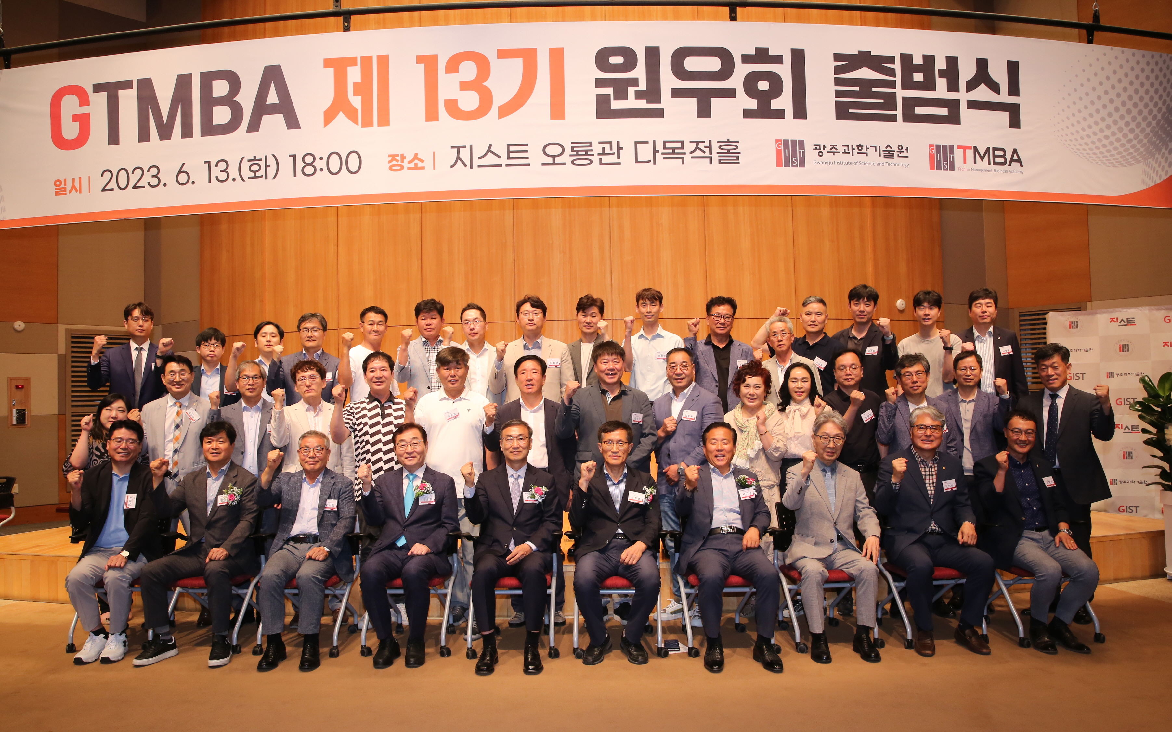▲ Participants are taking commemorative photos after the opening ceremony of the 13th Alumni Association of GIST Techno Management Business Academy.

GIST (Gwangju Institute of Science and Technology, Acting President Raekil Park) Technology Management Academy (GTMBA) held the launching ceremony of the 13th Alumni Association.

The event was attended by Acting President Raekil Park and executives of the Techno Management Business Academy Alumni Association, as well as Chairman Kyung-Sup Shim (CEO of Intops Technic Co., Ltd.) and was held on the 13th (Tuesday) at GIST Oryong Hall with about 50 members of the 13th Alumni Associationattending.

In his inaugural address, Alumni Chairman Kyung-Sup Shim said, "The 13th Alumni Association will do its best not to damage the reputation of the GIST Technology Management Academy, a luxury brand with well-organized educational programs, great instructors, and the best alumni. Through industry-academia cooperation, we will strive to contribute to the win-win development of the local community and increase the value of the Technology Management Academy."

In a congratulatory speech, Acting President Raekil Park said, "We ask for your interest and encouragement so that the Techno Management Business Academy can make a new leap forward based on your knowledge and experience accumulated in each field. We will be with GIST and the development of the Technology Management Academy in the future."

Jeongsoon Park, Executive Vice President of the Alumni Association, said, "On behalf of the alumni, I sincerely congratulate the launch of the 13th Alumni Association. We will work together so that the Techno Management Business Academy can be reborn as the best organization in the local community and that alumni companies can become the center of regional economic development."

The GIST Techno Management Business Academy provides systematic training courses by experts from various fields to corporate CEOs and executives and employees of public institutions to enhance their understanding of global trends and provide opportunities for technology transfer and industry-university cooperation.

In particular, since 2017, an agreement has been signed with the National University of Singapore to operate the ‘CEO Leadership Program’ and grant certificates to members who complete the course to support them in strengthening their capacity to establish global management strategies.

Since its opening in 2010, a total of 480 alumni have been produced, and they are making great contributions to society as leaders in various fields such as politics and relations as well as the business world. Classes at the Techno Management Business Academy are held every Tuesday at 7:00 PM.

The executives and executives of the 13th Alumni Association are as follows.

△ Chairman Shim Gyeong-seop, CEO of Intops Technic Co., Ltd. △ Auditor Shim Jae-hun, Law Firm Ilsam Representative Lawyer Sa, Yun Seo-young (L) Slow Step CEO △ Senior Vice Chairman Kim Jeong-hyeon (Top Environment Construction Co., Ltd.) CEO △ Standing Vice Chairman Kang Hyeon-gu Art & Architecture Office (Co., Ltd.) ) CEO Heo Seung-eop CEO Samwoo Industries Co., Ltd. Park Kwon-jin Head of Value Added Tax Division, Gwangju Tax Office △ Secretary General Jung Cheol-soo CEO Sejong Construction Technology Co., Ltd. △ Subcommittee Chairman Han Eok-soo CEO Namyoung Automation Co., Ltd. △ Subcommittee Chairperson Yoon Mi-sook ( CEO of Hyundai Food System Co., Ltd. △ Chief of Education Eul-Sung Park Vice President of Korea Cement Co., Ltd. △ Finance President Il-Seon Jung Vice President of Kwangju Bank △ Director of Public Relations Kyu-Deok Park CEO of K Partners Co., Ltd.



