GIST-National Intelligence Service sign cyber security and research security agreement

– Establishing cooperative relationships such as exchange of human resources and material resources and fostering for cyber/research security experts

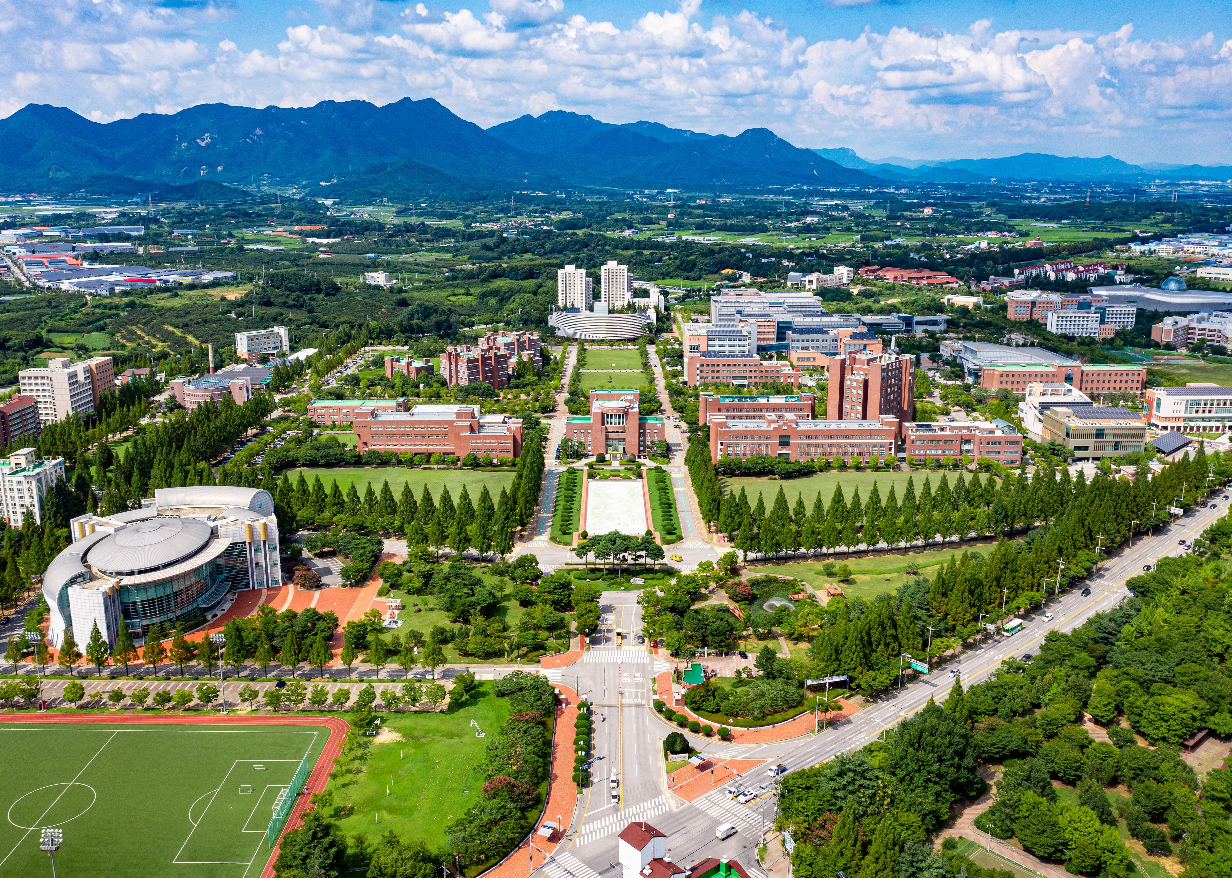
▲ [Photo] A view of the GIST campus

GIST (Gwangju Institute of Science and Technology, Acting President Raekil Park) and the National Intelligence Service have signed a business agreement for cooperation in cyber security and research security.

The signing ceremony was held on June 7th (Wednesday) at 11:00 am in the large meeting room on the 2nd floor of the GIST Administration Building, attended by key officials such as GIST Acting President Raekil Park, Dean of Academic Affairs Sang-Don Kim, General Affairs Director Seunghee Oh, and the National Intelligence Service branch manager.

Through this agreement, GIST and the National Intelligence Service plan to ▴ exchange human resources and material resources ▴ jointly discover and promote solutions for both institutions ▴ nurture cyber security experts ▴ check the status of security management to protect GIST research results and consult on cyber security.

Acting President Raekil Park said, "It is reassuring to conclude an agreement with the National Intelligence Service in a situation where security threats such as malicious e-mail and hacking are increasing day by day. Through this agreement, both organizations will develop together and strive to strengthen national competitiveness in the field of information and security."

Meanwhile, GIST, which celebrated its 30th anniversary this year, is a science and technology specialized university that has taken the lead in nurturing science and technology talents by producing world-class research achievements. With the signing of this agreement, GIST is expected to stand out in the field of cyber security and research security.

