GIST Social Contribution Group conducts career mentoring for middle school students

- On the 19th (Fri), Gwangju Center for Creative Convergence Education, 40 students from the Secondary School for Gifted Students visited GIST
- From special lectures on quantum mechanics to laboratory experience... sharing the dream of a scientist at GIST

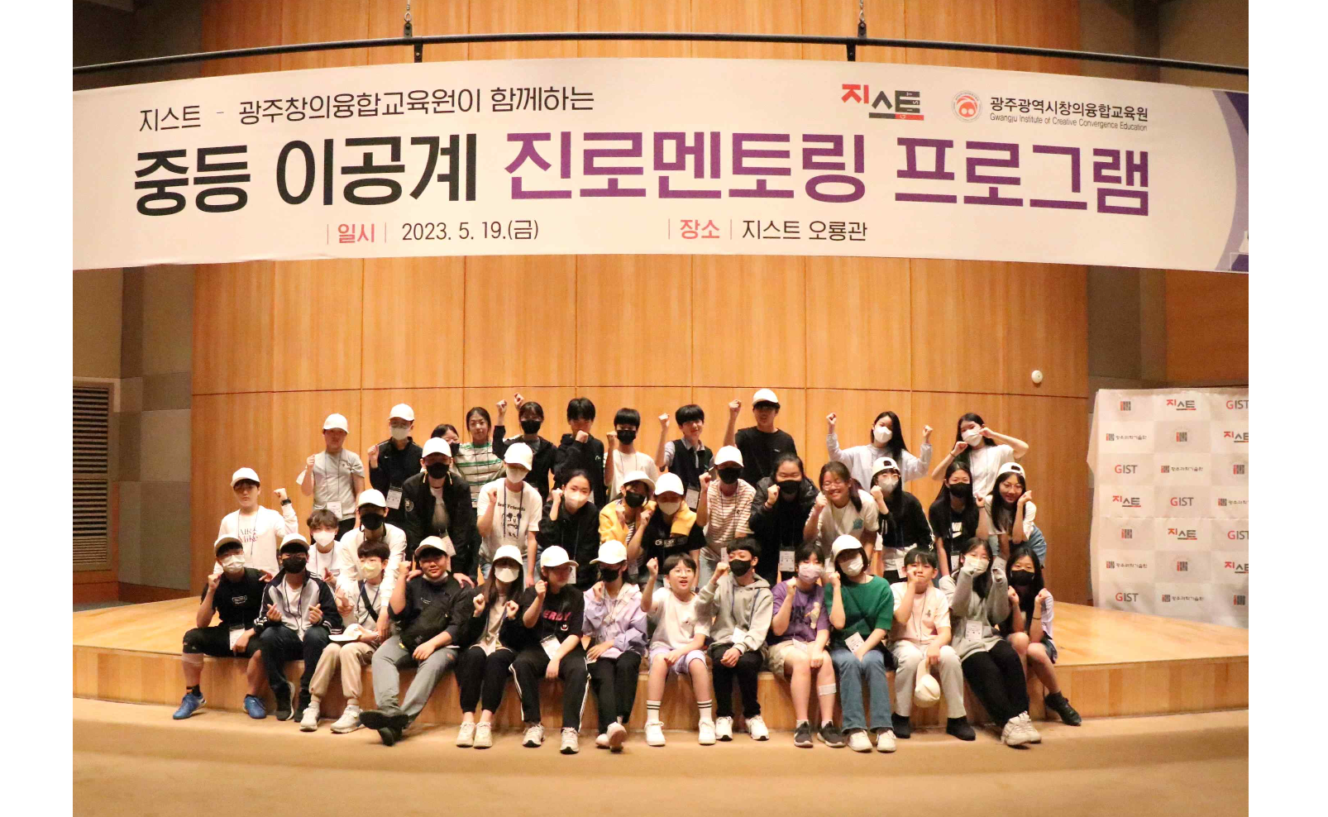▲ Students participating in the middle school gifted career mentoring program are taking a group photo.

GIST (Gwangju Institute of Science and Technology, Acting President Raekil Park) Social Contribution Group, together with the Gwangju Center for Creative Convergence Education, conducted the ‘Secondary Gifted Career Mentoring’ program for gifted students in the community on the 19th.

This career mentoring is a program designed to help gifted middle school students in the Gwangju area find their aptitude and aptitude and specifically explore their career path in the field of science and engineering. It was provided to 40 students in the first year of middle school at the Center for Creative Convergence Education in Gwangju Metropolitan City.

The program, which started with a special lecture on quantum mechanics by Department of Physics and Photon Science Professor Keun-Young Kim, includes a tour of labs such as the artificial intelligence lab. It was followed by research demonstration practice and campus tours, and it received a lot of response from students.

One student participating in the program said, "The professor made the physics lecture on quantum mechanics easy and fun, so I was able to understand it well, and I was able to visualize the future I dreamed of by visiting and experiencing the labs."

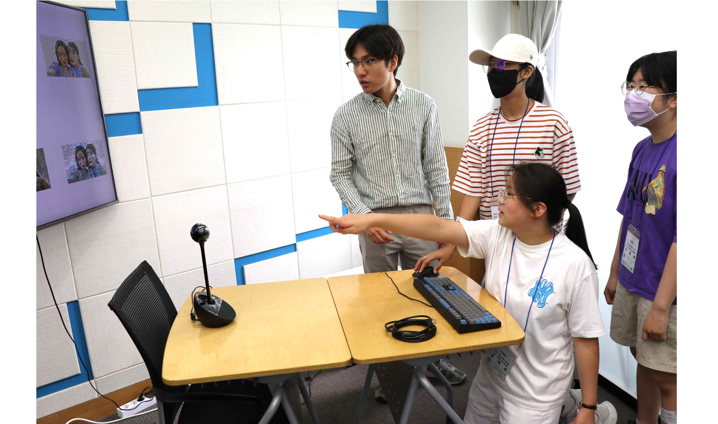▲ Students are experiencing a research demonstration using an image generation model in the artificial intelligence lab.

Acting President Raekil Park said, "I am glad that GIST helps local gifted science students develop their potential and grow into scientists and engineers by experiencing various fields of science and engineering at GIST. We will take the lead in fostering convergence science and technology experts who will lead the future."

Celebrating its 30th anniversary this year, GIST has been conducting various science camps and educational services for elementary, middle, and high school students since 2010. In the future, it plans to further expand the beneficiaries and prepare a substantial experience-type science and engineering career exploration program, etc., to further develop experts.

