Korean Quiz Contest held for foreigners

- On the 19th (Fri), a quiz contest was held for foreign members to open a place to learn about Korean culture

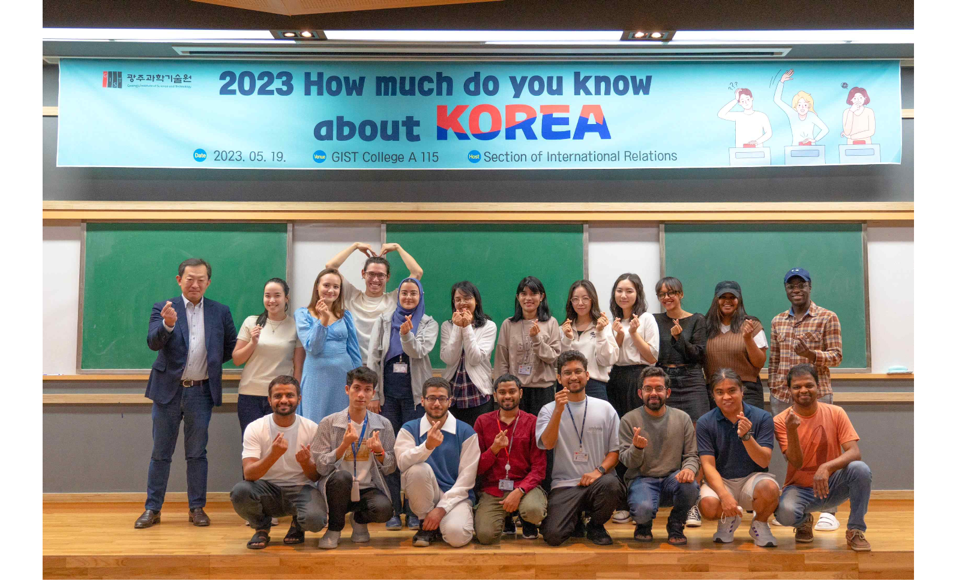▲ Foreign members participating in the GIST Korea Quiz Contest are taking a group photo with Zee Yong Park, Dean of International and Public Affairs (far left, concurrently serving as Dean of Planning)

GIST (Gwangju Institute of Science and Technology, Acting President Raekil Park) held the ‘2023 How much do you know about KOREA’ event on the 19th.

This is a quiz contest where foreign members of GIST gather to solve problems about Korea, and it has been held every year since 2021. This year, foreign members from 12 countries, including Kenya, Kazakhstan, India, and Pakistan, participated in the cultural exchange event to understand Korean culture and form a consensus.

The contest was conducted with questions about Korean history, Korean language, Korean etiquette, Korean culture, and Korean food. Participants had time to understand Korea more deeply by viewing photos of various cultural properties and listening to explanations. Particularly, they watched a Pansori video featuring the melody of Gu Seong-jin and received a great response.

Participants who knew Korean culture as well as Koreans competed fiercely. A 50-question quiz was presented, but the winner was determined with an additional quiz.

Zee Yong Park, Dean of International and Public Affairs (far left, concurrently serving as Dean of Planning) said, "We are happy to provide opportunities for GIST foreign members who have a common interest in ‘Korea’ to learn the correct knowledge about Korea and share friendships. Through this event, it is hoped that foreign members will become more familiar with Korea and strengthen their ties with Korean members."

