Team GIST presented music and performances that even hearing-impaired people can enjoy at the Barrier-Free Music Festival

- Team GIST, School of Integrated Technology, provides exhibitions and experiences to support hearing-impaired people enjoy music
- Collaboration performance with Crying Nut as AI sign language dancer <Sori Rabbit> at Nada Music Festival in Busan

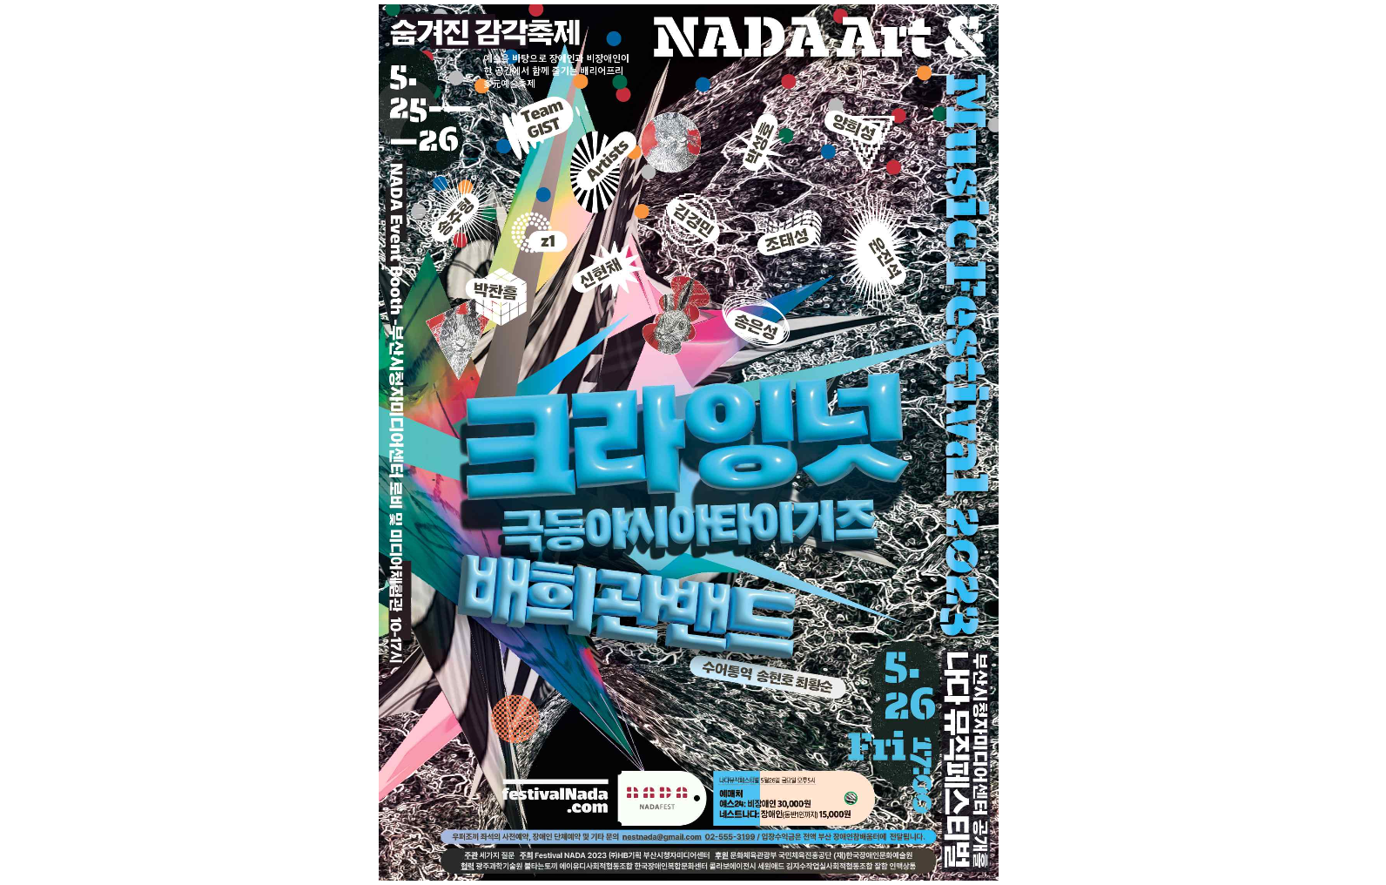[Picture 1] ‘Nada Music Festival 2023’ poster

GIST (Gwangju Institute of Science and Technology, Acting President Raekil Park), ‘Team GIST’ of the School of Integrated Technology, plans to showcase music and performance technology that even the hearing impaired can enjoy at ‘Festival Nada 2023’.

Festival Nada, the largest barrier-free* music festival in Korea that started in 2012, supports exhibitions and experiences for audiences with disabilities, and conducts live performances that even hearing-impaired people can enjoy by applying cutting-edge technologies such as AI and media art. This year, it will be held for two days on the 25th and 26th at the Busan Viewers Media Center located in Haeundae-gu, Busan.

* barrier-free: Refers to a movement and policy to remove physical obstacles and psychological barriers in the lives of the socially underprivileged, such as the disabled and the elderly.

Team GIST is a research team that develops ‘music and dance realization technology’ for the hearing impaired. Professor Jin Hyuk Hong of the School of Integrated Technology is in charge of guidance along with Professors Kyung-Joong Kim, Ji Hyun Yi, and Eunsung Song.

The live performances of the Crying Nut and Bae Hee-gwan bands will feature an AI sign language dancer named ‘Sori Rabbit’ developed by Team GIST to add to the excitement. AI technology that generates a sign language dance based on song lyrics is applied so that the hearing impaired can enjoy the song visually.

[Picture 2] AI sign language dancer 'Sori Rabbit' is converting song lyrics into sign language dance.

In addition, five booths will be prepared to showcase realistic visualization technology for the hearing impaired as interesting contents: ▴ AI sign language dancer Sori Rabbit ▴ BizHap Synthesizer, a tool to see, touch, feel, and create sound ▴ Viz-stage music education tool, a music education and instrument playing program featuring various sound characters ▴ Dance with Just Dance, a dance game enjoyed visually and tactilely ▴ An oral type bone conduction mouthpiece that listens to music through teeth will be exhibited.

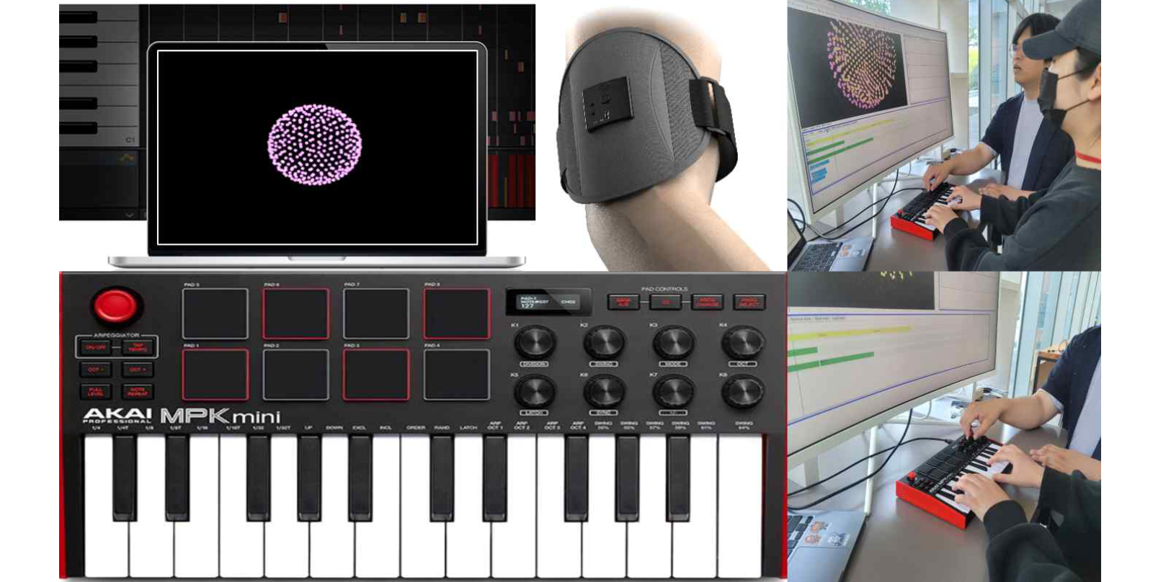[Picture 3] The audience is experiencing the ‘BizHap synthesizer,’ which sees, touches, feels and creates sound.

Professor Jin Hyuk Hong said, "By participating in this festival, I had a good opportunity to hear vivid feedback from the hearing-impaired audience. Team GIST will not stop just at developing technology but will continue to conduct various demonstrations outside the laboratory."

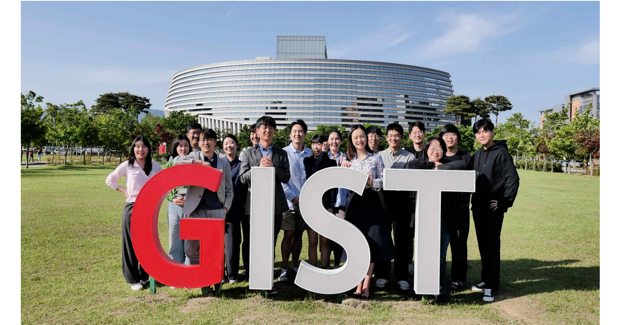[Picture 4] ‘Team GIST’ of the GIST School of Convergence Technology and Interdisciplinary Studies is taking a group photo.
(From left in the front row) School of Integrated Technology Professors Jin Hyuk Hong Kyung-Joong Kim, Eunsung Song, and Ji Hyun Yi

This research achievement was carried out with GIST as the host organization and CK Materials Lab Co., Ltd., KAIST, Sejong University, and Handspeak participating as joint research institutes. <Development of music and dance visualization technology for the enjoyment of music by the hearing impaired> was carried out with the support of the Ministry of Culture, Sports and Tourism and the Korea Creative Content Agency's cultural technology R&D support project.



