“Games, audio, songwriting… Experience AI” GIST participated in <2023 Korea Science Festival>

- The largest science event in Korea... Hosted by the Ministry of Science and ICT and Daejeon City, held for 4 days from the 27th
- GIST operates an experiential booth containing interesting research achievements in the field of AI to communicate with visitors

□ GIST (Gwangju Institute of Science and Technology, Acting President Raekil Park) participated in <2023 Korea Science Festival> and presented excellent research results in the field of artificial intelligence (AI).

<2023 Korea Science Festival> is the largest science event in Korea held every year since 1997, and people can enjoy science contents of various levels, from cutting-edge technology to scientific principles in everyday life. This year, it was held under the theme of ‘Meeting the Infinite Possibilities of Science’.

□ GIST set up three booths to provide content that the audience could experience: ▴ Emo-tris, an emotion recognition Tetris game (Professor Kyung-Joong Kim, School of Integrated Technology) ▴ Personalized AI-based voice/acoustic technology (Professor Hong Kook Kim, School of Electrical Engineering And Computer Science) ▴ Music with artificial intelligence composer EVOM (Lee Bom) (Professor Chang Wook Ahn, AI Graduate School).

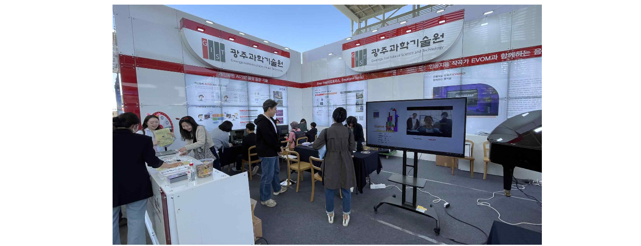▲ Visitors are enjoying a Tetris game that recognizes emotions.

∘ At the 「Emo-tris」 booth, users could experience 'Emo-tris', a Tetris game in which the type and speed of blocks change depending on the user's facial expression. ‘Emo-tris’ is a compound word of ‘Emotion’, which means emotion, and ‘Tetris’, the game name.

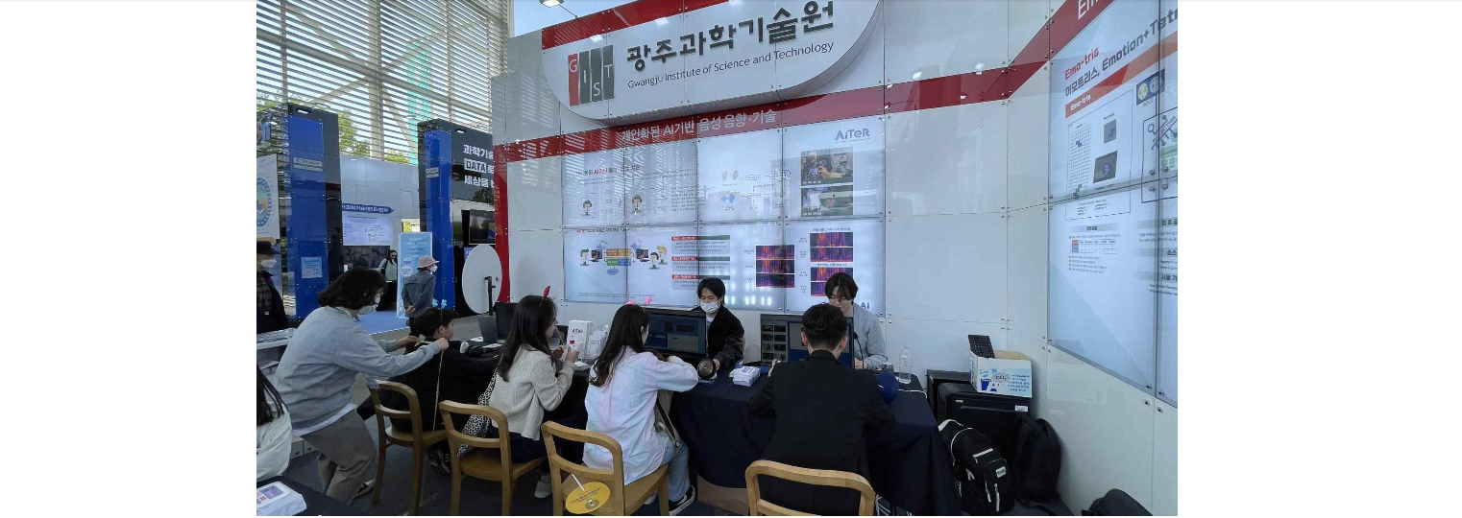▲ Visitors are experiencing AI-based customized voice and sound technology.

∘ 「Personalized AI-based voice/acoustic technology」 booth showed technology that provides optimized spatial audio for users by analyzing body information and ear shape with AI-based solutions. In addition, it attracted the attention of the audience with interesting contents, such as a technology that converts only human voices into text in a noisy environment and a technology that converts the voices of famous actors in media into the voices of users.

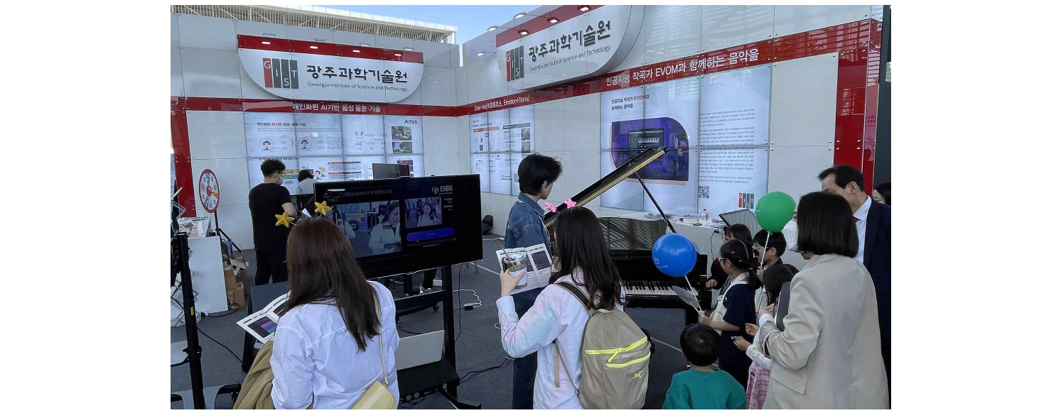▲ Visitors are composing music with AI.

∘ In the 「Music with AI Composer EVOM」 booth, after detecting facial expressions and analyzing emotions, the AI composition platform ‘MUSIA’ provided a special experience of composing a song in an atmosphere suitable for the emotion.

□ Acting President Raekil Park said, "Through this event, GIST was able to widely publicize its outstanding research achievements in the field of AI and enhance the general public's understanding of advanced science and technology. In the future, we will continue to provide opportunities for all citizens to enjoy and experience science."

□ This event, hosted by the Ministry of Science and ICT and Daejeon Metropolitan City and jointly organized by the Korea Foundation for the Advancement of Science and Creativity, Daejeon Tourism Organization, and the Science and Culture Private Council, will be held from April 27 (Thu) to 30 (Sun) for Daejeon Expo citizens at the Expo Science Park area.



