Advanced Photonics Research Institute opens ‘Elementary School Science World’ for science month

- Held in celebration of Science Month in April... targeting 70 students from 5 elementary schools in Gwangju
- Attracting children's interest with hands-on experiments using light and lasers

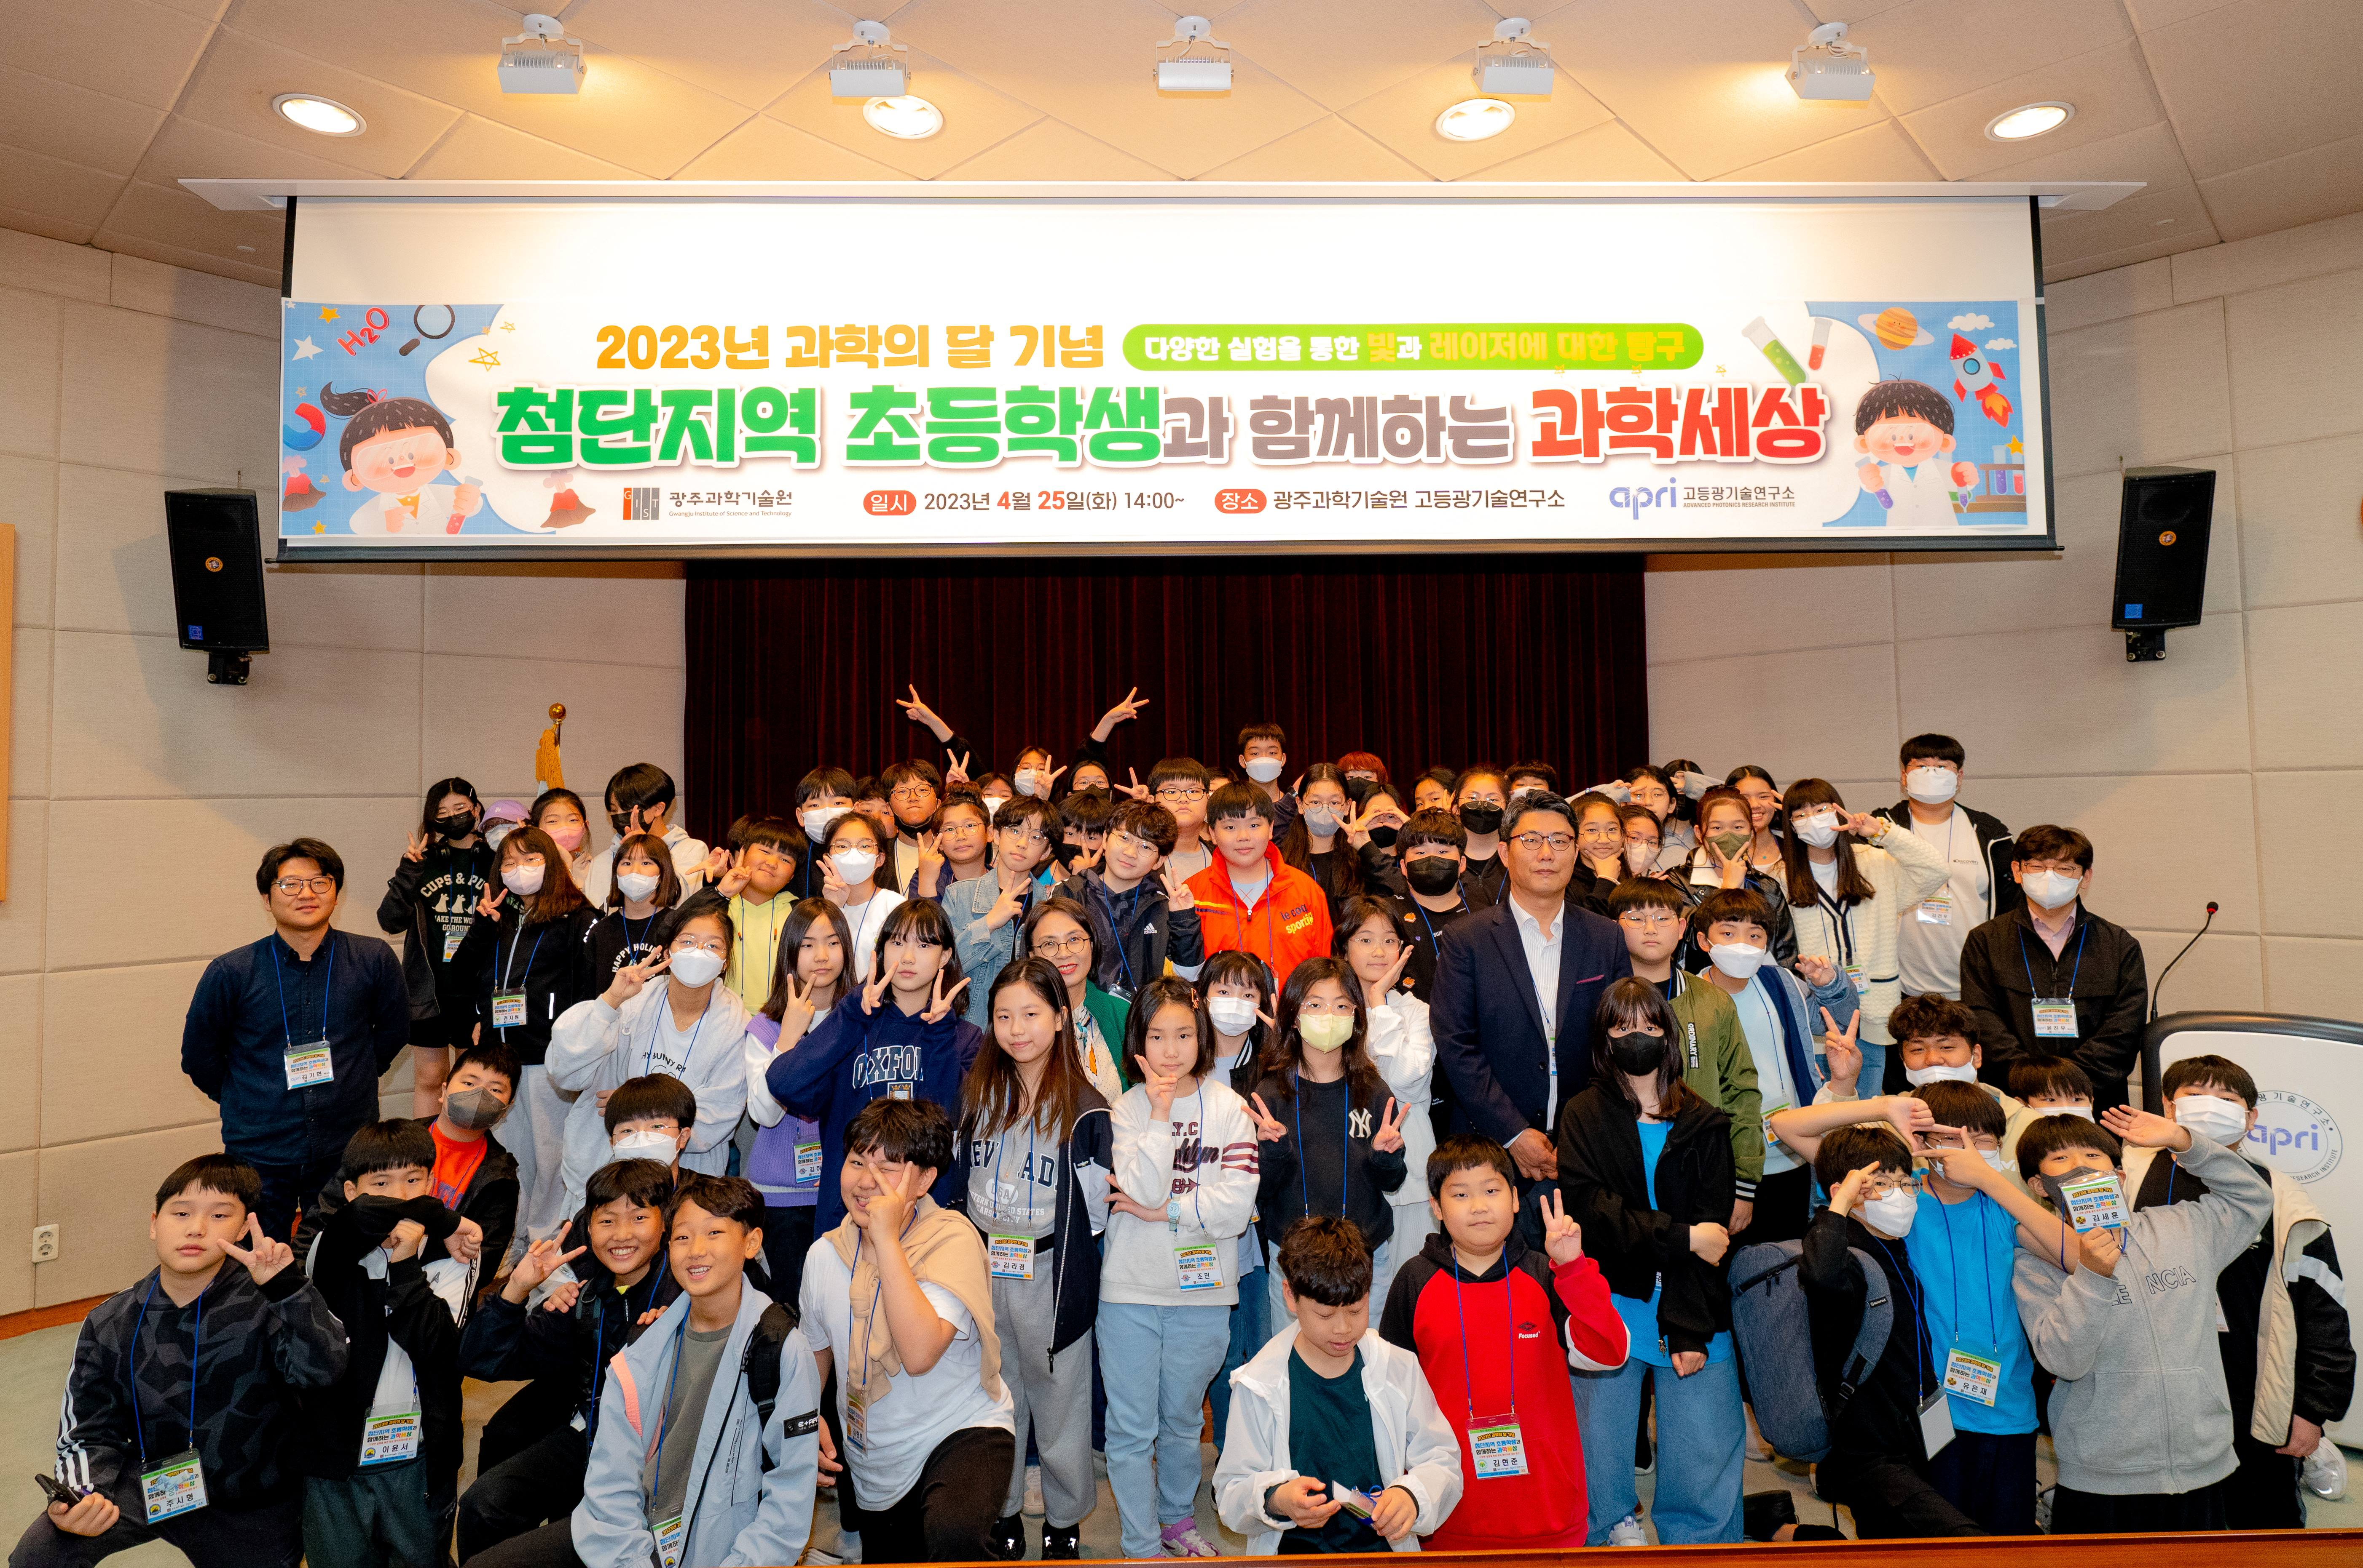▲ Teachers and students attending the event are taking a commemorative photo

On the 25th, GIST (Gwangju Institute of Science and Technology, Acting PresidentRaekil Park) Advanced Photonics Research Institute (APRI, Director Yeung Lak Lee) invited elementary school students from the high-tech area of Gwangju to hold the 「Science World with Elementary School Students in Advanced Areas」 event.

This year, a total of 70 students and teachers from 5 schools (Jeongam Elementary School, Sinyong Elementary School, Bia Elementary School, Wolbong Elementary School, and Bongsan Elementary School) participated from the the Advanced Science Industrial Complex.

This event has been held every April during Science Month since 2007, providing elementary school students with an opportunity to understand and experience light and laser.

Researchers working at the Advanced Photonics Research Institute participated as daily lecturers and conducted 5 experience programs, including quantum dot fluorescent material synthesis, laser drawing, balloon bursting with laser, making a Christmas tree with laser, and assembling a large-diameter optical system mount.

Director Yeung Lak Lee said, "We hope that elementary school students, who will lead the future of science in Korea, will have a meaningful time experimenting with light and lasers and experiencing the mysterious scientific phenomenon. Next year, we will prepare more diverse experiment topics and push forward so that many students in the region can benefit evenly."

Meanwhile, Advanced Photonics Research Institute is the only optical technology research center in Korea that has world-class lasers. It has developed the world's first 20 femtosecond (1 femtosecond: 1 trillionth of a second) 4.2 petawatt (1 petawatt: 1000 terawatt) ultra-powerful laser. Recently, it is expanding its research area to the field of defense technology using laser and optical technology.



