“Korea’s largest AI infrastructure for education and research, opened in Gwangju” GIST AI ultra-high-performance computing public infrastructure in operation

- Registered as the 178th in the world and the 6th in Korea... The largest scale in Korea for education and research
- Establishment of artificial intelligence industrial convergence foundation expected for various uses such as satellite, aviation, medical, and education
- From April 24 (Mon), schools, research institutes, and companies can use it after applying

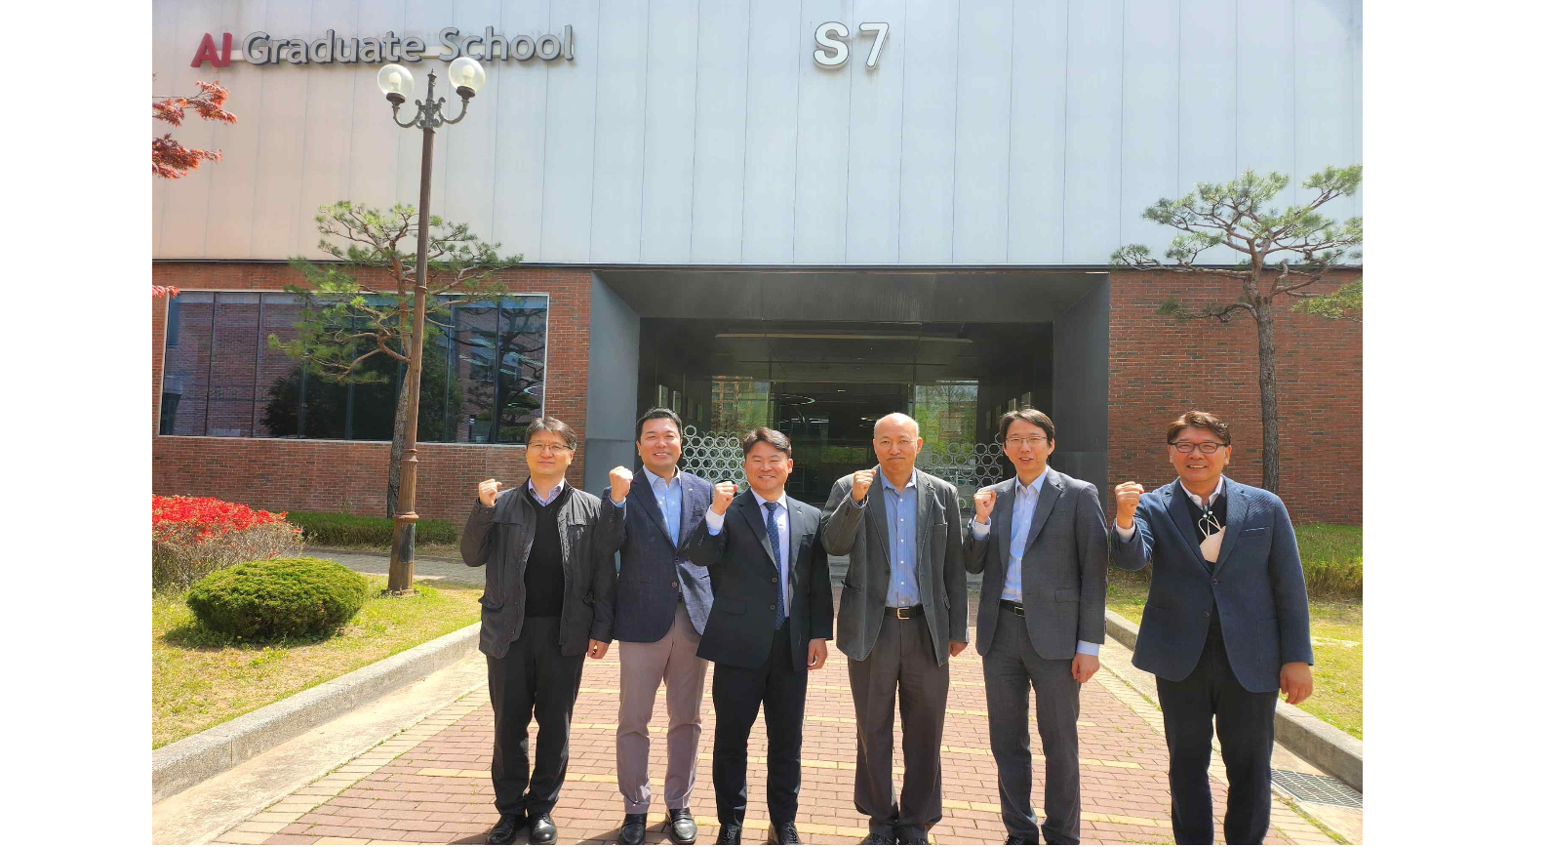▲ Commemorative photo taken after holding a signboard hanging ceremony for the HPC-AI-based public infrastructure data center at GIST AI Graduate School on the 13th. (Third from left) Joon Ha Kim, head of AI industry convergence project, (fourth from left) Jongwon Kim, head of GIST Super Computing Center

GIST (Gwangju Institute of Science and Technology, Acting President Raekil Park) is starting full-scale operation of the nation's largest artificial intelligence ultra-high-performance computing* public infrastructure for education and research.

The GIST Supercomputing Center (Director Jongwon Kim) held a signboard hanging ceremony for the ‘HPC (High Performance Computing)-AI Public Infrastructure Data Center’ on the 13th and officially began operation on the 24th. The Super Computing Center has piloted HPC-AI public infrastructure from November to March of last year.

* super computing: A high-performance computer costing more than $1.5 million. It collectively refers to a large computer system (“ultra-high-performance computer”) that performs large-capacity calculations at a much faster speed than a general computer and the application technology to utilize them.

This HPC-AI public infrastructure is a super-giant AI infrastructure that is ranked 178th among supercomputers in the world and 6th* in Korea, and is the largest in Korea for education and research purposes. It will be used for various purposes such as disease prediction using brain image data, analysis of satellite image data, and AI/big data/Internet of Things (IoT) model learning.

* Based on the Supercomputer Top 500 list (high-performance Linpack performance index) announced at the US Supercomputing Conference (SC22) in November 2022

The HPC-AI public infrastructure construction project is a public infrastructure that encompasses ▴ HPC-based computing/network ▴ storage ▴ space composition and ▴ development environment that can be used for education and R&D in AI convergence universities and industry, academia, and research. It is a project to build and utilize public infrastructure that encompasses the development environment.

This HPC-AI common infrastructure is provided by connecting 200 gigabytes (GB) of high-speed fabric networking with a maximum of 6 petaflops (PF) of 32 bits of computation and 10 petabytes (PB) of storage space. One petaflop (PF) is the level at which calculations can be performed 1,000 trillion times per second.

In particular, while providing data at a speed of more than 150 gigabytes (GB) per second, which is difficult to provide with the existing domestic GPU infrastructure, it can effectively support multi-node HPC-AI computing by integrating 320 top-of-the-line A100 GPUs and using them as one.

The HPC-AI public infrastructure is expected to be used to provide customized HPC-AI computing services to domestic industry, academia, and research institutes that need large-scale AI learning.

In particular, it is equipped with spaces such as an integrated control room*, data center room, power and cooling base room, artificial intelligence studio, mobility studio, media studio, and conference room, allowing for various uses.

* Integrated control room (DevSecOps Room): It is possible to secure the stability of computer operation through real-time monitoring of temperature, humidity, and power consumption of HPC-AI common infrastructure facilities and equipment.

The supercomputing center plans to provide computing resources by classifying necessary resources according to HPC utilization experience, proficiency level, and purpose of utilization.

Schools, research institutes, and companies that want to use HPC-AI public infrastructure can apply through the service portal (http://openhpc.kr).

GIST Super Computing Center Director Jongwon Kim said, "When the HPC-AI public infrastructure is officially operated, it is expected that many achievements will be created in industry, academia, research, and government AI research as it will be able to support resources necessary for large-scale AI learning for schools, research institutes, and companies. It is expected to make a great contribution to establishing a system for producing and distributing data and leading AI models and establishing a foundation for convergence of various AI industries."



