Appointment of the 9th president of GIST rejected

- Meeting of the board of directors on the afternoon of April 5 (Wed)

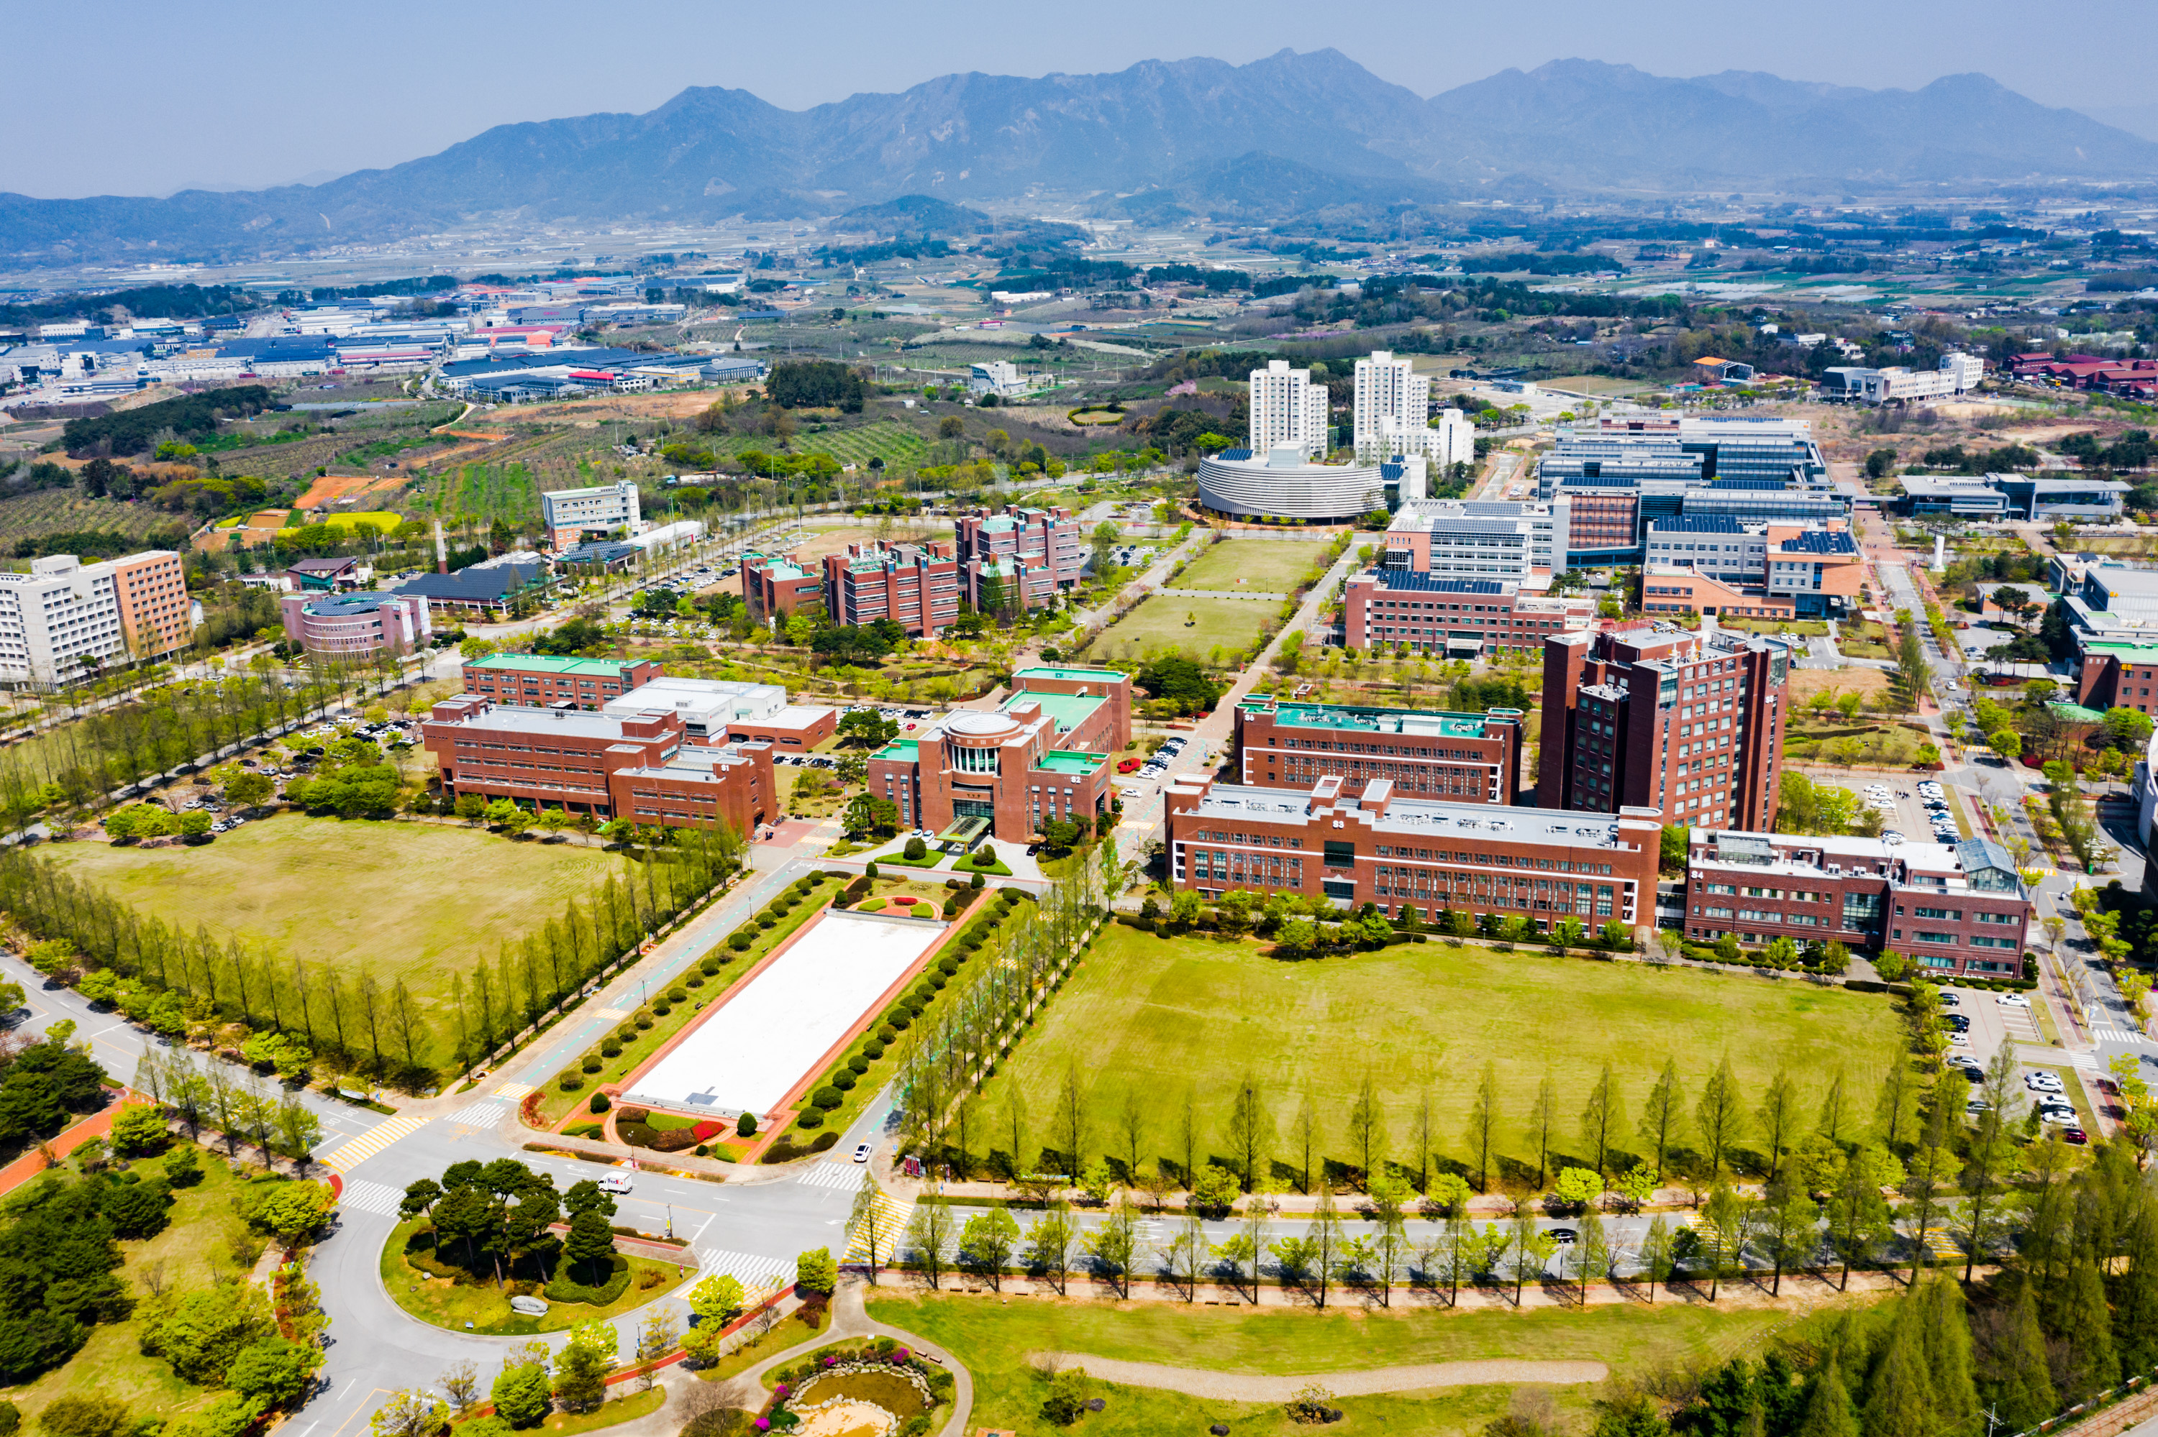▲ Front view of GIST (Gwangju Institute of Science and Technology)

The board of directors of GIST (Gwangju Institute of Science and Technology) held a board meeting to appoint the 9th president of GIST on the afternoon of April 5 (Wednesday). According to the articles of incorporation for the Gwangju Institute of Science and Technology, the board of directors announced that the appointment was rejected because there was no candidate who met the criteria for a majority of votes.

The board of directors plans to go through a re-application process to appoint the ninth president as soon as possible.



