GIST Climate Change Academy entrance ceremony and development fund donation ceremony held

- 31 students enrolled in the 6th class... Alumni Seok-jong Kim, CEO of Namah Food, donated 10 million won to the development fund

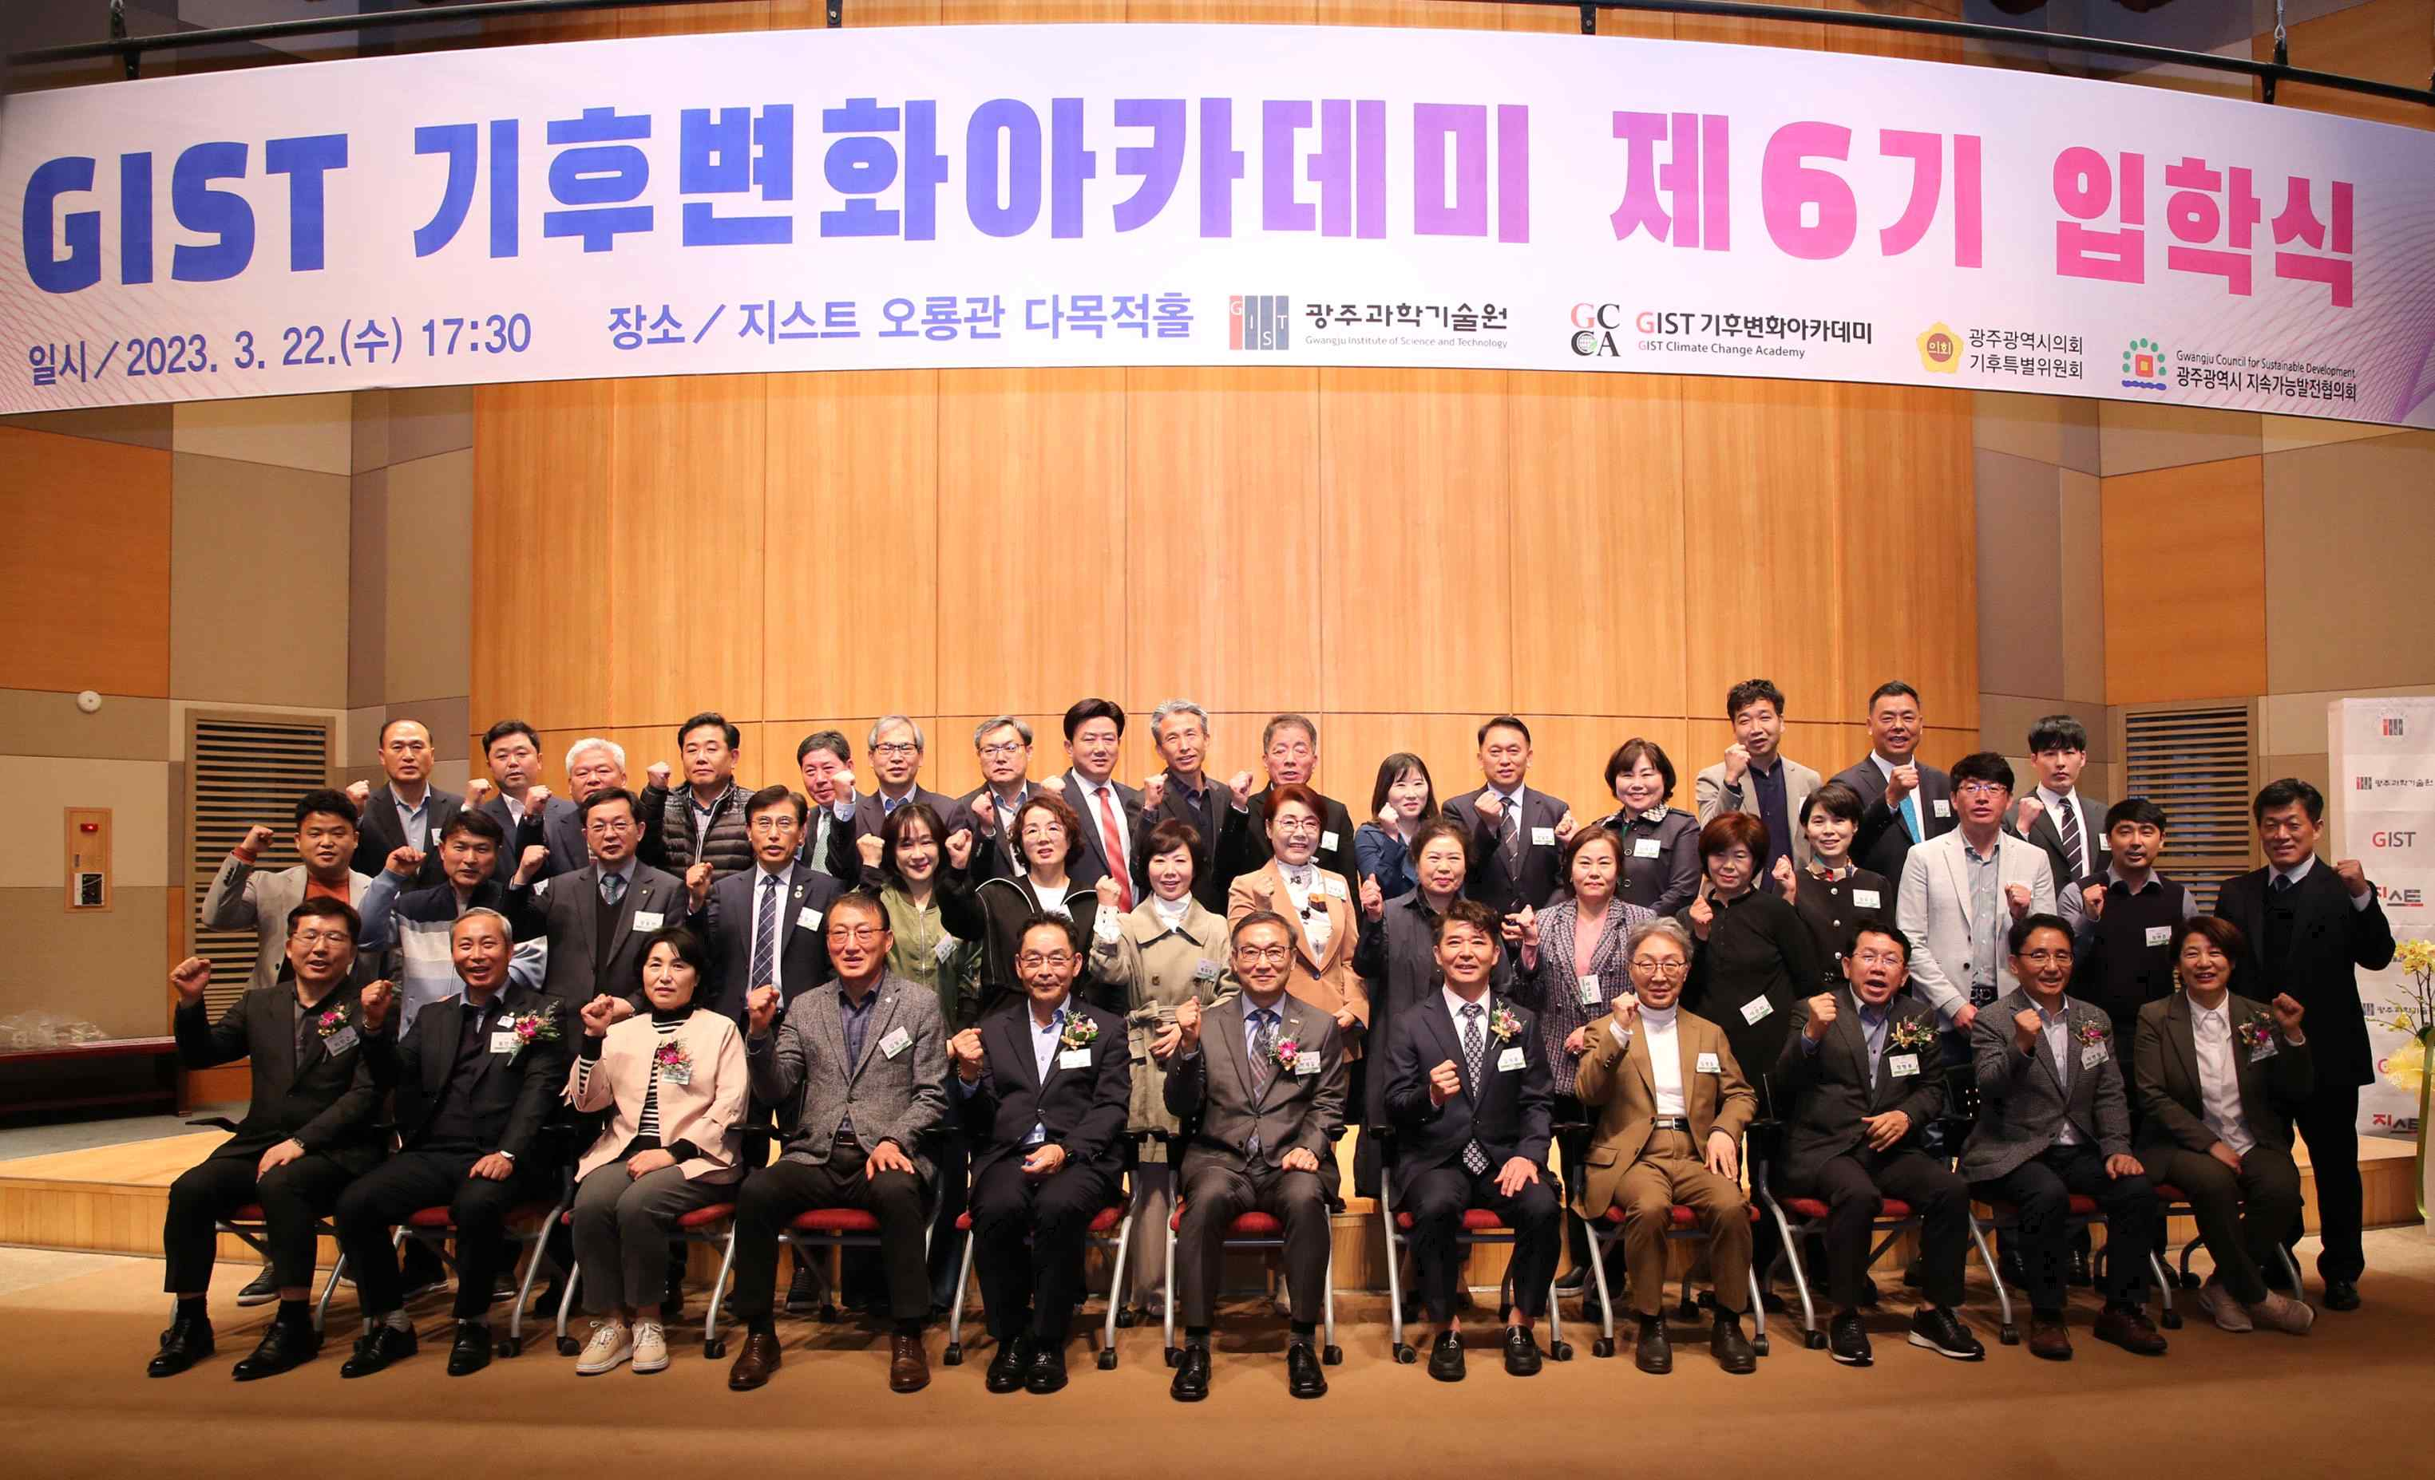
▲ The 6th GIST Climate Change Academy (GCCA) entrance ceremony was held at Oryong Hall and, a commemorative photo was taken.

GIST (Gwangju Institute of Science and Technology, Acting President Raekil Park) Climate Change Academy (GCCA) held its 6th entrance ceremony on March 22 (Wednesday) at GIST Oryong Hall.

The event was held with the participation of 31 GIST new students and key officials, including Acting President Raekil Park, Research Director Chang-Duk Jun, and GIST Academy Director Myeong-joong Kim.

Acting President Raekil Park delivered a welcome speech, saying, "It is hoped that through the high-level programs provided by the Climate Change Academy, future climate change response strategies can be prepared and the foundation for sustainable growth can be laid. I hope that this academy will serve as a valuable forum for communication between managers in each field and top leaders in Korea."

Also, a donation ceremony was also held for the development fund with 10 million won by Seok-jong Kim, a 5th class alumni (representative of South Asian Food). The donations delivered on this day will be used as a development fund for the GIST Climate Change Academy.

Namah Food is a specialized company that manufactures pickled fruits and other vegetables by researching and developing various technologies that combine lactic acid bacteria with food. It has expanded its business to processing to deliver pizza toppings nationwide, and its subsidiary, JS Bio Company, is continuously researching intellectual property rights and patents related to complex lactobacillus food.

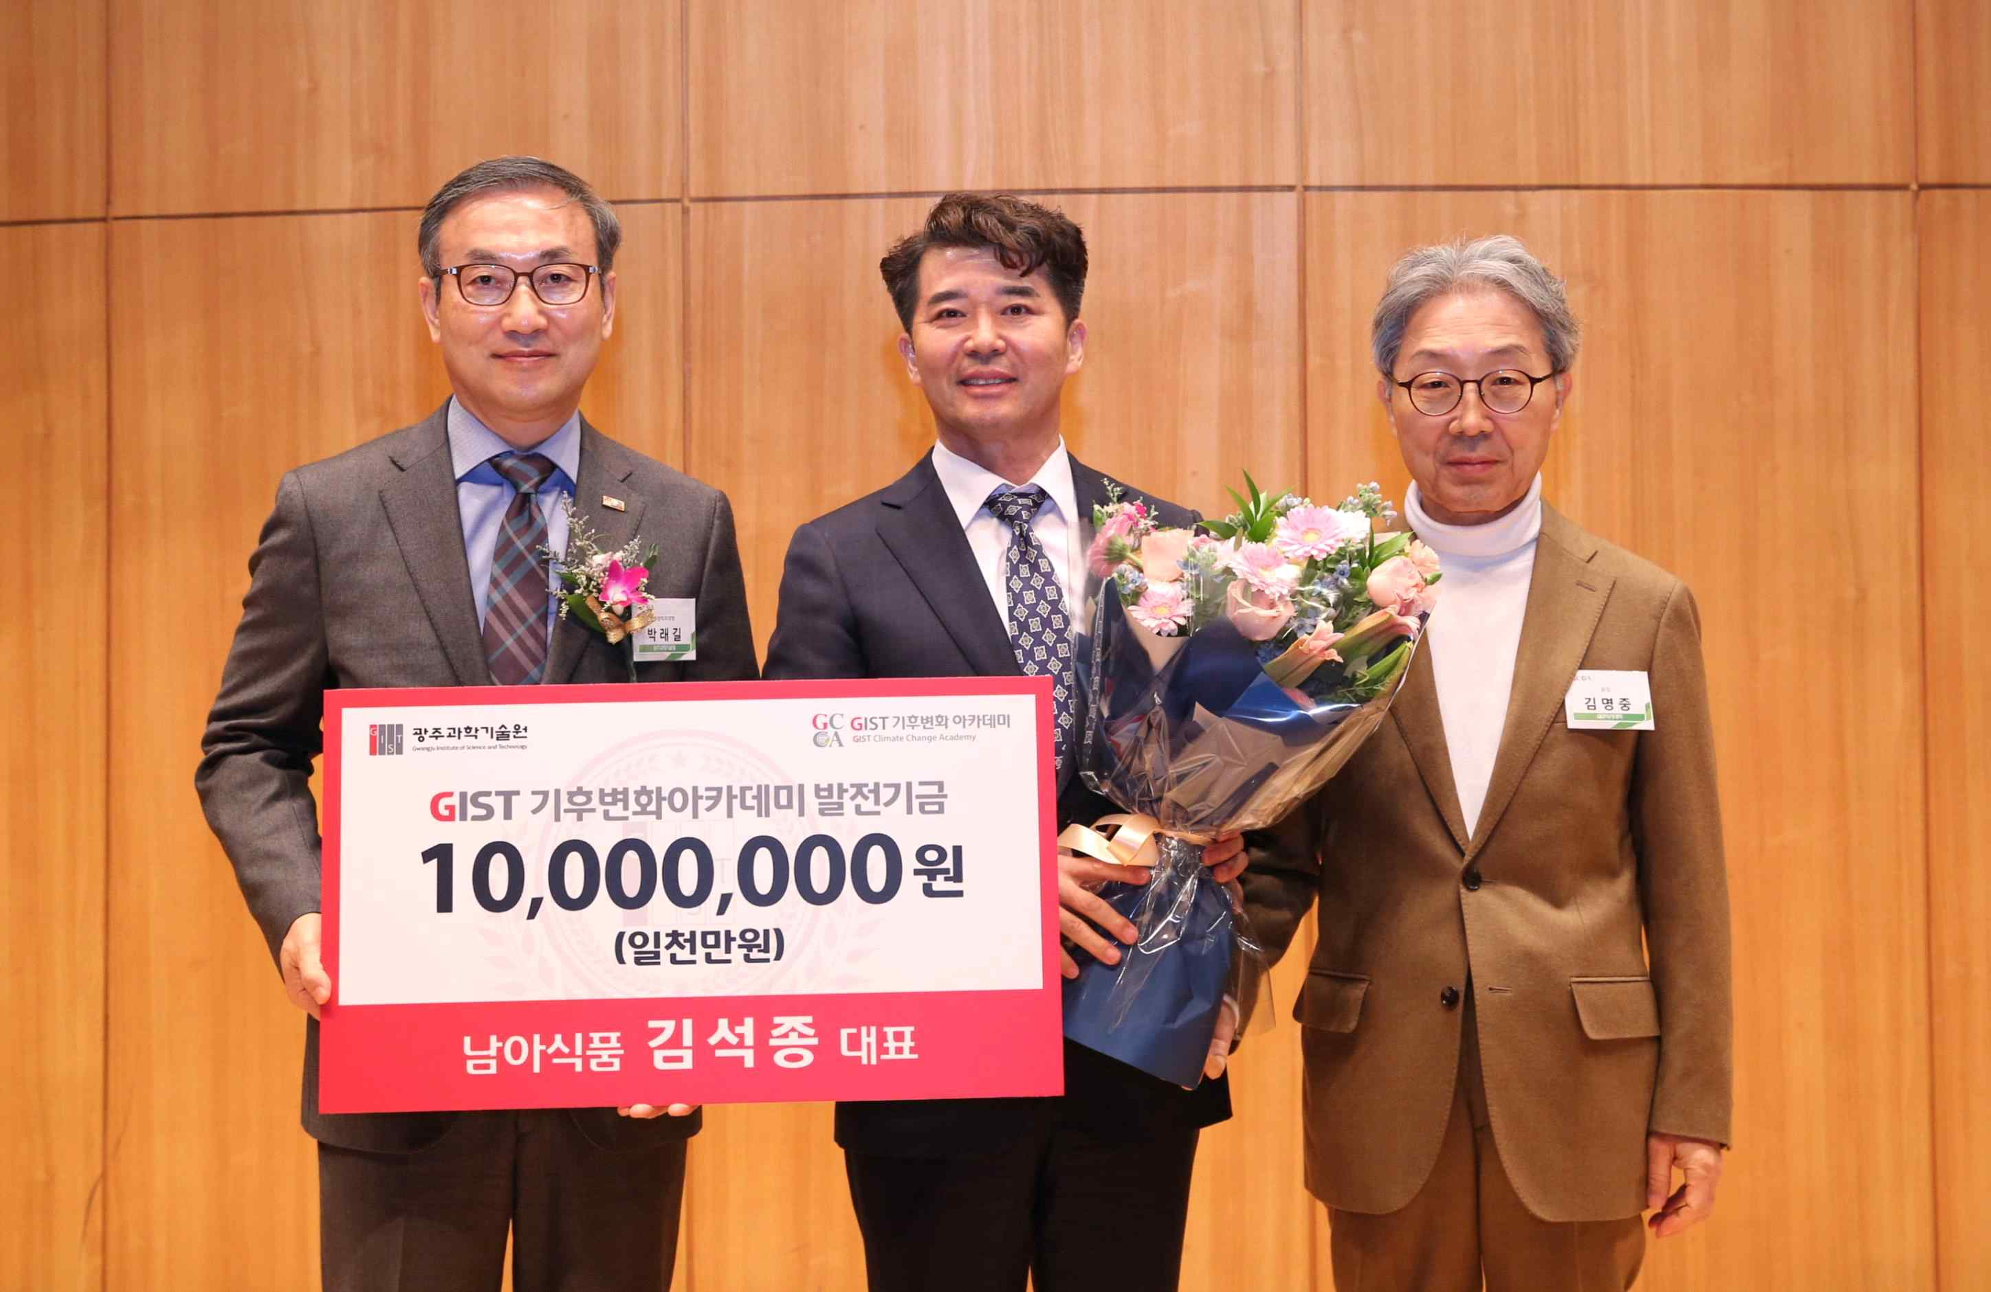
▲ Alumni Seok-jong Kim (CEO of Namah Food) is at a development fund donation ceremony and taking commemorative photos. (From left: Acting President Raekil Park, Alumnae Seok-jong Kim, Director Myeong-joong Kim of GIST Academy)

Alumni Seok-jong Kim said, "I am delighted to be able to contribute even a little to the development of the GIST Climate Change Academy. I hope to become the best luxury brand that will lead the future of the climate industry and develop the region."

GIST Academy is running two courses, the Techno Management Business Academy and the Climate Change Academy. Through the lectures of the best experts in Korea, they deliver expertise in global management strategy and climate change, and contribute to the development of the local economy and vitalization of industry-university cooperation by forming a wide human network.

The Climate Change Academy opened the CEO Climate Management Course in 2016 to provide a systematic CEO education program to the local community. So far, about 180 alumni are active as leaders in each field of society.



