GIST and Inha University team up to respond to the manned space age

- MoU for space biomedical science translational research signed... Research on solving real problems in space
- Expect international research cooperation such as joint research with NASA along with the opening of the Korea Aerospace Administration

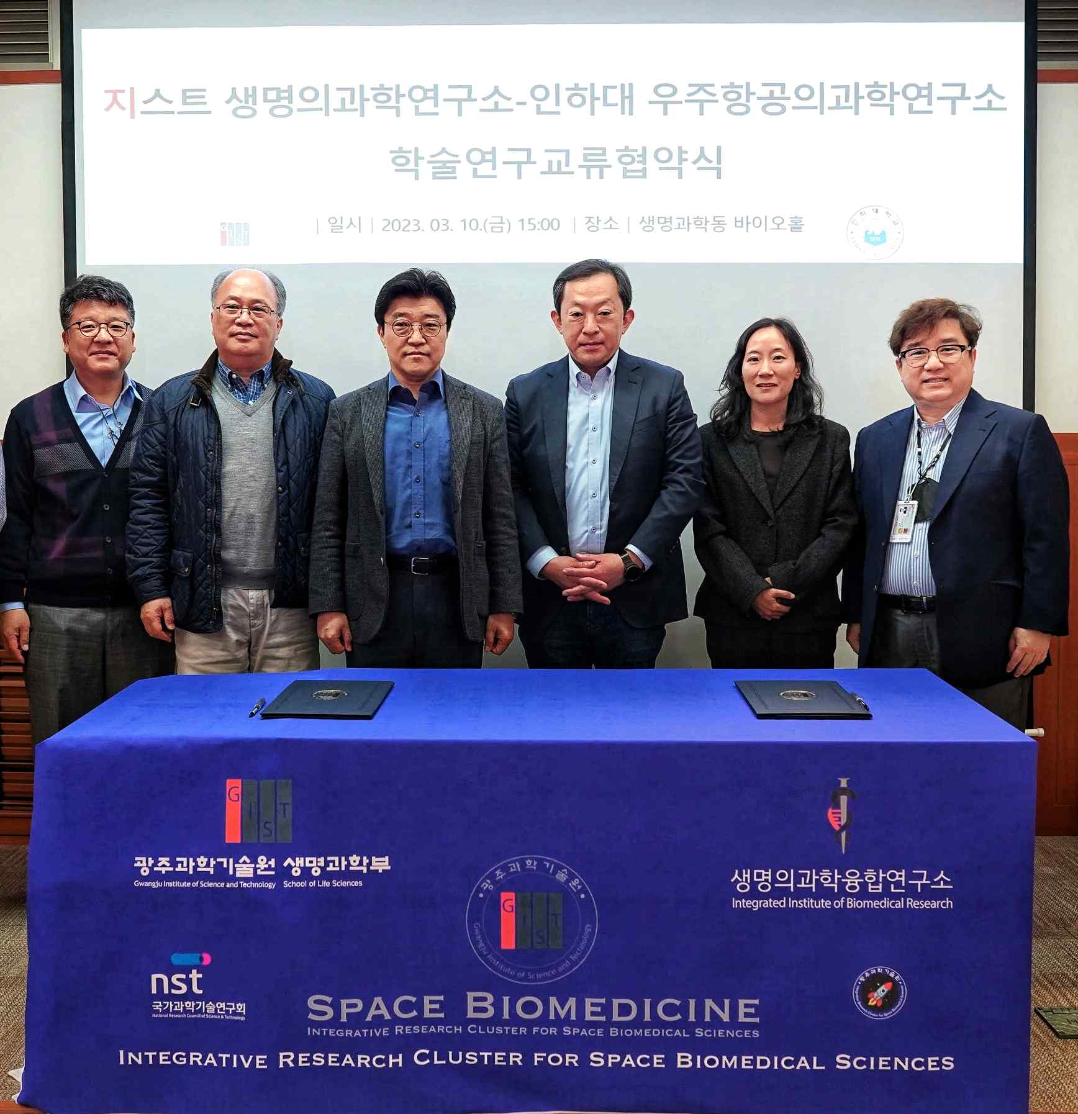
▲ The GIST Integrated Institute of Biomedical Research and Inha University Aerospace Medical Research Institute signed a business agreement on March 10th for cooperation in the field of space biomedical science translational research, and the participants took a commemorative photo. (From left) Inha University Professor Soo-geun Yang, GIST Professor Chul-Seung Park, Inha University Director Gyu-seong Kim, GIST Director Zee-Yong Park, GIST Professor Mi-Ryoung Song, and Professor Steve K. Cho

GIST (Gwangju Institute of Science and Technology, Acting President Raekil Park) Integrated Institute of Biomedical Research (Director Zee-Yong Park, professor in the School of Life Sciences) has signed a business agreement (MoU) with Inha University Aerospace Medical Research Institute (Director Gyu-seong Kim)for joint research in the field of space biomedical science translational research and exchange of technology and personnel.

The signing ceremony was held in the afternoon of March 10 (Friday) at the Bio Hall of the School of Life Sciences at GIST and was attended by senior officials, including GIST Research Director Zee-Yong Park, School of Life Sciences Dean Mi-Ryoung Song, Professor Chul-Seung Park, Professor Professor Steve K. Cho, Inha University Research Director Gyu-seong Kim, and Department of Biomedical Biology at the College of Medicine Professor Soo-geun Yang.

Under the agreement, the two organizations agreed to cooperate in planning and participating in new research projects for the Korea Aerospace Administration, which is scheduled to be established this year, including ▴ planning new research projects and participating in joint research ▴ cooperation for NASA-HRP joint participation and translational research ▴ data sharing and holding academic events such as seminars, workshops, and short-term training ▴ exchange of technical and professional researchers ▴ joint use of research facilities and equipment.

Space biomedical science translational research studies biological and medical processes on various topics such as the effect of the space environment on human physiology and cognitive behavior, and it uses research method that develops response strategies that can be applied to real problems that occur in space flight.

The US National Aeronautics and Space Administration (NASA) is increasing investment in translational research for life sciences in space, such as the Human Research Program (HRP), prior to the manned space era and deep space* exploration.

* deep space: Space that is beyond the moon. According to the International Radio Regulations, it means a place more than 2 million km away from the earth.

The research is devoted to developing exercise programs and customized nutritional supplements to alleviate the problem of bone and muscle reduction of flight attendants, developing equipment and protocols for health monitoring and emergency medical condition management during long flights, and researching strategies for responding to crew cognitive impairment.

GIST Director Zee-Yong Park said, "We are confident and happy to have a cooperative relationship with Inha University Aerospace Medical Research Institute, which is leading the field of space medicine in Korea. Through this agreement, we will make efforts to become a standard model for convergence and cooperative research in Korea's space industry by actively utilizing GIST's artificial intelligence (AI) research, as well as intermediary research on space life sciences."

Inha University Director Gyu-seong Kim said, "We are delighted to be able to apply the know-how accumulated by GIST in the field of science and engineering research, especially the abundant research experience in the field of life and medical science, to a new platform called the space environment. This is expected to be of great help in the future for international joint research planning and vitalization of personnel exchanges in the field of space biomedical science translational research."

Prior to the signing of the cooperation, the two researchers participated in the 2023 NASA HRP-IWS (Investigators) Workshop in Galveston, Texas, in February to discuss future research projects with key NASA researchers in space biomedical sciences.



