GIST Techno Management Business Academy matriculation ceremony and development fund donation ceremony held

- March 7th (Tuesday) 13th Admission Ceremony CEO In-myeong Seo of Keummyung Hitech donates 15 million won for development with the region

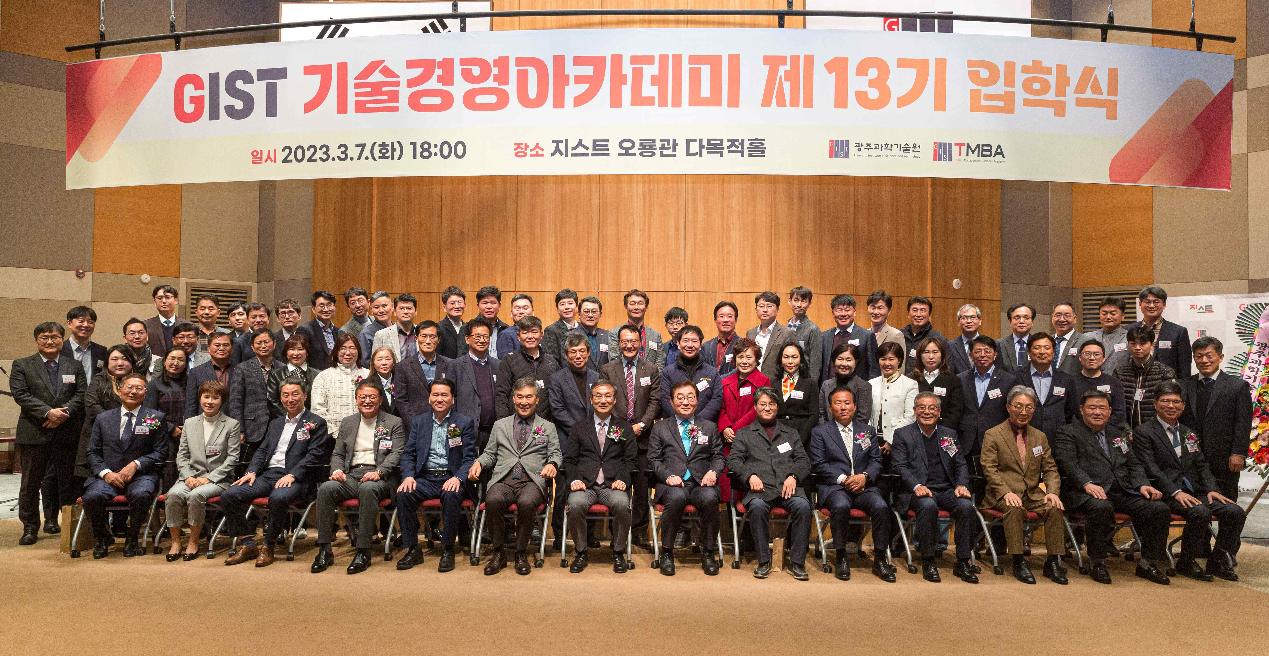
▲ GIST Techno Management Business Academy the 13th matriculation ceremony at Oryong Hall on March 7th (Tuesday) and took a group photo.

GIST (Gwangju Institute of Science and Technology, Acting President Raekil Park) Techno Management Business Academy (Director Myeong-joong Kim, GTMBA) held the 13th GTMBA entrance ceremony on March 7th (Tuesday).

The event was held at Oryonggwan with the participation of 48 GTMBA 13th class students and key officials such as Acting President Rae-gil Park, Research Director Chang-Duk Jun, GIST Techno Management Business Academy Director Myeong-joong Kim.

In his welcome address, Acting President Raekil Park said, "We sincerely welcome you to enter the GIST Technology Management Academy, which is becoming increasingly sophisticated as a venue for CEO core competencies that will lead the 21st century. GTMBA alumni will be able to create groundbreaking growth engines through local industry-academic cooperation and GIST's differentiated programs, such as new start-ups, technology transfers, patents, and research institute establishments."

On the other hand, on the same day, the Development Fund donation ceremony of the 12th alumni president, In-myeong Seo (Keummyung Hitech Co., Ltd.) was also held. The donated KRW 15 million will be used as a development fund for the GIST Techno Management Business Academy for cooperation and win-win development with the region.

Established in 2013, Keummyung Hitech Co., Ltd. is a company specializing in the production of secondary battery automated fish equipment and awarded the 5 million dollar export tower.

Alumni In-myeong Seo said, "We welcome the admissions of the 13th class of GTMBA, and I hope to cooperate in cultivating managerial mindset and promoting community development through continuous human network formation and high-quality lectures. I hope that GIST will contribute to the balanced development of national science and technology and regional development, helping to emerge as a global prestigious university."

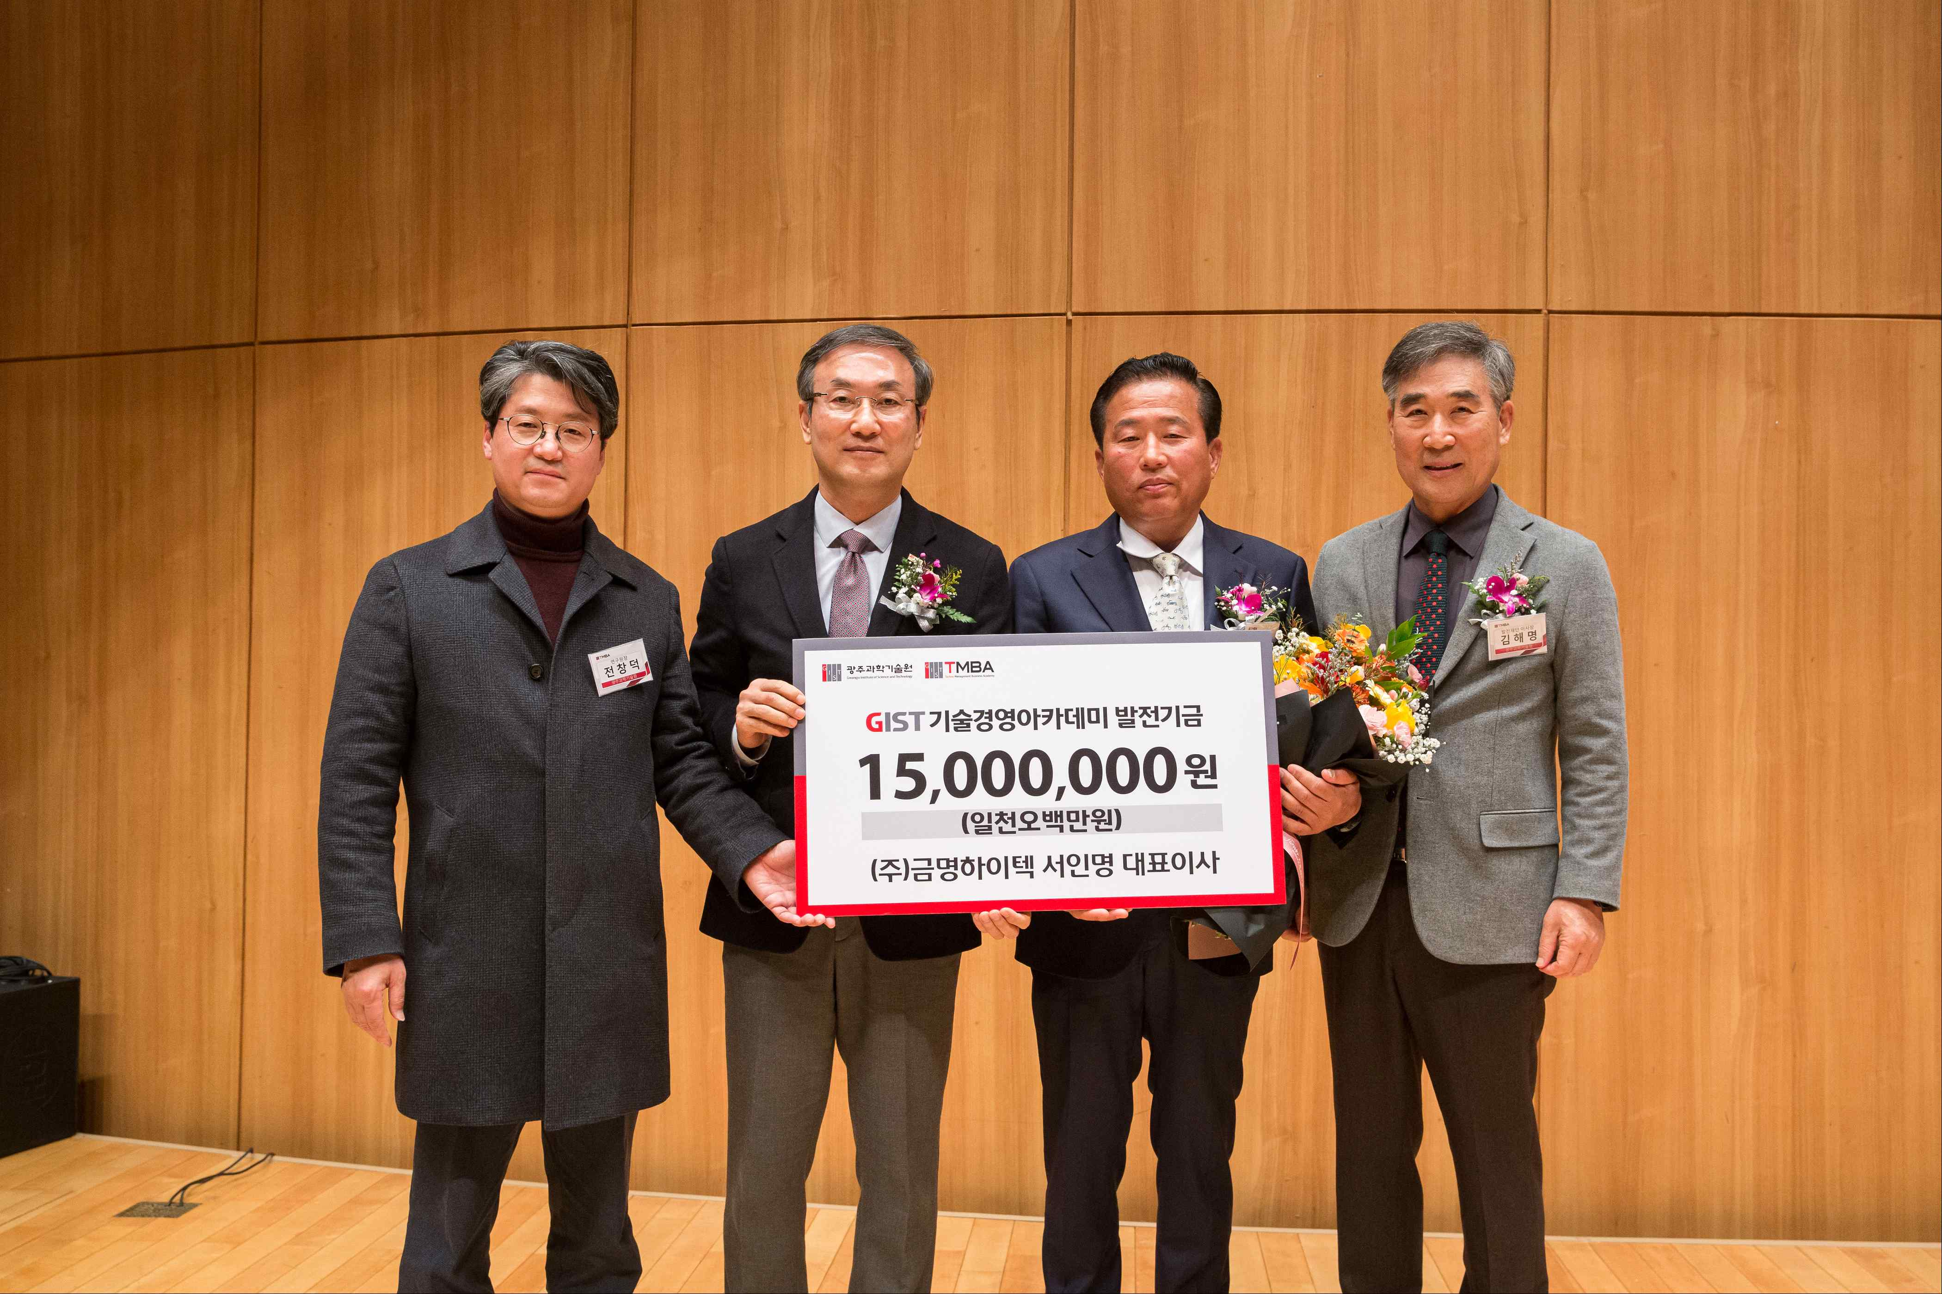
▲ CEO In-myeong Seo (Keummyung Hitech Co., Ltd.), the 12th alumni president, holds a development fund donation ceremony and takes commemorative photos. (From left) Research Director Chang-Duk Jun, Acting President Raekil Park, In-myeong Seo, CEO of Kummyung Hitech Co., Ltd., and Chairman of the Development Foundation Seo Hae-myeong Kim.

GIST Academy operates two courses: Techno Management Business Academy (GTMBA, opened in 2010) and Climate Change Academy (GCCA, opened in 2016). Through the lectures of the best experts in Korea, the business environment, global management strategy, and cultural sense are cultivated, and a wide human network is formed to contribute to the development of the local economy and vitalization of industry-university cooperation.

Since GTMBA opened the CEO course in 2010 to serve as a business hub through systematic CEO education programs, about 480 alumni have been active as global leaders in various fields of society.



