GIST Technology Commercialization Center, discovering and revitalizing of local technology

- Fostering local technology startups through promising technologies and excellent ideas
- Additional support of 2 million won to 4 companies including Sigorjavjong Co., Ltd., which were selected as excellent companies

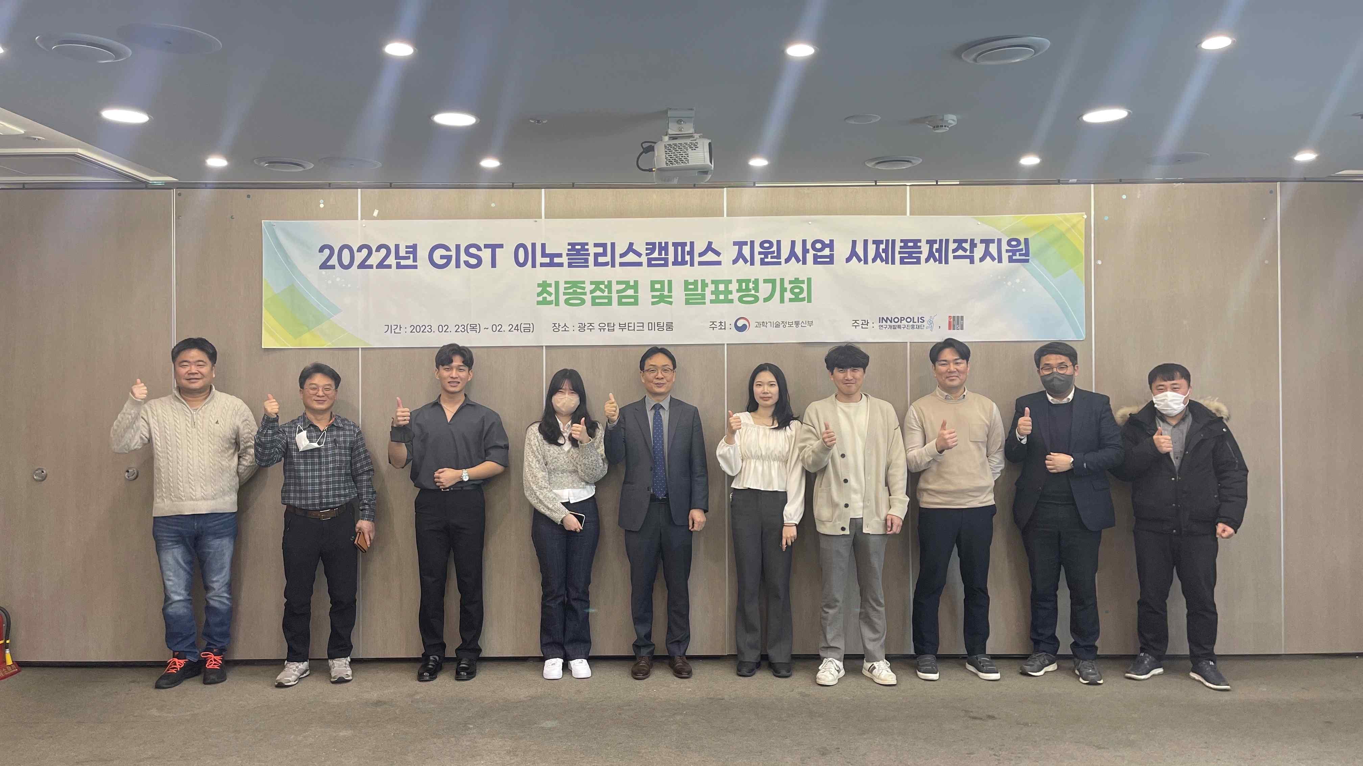
▲ 2022 GIST Innopolis Campus Support Project held final project inspection and presentation evaluation meeting for prototype production support

GIST (Gwangju Institute of Science and Technology, Acting President Raekil Park) Technology Commercialization Center (Center Director Seong-geun Ki) held a final inspection and presentation evaluation session for the '2022 GIST Innopolis Campus Support Project' in February.

The GIST Innopolis Campus Support Project supports not only GIST students, researchers, and professors but also supports companies within one year of starting their business and preliminary start-ups in order to promote local technology start-ups and foster youth start-ups by discovering promising technologies and excellent ideas.

It proceeds in the order of 『recruitment of entrepreneurs → materialization and verification of ideas → support for prototype production → market verification』, and prospective entrepreneurs who have a start-up item applied for this project receive essential training and in-depth education courses for entrepreneurship cultivation and business model development provided by the Technology Commercialization Center and are selected for prototype production support through item specification and evaluation.

The Technology Commercialization Center provides start-up education, such as product improvement academy and joint AI training, as well as prototype production support costs and linkage support for market verification for companies selected for prototype production support.

In this Innopolis Campus prototype production support presentation evaluation and final performance check, goal achievement, degree of effort, business feasibility, business feasibility, etc. were evaluated, and an additional 2 million won was provided to four companies, Enton Co., Ltd., Shigorzabjong Co., Ltd., Servo Tech Co., Ltd., and Joyful Turtles Co., Ltd.

The GIST Technology Commercialization Center utilizes the Innopolis Campus support project hosted by the Gwangju Special Zone Promotion Foundation of the Ministry of Science and ICT as a 2nd year project in 2021 to promote the growth of promising technologies in the future through final inspection and presentation evaluation of deep tech-based startups.

14 teams, including REGO (CEO Sung-jin Cho and 13 other companies), will contribute to revitalizing projects such as innovating existing industries or seeking to create new markets by utilizing advanced science technologies, which are promising future technologies for deep tech.

Technology Commercialization Center Director Seong-geun Ki said, "We hope that the GIST Innopolis Campus support project will actively help start-up activities of early start-ups and prospective start-ups to become a stepping stone to grow into promising domestic companies."



