GIST holds face-to-face matriculation ceremony for the first time in 4 years

- February 23 (Thursday), 217 undergraduate students, 220 graduate students, total of 437 students enrolled
- GIST undergraduate course regular recruitment competition rate 123.8 to 1...highest ever

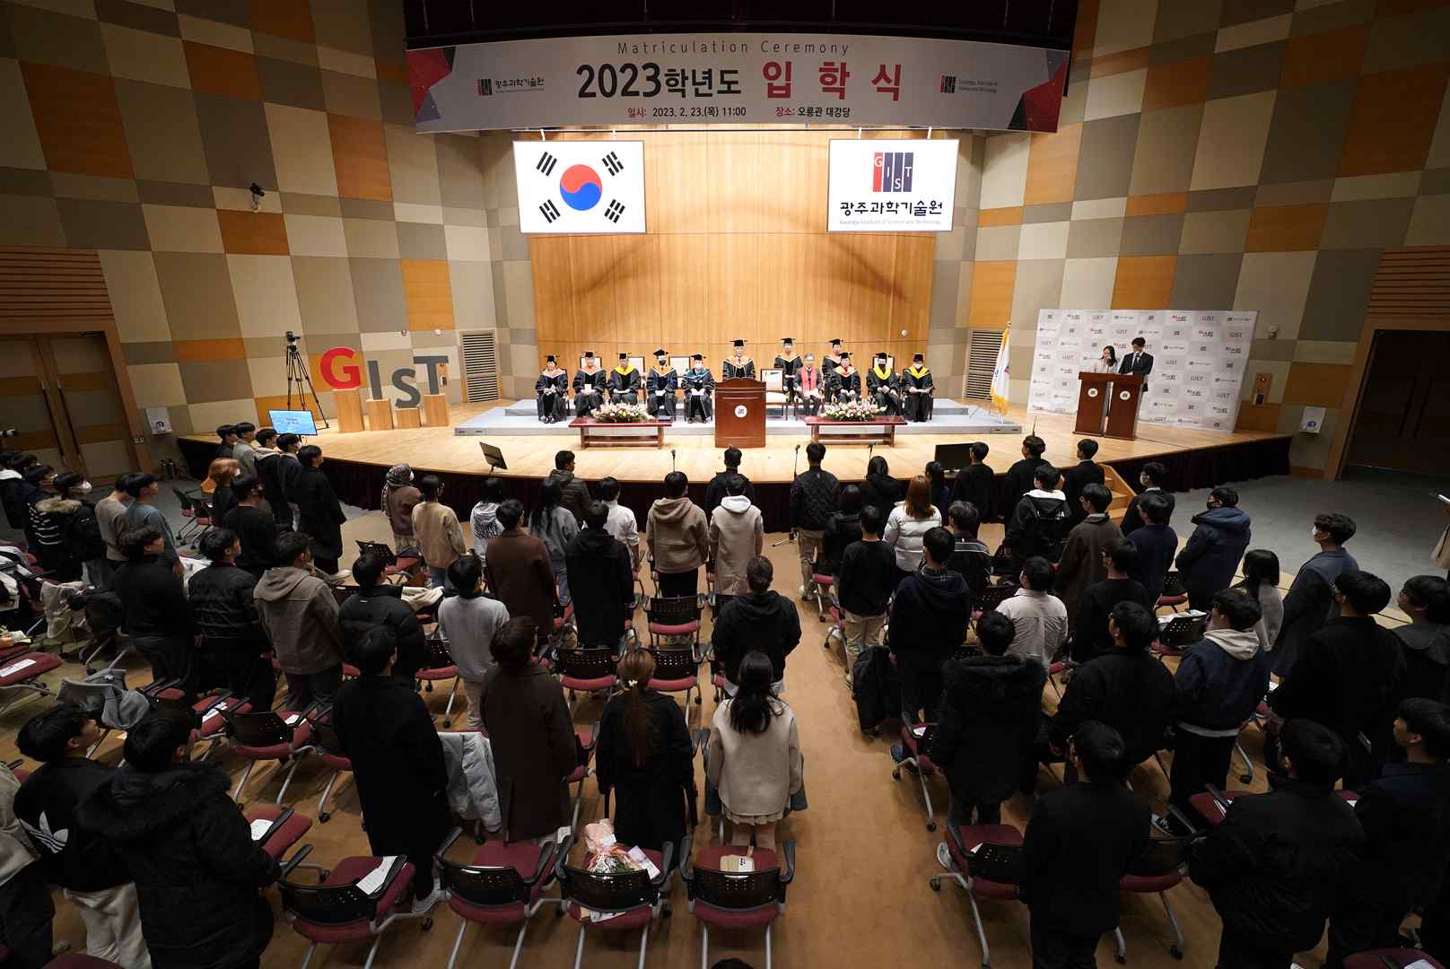
▲ GIST is holding their first face-to-face matriculation ceremony in 4 years at 11:00 AM on Thursday, February 23, at the GIST Oryong Hall Auditorium.

GIST (Gwangju Institute of Science and Technology, President Kiseon Kim) held a face-to-face matriculation ceremony for the first time in four years since the 2019 school year, which was before the COVID-19 pandemic, and welcomed around 400 new students.

GIST was held on February 23 (Thursday) at 11:00 am in the auditorium of Oryong Hall for a total of 437 freshmen and their families, including 217 undergraduate students, 134 master's students, 46 master's and doctoral students, and 40 doctoral students. About 500 people, including professors and staff, attended the 2023 matriculation ceremony in a face-to-face manner with no restrictions on the number of people.

On this day, the matriculation ceremony began with an academic report by Dean of Academic Affairs Sang-Don Kim, followed by a declaration of acceptance by President Kiseon Kim. ▲ Jaehyun Park (mechanical engineering, Ph.D.) ▲ Yeongjun Lim (physics, integrated course) ▲ Minjun Kim (AI, master’s course) ▲ Yoon Ra-bin (liberal arts, undergraduate course) students took the oath of admission and read the spirit of GIST, and 27 incoming students were awarded the President's Scholarship Certificate.

President Kiseon Kim said, "I am very happy to meet the 2023 students who spent a significant period of their high school and college years with the corona pandemic in person at the matriculation ceremony in this face-to-face manner. I hope that life at GIST will be an opportunity for you to grow and take off one step further, and we will spare no effort to provide you with a variety of support for a beneficial and safe campus life."

Meanwhile, the number of full-time applicants for the 2023 GIST undergraduate program totaled 1,238, recording the highest ever competition rate of 123.8 to 1. GIST introduced the ‘liberal arts college’ system for the first time in Korea in its undergraduate course, fostering a small elite of global science and technology leaders with humanities knowledge through various required lectures in the humanities, social studies, arts and sports as well as science and engineering subjects such as mathematics and science.



