GIST Oryong Art Hall, <Meeting with the Artist> program

– Hosted ‘Choi Soon Im Invitational Exhibition’… Exhibits a total of 49 works, including three-dimensional installations and two-dimensional paintings
– A program for groups of 5 or more to watch while listening to the artist's explanation through advance reservation

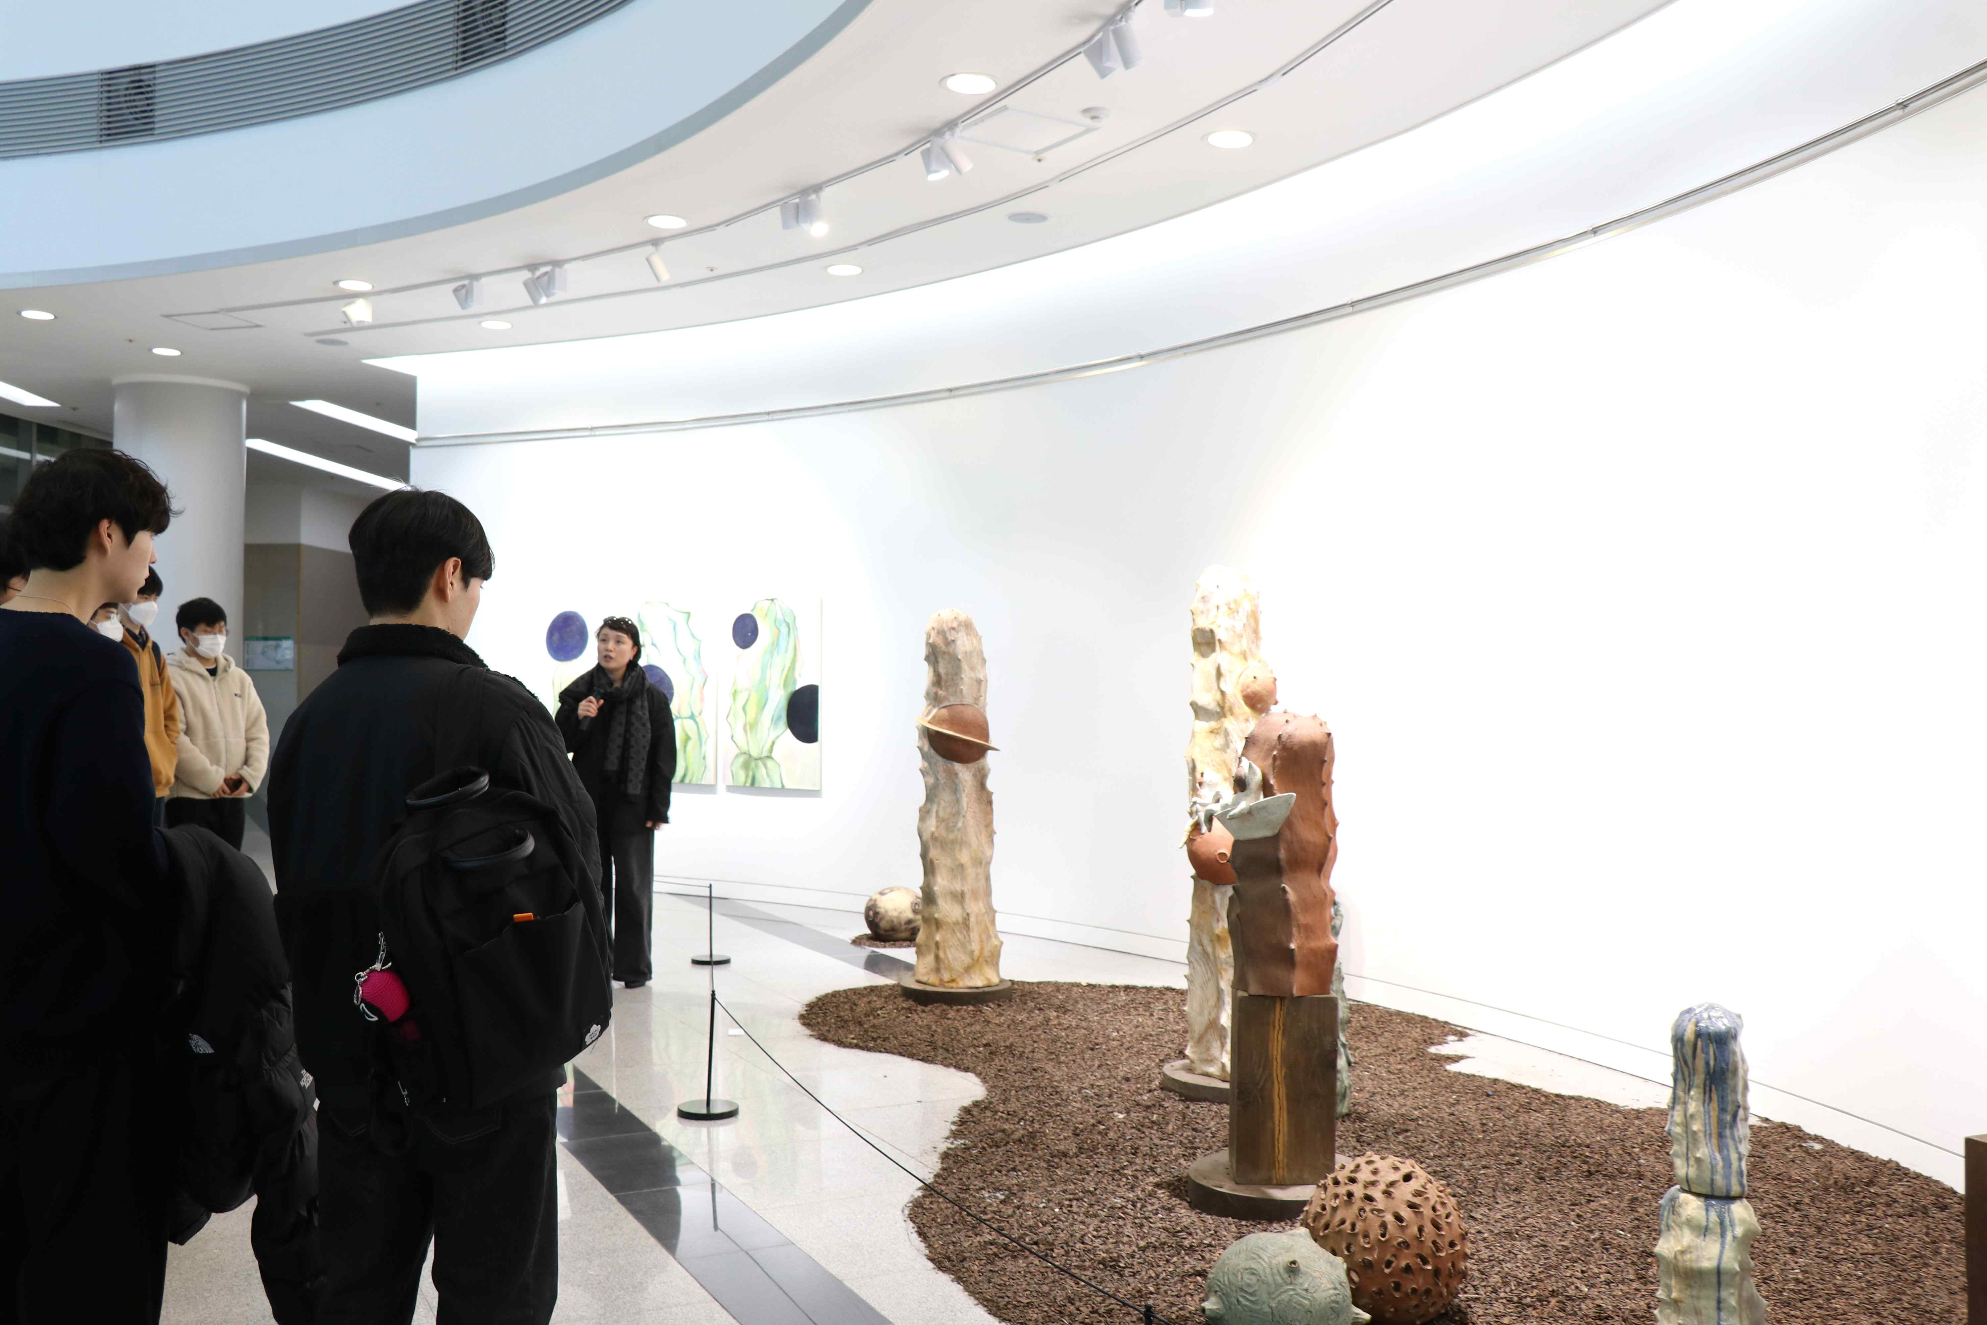
▲ At the 2nd Invitational Exhibition <Meeting with the Artist>, GIST undergraduate freshmen are listening to the artist Choi Soon Im explain the work.

GIST (Gwangju Institute of Science and Technology, President Kiseon Kim) opened 「Oryong Art Hall」 in December of last year to communicate with the local community and provide citizens with a space for culture and art and will host a <Meeting with the Artist> program.

If a group of 5 or more visitors applies for <Meeting with the Artist> through advance reservation, they can have time to appreciate the work while listening to the explanation directly from the artist who opened the exhibition.

Since its opening, 「Oryong Art Hall」, which has successfully completed the exhibition of Western painter Kim Hyuk-jeong as the first invitational exhibition, is currently holding <BON VOYAGE – Greetings Supporting the Journey of Life> by Choi Soon Im as the second invitational exhibition. About 200 GIST undergraduate students were invited to hold the first <Meeting with the Artist>, and, as new members of the campus, they had time to expand their thinking by experiencing culture and art and directly communicating with the artist.

Artist Choi Soon Im graduated from the Department of Sculpture at Chonnam National University and participated in the Gwangju Museum of Art International Residency, Biennale Special Exhibition, and China International Ceramic Expo, and the exhibition will be shown until the 10th of May.

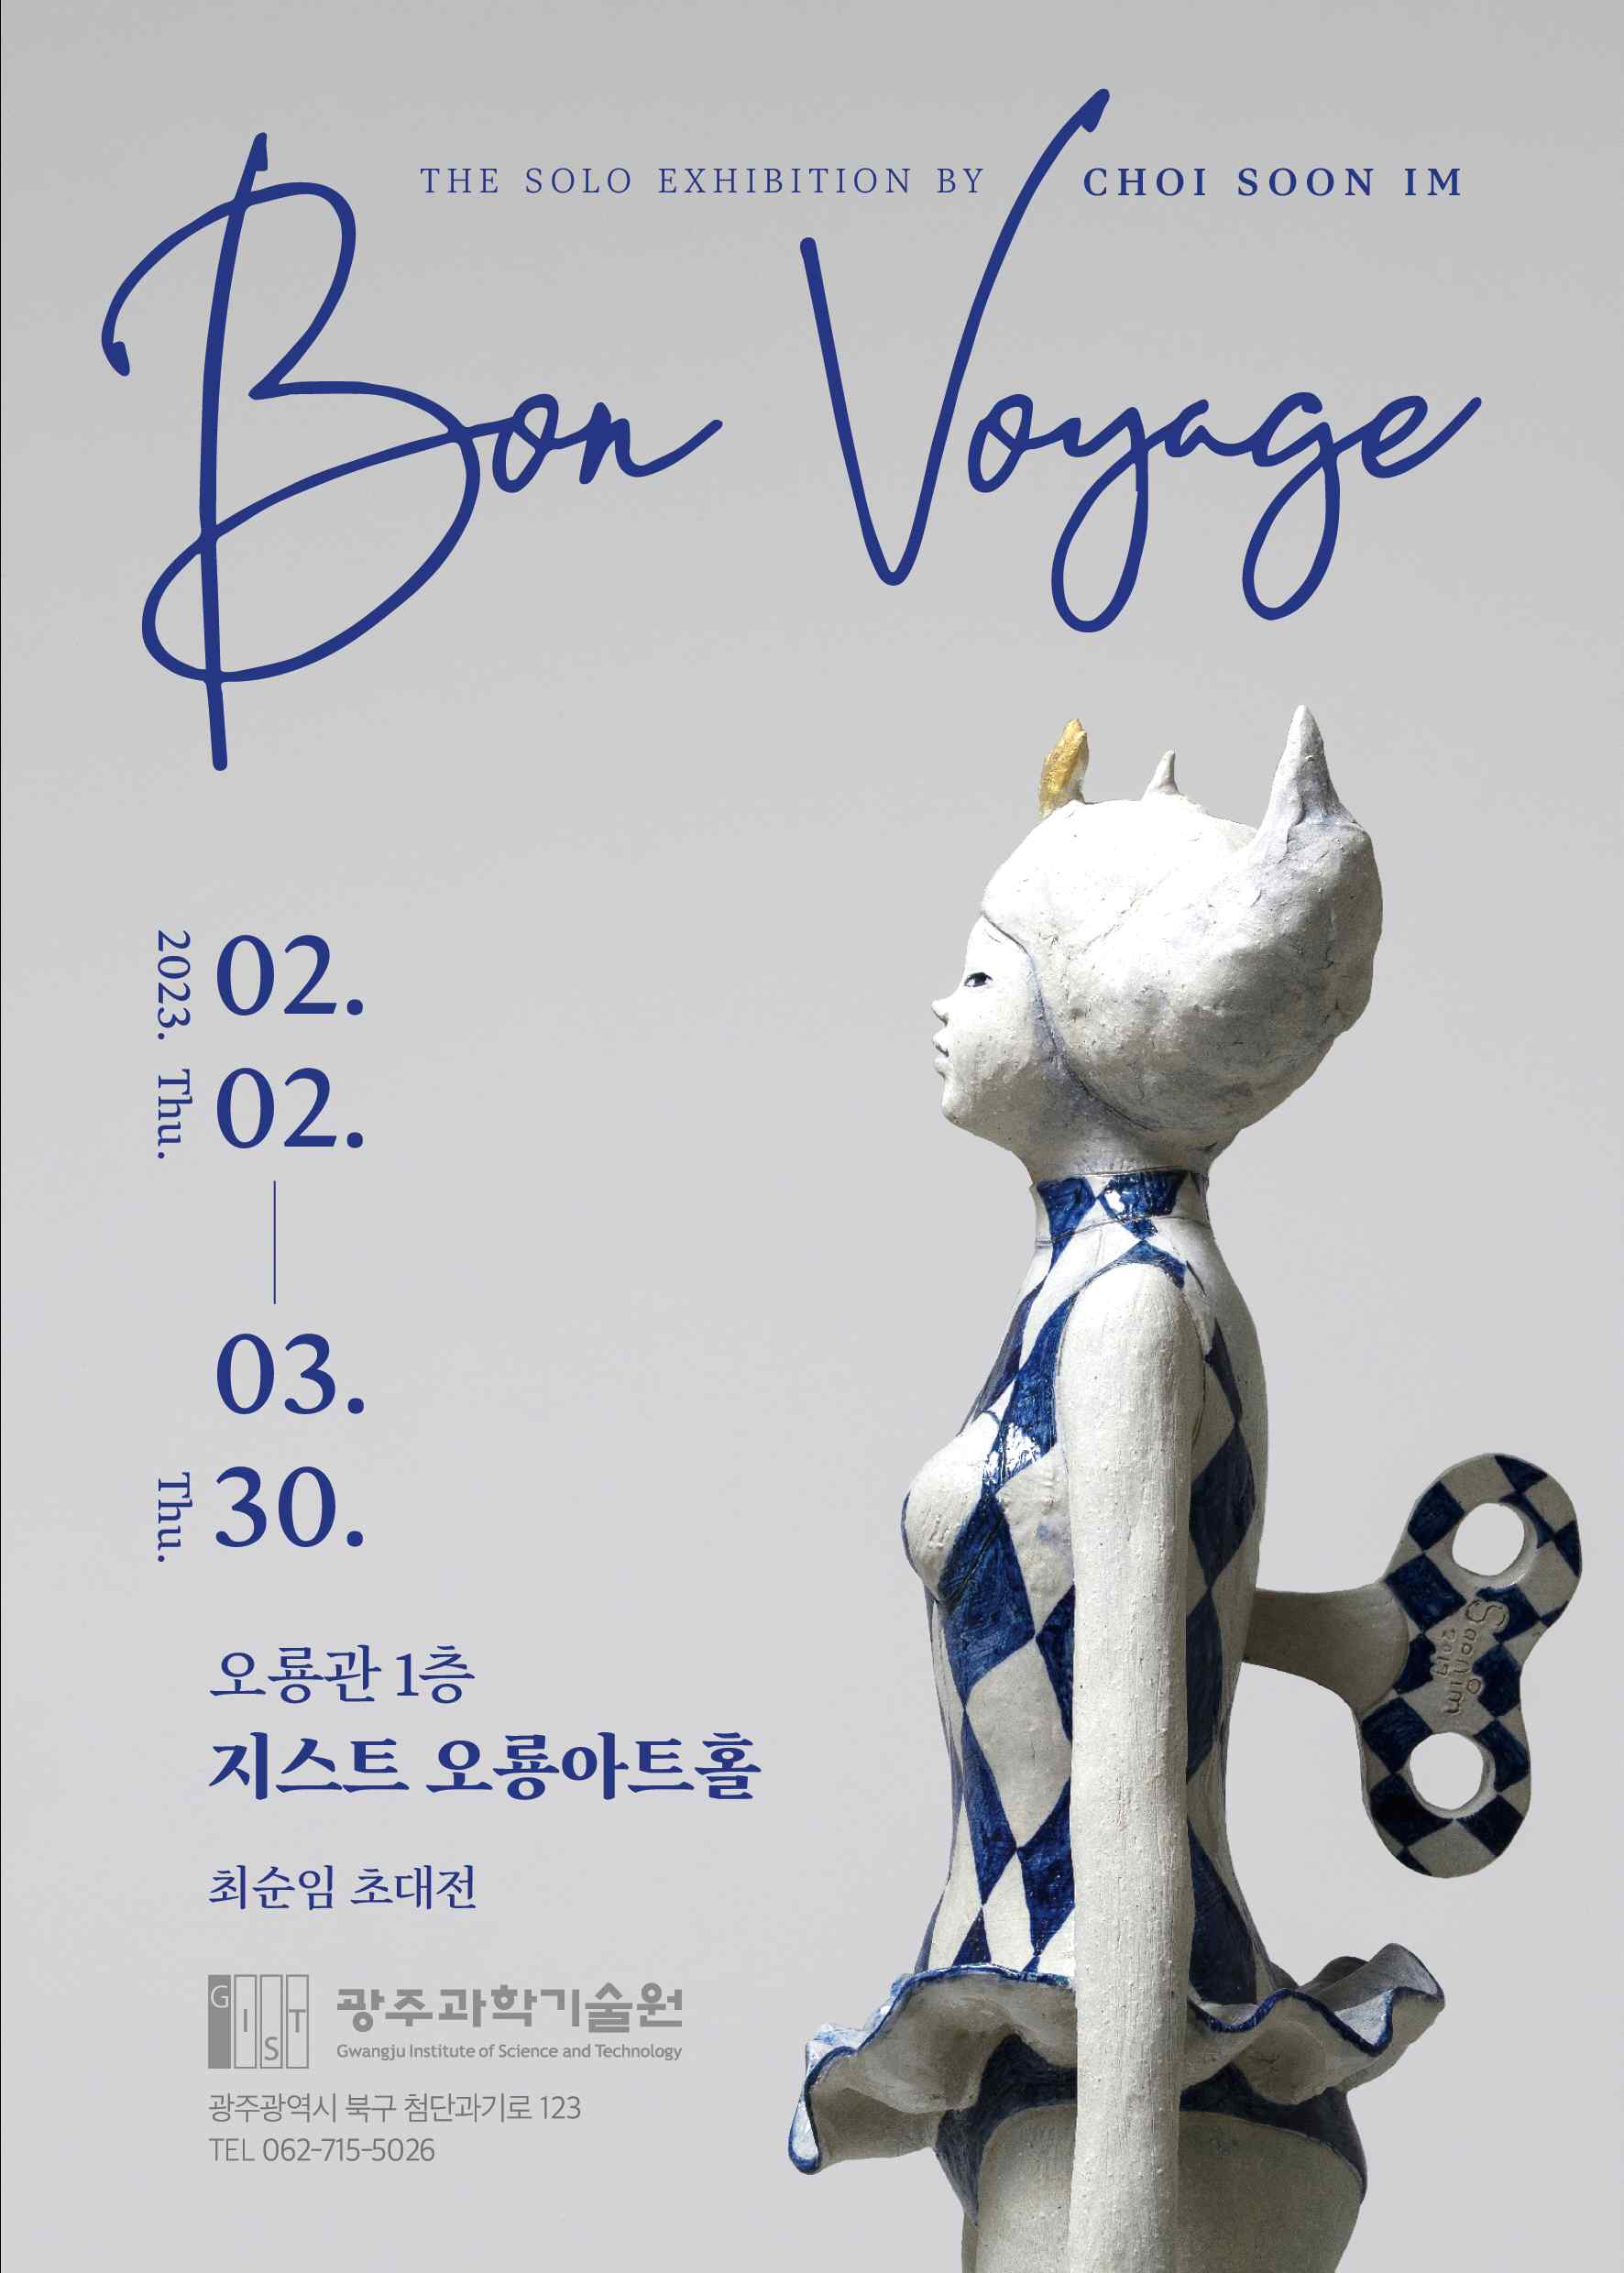
▲ Poster for the 2nd Invitational Exhibition at GIST Oryong Art Hall

Artist Choi Soon Im said, "It is very meaningful and joyful to have a good opportunity from preparing for the opening of the 「Oryong Art Hall」 to participating in the exhibition, and I hope that 「Oryong Art Hall」 will be known to more people as a representative space for enjoying culture for local residents."

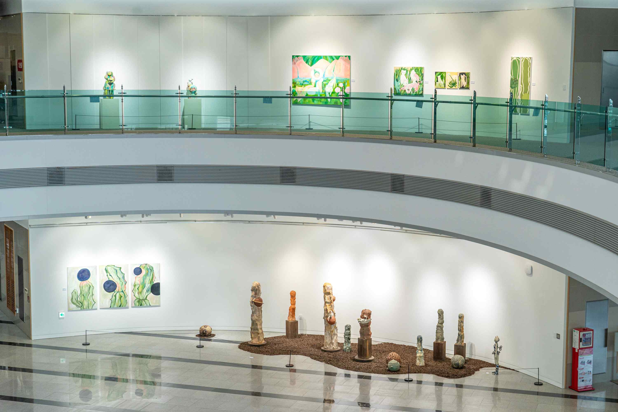
▲ The 2nd invitational exhibition site

「Oryong Art Hall」 plans to display various cultural contents so that it can become a space for everyone to enjoy culture in accordance with the opening purpose of strengthening exchange and cooperation with the local community. Information on exhibitions and exhibited works will be provided through the homepage of 「Oryong Art Hall」, which is scheduled to be built.

「Oryong Art Hall」 is open from 9:00 am to 6:00 pm on weekdays and Saturdays (closed on Sundays), and anyone can enter Oryong Hall and view the works displayed on the first and second floors.

Viewing inquiries: 062-715-2628 (GIST Academy)



