“I will become an AI researcher who makes people happy!” GIST AI Graduate School 1st Ph.D.

- Dr. Man-Je Kim of Professor Chang Wook Ahn’s laboratory, “I want to focus on AI research in the field of robotics and energy”
- On the 17th (Fri), a face-to-face graduation ceremony was held for the first time in 3 years since the COVID-19 outbreak... A total of 277 degrees were awarded.

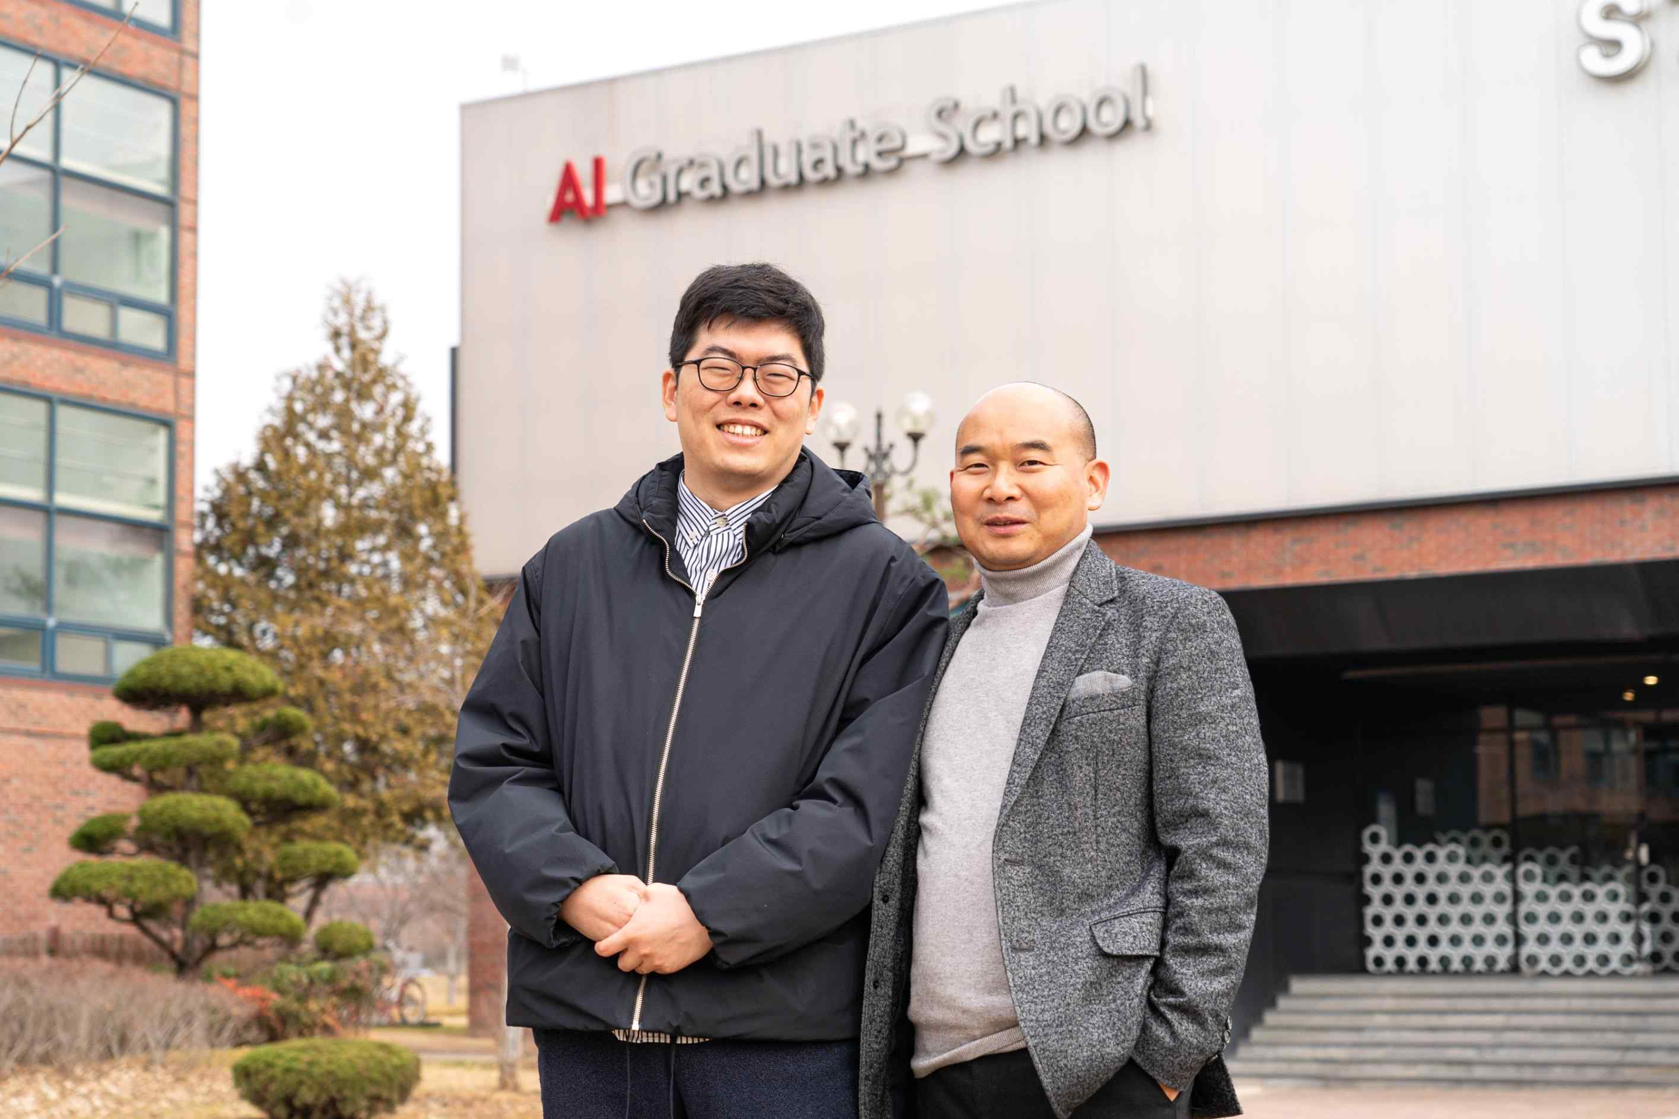
▲ The GIST AI Graduate School, which opened in 2019, will produce the first doctorate at the 「2022 Commencement Ceremony」. (From left) Dr. Man-Je Kim and his advisor Professor Chang Wook Ahn, famous for ‘AI composition’

GIST (Gwangju Institute of Science and Technology, President Kiseon Kim) Ai Graduate School, which opened in 2019 with the goal of fostering global convergence experts that connect education, research, and entrepreneurship in the field of artificial intelligence (AI), is graduating its first doctorate.

The main character is Dr. Man-Je Kim (32) of Professor Chang Wook Ahn's laboratory, famous for "AI Composition," and Dr. Kim will receive his first doctorate certificate at the 2022 Degree Ceremony held at 2 p.m. on February 17 (Fri) at the multi-purpose hall auditorium of GIST Oryong Hall.

During his degree course, Dr. Man-Je Kim conducted deep learning AI development and algorithm research, published 6 SCI-level theses in renowned international journals in the field of AI, such as 「Expert Systems with Applications」. He has made outstanding research achievements, such as presenting eight international conference papers.

While studying at the Department of Computer Science and Engineering at Sejong University, he became interested in AI research after meeting Professor KyungJoong Kim (currently a professor at the GIST Institute of Convergence Technology), who was working at Sejong University at the time. Dr. Kim has stood out since his college days, such as publishing a thesis on ‘StarCraft game artificial intelligence’.

Dr. Kim said, "I came across Professor Chang Wook Ahn’s ‘Composition AI’ and was attracted to the fact that AI can be used in the arts to make people happy. I passed master's courses at other leading universities in Korea, including the Korea Institute of Performing Arts, but went to GIST because I wanted to research with Professor Chang Wook Ahn."

Dr. Kim, who has been interested in AI that plays the StarCraft game even while completing his degree course after joining Professor Chang Wook Ahn's lab, participated in the 'StarCraft 2 AI Global Competition' held by GIST with GIST College students. He even won the championship by beating AIs from various countries such as Germany and England.

In addition, Dr. Kim has accumulated various experiences and achievements in the AI field by being invited as an excellent thesis presenter at the Samsung AI Forum, where world-class scholars and experts in the AI field gather to share the latest AI research results.

Dr. Man-Je Kim, who plans to work as a postdoctoral researcher at GIST AI Graduate School after graduation, said, "It is an honor to become the first Ph.D. of GIST AI Graduate School. Based on the knowledge and passion gained at GIST, I want to conduct artificial intelligence research that can make people happy and highlight Korea with various researchers and students in the field of AI in the future."

Meanwhile, GIST plans to hold a graduation ceremony on the 17th (Friday) and confer degrees to a total of 277 students, including 74 doctors including Dr. Man-Je Kim, 112 masters and 91 undergraduates.

In particular, this graduation ceremony will be held face-to-face with all graduates and their families for the first time three years after the COVID-19 pandemic. Graduates and parents who could not attend the event can participate in real time through YouTube streaming.

It was found that 74 doctoral students receiving their degrees this time published an average of about 6 papers per person in SCI-level academic journals during their school years.

In particular, Dr. Jaewon Kim (Advisor Professor Jae Gwan Kim ) of the Department of Biomedical Science and Engineering founded N.CER, a company specializing in dementia diagnosis, by developing a technology to easily diagnose dementia using a patient's sense of smell while attending school. In recognition of its challenging start-up and research achievements, including nine patents, including a dementia diagnosis system using the sense of smell, he received the "Minister of Science and ICT Award" at the degree ceremony.

President Kiseon Kim said, "I sincerely congratulate the precious fruits achieved through hard work over the past few years and support the new challenge of 277 graduates. I hope that you will become passionate scientists and engineers who can present alternatives that are different from others with the research capabilities you have acquired at GIST."

With this graduation ceremony, since its establishment in 1993, GIST will produce a total of 7,725 high-quality science and technology personnel, including 1,780 PhDs, 4,819 master's, and 1,126 bachelor's.



