GIST-Samsung Electronics, 'recruitment linked' talent development! Signed an agreement to establish an 'intelligent motor track'

- Provide customized curriculum to advance motor technology, a core technology for home appliances
- Target 15 students every year among master's course students... Join Samsung Electronics after graduation

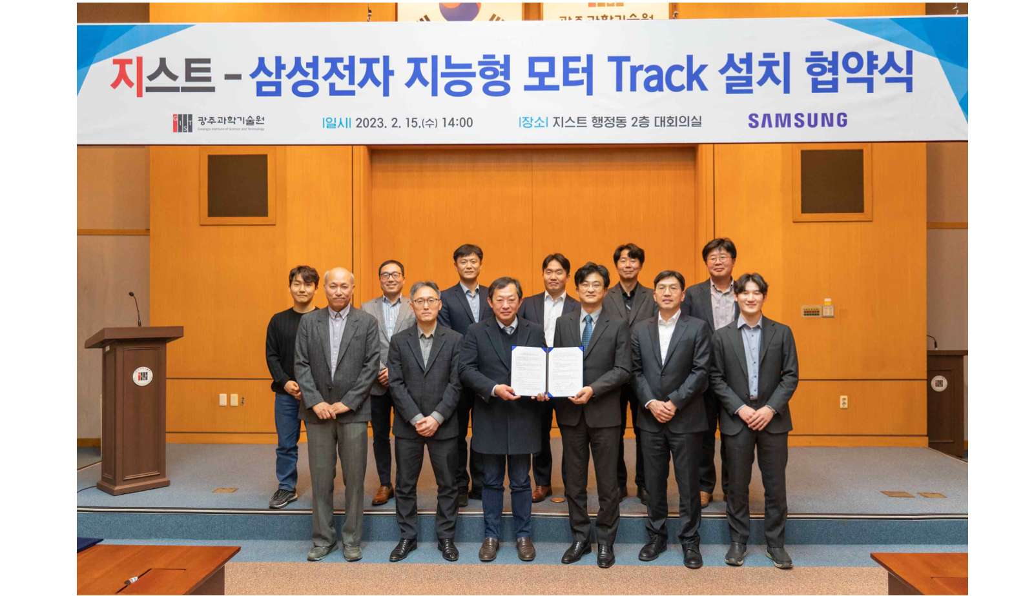▲ On the afternoon of February 15 (Wednesday), GIST and Samsung Electronics held an agreement ceremony to nurture professional talent in the field of employment-linked intelligent motors at the GIST Administration Building meeting room and took commemorative photos.

GIST (Gwangju Institute of Science and Technology, President Kiseon Kim) and Samsung Electronics signed an agreement to establish an ‘Intelligent Motor Track’ linked to recruitment in the master’s course to nurture professional talent in the field of intelligent motors.

On the afternoon of February 15 (Wednesday), the agreement ceremony held in the conference room of GIST Administration Building was attended by GIST Dean of Planning Zee Yong Park and Vice President Moo-hyung Lee of Samsung Electronics' home appliance division.

The 'Intelligent Motor Track', which will be installed and operated by GIST and Samsung Electronics, will be operated as a master's course. From this year, 15 students in related departments will be provided with customized education on related software, artificial intelligence, and machinery to grow into motor-specialized talents every year.

Students who apply for and are selected for the ‘Intelligent Motor Track’ receive tuition and subsidies, and after graduation, will work for Samsung Electronics. Various opportunities are also open, such as Samsung Electronics internship programs and participation in prestigious overseas conferences.

Starting this year, Samsung Electronics plans to contribute funds to GIST to develop its curriculum, invest in facilities, and train its workforce by attending overseas academic conferences.

GIST has a curriculum covering all areas of motor technology. Through this industry-academia cooperation, the School of Mechanical Engineering, School of Electrical Engineering and Computer Science, and AI graduate school are organically connected to provide a comprehensive educational infrastructure that can nurture professional talents in the field of intelligent motors.

To this end, 11 professors from three departments will participate in convergence education and research in the field of intelligent motors.

※ GIST-related departments (departments): School of Mechanical Engineering (mechanics, control, and design), School of Electrical Engineering and Computer Science (signal processing), Graduate School of AI (artificial intelligence)

Motor technology is a key technology for home appliances. Through the establishment of this track, which is jointly operated by a science and technology specialized university and a global company, it is expected to discover excellent local talents and nurture research personnel specialized in the development of next-generation intelligent home appliances.

Vice President Moo-hyung Lee of Samsung Electronics' home appliance division said, "To build a talent infrastructure that will lead motor technology, it was decided to establish a specialized talent training course with GIST. We will continue active industry-academia cooperation to contribute to the development of motor technology and industrial development that will create innovation in home appliances."

GIST Dean of Planning Zee Yong Park said, "We hope that this agreement will serve as a model example of industry-university cooperation to nurture excellent talent in the region, and we will strive to foster motor-specialized talent and successfully operate the track."



