7 universities including GIST - Jeollanam-do - industry signed an agreement to train ‘the world’s largest’ super-powerful laser experts in Jeollanam-do

– On the 9th, the Jeonnam Provincial Government Office started training laser experts necessary for basic scientific research and development of high-tech strategic industries.

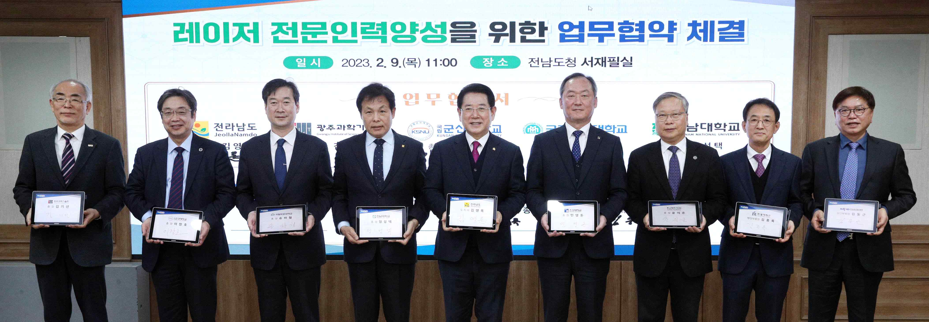
▲ Seven local universities, including GIST, Jeollanam-do, and the optics and laser industry decided to join forces to attract 「Super Powerful Laser Research Facility」 to Jeonnam-do, and a commemorative photo is being taken after a business agreement for training laser experts was held at the Jeollanam-do Provincial Office on the 9th (Thu).

Seven local universities, including GIST (Gwangju Institute of Science and Technology, President Kiseon Kim), Jeollanam-do (Governor Young-rok Kim), will join forces to attract the world's largest laser research facility to Jeollanam-do and the only large national research facility in the Honam region, and to strengthen the bid signed a business agreement for this purpose on the 9th (Thu).

A business agreement was signed for ‘nurturing laser experts’ to secure mid- to long-term laser experts was at the Jeonnam Provincial Office by Jeollanam-do Governor Kim Young-rok with GIST President Kiseon Kim, Korea Mining Industry Promotion Association Vice Chairman Dong-geun Kim, Kunsan National University President Jang-ho Lee, Mokpo National University President Ha-cheol Song, Chonnam National University President Seong-taek Jeong, Chosun University President Young-don Min, Korea Energy Engineering University President Eui-jun Yoon, and Handong Global University Vice President Jong-rok Kim in attendance.

Through this agreement, GIST and Jeollanam-do, etc. agreed to cooperate in ▴ opening laser training courses and exchanging experts, ▴ forming a personnel training consultative group and making joint proposals for national projects, ▴ creating the basis for mutual cooperation, such as joint use of equipment and research information.

First of all, while sharing curriculum and research facilities such as integrated master's and doctoral courses, they plan to focus on securing core original technologies such as design and manufacturing, and also plan to strengthen customized joint practical training so that they can be used right away in the industrial field.

Recently, the domestic optics and laser industry is in need of special measures to nurture laser personnel due to the decline in overseas competitiveness due to the lack of skilled and high-quality manpower.

Although laser is an essential element technology in all high-tech industries such as semiconductor, aerospace, and energy, there are currently only 15 graduate schools nationwide that train laser-related master's and doctoral level experts, and only about 70 people graduate annually.

The lack of professional personnel is also affecting the industry where securing original technology is the key. There are about 2,000 optical and laser-related companies in Korea, but most of them are small and medium-sized enterprises. In addition, domestic technology is less than 50% of advanced countries, and in particular, more than 90% of core parts are dependent on imports.

GIST plans to contribute to the cultivation of local personnel in the laser field centered on the Advanced Photonic Research Institute, which is the only basic and application research institute specializing in optical technology in Korea established by the government.

President Kiseon Kim said, "GIST, centered on the world-class Advanced Photonic Research Institute, will cooperate to preoccupy the new ultra-powerful laser business in Jeonnam-do, and will do its best to foster personnel to leap forward to become an advanced country in laser basic research and optical technology, thereby actively contributing to strengthening national competitiveness."



