12th GIST Techno Management Business Academy Alumni Association donated 20 million won to the development fund

– February 7th (Tue) 47 students of the 12th class... donated to the development fund

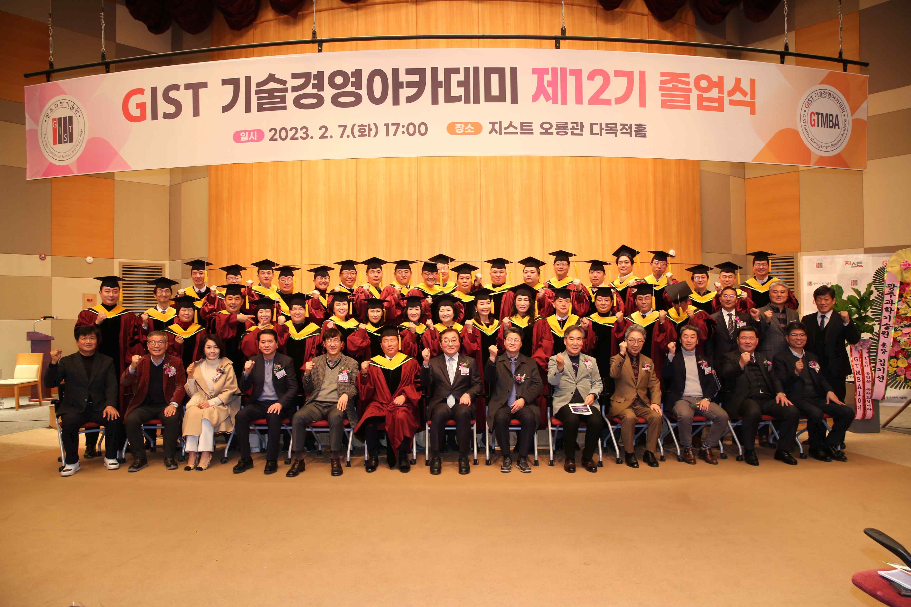
▲ The GIST Technology Management Academy held its 12th graduation ceremony at Oryong Hall on February 7th (Tuesday) and took a group photo of the attendees.

GIST (Gwangju Institute of Science and Technology, President Kiseon Kim) Techno Management Business Academy (Director Myeongjoong Kim, GTMBA) held the 12th GTMBA graduation ceremony on February 7th (Tuesday). A donation ceremony was held for the development fund after 20 million won was collected by the 12th Alumni Association.

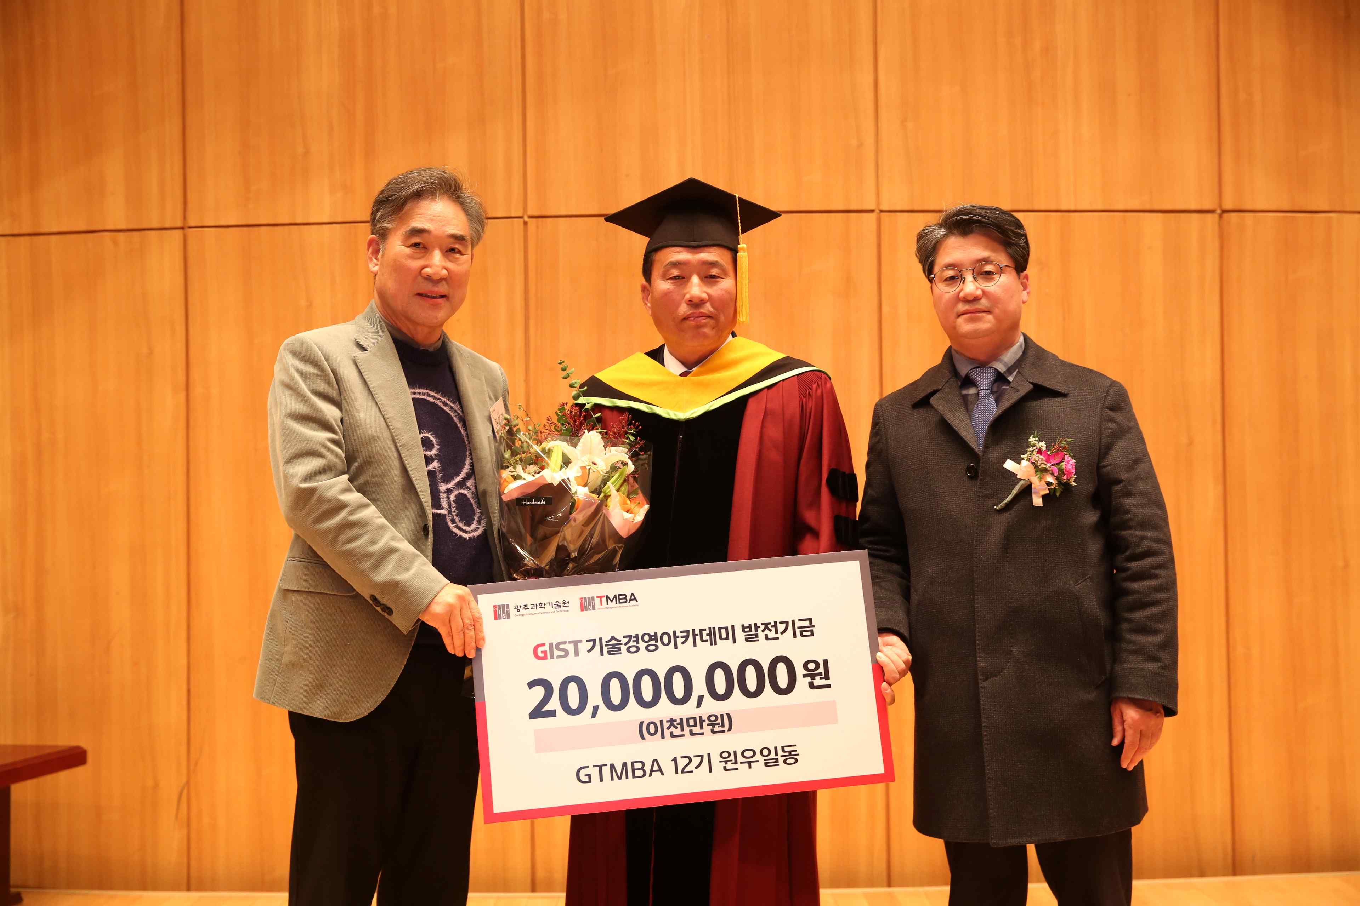
▲ The GIST Technology Management Academy is holding the 12th graduation ceremony at Oryong Hall on February 7th (Tuesday) and is holding a donation ceremony for the 20 million won development fund raised by the 12th Alumni Association. (From left) GIST Development Foundation Chairman Hae-myung Kim, Kummyung Hitech Chairman In-myeong Suh, and GIST Research Director Chang-Duk Jun.

The event was held at the multi-purpose hall of Oryong Hall with about 60 people attending, including GTMBA members, Professor Chang-Duk Jun, the 12th graduates, and GIST staff.

At the graduation ceremony, a total of 47 students who completed the GTMBA curriculum, including the latest science and technology and global management issues over a total of 29 weeks, were given certificates in the name of the president, and the GIST President’s Award was presented to the 12th Alumni Association leader, In-myeong Suh, chairman of Kummyung Hitech Co., Ltd.

12th Alumni Association Chairman In-myeong Suh said, "With the hope that GIST will stand tall as a world-class science and engineering education and research institute based in the region, we agreed to donate the development fund together with the alumni. I would like to thank GIST Techno Management Business Academy and GIST officials for providing a high-quality education program, and I will work with the alumni to contribute to the development of GIST and revitalization of the local economy."

Research Director Chang-Duk Jun said, "We ask that you always bear in your heart the pride and pride of being a member of the GTMBA alumni and take the lead in improving management skills and enhancing regional industrial competitiveness based on the insights and human networks you gained through the CEO course. Please make efforts for continuous communication and cooperation between GIST and the industry in the future."

GTMBA opened the CEO course in 2010 to serve as a business hub through systematic CEO education programs. To date, about 480 alumni are active as the best global leaders in each field of society.

GTMBA is a one-year course starting in March every year and ending in February of the following year. It is held every Tuesday at 7:00 pm at GIST Oryong Hall, and it is currently recruiting students for the 13th class of 2023.



