Seung-jong Na, CEO of Hyojin Co., Ltd., was inaugurated as the alumni president of GIST Techno Management Business Academy

- Following the 5th president Yong-beom Lee, he will serve as the 6th president of the alumni association... inauguration ceremony held on the 31st of last month

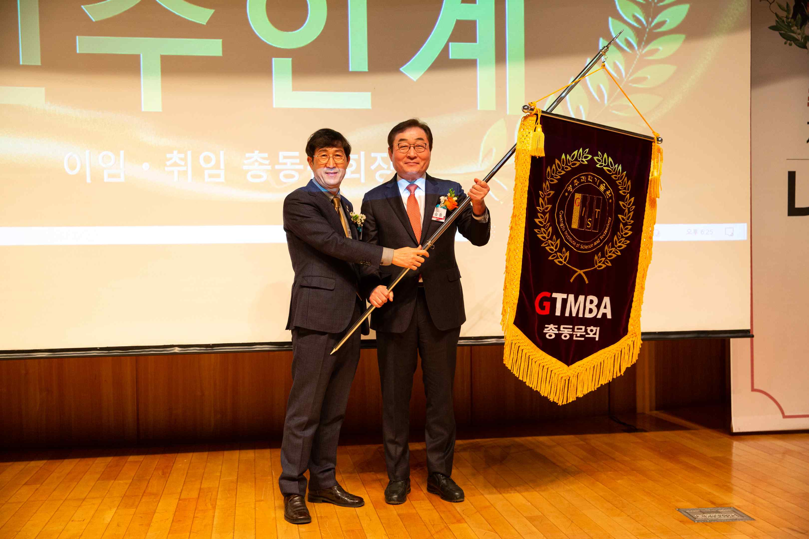
▲ The 6th Alumni Association President Seung-jong Na (right) is taking over the GTMBA flag from the 5th Alumni Association President Yong-beom Lee (left).

GIST (Gwangju Institute of Science and Technology, President Kiseon Kim) Techno Management Business Academy (GTMBA) Alumni Association (President Seung-jong Na) held the 9th GTMBA regular general meeting and the inauguration ceremony of the general alumni president on January 31 (Tue) at GIST Oryong Hall.

The ceremony was attended by GIST President Kiseon Kim, Chairman Yong-beom Lee Protec Co., Ltd., and 120 alumni attended, and CEO Seung-jong Na of Hyojin Co., Ltd. was elected as the 6th Chairman of the Association.

Hyojin Co., Ltd., founded in 1996 by Seung-jong Na, a 7th GTMBA alumni, is a company specializing in electrical engineering and construction. Major industries include electrical construction, firefighting construction, and installation and maintenance of firefighting construction.

Seung-jong Na, the 6th president of the alumni association, said in his inaugural address, "During my tenure, I will do my best to help the GTMBA Alumni Association take a new leap forward through new projects, etc. We will further solidify and develop our achievements so far to create an alumni association that respects and encourages each other."

Alumni President Yong-beom Lee, who led the alumni association for the past year, said, "With the generous love and support of the alumni, I was able to successfully lead the GTMBA Alumni Association. I would like to express my deep gratitude to the 5 executives and executives of the Alumni Association and GTMBA alumni who have taken the lead in the development of the Alumni Association."

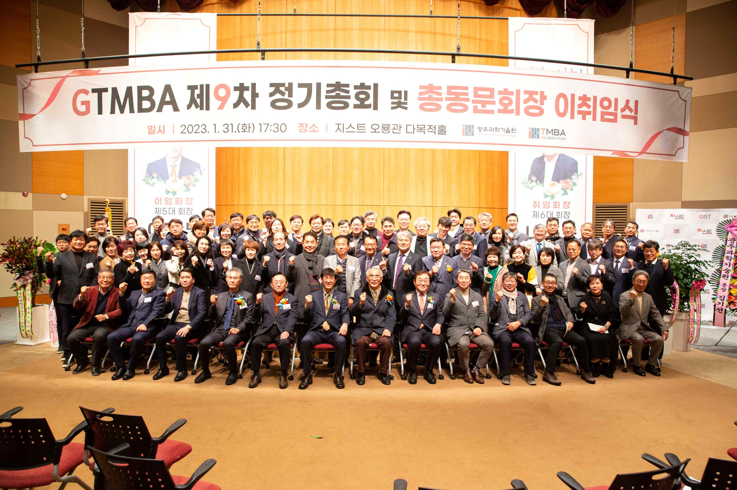
▲ On January 31st (Tuesday), the 9th regular general meeting and the inauguration ceremony of the general alumni president were held at GIST Oryong Hall, and a group photo was taken.

Meanwhile, the GIST Techno Management Business Academy invited Gwangju Metropolitan City Mayor Ki-jeong Kang as a speaker to the <GIST Academy Forum> held as a pre-event and gave a special lecture on the ‘2023 Gwangju Municipal Administration Plan’.

Mayor Ki-jeong Kang gave a lecture focusing on pending projects of Gwangju City: ▴ Jisan IC, installation of an underground roadway at Baegun Square ▴ Development of new textile sites in Jeonnam and Japan ▴ Development of Eodeungsan Tourism Complex ▴ Attraction of a shopping mall ▴ Relocation of a military airport.

The GIST Academy operates the Techno Management Business Academy (GTMBA, opened in 2010) and the Climate Change Academy (GCCA, opened in 2016) as non-degree courses, and is recruiting new students for the 13th class of GTMBA and the 6th class of GCCA in 2023. The training targets include CEOs and executives, high-ranking public officials, and opinion leaders from all walks of life, and about 40 people were recruited.

The GIST Academy supports executives in each field to deeply understand changes in the business environment and global management strategies through lectures by the best experts in Korea, form a wide human network, and contribute to the vitalization of the local economy and industry-university cooperation.



