GIST Why do we play online games? Published <The Paradox of Proteus: The Psychology of Virtual Worlds and Online Games>

- Publication of GIST PRESS... Unraveling the amazing psychological mechanism hidden in the virtual world from various angles
- Written by Dr. Nick Yee, a researcher on the ‘Proteus Effect’, translated by Professor Wonil Choi of the Department of Basic Education at GIST

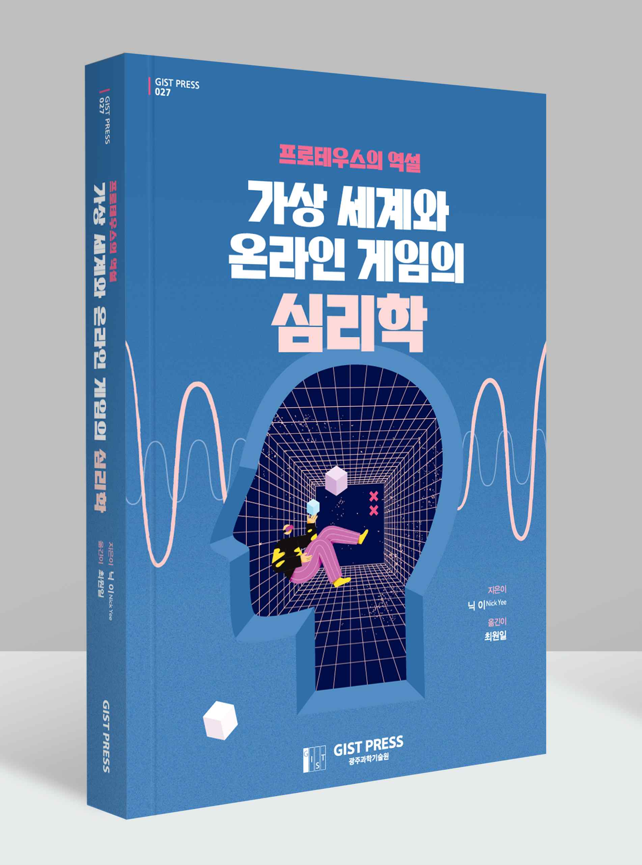
▲ [Book Cover] <The Paradox of Proteus: The Psychology of Virtual Worlds and Online Games>

This book contains more than just a game. It questions what it means to be human in a digital world and how technology is changing the way we exist, live and relate.
- <The Paradox of Proteus: The Psychology of Virtual Worlds and Online Games>, Introduction - xix

'Why do we invest so much time and effort to play online games?', 'Does using an attractive avatar actually build confidence?', 'Why are there few female users in online games?' Can I miss it?'. A translation book has been published that will answer questions that online gamers might have wondered about at least once through the lens of psychology.

GIST PRESS (Gwangju Institute of Science and Technology, President Kiseon Kim) published <The Paradox of Proteus: The Psychology of Virtual Worlds and Online Games>, a study on the various psychological mechanisms found in virtual and online games and the impact of this virtual world on human thinking and behavior.

* Proteus effect: Proteus, the god of the sea in Greek mythology, can recreate himself as one or several at the same time. It is comparable to creating a virtual self called an avatar in an online game. The ‘Proteus effect’ refers to a phenomenon in which an individual’s behavior changes depending on the characteristics of an avatar they have in virtual reality. For example, it refers to the effect that a person who uses an attractive avatar in the virtual world shows the characteristics of an attractive person in the real world.

This book, translated by GIST Professor Wonil Choi of the Division of Liberal Arts and Sciences, presents situations that would have been experienced if you have played online games based on vivid examples of online gamers, and analyzes them based on psychological grounds. Interesting psychological mechanisms such as online gamers' psychological reactions and behaviors, stereotypes and rules, and romance are unraveled in the book.

Nick Yee, the author of the original book, The Proteus Paradox, received a PhD in communication from Stanford University in the United States and founded Quantic Foundry, an online gamer psychological analysis company. It is known for its original research on the ‘Daedalus Project’, a psychological analysis study on more than 40,000 gamers, and the ‘Proteus Effect’, which states that avatars change the way they behave in reality.

Professor Wonil Choi, the translator, received his Ph.D. in cognitive psychology from the University of North Carolina, USA, and is currently teaching psychology as a professor in the GIST Division of Liberal Arts and Sciences. He is conducting research on what happens in the eyes and brain when humans think, understand language, and speak. He has recently expanded his field of interest to the interaction between humans, machines and society.

The author focuses on the Proteus Paradox, in which the virtual world we think we have complete control over actually changes and controls the way we think and act. This is a very different view from the view of existing researchers that freedom and empowerment in the virtual world can be an escape from reality.

Professor Wonil Choi said, "This book gives readers who are familiar with online games the pleasure of realizing the psychological mechanism they have experienced in the game. Readers who have children or spouses who play online games have the opportunity to gain a deeper understanding of the mechanisms that keep them playing online games. I hope that all modern people who have no choice but to live closely intertwined with the virtual world will have a wiser and healthier perspective to accept the virtual world."

Professor Choi also adds, "With growing interest in the direction of the metaverse (three-dimensional virtual world) craze, which is drawing attention again due to the COVID-19 pandemic, the publication of this translation will serve as an opportunity to contemplate the impact of online games and virtual worlds on humans, which have been popular for more than 20 years."



