MSL Chairman Hae-myeong Kim donated 300 million won to GIST Development Foundation

– Donation ceremony held on the 18th... the 30th anniversary of GIST and the Development Foundation will work together to contribute to the development of the community

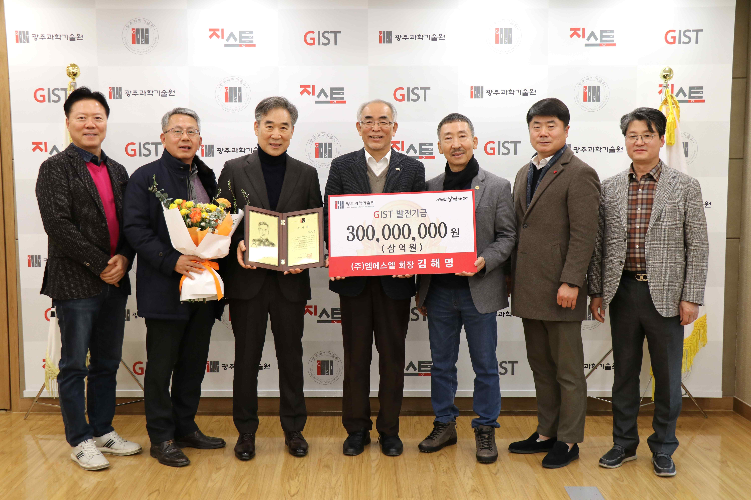
▲ On the 18th (Wednesday) at 5:00 PM, a development fund donation ceremony is held in the president's office on the 5th floor of the administrative building, and a commemorative photo was taken. (From left) CEO of Seongil Livestock Farming Association Yong-gi Lee, Korea Threeaxis Co., Ltd. Chairman Gu-hyun Ryu, MSL Co., Ltd. Chairman Hae-myeong Kim, GIST President Kiseon Kim, Woosung Precision Co., Ltd. Chairman Hwa-seok Park, NH Networks Co., Ltd. CEO Geun-shin Lee, and GIST Research Director Chang-Duk Jun.

GIST (Gwangju Institute of Science and Technology, President Kiseon Kim) MSL Co., Ltd. Chairman Hae-myeong Kim Kim Hae-myeong, who serves as the chairman of the Development Foundation, donated 300 million won to the GIST Development Foundation.

The donation ceremony was held on January 18 (Wednesday) at 5:00 PM in the president's office and was attended by GIST President Kiseon Kim, Research Director Chang-Duk Jun, and directors of the GIST Development Foundation.

The GIST Development Foundation was established in 2016 and promotes the development of science and technology in Korea and contributes to resolving local issues by supporting educational and research activities of GIST, such as fostering high-quality science and technology experts, mid- to long-term research and development at the national level, and conducting basic and applied research.

In particular, as a social contribution project, it practices the spirit of sharing by donating books for children in underprivileged areas and providing scholarships to students with excellent academic performance.

Chairman Hae-myeong Kim donated more than 150 million over time to GIST, and this time he donated an additional 300 million won.

MSL Co., Ltd. Chairman Hae-myeong Kim said, "As the chairman of the board, I will do my best to contribute to the development of the local community through cooperation between GIST and the Development Foundation, which celebrates its 30th anniversary this year."

President Kiseon Kim said, "I am deeply grateful to Chairman Hae-myeong Kim for his donation, which will be used to improve the research environment and nurture scientific talent so that GIST can take a step forward as a world-class research-oriented university."



