Litigation related to the future of GIST President ends with mediation

- Current President Kiseon Kim resigns on the 24th of next month... Submits resignation to the Board of Directors on January 17th (Tuesday)
- Board of Directors, “Accepting the court’s mediation decision, the best decision is to quickly stabilize the institution”

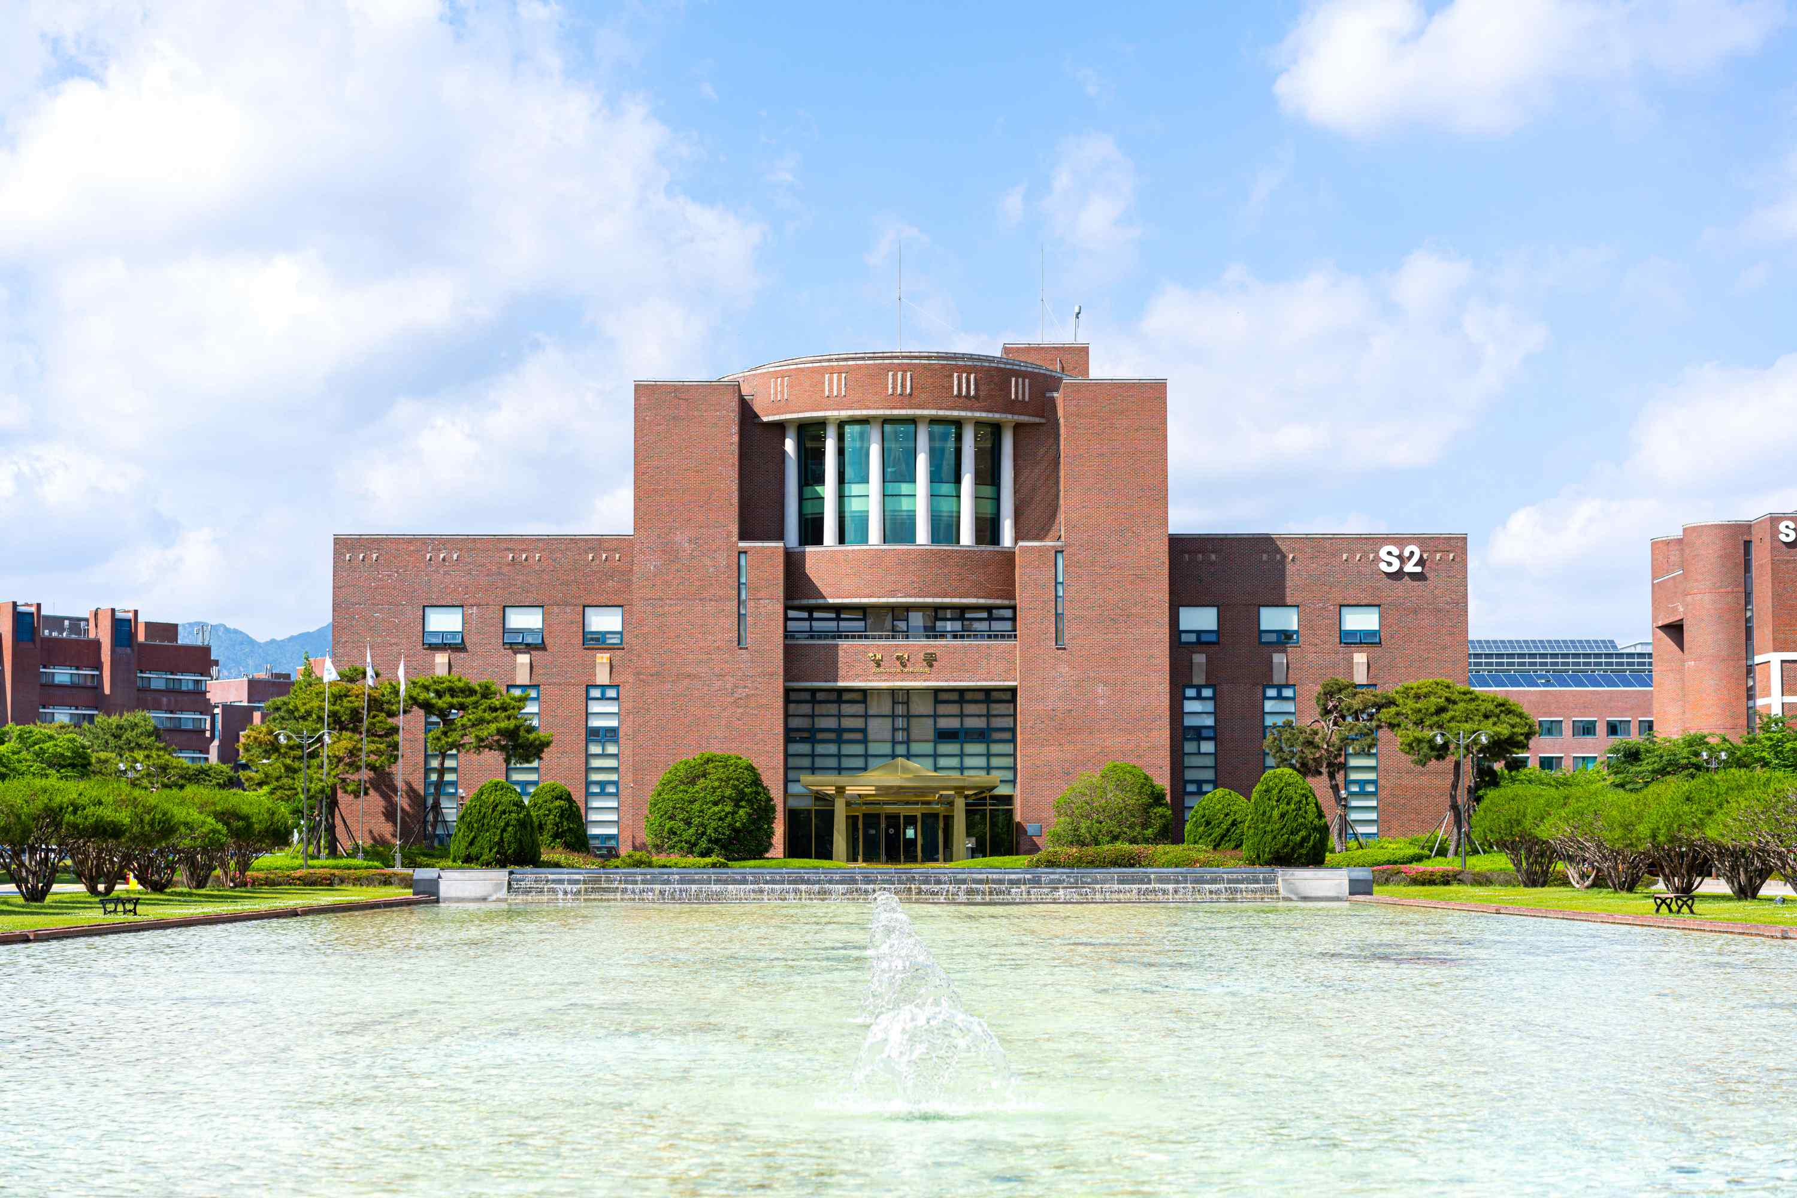
▲ Panoramic view of GIST Administrative Building

GIST (Gwangju Institute of Science and Technology) Board of Directors (Chairman Moon-Hee Han) announced on the 18th that the appeal (second trial) of the lawsuit filed by the 8th President KiSeon Kim against GIST for the invalidation of the resolution of the board of directors was terminated by the mediation method proposed by the court.

Earlier, President Kiseon Kim filed this lawsuit when the GIST Board of Directors resolved to dismiss the president in June 2021. In June 2022, the court at the first trial ruled (plaintiff’s loss) to the effect that 'the decision of the Board of Directors to dismiss the president was justified'.

President Kiseon Kim appealed against the ruling of the first trial, and the appeal has been ongoing until recently.

As a result of this adjustment, President Kiseon Kim resigned as president on February 24, 2023, earlier than the official term (4 years) with an end date of March 5, 2023. To this end, he submitted his resignation to the Board of Directors on Tuesday, January 17th.

Accordingly, the GIST Board of Directors plans to hold an extraordinary board meeting on January 20th (Friday) to accept President Kiseon Kim's letter of resignation.

The GIST Board of Directors said, “This decision was made after carefully considering the plan to normalize the operation of the institution as soon as possible and prevent further damage to the reputation of GIST.”

“▲ Regardless of the trial result, the president’s term of office is about to end, so even if the case is won by judgment, there is no practical benefit to the lawsuit. ▲ If the lawsuit continues, there is a concern that it will negatively affect the process of appointing a new president in the future. ▲ (After the conclusion of the second trial by judgment without mediation) The mediation plan was discussed in comprehensive consideration, including the fact that the new president will bear the burden of succession of the lawsuit in the event of an appeal to the Supreme Court.”

As the term of President Kiseon Kim ends on February 24, 2023, through the end of the lawsuit. GIST will operate as an acting president from February 25, 2023, until the 9th president is appointed.

The GIST board of directors formed the Presidential Candidate Recommendation Committee to elect the 9th president and started the process for appointing a new president. On January 16 (Monday), a notice of invitation for the president was published. The application for the 9th president will be accepted for three weeks until February 5th (Sun).



