GIST begins the process of appointing the 9th president in earnest

– Posting an invitation announcement to recruit candidates for the new president... Applications received for three weeks from January 16th to February 5th

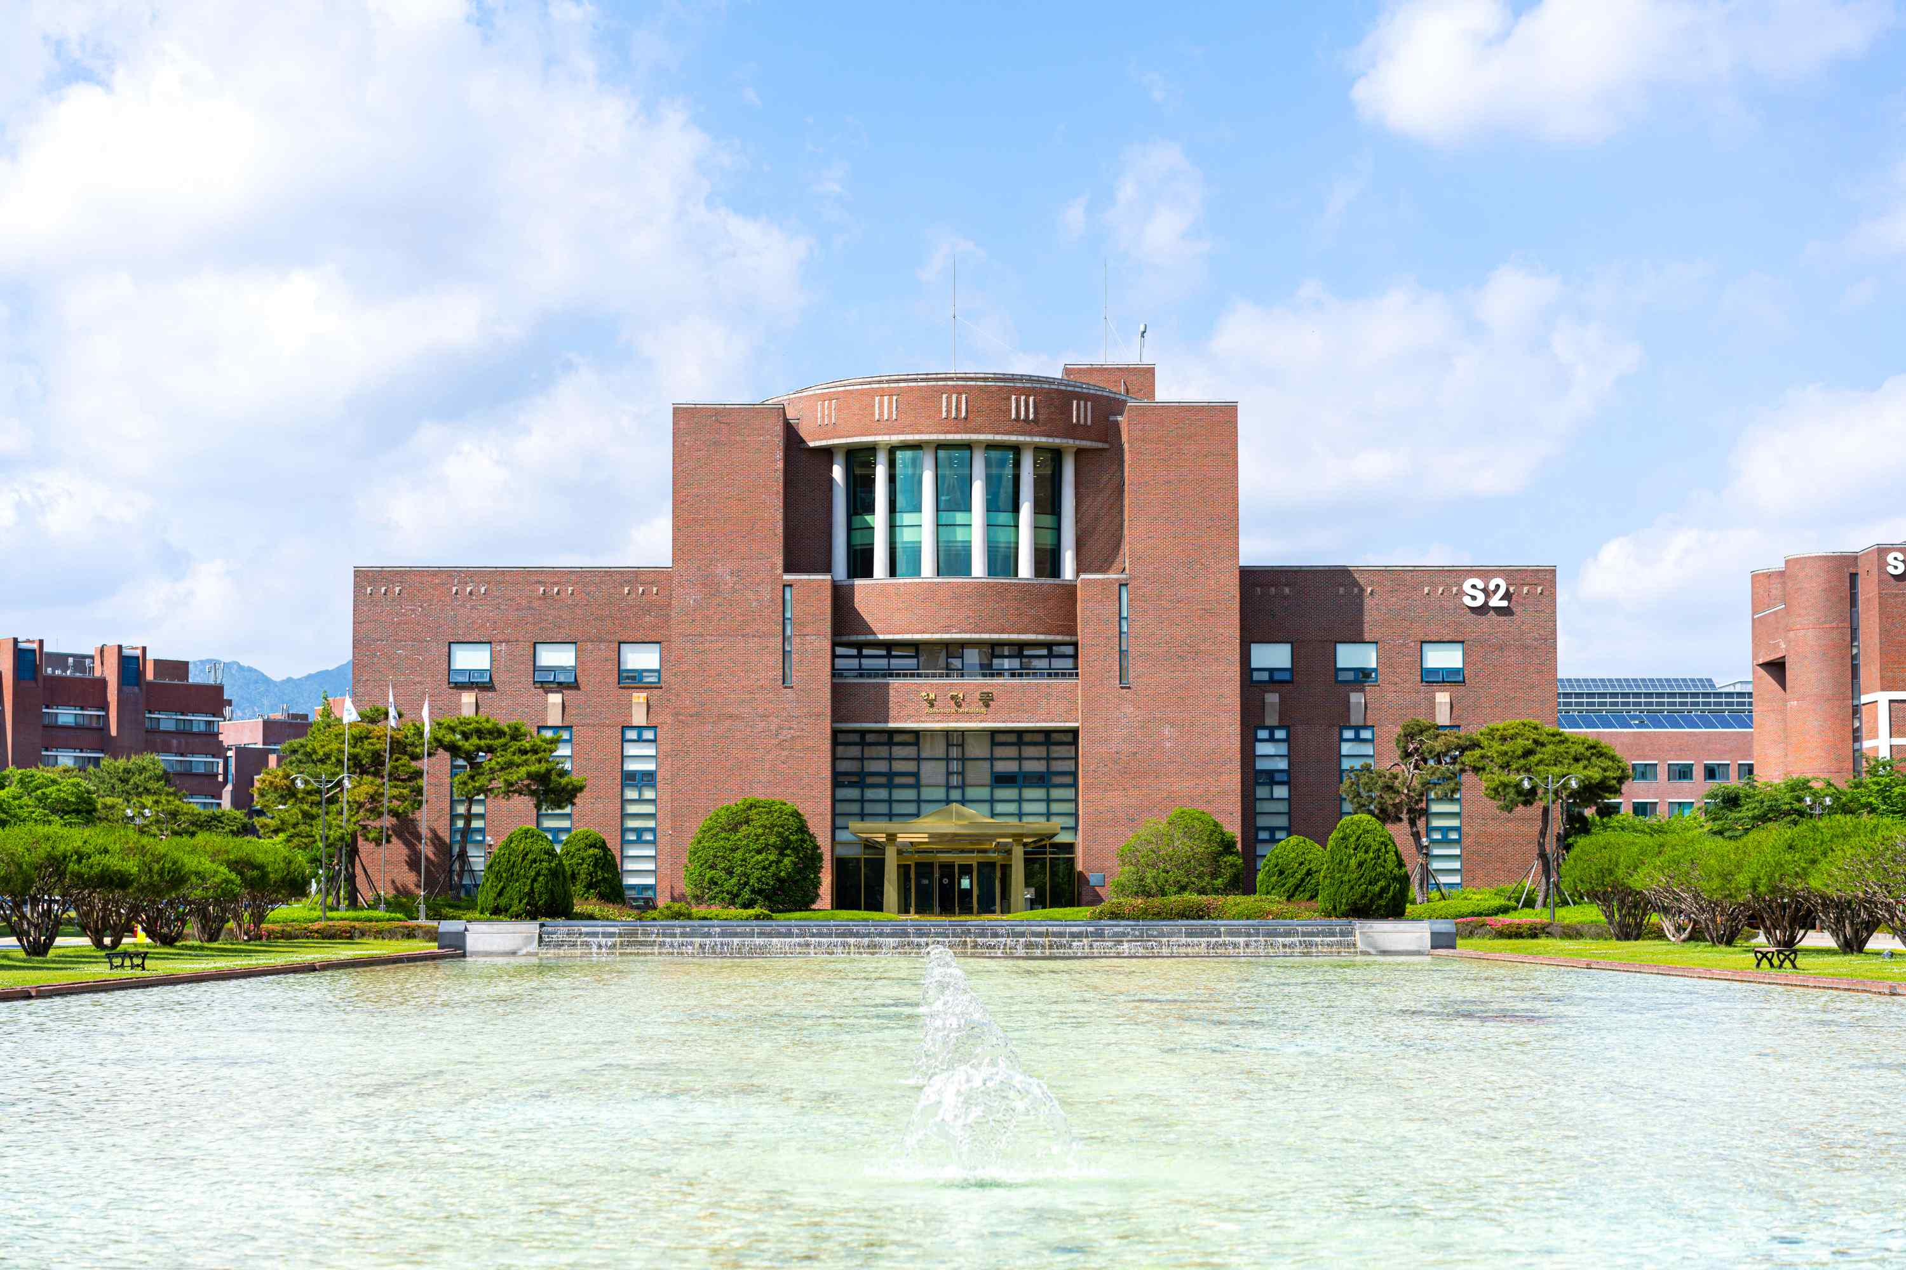
▲ Panoramic view of GIST administrative building

GIST (Gwangju Institute of Science and Technology, President Kiseon Kim) issued invitation announcement to appoint the ninth president and began the process of recruiting candidates for the next president.

The GIST Board of Directors (Chairman Moon-hee Han) will issue an invitation announcement to appoint for the next president on January 16th (Mon) and will proceed with accepting applications for the 9th president until February 5th (Sun).

Upon completion of the three-week (21-day) candidate application process, the Presidential Candidate Recommendation Committee recommends candidates to the Board of Directors after a predetermined examination. If the president is appointed by the Board of Directors, the four-year term begins with the approval of the Minister of Science and ICT (with the consent of the Minister of Education).

[Reference] GIST President Appointment Process

Receipt of application ☞ Review of the President Candidate Recommendation Committee and recommend candidates to the Board of Directors ☞ Appointment of the President by the Board of Directors ☞ Approved by the Minister of Science and ICT (with the consent of the Minister of Education) ☞ Start of term (4 years from the date of approval)

In particular, with the appointment of the president, for the first time, a separate ‘president candidate discovery subcommittee’ was formed in which internal and external personnel participate, and plans to discover suitable candidates for the president and guide the process.

GIST Board of Directors said, "As this year marks the 30th anniversary of its establishment, we hope that many great people with leadership, morality, and passion who can contribute to developing GIST's research capabilities to the next level and fostering excellent science and technology specialists through innovative education programs will apply."





