GIST-Chonnam National University Hospital Collaborative Research Symposium held

- Performed a total of 37 tasks for 11 years from 2012... Established a solid research cooperation system
- Presentation of convergence research on various topics such as nerve cell regeneration, antibacterial peptoid, and hemodynamic sensor patch

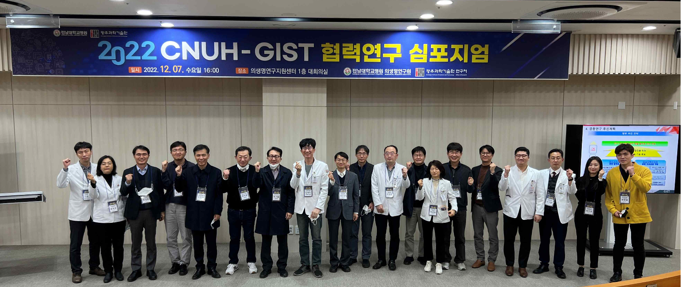▲ GIST held the ‘Collaborative Research Symposium’ with Chonnam National University Hospital last December, and participants are taking commemorative photos.

GIST (Gwangju Institute of Science and Technology, President Kiseon Kim) held the ‘Cooperative Research Symposium’ with Chonnam National University Hospital last December.

This symposium, co-planned by the GIST Research Department and the Biomedical Research Institute of Chonnam National University Hospital, strengthens the research competitiveness of each institution and promotes the community and science and technology. To contribute to development, it was held on December 7th (Wednesday) of last year in the conference room on the 1st floor of the Biomedical Research Support Center at Chonnam National University Hospital.

Kihong Park, Director of Research at GIST, Zee-Yong Park, Director of Planning, Jae-Min Kim, Research Director of Biomedical Research Institute at Chonnam National University Hospital, and Seung-Jung Ki, Director of Translational Medicine Research Center, attended as moderators. It was a great success with a total of 70 researchers, including directors of research and participating researchers from both institutions, attending.

The GIST Research Department and the Biomedical Research Institute of Chonnam National University Hospital are conducting convergence research by investing a total of 2.2 billion won (550 million won per year) for 4 years in 16 cooperative research projects discovered through a joint public offering in 2020.

The event was held as an interim report on joint research projects that the two institutions are conducting to promote convergence research. On behalf of the two institutions, it was conducted in the form of a research presentation seminar on eight cooperative research projects, divided into parts 1 and 2, starting with greetings from Kihong Park, Director of Research at GIST, and Jae-Min Kim, Research Director of Chonnam National University School Hospital.

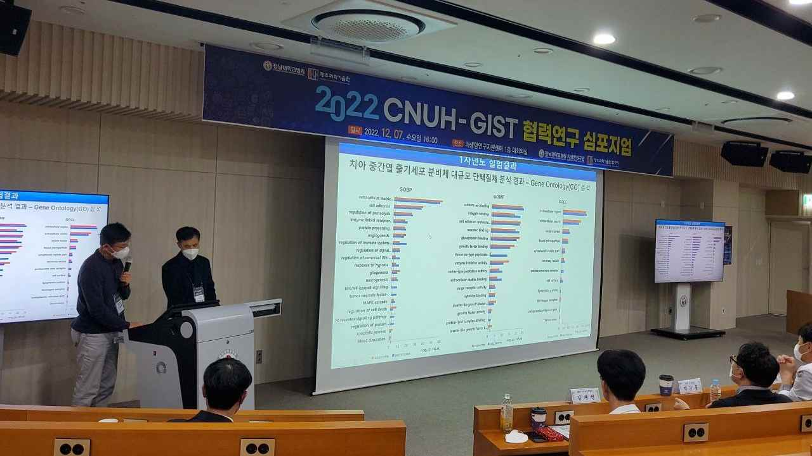
▲ GIST-Chonnam National University Hospital Collaborative Research Symposium site

Announces research projects included ▴ regeneration of basal ganglia dopaminergic neurons using human stem cell secretion in Parkinson's disease animal model ▴ evaluation of multidrug-resistant sepsis clinical strains of antibacterial peptoids and efficacy in animal models of infectious diseases ▴ development of ultra-tight hemorrhagic epidemiological sensor patch for monitoring emergency patients outside the hospital ▴ development of a non-invasive brain & tactile electrical stimulation integrated platform for lower extremity rehabilitation training for stroke patients ▴ development of renal-specific delivery of anti-fibrotic drugs using smart graphene oxide transporter and development of renal disease progression control technology ▴ development of LIBS technology for melanoma diagnosis ▴ development and verification of non-invasive treatment for neurodegenerative diseases through optical stimulation of the olfactory bulb ▴ development of a wearable bio-signal detection sensor for monitoring diabetic cardiovascular complications.

The GIST-Chonnam National University Hospital collaborative research, which started in 2012, has conducted a total of 37 studies over the past 11 years. This is a great driving force in expanding the foundation for joint research between the two universities and establishing a cooperative research system.

The first 8 tasks (research period: 2020-2021) discovered through a joint competition in 2020 include 17 SCI papers, 12 patent applications/registrations, 1 prototype, and 10 academic conference presentations after the completion of two years of research. It has achieved remarkable collaborative results.

Director of Research Kihong Park said, "This cooperative research project is expected to not only strengthen the research competitiveness of the two institutions, but also strengthen cooperation with the local community and play a role in contributing to the development of national science and technology."



