GIST Senior-Friendly Industry Support Center, Research Cooperation in the field of 'Healthy Longevity' with Amorepacific

- Plan to promote scientific verification research cooperation for health functional food specialized for human body application system
- “We will contribute to strengthening the global competitiveness of healthy longevity, such as research on vital beauty products”

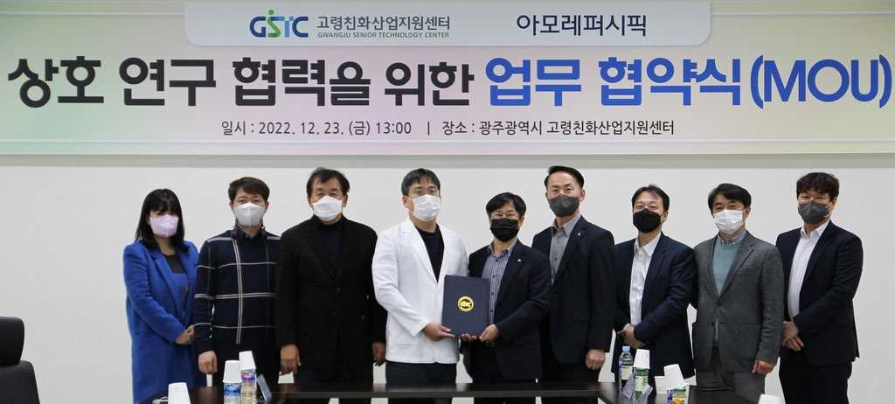
▲ On December 23rd (Friday), at the GIST Senior-Friendly Industry Support Center located in Gwangju Metropolitan City, the Senior-Friendly Industry Support Center and Amorepacific signed a business agreement for research cooperation in the field of health and longevity, and are taking commemorative photos.

GIST (Gwangju Institute of Science and Technology, President Kiseon Kim) Senior-Friendly Industrial Support Center (Director Chang-Myung Oh, Department of Biomedical Science and Engineering professor) signed a research cooperation agreement with Amorepacific on December 23rd (Friday) in the field of healthy aging.

"Health longevity" is a concept that emerged as the lifespan of mankind is prolonged and aging around the world, and social interest in living a long healthy life (as a period expected to live healthy) rather than "prolonged longevity."

Through this business agreement, the two institutions plan to further systematize existing healthy aging research and conduct applied research to commercialize it.

The Senior-Friendly Industry Support Center plans to continue various attempts to innovate the development of the senior-friendly industry by strengthening research competitiveness in the field of healthy longevity, such as anti-aging, microbiome, and inner beauty.

Amorepacific R&I Center recently published the results of a study on ‘Mechanism of Longevity through Dietary Restriction and its Key Components’ with Professor Dong-Ryeol Ryu of Sungkyunkwan University in Nature Communications. In particular, they are planning a large-scale clinical study using Vital Beauty's ginseng berry ampoule masterpiece product.

GIST Senior-Friendly Industry Support Center Director Chang-Myung Oh said, "With this agreement, I am delighted to be part of the process of revealing the excellence of Amorepacific products through the advanced human application test evaluation system of the Senior-Friendly Industry Support Center. Through joint research and product development with AMOREPACIFIC, we will contribute to setting international standards to realize healthy longevity."

Amorepacific R&I Center Director Young-ho Park said, "I think this research agreement is a meaningful collaboration in that Amorepacific's healthy longevity products and the Senior-Friendly Industry Support Center can create mutual synergies. Amorepacific will focus on further strengthening the development of effective materials and developing innovative products in line with the global growth of the health and longevity industry."

The agreement ceremony, held at the Senior-Friendly Industry Support Center located in Nam-gu, Gwangju, was attended by Chang-myeong Oh, head of the Aging-friendly Industry Support Center, Young-ho Park, director of R&I (Research & Innovation) Center at Amorepacific, Wan-ki Kim, director of the Healthcare Research Center, Dong-ryeol Ryu, professor at Sungkyunkwan University's Graduate School of Basic Medicine, and others.

The GIST Elderly Friendly Industry Support Center is building space and equipment that can evaluate usability based on living labs such as care robots, cosmetics, and healthcare products. About 5,000 seniors participate in product experience and usability evaluation every month.

Recently, it is expanding its business areas to various research fields such as establishing test beds and participating in projects to establish standards for mobile robots, and is striving to become a new mecca in the elderly-friendly industry.



