Chairman Yong-man Kim of the Garden Scholarship Welfare Foundation donated to the GIST Development Fund

- Held a donation ceremony on the 23rd... donated 10 million won for student scholarships to nurture excellent science and technology specialists

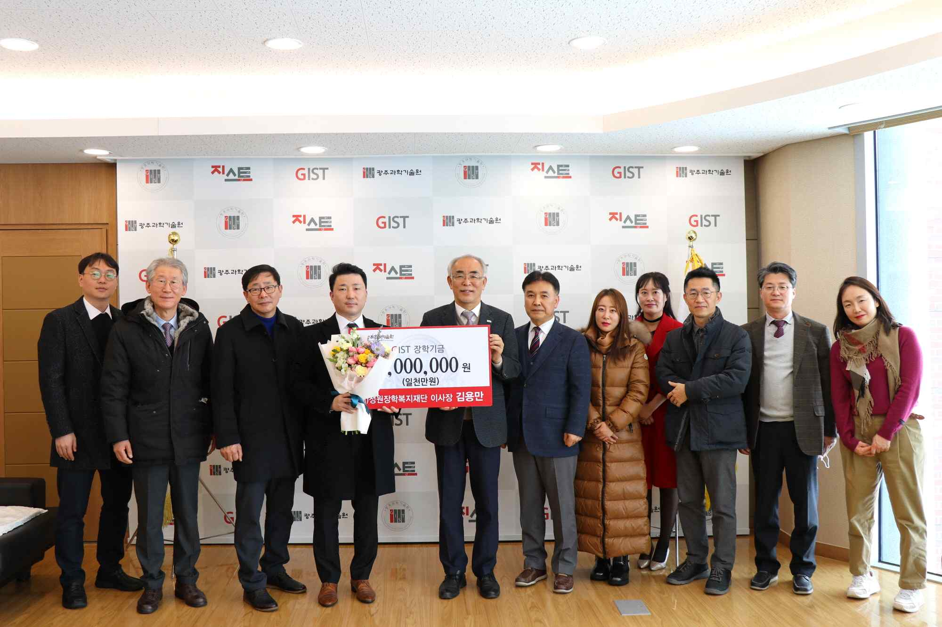
▲ On the 23rd (Fri) at 11:00 a.m., the President's Office on the 5th floor of the Administration Building held the 'Donation Ceremony for the Development Fund of the Jeongwon Scholarship and Welfare Foundation' with 11 officials including President Kiseon Kim and Research Director Chang-Duk Jun attending and taking commemorative photos. (Fourth from the left) Chairman Yong-man Kim of the Garden Scholarship Welfare Foundation and GIST President Kiseon Kim

Yong-man Kim, chairman of Cheongsong Academy, a school corporation of Soongdeok High School in Gwangju, donated 10 million won in scholarship funds to GIST (Gwangju Institute of Science and Technology, President Kiseon Kim) to support students with high academic performance.

The deposit ceremony was held at 11:00 am on December 23 (Friday) in the President's Office with the participation of President Kim Ki-sun, Research Director Chang-Duk Jun, and other officials from GIST and Jeongwon Scholarship and Welfare Foundation.

The Garden Scholarship Welfare Foundation was established in March 2000 by Gil-soo Kim, the founder of Cheongsong Academy Soongdeok High School, to honor the will of his parents, and has been steadily carrying out scholarship projects and social welfare projects.

In particular, as a social welfare project, it practices the spirit of sharing by providing donations and goods to the disabled, orphans, single mother families, multicultural families, underprivileged youth, and the elderly who lack assistance.

After Yong-man Kim took office as the 2nd chairman, he decided to support scholarships to GIST this year by further expanding scholarship projects and business welfare projects.

Chairman Yong-man Kim of the Garden Scholarship Welfare Foundation said, "Among the GIST students who nurture excellent specialists in science and technology, if there are students in difficult living conditions, I made the donation with the desire to generously support their studies and nurture them into greater experts."

President Kiseon Kim said, "I am grateful for the warm heart of Yong-man Kim who supported GIST's talented students so that they could focus on their studies without financial difficulties. Celebrating its 30th anniversary next year, GIST will continue to focus on research, education and regional innovation without losing its original focus."



