"Contributing to solving social problems through artificial intelligence convergence research" GIST held an AI convergence talent training performance presentation

– Expected to nurture X+AI convergence scientists and engineers who explore social issues with convergence thinking by grafting AI technology

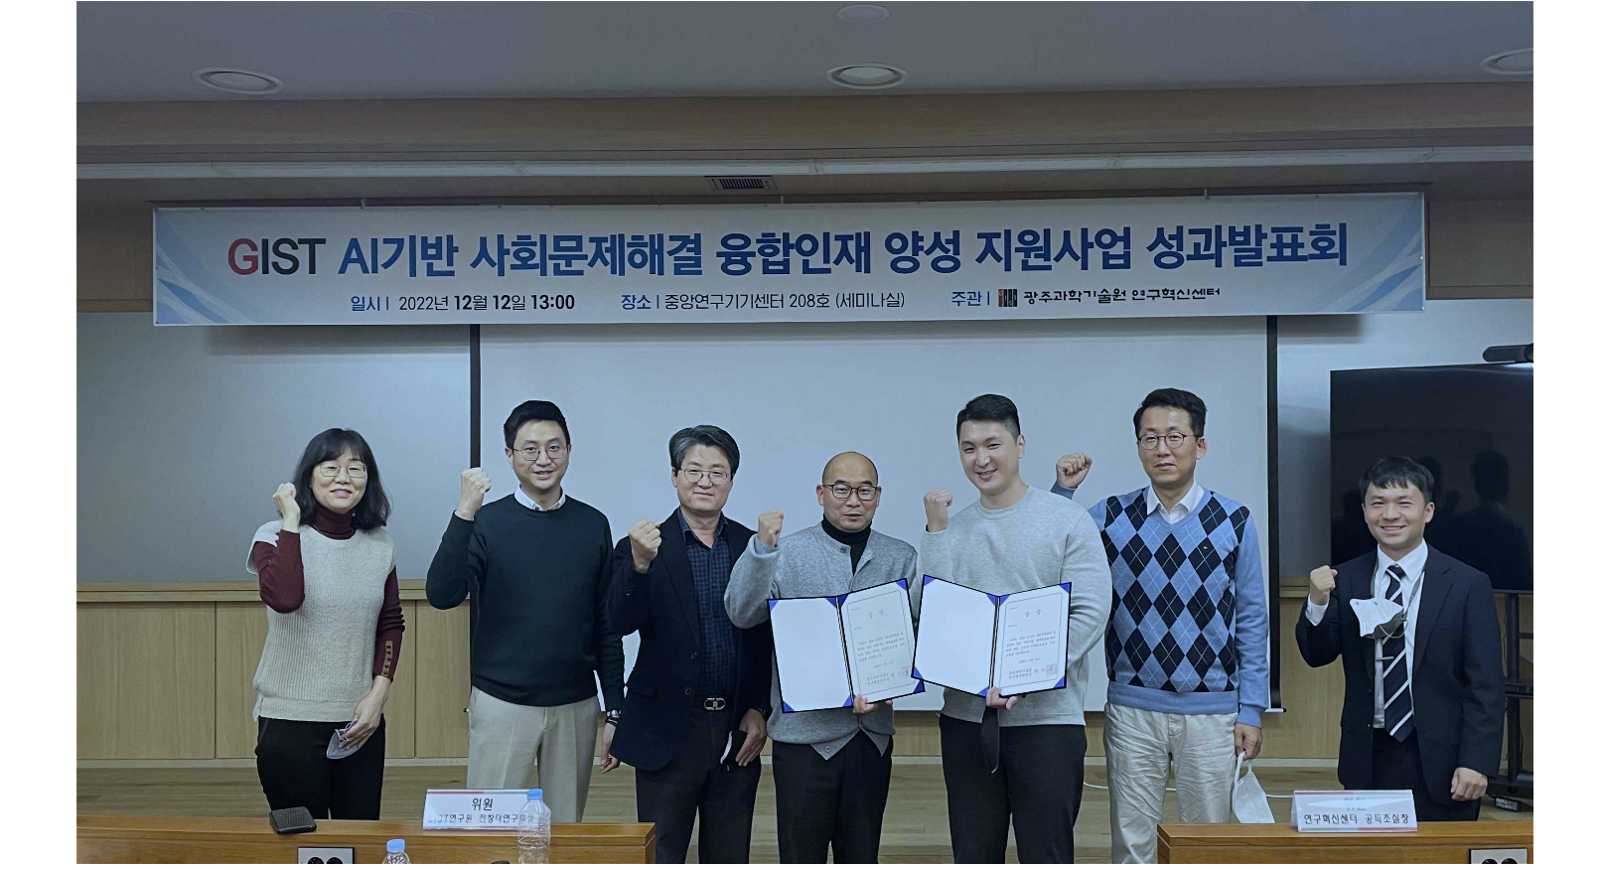▲ Presentations and award ceremonies held for 23 cases at the performance presentation. Dr. Young Jin Yoo (Professor Young Min Song's Lab, School of Electrical Engineering and Computer Science) won the first prize (fifth from the left), and Professor Chang Wook Ahn's (AI Graduate School) research team received the Excellence Award (fourth from left)

GIST (Gwangju Institute of Science and Technology, President Kiseon Kim) concluded the ‘2022 AI-based Social Problem Solving Convergence Specialists Training Support Project’ for new doctoral-level researchers and recently held a performance presentation.

The ‘2022 AI-based Social Problem Solving Convergence Specialists Training Support Project’ supports the AI convergence research of doctoral-level researchers with various majors to develop national core science and technology talents. It is a research project that helps students grow into convergence specialists with social problem-solving capabilities and has been conducted for one year since January this year as part of GIST's Science and Technology Leading Basic Project.

In this project, GIST divided into three tracks according to the composition of researchers, and supported research funds for a total of 24 tasks for 66 new researchers. In order to solve difficult problems in various disciplines (X), AI technology was applied to support research that explored new approaches that did not exist before.

The three tracks are centered around doctoral-level researchers for ‘X majors’: △ track 1 had a single composition of ‘X majors’ △ track 2 consisted of ‘X major’ and AI major doctoral students △ track 3 consisted of ‘X majors’ and doctoral level researchers majoring in AI. Research activity expenses were supported in stages according to core competencies.

In addition, for about two weeks (2022.6.20.~7.1.), in conjunction with the K-digital Platform project, it provide digital basic-intermediate course data processing training together with CJ OliveNetworks to help non-AI majors understand and acquire AI technology to solve social problems. It also operated retraining courses for incumbents so that they could grow into problem-solving specialists.

At the performance presentation held on December 12, 23 1st and 2nd support tasks were announced and an award ceremony was held. Professor Young Min Song (School of Electrical Engineering and Computer Science) ahd Dr. Young Jin Yoo from the laboratory won the first prize, the Grand Prize.

Dr. Young Jin Yoo conducted a study on ‘virus color detection’ using the AI deep learning-based ‘Gires-Tournois’ platform and improved the existing virus detection technology through AI, receiving great response from the judges.

▲ The Excellence Award was awarded to Professor Chang Wook Ahn (AI Graduate School) research team (Dr. Kumar Gautam, doctoral student Man-Je Kim) ▲ The Encouragement Award was awarded to Professor Jung Won Yoon (School of Integrated Technology) research team (Dr. Hosu Lee and integrated student Yun-ho Choi) who conducted the research on ‘Development of AI convergence soft 3D force sensor-based tactile feedback system for lower extremity rehabilitation training’.

With this project as a starting point, GIST will continue to play a leading role in activating creative and challenging X-AI convergence research and helping young researchers with doctorates, who are the core personnel of national source research, grow into convergence specialists who can make good use of AI in their fields.

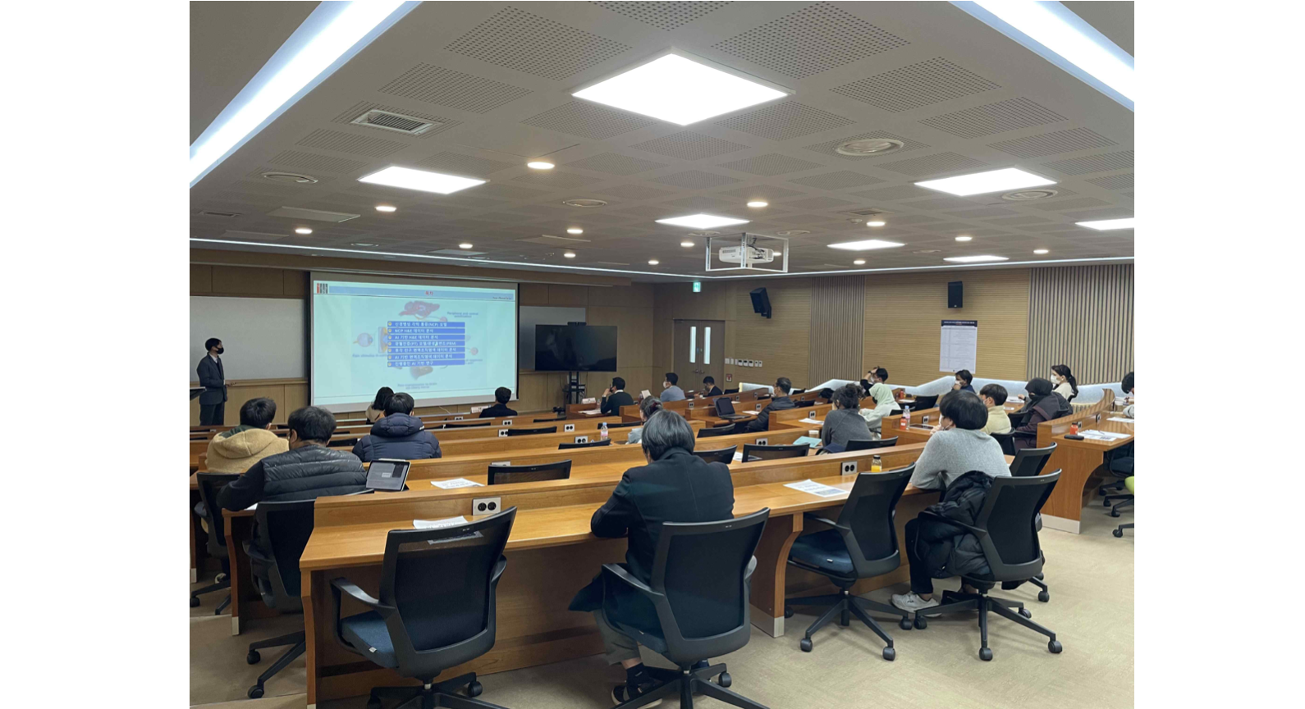▲ GIST is holding a performance presentation after finishing the ‘2022 AI-based Social Problem Solving Convergence Specialists Training Support Project’, which was conducted for new doctoral-level researchers.

President Kiseon Kim said, "Recently, AI technology has been applied to various fields and exerts tremendous synergy. By continuously expanding this support project, based on GIST's excellent resources such as HPC-AI (High Performance Computing) public infrastructure, we are fostering X+AI convergence scientists and engineers who think and explore social issues convergently. We will contribute to enhancing regional and national science and technology competitiveness."



