Professor Jae-Suk Lee's research team develops 'high-molecular antibiotics' to overcome antibiotic resistance

- Confirmation of antibacterial properties such as Escherichia coli... Expected to be applied to the development of new antibiotics against antibiotic-resistant bacteria
- Selected as the cover paper of 「Ange Bantechemie」


▲ (From left) Professor Jae-Suk Lee, Professor Jiwon Seo, Professor Eunji Lee, Dr. In Gyu Bak

A research team at GIST (Gwangju Institute of Science and Technology, President Kiseon Kim) developed a new polymer material that mimics the structure and function of antibacterial peptides, proteins that fight bacteria in our body.

* antimicrobial peptide: Peptides with an amphiphilic helical structure are representative and destroy microorganisms such as bacteria by crushing the phospholipid membrane.

The results of this research are expected to serve as an important foundation for follow-up research to develop new antibiotics against antibiotic-resistant bacteria through artificial polymer synthesis.

The development of antibiotics such as penicillin has contributed greatly to mankind overcoming various diseases and increasing life expectancy. However, as bacteria become more resistant to antibiotics as they are exposed to them, efforts to find new antibiotics are ongoing.

Since artificial polymers that are not synthesized naturally are very unfamiliar to bacteria, it is difficult for bacteria to acquire resistance. Even if resistance is acquired, it is possible to avoid the acquired resistance by bacteria by artificially adjusting the structure of the polymer. For this reason, attempts to make new antibiotics with artificial polymers have continued.

The research team led by School of Materials Science and Engineering Professor Jae-Suk Lee developed a new artificial polymer material that mimics an antibacterial peptide from 'polyisocyanate', a polymer with an amide structure similar to natural peptides, and confirmed the antibacterial properties of this material.

Polyisocyanate is a rod-shaped polymer with a helical structure, which is environmentally friendly due to its high degradability and attracts attention as a physiologically active material that is harmless to the human body due to its molecular structure similar to that of peptides.

The ‘alternating sequence* polyisocyanate’ copolymer that the research team successfully synthesized has a structure very similar to natural antibacterial peptides, so it can destroy the phospholipid bilayer that makes up the surface of bacteria. The research team confirmed the antibacterial properties of this material through an antibacterial test targeting Staphylococcus aureus and Escherichia coli.

* alternating sequence: two monomers A and B are arranged alternately, in the form of ABABABAB...

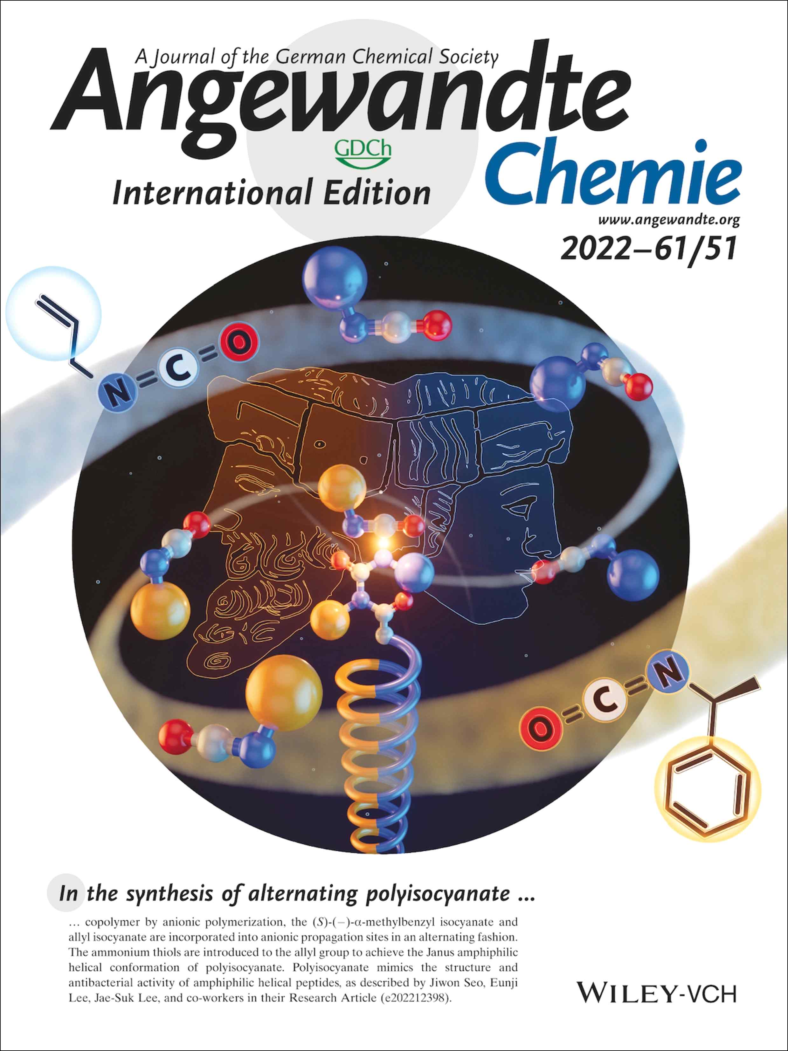
▲ Angewante Chemie International Ed. Selected as a cover paper in the 61st edition, issue 51

There have been many studies on the principle of action of antibacterial peptides in the human body, but antibiotics clinical trials have failed every time because proteolytic enzymes in the human body immediately decompose antimicrobial peptides. Polyisocyanates are not expected to be readily degraded by proteolytic enzymes because they do not have the same molecular structure as proteins.

Professor Jae-Suk Lee said, "We are trying to synthesize an antibiotic substance, an artificial polymer that is similar in function to existing antibiotics but difficult to attack from proteolytic enzymes. This study is significant in that it can solve the problem of antibiotic resistance with a polymer-based material and increase the antibacterial effect of polyisocyanate through optimization of molecular structure."

This research was led by GIST Professor Jae-Suk Lee (corresponding author) and conducted by GIST Dr. In Gyu Bak, Dr. Chang-Guen Chae, researcher Jieun Choi, and doctoral student Woo-Young Song with joint research by GIST School of Materials Science and Engineering Professor Eunji Lee (corresponding author) and Department of Chemistry Professor Jiwon Seo (corresponding author) with the support of the National Research Foundation of Korea's personal basic research project and the GIST project and published online on December 12, 2022 (Monday) in ‘Angewante Chemie International Ed.’, a renowned academic journal of the German Chemical Society and was selected as the cover paper.



