Preparing for the open space era, finding the secret of life aging in microgravity!

- Symposium held on ‘Integrative Research Cluster for Space Biomedical Sciences’ organized by GIST
- Professor Makoto Kuro-o, an authority on aging research, is invited to share research data and know-how with domestic researchers

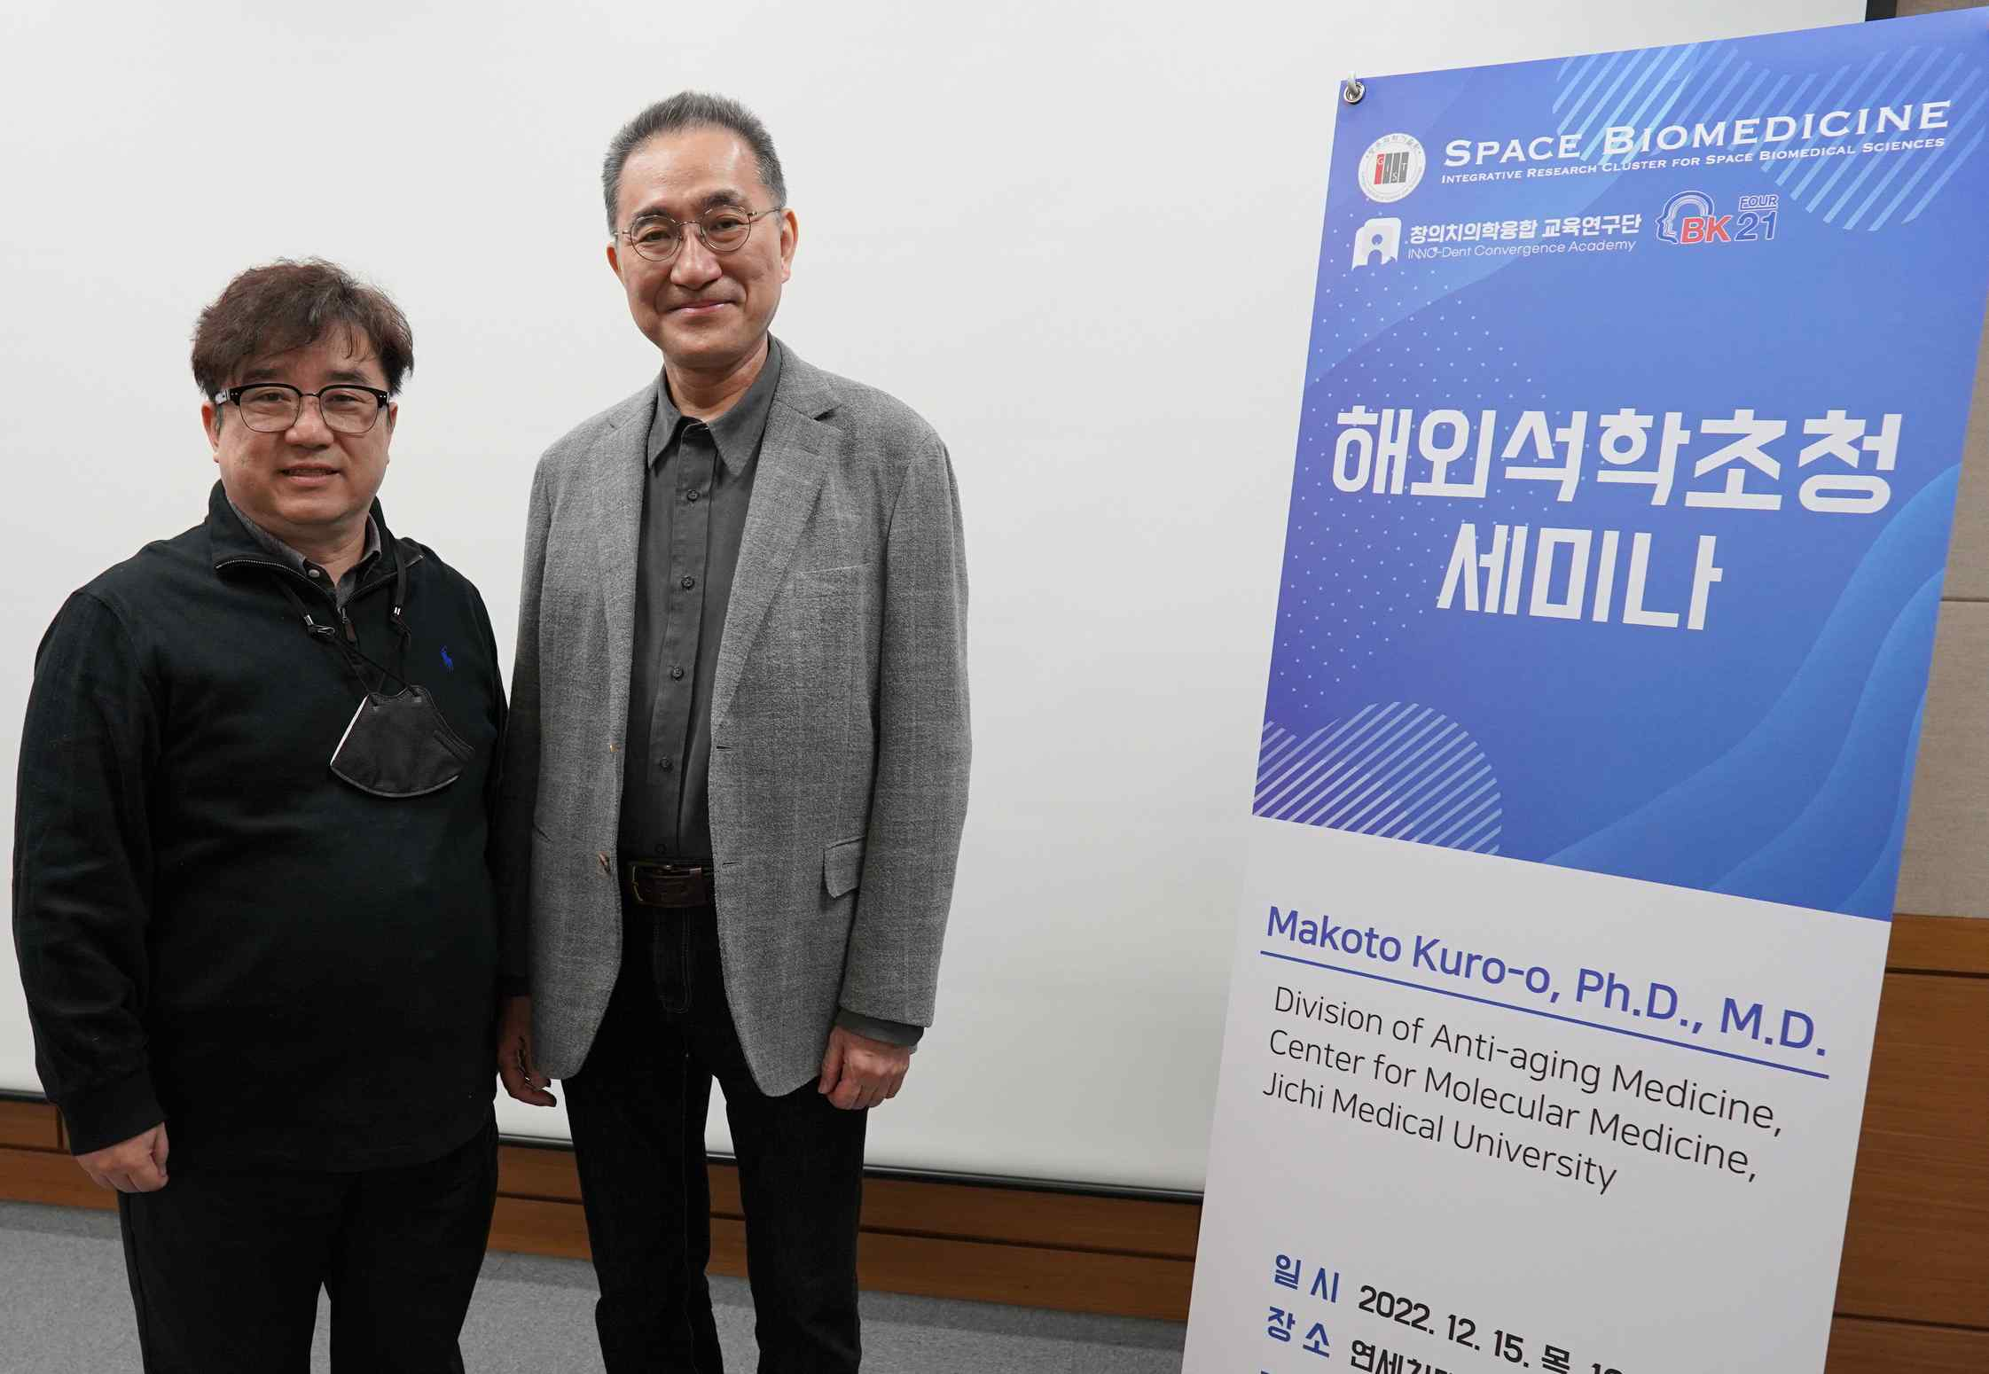
▲ Professor Steve K. Cho (left) and Professor Makoto Kuro-o (right). The two first met in 1998 as graduate students (3rd year) and assistant professors (1st year) at Southwestern University Medical School, and they have continued to collaborate in research.

GIST (Gwangju Institute of Science and Technology, President Kiseon Kim) invited world-renowned experts in aging research to hold a symposium on the theme of ‘Space Biomedicine and Aging’.

GIST School of Life Sciences Professor Steve K. Cho is the Research Director of the ‘Integrative Research Cluster for Space Biomedical Sciences,’ which held a symposium on December 15-16 (Thursday-Friday) by inviting Professor Makoto Kuro-o, Director of Anti-Growth Research Center, Jichi Medical University, Japan, to speak at the Yonsei University School of Dentistry Seo Byung-in Hall and Inha University Medical School Auditorium.

Professor I would like to thank Professor Kuroo for sharing up-to-date information, including experimental data currently being conducted on the International Space Station, and many years of space medicine research experience with domestic researchers.

Korea, which jumped into the space age in earnest with the successful launch of the Nuri and Danuri in 2022, is now deeply concerned about the use of launch vehicles and is in the field of 'space biomedical science research' to respond to exposure to the space environment (microgravity and cosmic radiation) should take an active interest in and invest in.first discovered a gene called 'Klotho' in 1997 and published a paper in 「Nature」 that revealed that this gene is involved in aging. He is a world-renowned authority in the field of aging research who re-reported the thesis that revealed the aging suppression principle of clotho hormone in 「Science」 in 2005 and 「Nature」 in 2018.

Through research results, Professor Kuro-o's research team revealed that the concentration of phosphoric acid and CPP (Calciprotein Particles) in cells and blood along with Klotho hormone are deeply involved in the aging process, especially vascular aging. He argued that reducing the amount of phosphoric acid, which is absorbed in large amounts by the human body due to additives in processed foods familiar to modern people, slows down the aging process and is very important for maintaining health.

Based on these achievements, Professor Kuro-o served as a professor at Southwestern University Medical School in the United States for 15 years from 1998 and then returned to his native Japan as a professor at Jichi Medical University in 2013 to continue his research. He is currently conducting aging-related research on a new platform called ‘space medicine’.

Professor Kuro-o is currently working on the NASA Human Research Program (HRP) and the Japan Aerospace Exploration Agency (JAXA) aging research project. (ISS) Comparative experiments are underway at the same time in the laboratory and on the ground.

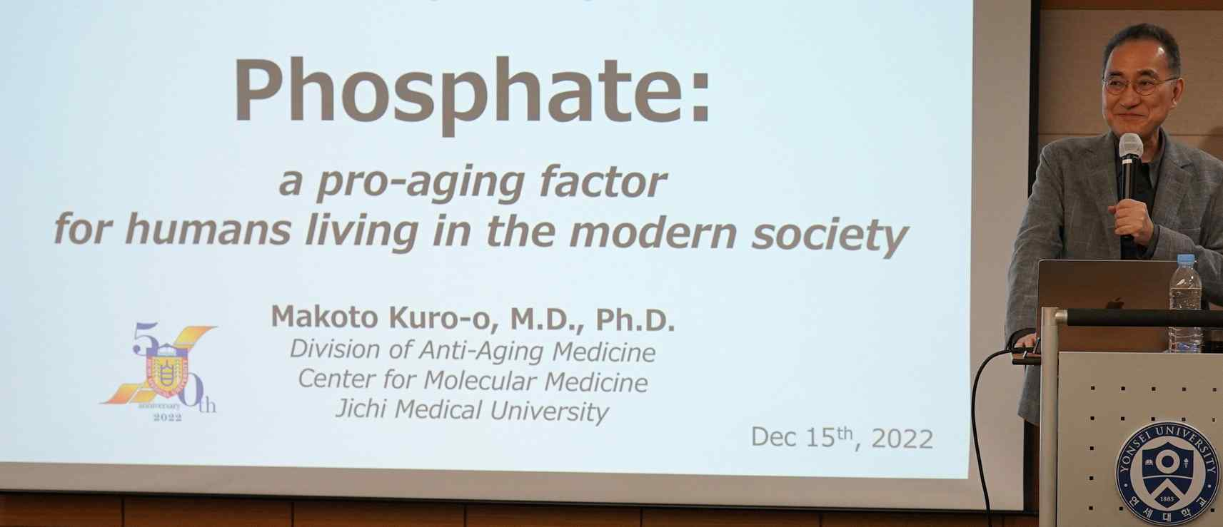
▲ Professor Makoto Kuro-o is giving a keynote speech at the symposium.

GIST Professor Steve K. Cho and his teacher Kuro-o shared valuable data and experiences with Korean researchers who took the first step in the field of life science in space, confirming the possibility of a new international joint study between Korea and Japan.

GIST Professor Steve K. Cho said, "I would like to thank Professor Kuro-o for sharing up-to-date information, including experimental data currently being conducted on the International Space Station, and many years of space medicine research experience with domestic researchers. Korea, which jumped into the space age in earnest with the successful launch of the Nuri and Danuri in 2022, is now deeply concerned about the use of launch vehicles and is in the field of 'space biomedical science research' to respond to exposure to the space environment (microgravity and cosmic radiation) should take an active interest in and invest in."

Professor Cho's research team will be participating in the NASA Human Research Program (HRP) in Galveston, Texas, USA on February 7-9, 2023, and plans to participate in the ‘2023 NASA HRP-IWS (Investigators’ Workshop)’ held by the host.

The '2022 Multidisciplinary Convergence Cluster Project' supported by the National Science and Technology Research Council (Chairman Bok-cheol Kim), 'Integrative Research Cluster for Space Biomedical Sciences' research item discovery and task planning for convergence research in response to the space environment and are developing a basic technology platform to respond to microgravity and space radiation exposure in the manned space age by establishing a domestic space biomedical R&D community network and international cooperation network.

Progress is being made in the way of multidisciplinary convergence research on diseases with researchers from 20 domestic and foreign universities and companies are participating, including the Korea Atomic Energy Research Institute Proton Science Research Center (KMAC), Korea Research Institute of Chemical Technology (KRICT), Korea Research Institute of Bioscience and Biotechnology (KRIBB), Daegu Gyeongbuk Institute of Science and Technology (DGIST) and Inha University College of Medicine Aerospace Medical Research Center (Director: Kyu-Sung Kim), Yonsei University Medical School, Yonsei University Dental School, Sungkyunkwan University Medical School, Ulsan University Asan Medical Center, Yonsei University Wonju University, Gachon Medical University, Southwestern Medical University, Houston McGovern Medical University , Japan Chichi Medical University, Celtroy Co., Ltd., Carnaphtherapeutics Co., Ltd., Humap Co., Ltd., Meritz Co., etc.



