'Open GIST' communicating with the local community! GIST 「Oryong Art Hall」 Open to local residents

- Creation of an art gallery using the inner walls of the 1st and 2nd floors of the existing Oryong Hall... Free entry and viewing for anyone
- Exhibiting the works of Western painter Hyukjeong Kim as the 1st invitational exhibition... Opening ceremony held on the 21st (Wednesday)

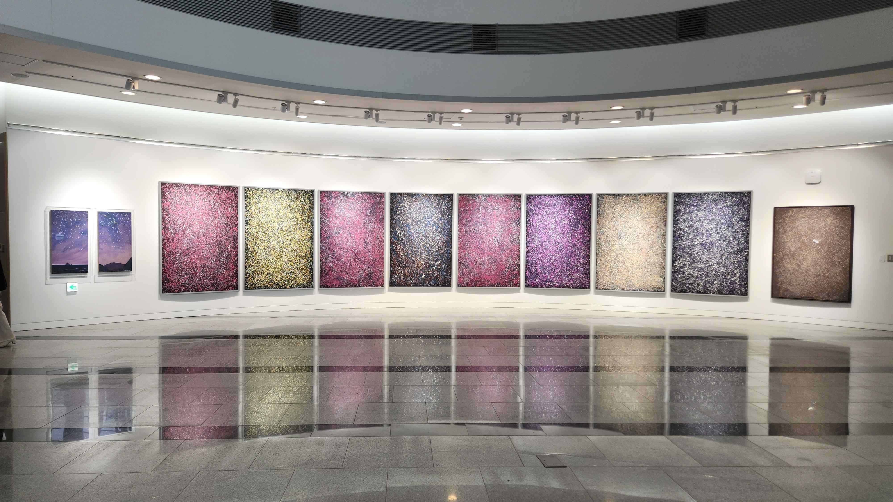
▲ The appearance of Oryong Art Hall, newly renovated with Hyukjeong Kim's Universe - The Time of the Stars series

GIST (Gwangju Institute of Science and Technology, President Kiseon Kim), which is striving to communicate with the local community and become an open and fair university, newly created 「Oryong Art Hall」 in the existing Oryong Hall, which consists of an auditorium and lecture halls. It is fully open as an open space where local residents can enjoy cultural life.

GIST is scheduled to hold the opening ceremony of 「Oryong Art Hall」 on December 21st (Wed) at 5:00 PM. As the 1st invitational exhibition, artist Hyukjeong Kim, a Western-style painter representing the region, will be invited to present <Rise as an island and bloom as a flower>. The first exhibition under the title will be held until January 31 next year.

Located near the main entrance of the GIST campus, Oryong Hall is a multi-purpose building that can accommodate up to 1,000 people. Entrance ceremonies, graduation ceremonies, establishment ceremonies, and various academic events and lectures have been held there.

GIST has been devising a new operating strategy for Oryong Hall since the beginning of this year to strengthen exchanges and networking with the local community by opening Ohryonggwan to local residents as well as members. We have been preparing the creation of 「Oryong Art Hall」 in order to recreate Oryong Hall as an open cultural space for everyone with local residents and a ‘big gate’ for future vision projects that connect the region and the whole country.

「Oryong Art Hall」 was created in the form of an art gallery using the inner walls of the 1st and 2nd floors of Oryong Hall. From 9:00 am to 6:00 pm on weekdays and weekends, it was created as a space where anyone can enter Oryong-gwan and enjoy the various art works displayed on the first and second floors without restrictions.

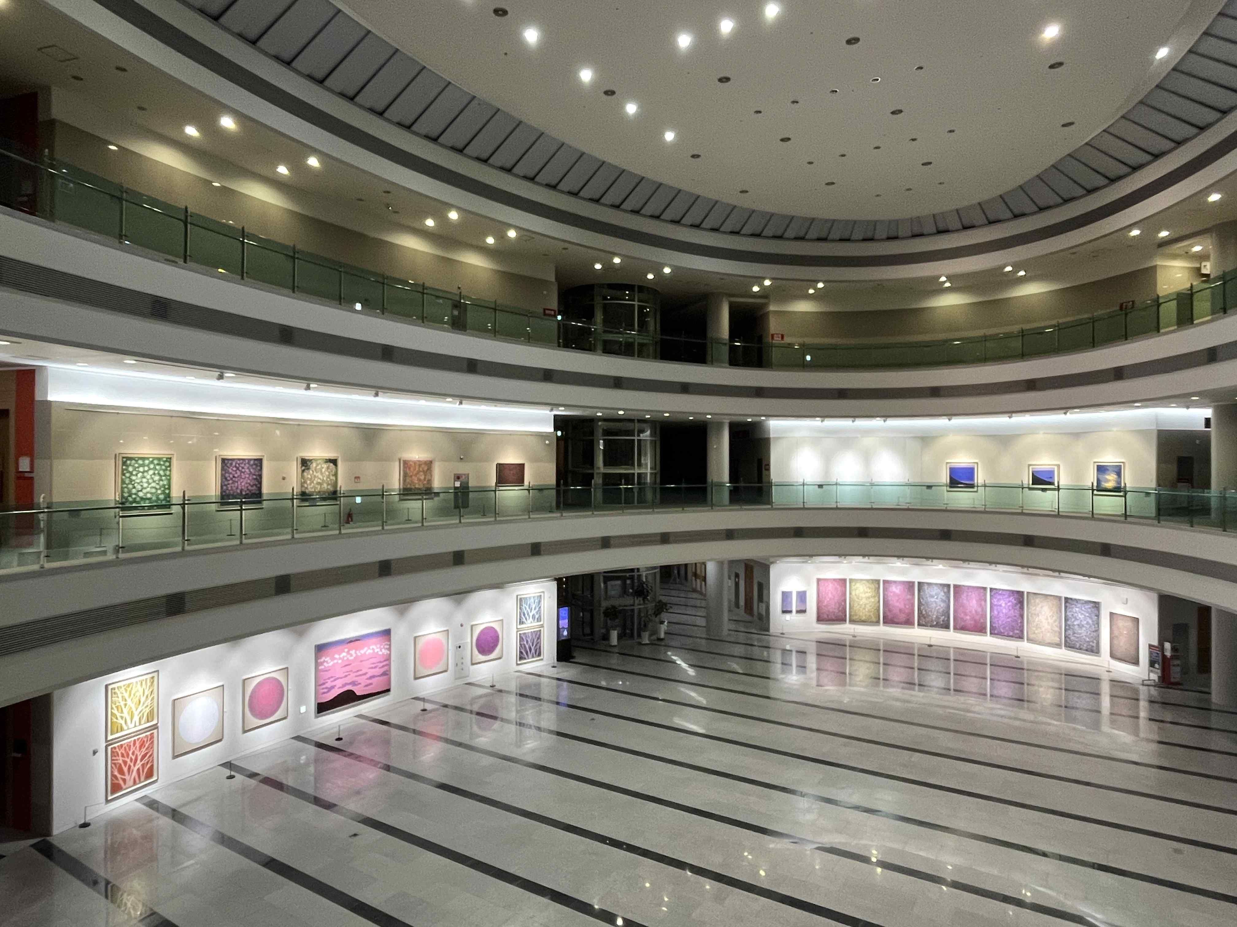
▲ The Oryong Art Hall where the 1st invitational exhibition ‘Rise as an island and bloom as a flower’ is being held

Artist Hyukjeong Kim, the main character of the 1st Invitational Exhibition of 「Oryong Art Hall」, graduated from the Department of Art Education at Chonnam National University and completed a doctoral course at the Sorbonne in France. He is a local artist who held an invitational exhibition in Ludwigsburg, Germany, exhibited his work before the Paris Salon, and participated in the Art Fair at the Seoul Arts Center.

In this invitational exhibition by Hyukjeong Kim, 41 works that reinterpret nature and life as the artist's own image will be displayed.

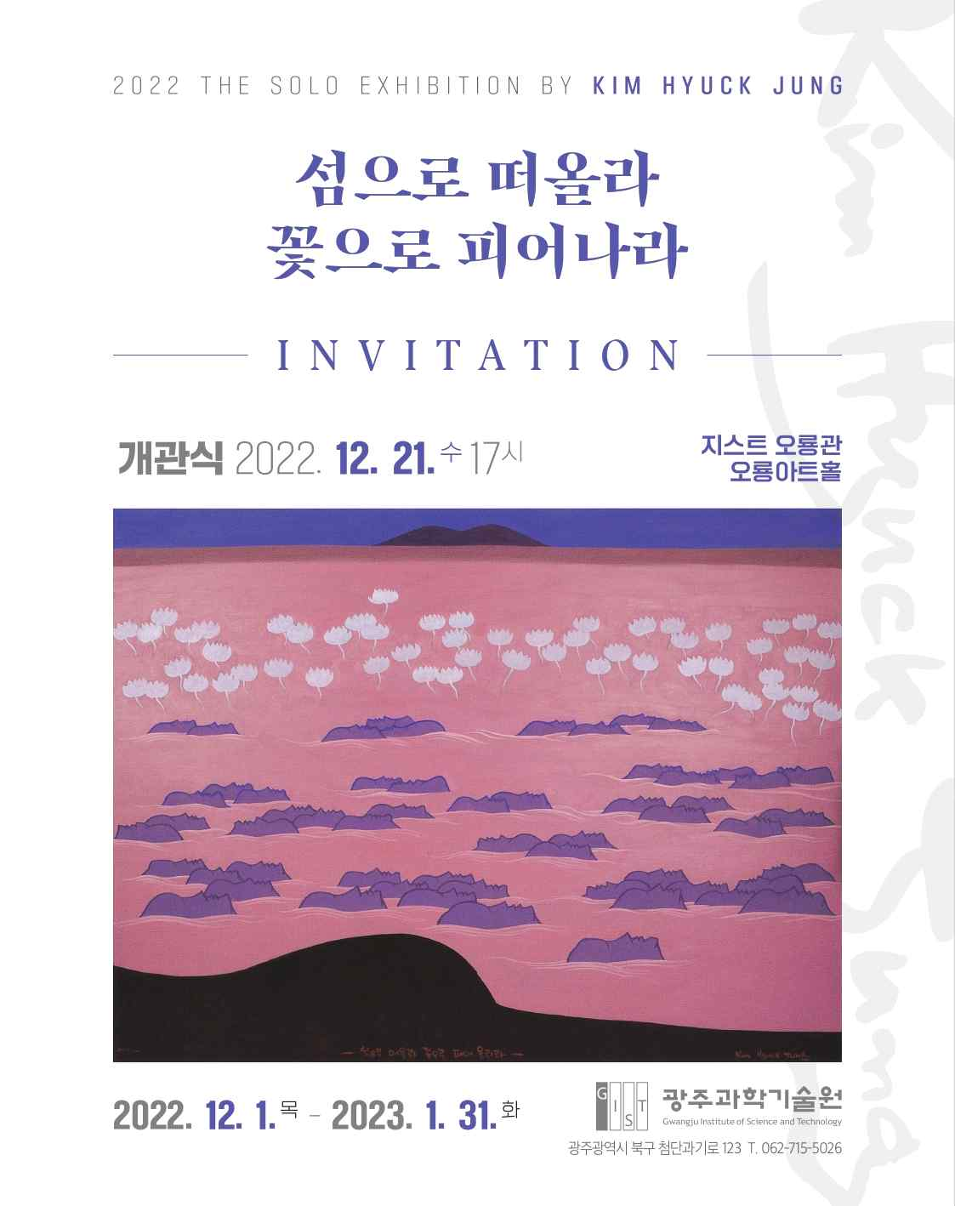
▲ ‘Rise as an island and bloom as a flower’ GIST Ohryong Art Hall Hyukjeong Kim invitational letter

In the future, 「Oryong Art Hall」 will be used as a space to promote local artists to the public and provide exhibition opportunities to young and new artists. The second invitational exhibition is scheduled for <BON VOYAGE> by Soonim Choi.

International and Public Affairs Dean Chang-Duk Jun said, "It is hoped that the Oryong Art Hall will further enhance the Oryong Hall as a space for knowledge and academic exchange and a space for cultural enjoyment. In addition, it is hoped that Oryong Art Hall can serve as a channel through which science technology and science culture as well as GIST can be naturally promoted and spread."

President Kiseon Kim said, "As a reward for the local community that has supported GIST for the past 30 years, the opening of the Oryong Art Hall aims to communicate with the local community and become a more open-minded GIST. As a cultural space that brings GIST closer to the locals, I hope Oryong Art Hall will become a place loved by many people."



