GIST participates in <2022 Korea Science and Technology Fair> and exhibits outstanding achievements such as AI composition and XR contents

– The largest science and technology achievement exhibition in Korea... 2 booths set up at KINTEX in Ilsan from December 15 to 17

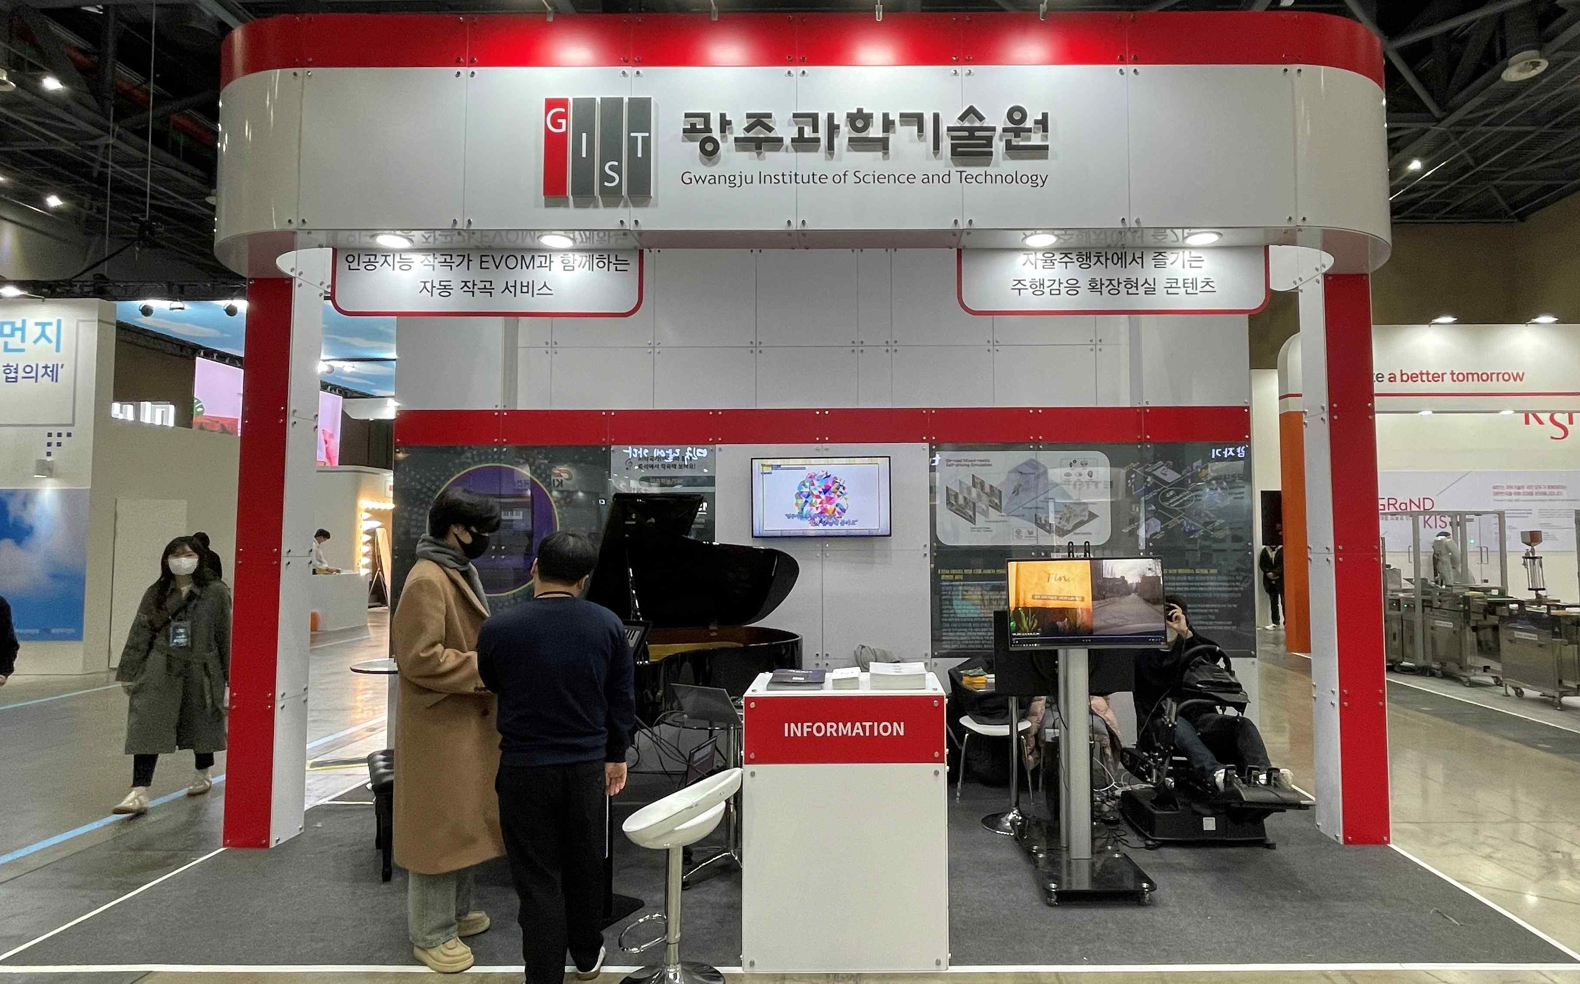
▲ A view of the GIST booth participating in <2022 Korea Science and Technology Fair>

GIST (Gwangju Institute of Science and Technology, President Kiseon Kim) participated in <2022 Korea Science and Technology Exhibition>, an event to share the achievements of Korea's science and technology and current R&D achievements with the public and to present outstanding achievements in the field of artificial intelligence.

The 2022 Korea Science and Technology Exhibition, hosted by the Ministry of Science and ICT and co-hosted by the National Research Foundation of Korea and the National Science and Technology Research Council, will be held from December 15th (Thu) to 17th under the theme of 'Science and Technology, Answering the Future'. It will be held at KINTEX (Exhibition Hall 1) in Ilsan until (Sat).

In Hall 1 of Exhibition Hall 1, GIST prepared a booth to introduce and prepare exhibits for visitors to experience ▲ instant automatic composition and piano performance with AI composer ‘EvoM’ (AI Graduate School Professor ChangWook Ahn) ▲ driving-sensitive XR contents enjoyed in autonomous vehicles (School of Integrated Technology Professor SeungJun Kim).

In the ‘Immediate composition and piano performance’ booth, AI composer ‘EvoM’ detects the face of the audience and analyzes the current emotion. You can compose a song with an atmosphere that matches the analyzed emotion and experience the automatic performance of the corresponding music on the actual piano.

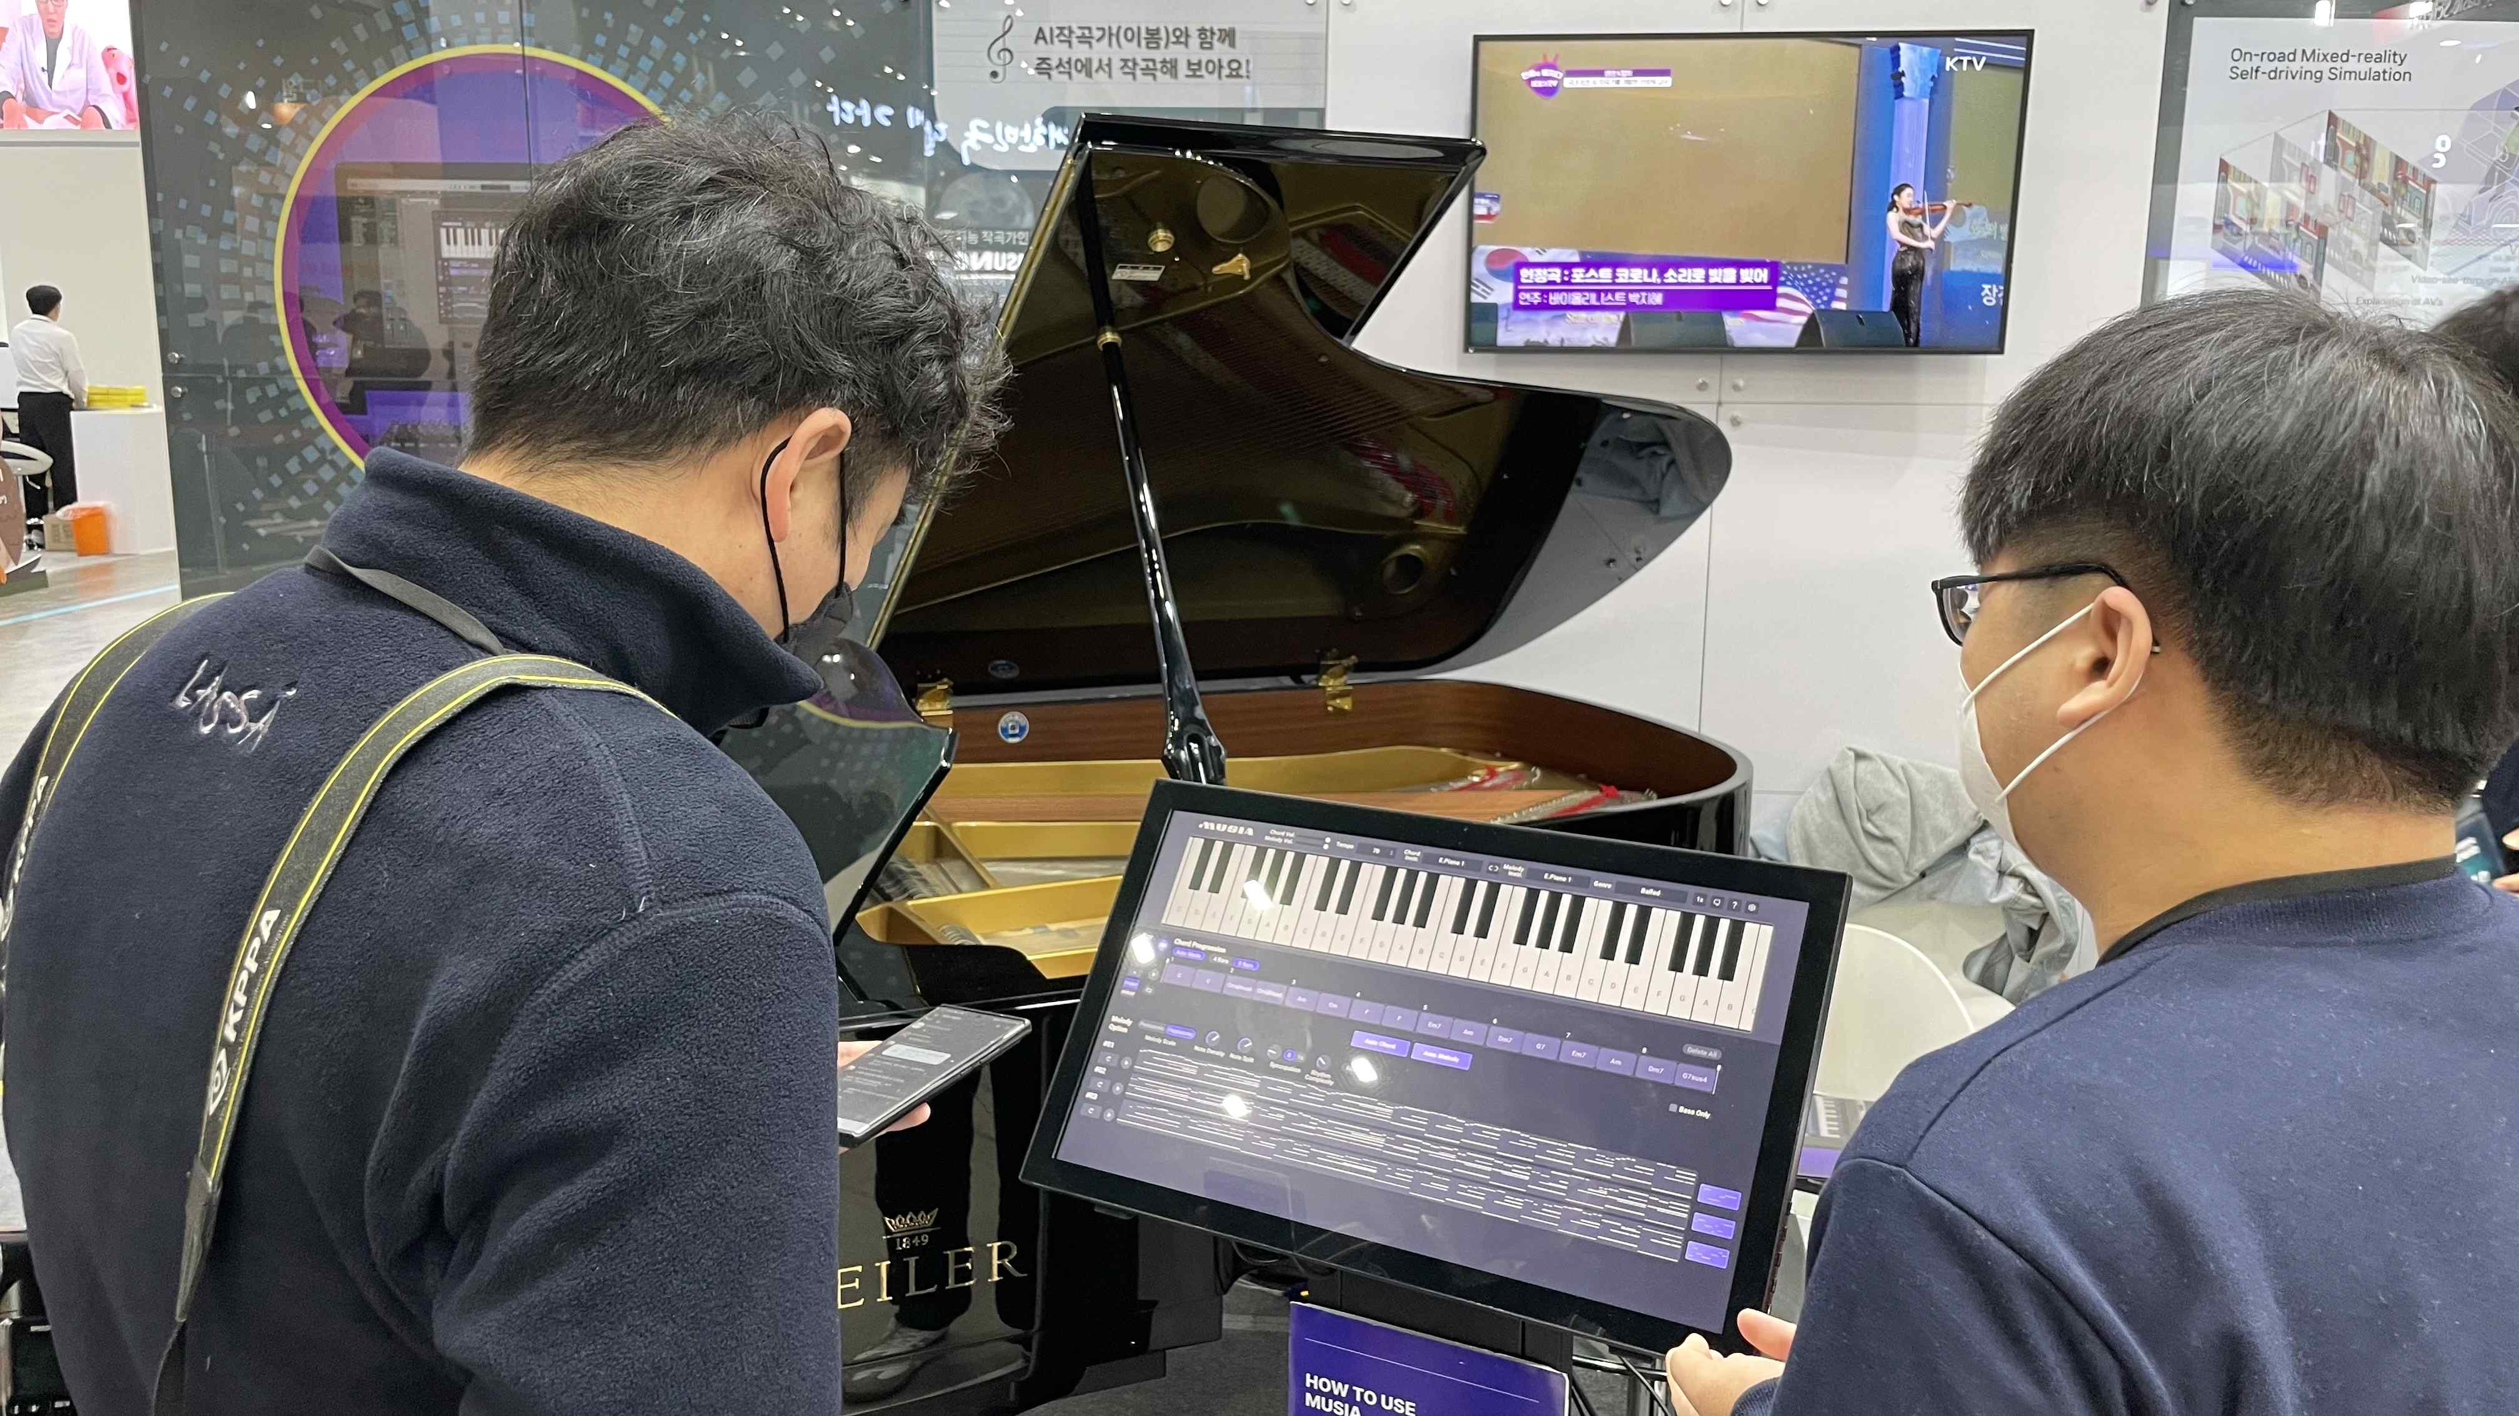
▲ At the <2022 Korea Science and Technology Exhibition>, visitors to the GIST booth are experiencing instant automatic composition and piano performance (AI Graduate School Professor ChangWook Ahn) with AI composer ‘EvoM’.

At the ‘Driving Sensitive XR Contents Enjoyed in Self-Driving Vehicles’ booth, you can experience extended reality game contents that are created based on terrain information and surrounding object information in driving situations. Vibration and movement in real driving situations can be vividly felt through the VR headset and motion providing platform for providing virtual reality.

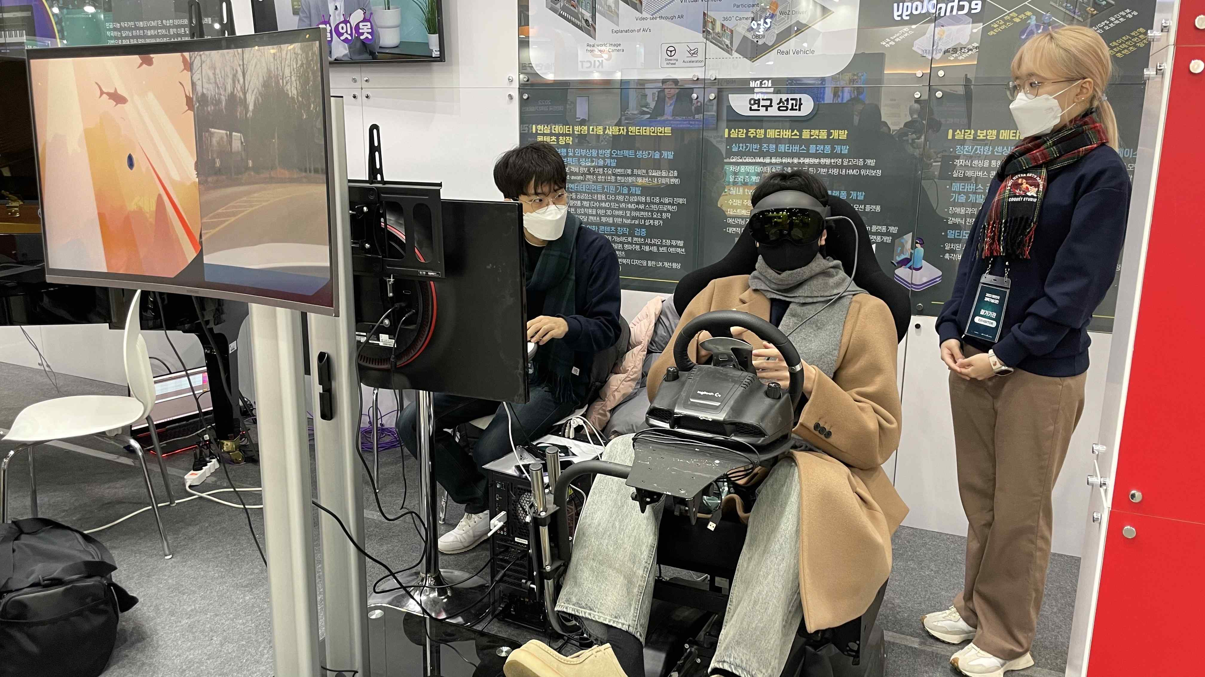
▲ At the <2022 Korea Science and Technology Exhibition>, visitors to the GIST booth are experiencing driving-sensitive XR content (School of Integrated Technology Professor SeungJun Kim) enjoyed in an autonomous vehicle.

President Kiseon Kim said, "It is hoped that <2022 Korea Science and Technology Exhibition> will publicize the importance of research and development in the field of artificial intelligence and fostering experts, along with GIST's excellent research achievements. GIST will continue to contribute to the development of national science and technology by researching innovative technologies to improve the quality of life of the people and fostering future science talents."



