"Certification of the original handicraft? With digital fingerprint and blockchain!" GIST introduces AI-based smart craft technology!

- Participated in the 「2022 Craft Trend Fair」 at COEX, Seoul on the 9th to 11th, showcasing the 4th industrial technology convergence smart craft technology
- Provide opportunities to experience digital fingerprint technology, craft distribution system and auction system

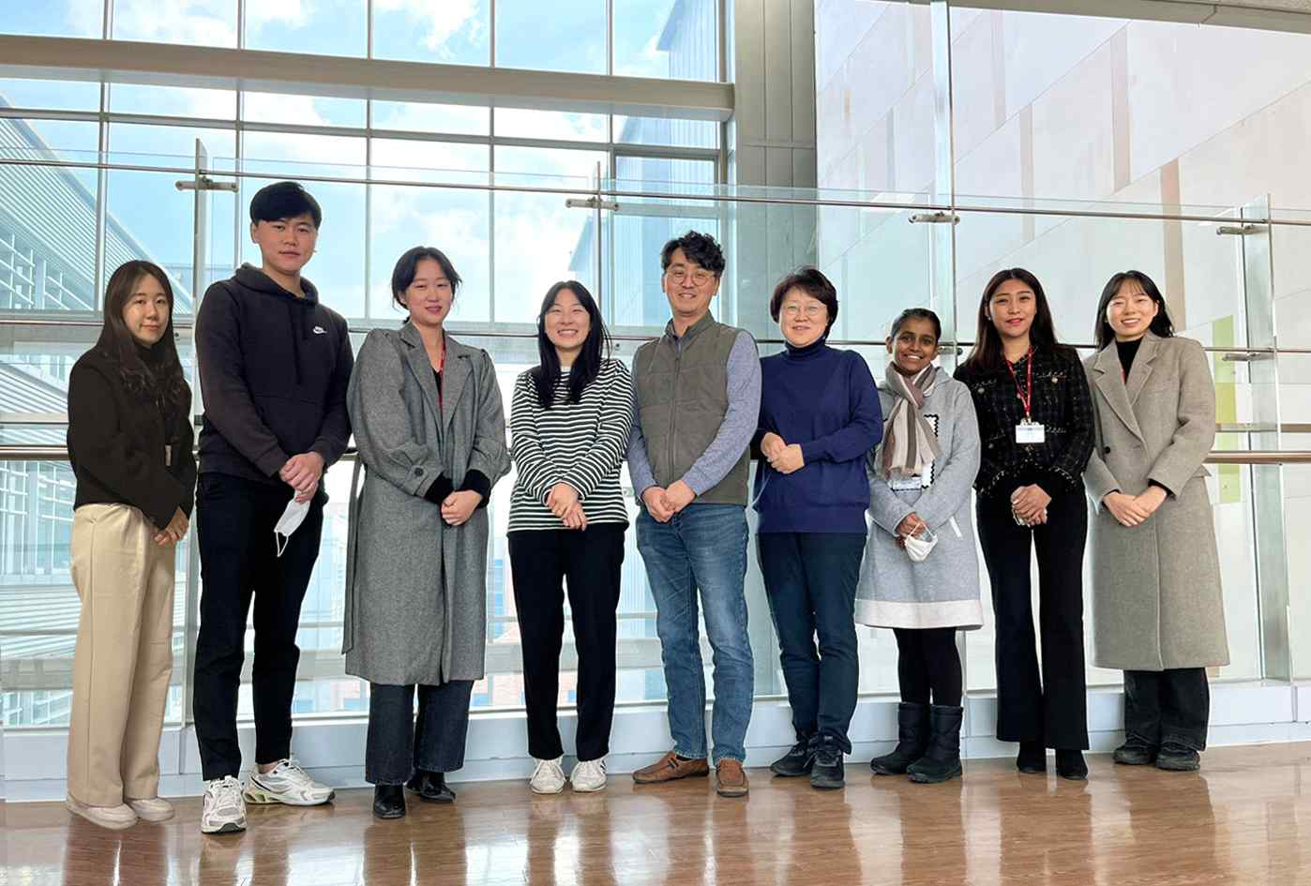
▲ Professor Ji Hyun Yi (sixth from the left) and Professor Jin Hyuk Hong (fifth from the left) research team

A research team from GIST (Gwangju Institute of Science and Technology, President Kiseon Kim) presents a technology to block the distribution of so-called 'counterfeit' crafts by authenticating the original craftwork with digital fingerprints and blockchain at 「2022 Craft Trend Fair」, the largest craft fair in Korea .

The research achievements of GIST introduced in this exhibition are the results of the 3rd year of the ‘Development of Creative Support Technology Based on Authentication and Distribution of Crafts*’ supervised by the Ministry of Culture, Sports and Tourism (Minister Bo-gyun Park) and the Korea Creative Content Agency (Director Hyun-rae Cho). Professor Ji Hyun Yi (CTT Lab, Creative Thinking Technology Lab) and Professor Jin Hyuk Hong (SCI Lab, Soft Computing & Interaction Lab) of the Cultural Technology Program of the School of Integrated Technology at GIST are in charge of research.

* 2020 Cultural Technology R&D Designated Task (2020-2022), R&D Expenditure: KRW 2,200,000,000

The research team built craft big data and held a craft original authentication distribution system that combines smart craft creation support system based on artificial intelligence (AI) technology and blockchain technology for 3 days from December 9th (Friday) at COEX in Seoul. It will be open to the public through 「2022 Craft Trend Fair」.

At the site, people can see an exhibition that visualizes the classification system of crafts according to ceramics, metal, wood, leather, glass, paper, and plants, the method of making shapes in all crafts, and the creative process of decorative techniques. People can experience the intelligent creation recommendation system and craft design generator using AI and craft data.

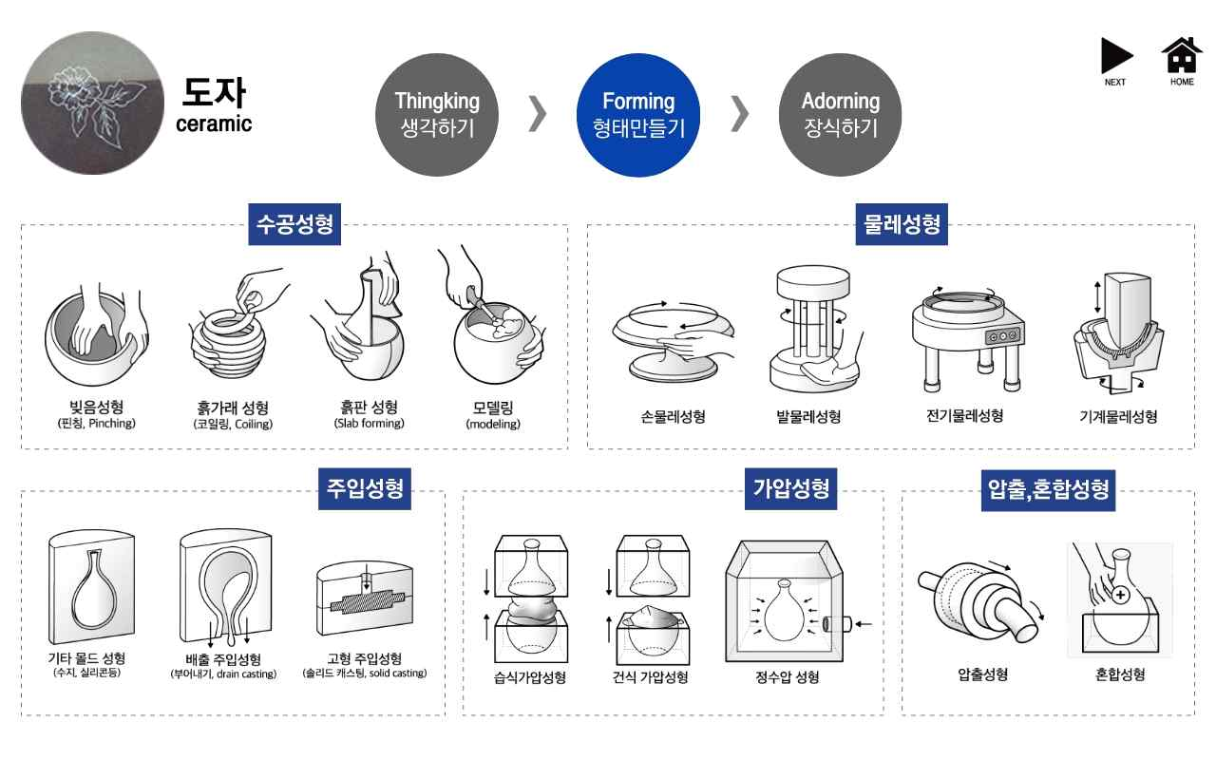
▲ Form making process during visualization of the creative classification system in the field of ceramics

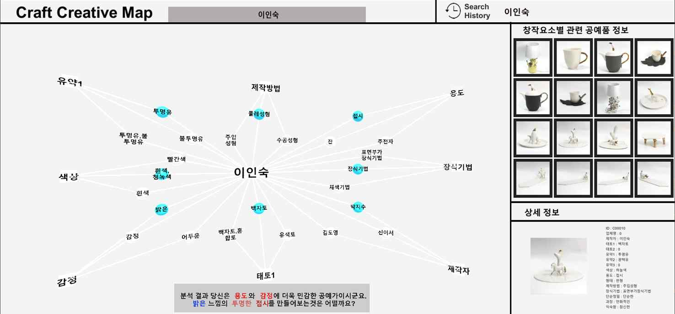
▲ Intelligent creative recommendation system

In addition, M2Cloud Co., Ltd., which is well known for its block chain technology, uses digital fingerprints for crafts based on various craft classification systems to solve the problem of copying domestic crafts. They developed a craft distribution system and an auction system based on technology and block chain so that the audience can experience it directly at the exhibition.

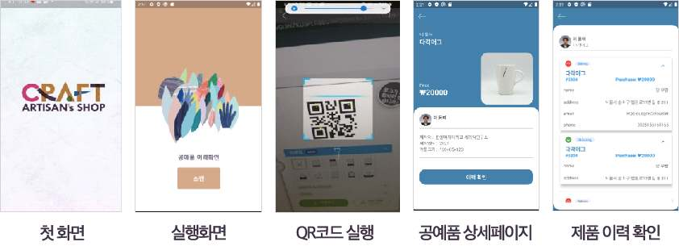
▲ Craft digital fingerprint technology

Professor Ji Hyun Yi's 'Creative Thinking Technology Lab (CTT Lab)' and Professor Jin Hyuk Hong's 'Soft Computing & Interaction Lab (SCI Lab)' research team, as well as Hanyang Women's University Ceramic Design Department, a joint research institute, cultural and artificial intelligence experts, such as Professor Ji Hyun Yi's team, Handong University's Department of Content Convergence Design Professor Eun-Jong Lee's and Jung-Seop's Lee team, and M2Cloud Co., Ltd.'s CEO Jin-Soo Moon, who developed a blockchain-based vaccine management system, have collaborated for various More than 8,000 artifacts to which classification systems of viewpoints were applied were constructed as metadata.

Researchers at M2Cloud Co., Ltd. created unique digital identification information by using the unique characteristics of artifacts extracted from photographs of artifacts. The serial number and mapping assigned to the product and a digital fingerprint unique to the product were created.

Afterwards, by developing a smartphone application (DApp) that can be linked with the blockchain network, it is possible to identify the transaction history and authenticity of the product (NFC tagging, QR code scanning function) by scanning the product serial number. By establishing an e-commerce platform, they developed original craft authentication and distribution services that enable blockchain-linked purchases and auctions.

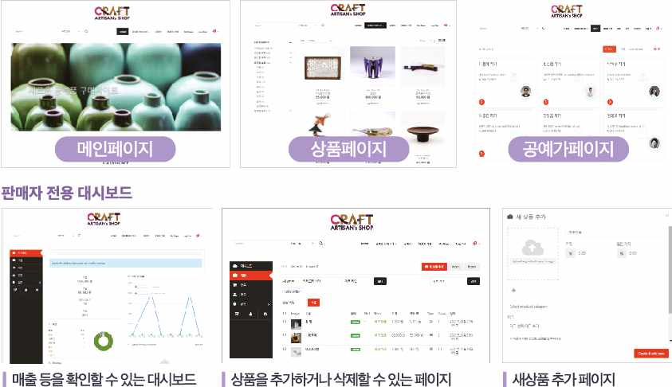
▲ Blockchain-based distribution system

In addition, researchers at Hanyang Women's University and GIST directly photographed the craftworks, collected data, and based on the collected data, expanded to the viewpoint of formative elements such as color, shape, and material, functional viewpoint, and creative process such as form production method and decoration technique. A classification system was systematically established.

Hanyang Women's University built metadata using this classification system, and Professor Jin Hyuk Hong's team developed an intelligent recommendation system that can search for artifacts by analyzing search attributes using AI technology based on craft data and a craft design generator.

Researchers at Handong Global University collected craft experience data and designed a classification system such as overall expression from the user's point of view, formative composition, and surface composition, and a craft search system according to key context.

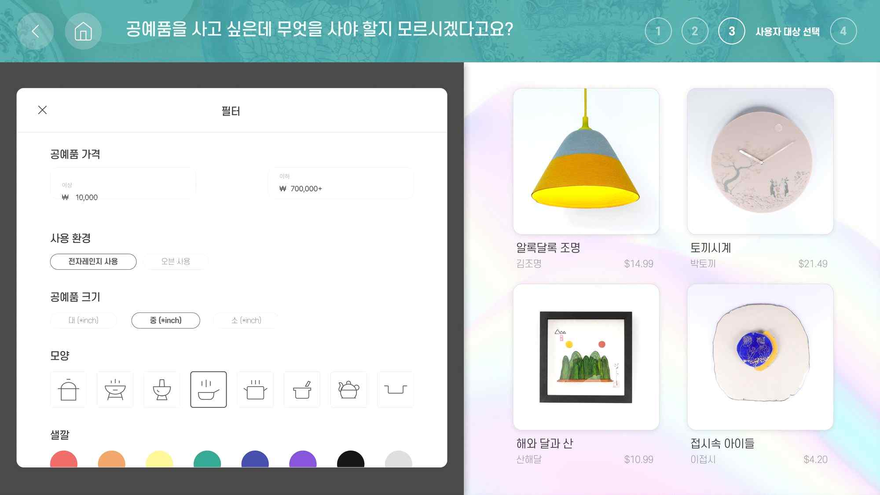
▲ Artifact search system

Professor Ji Hyun Yi, the research director, said, "Following the Craft Trend Fair in 2021, you can expect good results from the convergence of art, culture, and 4th industrial technologies at this exhibition. People can see the systematic classification system and creative process in the craft field visualized in an easy-to-understand way, and they can experience the results of the convergence of craft and AI, and craft and block chain on site."

Meanwhile, 「2022 Craft Trend Fair」, the largest craft festival in Korea, which celebrates its 17th this year, will be held from December 9th (Friday) to 11th at COEX Hall C, Seoul, with the theme of 'Question of reality, answer of craft'. It will be held for 3 days until (Sun).



