GIST CT Research Institute, Gwangju National Museum, demonstrates exhibition commentary service for the hearing impaired

- Demonstration of sign language service in the Asian Ceramics Exhibition Room and the History and Culture Room from December 8 (Thursday) to February next year
- Application of 3D motion correction technology, verification of experience groups for the disabled, etc..."Improving the environment for the enjoyment of cultural life for the disabled"

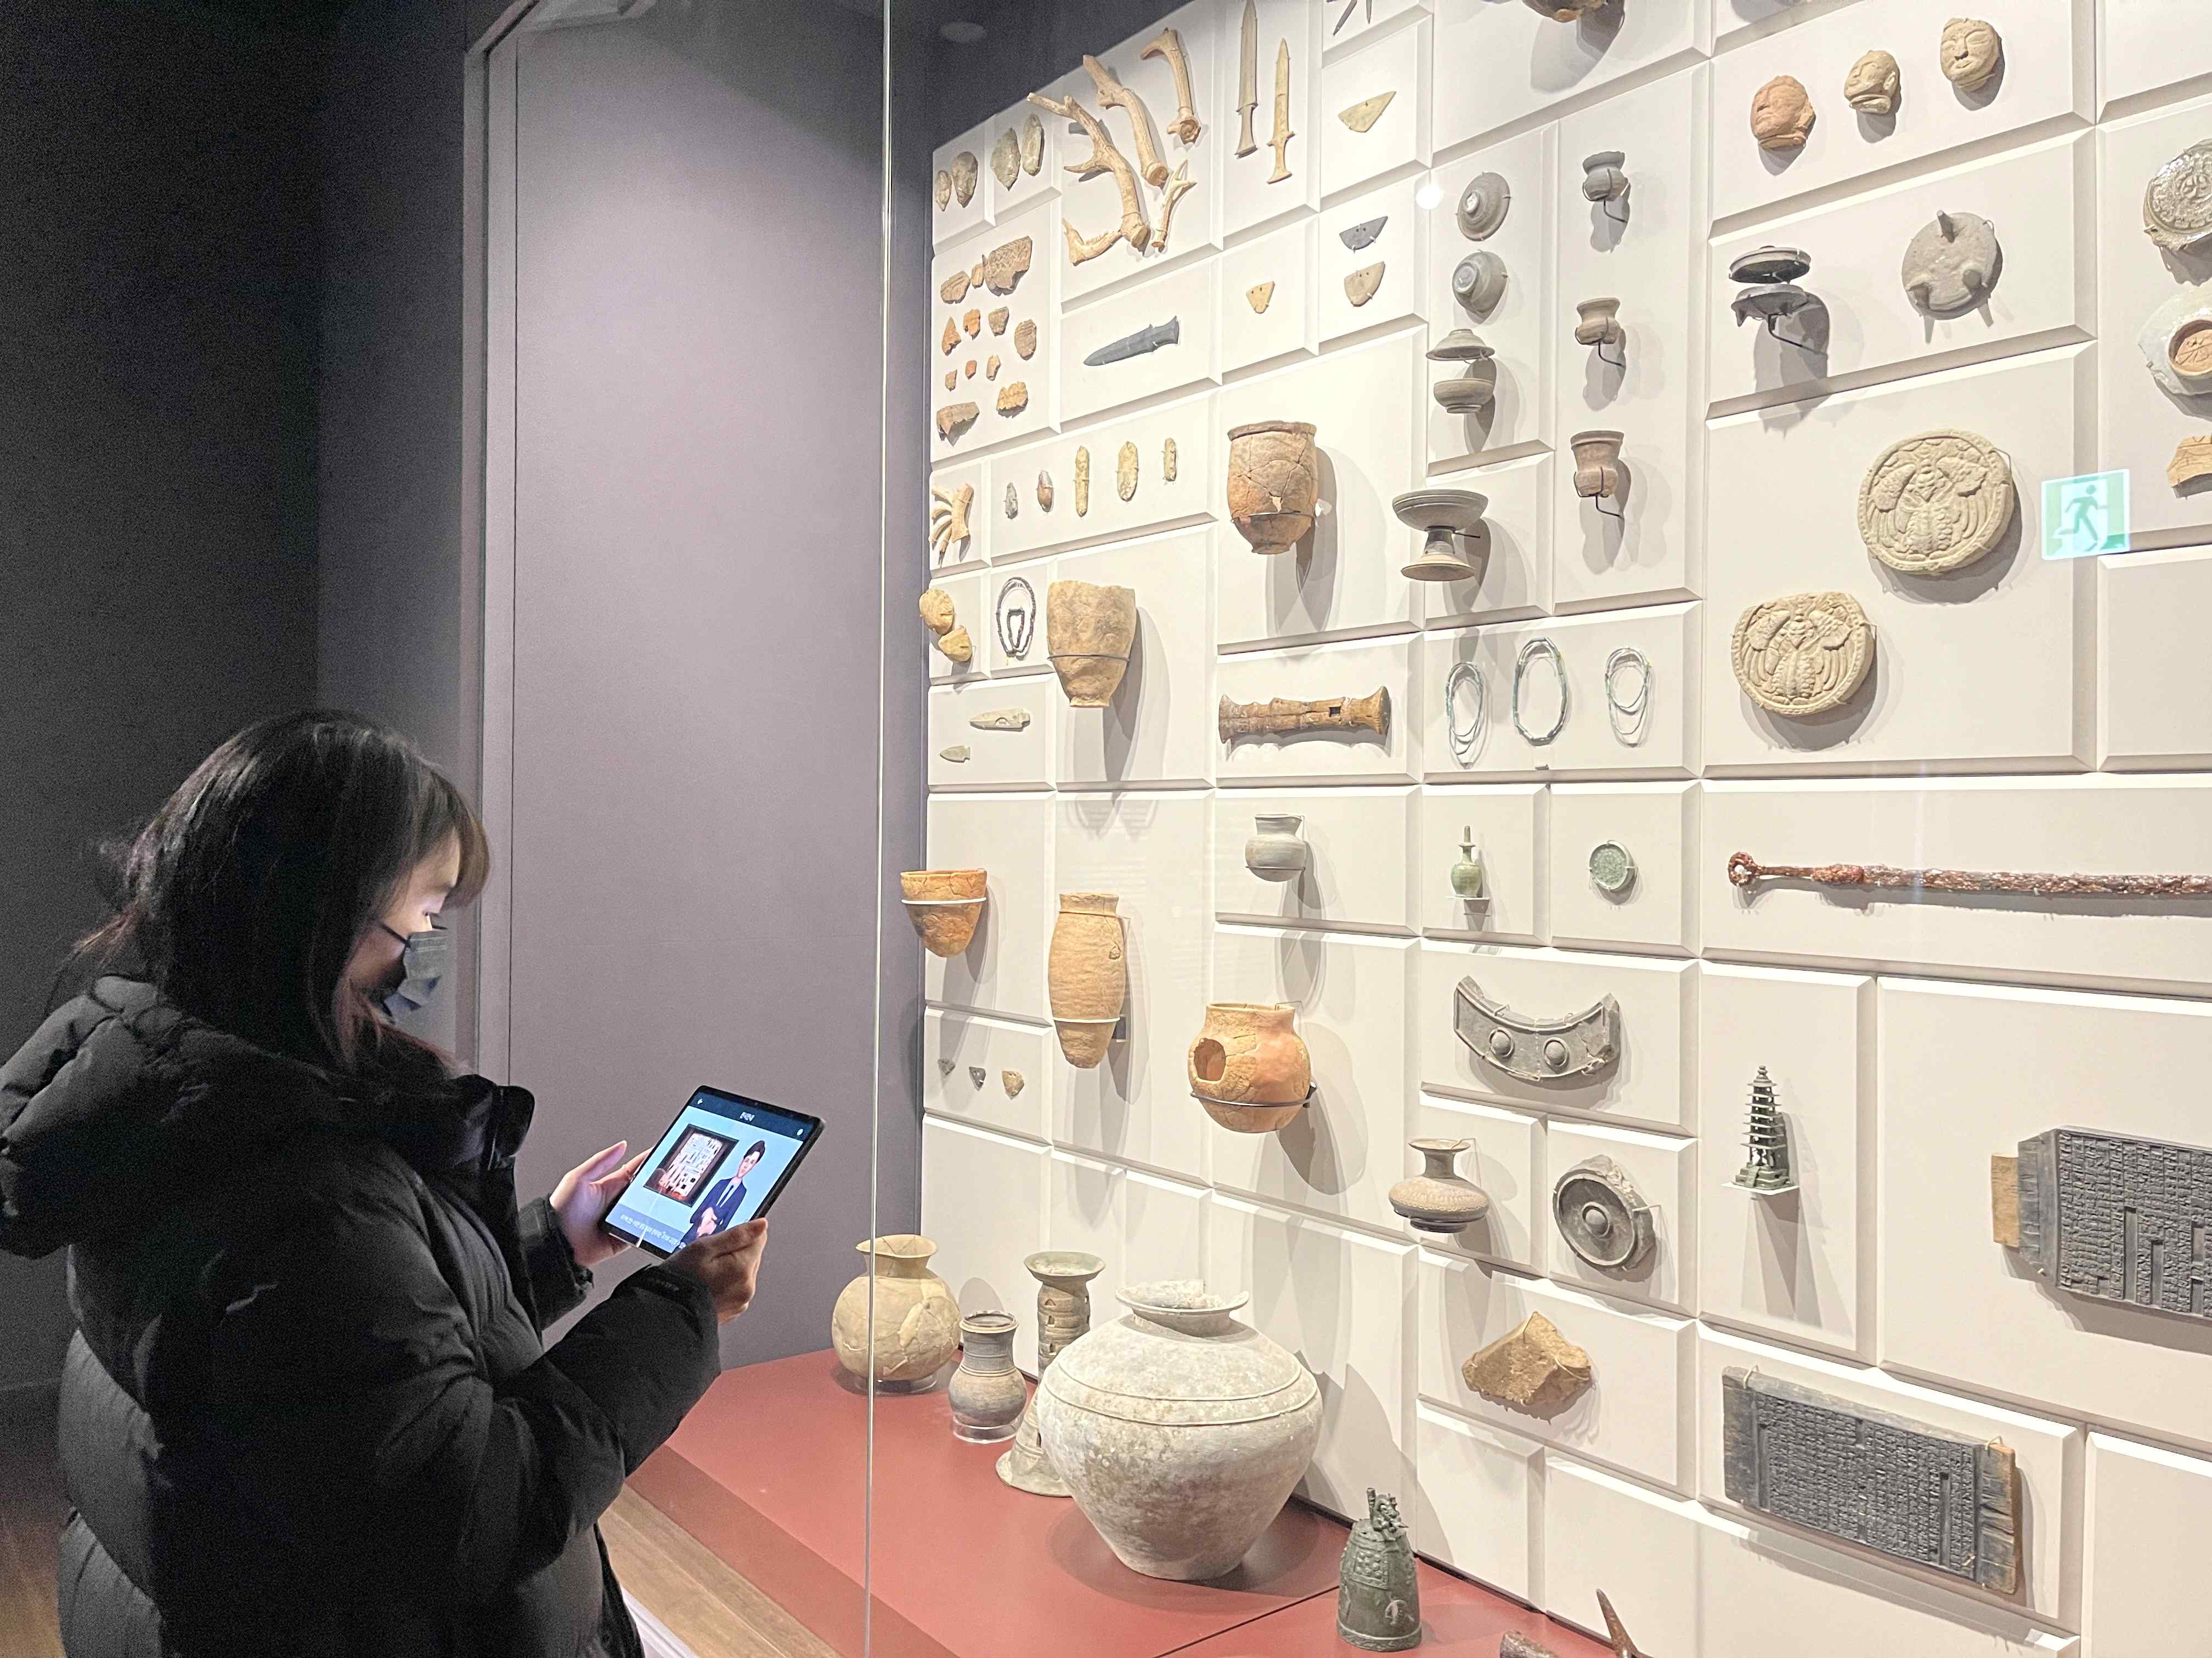
▲ Exhibition commentary sign language translation demonstration service at the Gwangju National Museum: Visitors are watching the avatar's sign language commentary video through a device for experiencing sign language translations while enjoying the exhibit "The Past Is Alive" displayed at the museum.

GIST (Gwangju Institute of Science and Technology, President Kim Ki-seon) Korea Culture Technology Research Institute* (Director Moongu Jeon, hereinafter CT Research Center) will implement service of 'development of intelligent display commentary text/Korean sign language* conversion technology for the hearing impaired' from December 8 (Thursday) to February 28, 2023 (Tuesday) at the Gwangju National Museum (Director Soo-mi Lee).

* sign Language: a language in which hearing-impaired people convey meaning through hand movements
* Korea Research Institute for Culture Technology (KRICT)

This demonstration service, which is carried out by applying the '3D motion correction technology' developed by the CT Research Institute, was as a second proof followed by the first demonstration conducted for some of the artifacts in the 'Asian Ceramics Exhibition Room', a permanent exhibition space on the 1st floor of the Gwangju National Museum last November. This year, not only the first floor of the museum, but also the [History and Culture Room 1] and [History and Culture Room 2] located on the second floor have expanded the exhibition space so that visitors can experience the sign language conversion service of the exhibition commentary.

In addition to the expansion of the exhibition space, the quality of the service has been upgraded so that the hearing-impaired can easily understand difficult museum commentaries through advanced avatar sign language implementation advanced technology.

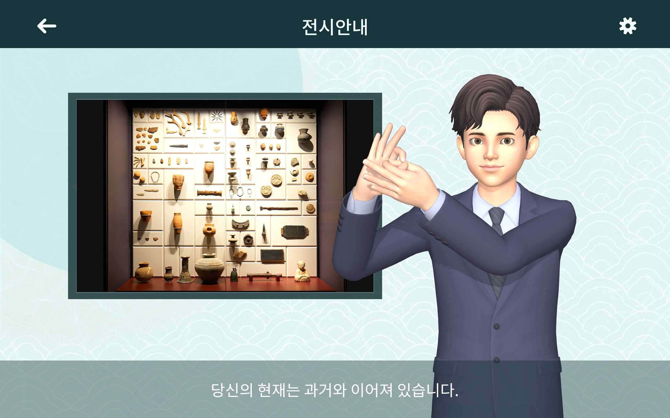
▲ Exhibition commentary sign language translation service device execution screen: The ‘Sign Language Exhibition Commentary Smart Guide’ for the hearing impaired jointly developed by GIST Korea Culture Technology Institute and others delivers the commentary displayed at the Gwangju National Museum in sign language.

In this demonstration, hearing-impaired people visiting the Gwangju National Museum rented a sign language translation experience device and recognized the QR code attached to the exhibition commentary on the device, and the avatar provided a translation service in Korean sign language, allowing the hearing-impaired people to watch sign language commentary videos, making it possible to appreciate the works displayed in the museum without any inconvenience.

In particular, in this demonstration service, through the advanced technology of building a Korean sign language data collection platform and advanced avatar sign language implementation, it implemented a sign language translation service for the hearing impaired, and various relics from prehistoric and ancient times to celadon and white porcelain from the Goryeo and Joseon periods has been prepared so that visitors can experience Asian pottery.

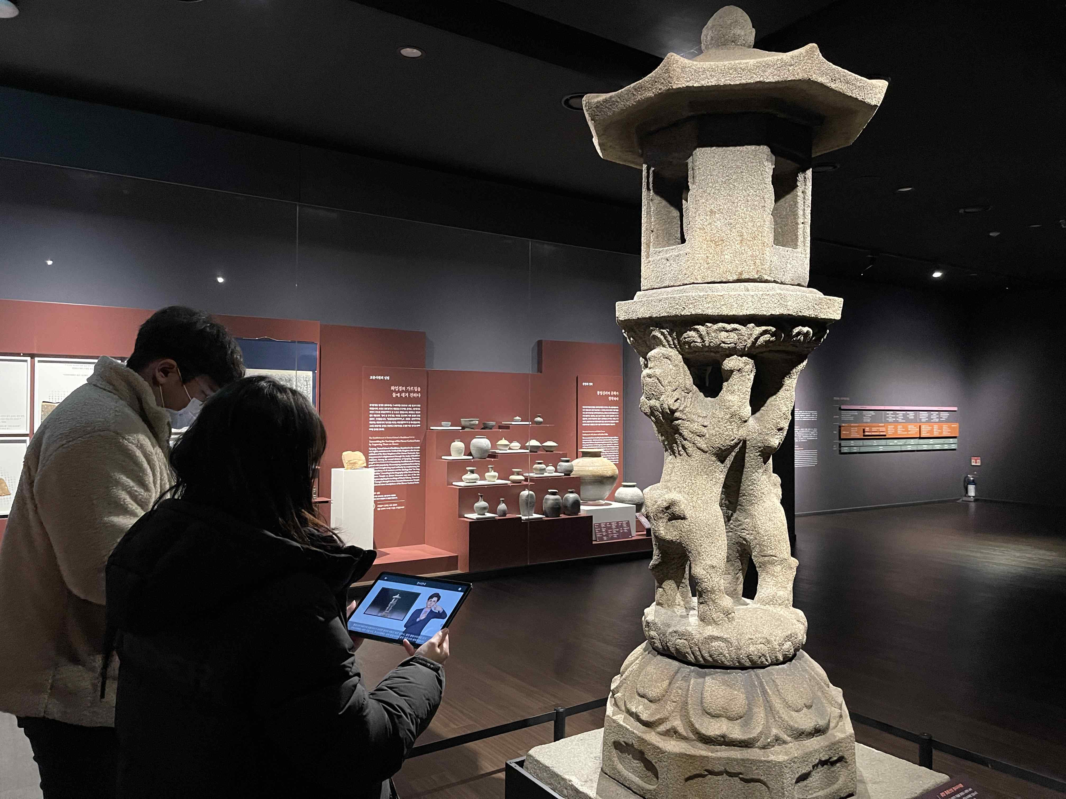
▲ Sign language translation demonstration service of exhibition commentary at the Gwangju National Museum: Visitors are watching the avatar’s sign language commentary video through a device for experiencing sign language translation while enjoying the ‘Gwangyang Jungheung Mountain Fortress Twin Lion Stone Lantern’ exhibit at the museum.

In addition, to verify the excellence of the research results, during this demonstration service period, a hearing-impaired experience group is planned to conduct usability evaluation.

In April 2020, the CT Research Center was selected as the host research institute for the ‘Cultural Technology Research Supervisory Organization Support Policy Designation Task’ supervised by the Ministry of Culture, Sports and Tourism. After being selected, over the past two years, it has been developing technology that converts exhibition commentary and announcements of cultural infrastructure into text and Korean sign language animations.

Previously, last October, at the ‘Paejae Hakdang Museum of History’ located in Jung-gu, Seoul, for one month, barriers to cultural life for the hearing impaired were reduced. In order to realize a low-key and high-quality cultural life, a demonstration service was conducted to translate the commentary in the museum into Korean sign language.

CT Lab has been cooperating with Chonnam National University (President Seong-taek Jeong) and Witches Co., Ltd. (CEO Mia Koh), a joint research institute, and Korea Association of the Deaf Gwangju Metropolitan City Association (President Sang-wan Kim), a consigned research institute, for this technology development. After signing a business agreement with the Gwangju Metropolitan City Welfare Center for the Disabled (Director Mi-ran Kim) in 2020, we have been working hard to implement advanced services based on a practical understanding of sign language through consultations and experts from the sign language interpretation team of the welfare center.

In the reality that there is still a lack of services that convert voice not only into text but also into Korean sign language, the first language of the hearing-impaired. This demonstration service is expected to contribute to the enjoyment of cultural life as well as daily life of the hearing-impaired.

CT Research Center Director Moongu Jeon said, "The purpose of this demonstration service at the Gwangju National Museum is to lower barriers to entry into cultural life and implement practical services so that hearing-impaired people can enjoy cultural life without any inconvenience. We hope that the hearing impaired will be able to enjoy the culture without being alienated through the advanced sign language service of the CT Lab."

The CT Research Center provides immersive content utilizing cultural heritage, including policy designation tasks for research and development of cultural technology by the Ministry of Culture, Sports and Tourism. It is carrying out a number of projects such as AI-based art convergence creation and media facade mapping technology, and is concentrating on research and development of core cultural technologies to lead the development of the national cultural industry.



