Seong-soo Koh, CEO of Sungwon Engineering Co., Ltd., donated 10 million won to GIST

– GIST Techno Management Business Academy (GTMBA) 10th class alumni... “Please use it to improve the research environment and nurture experts”

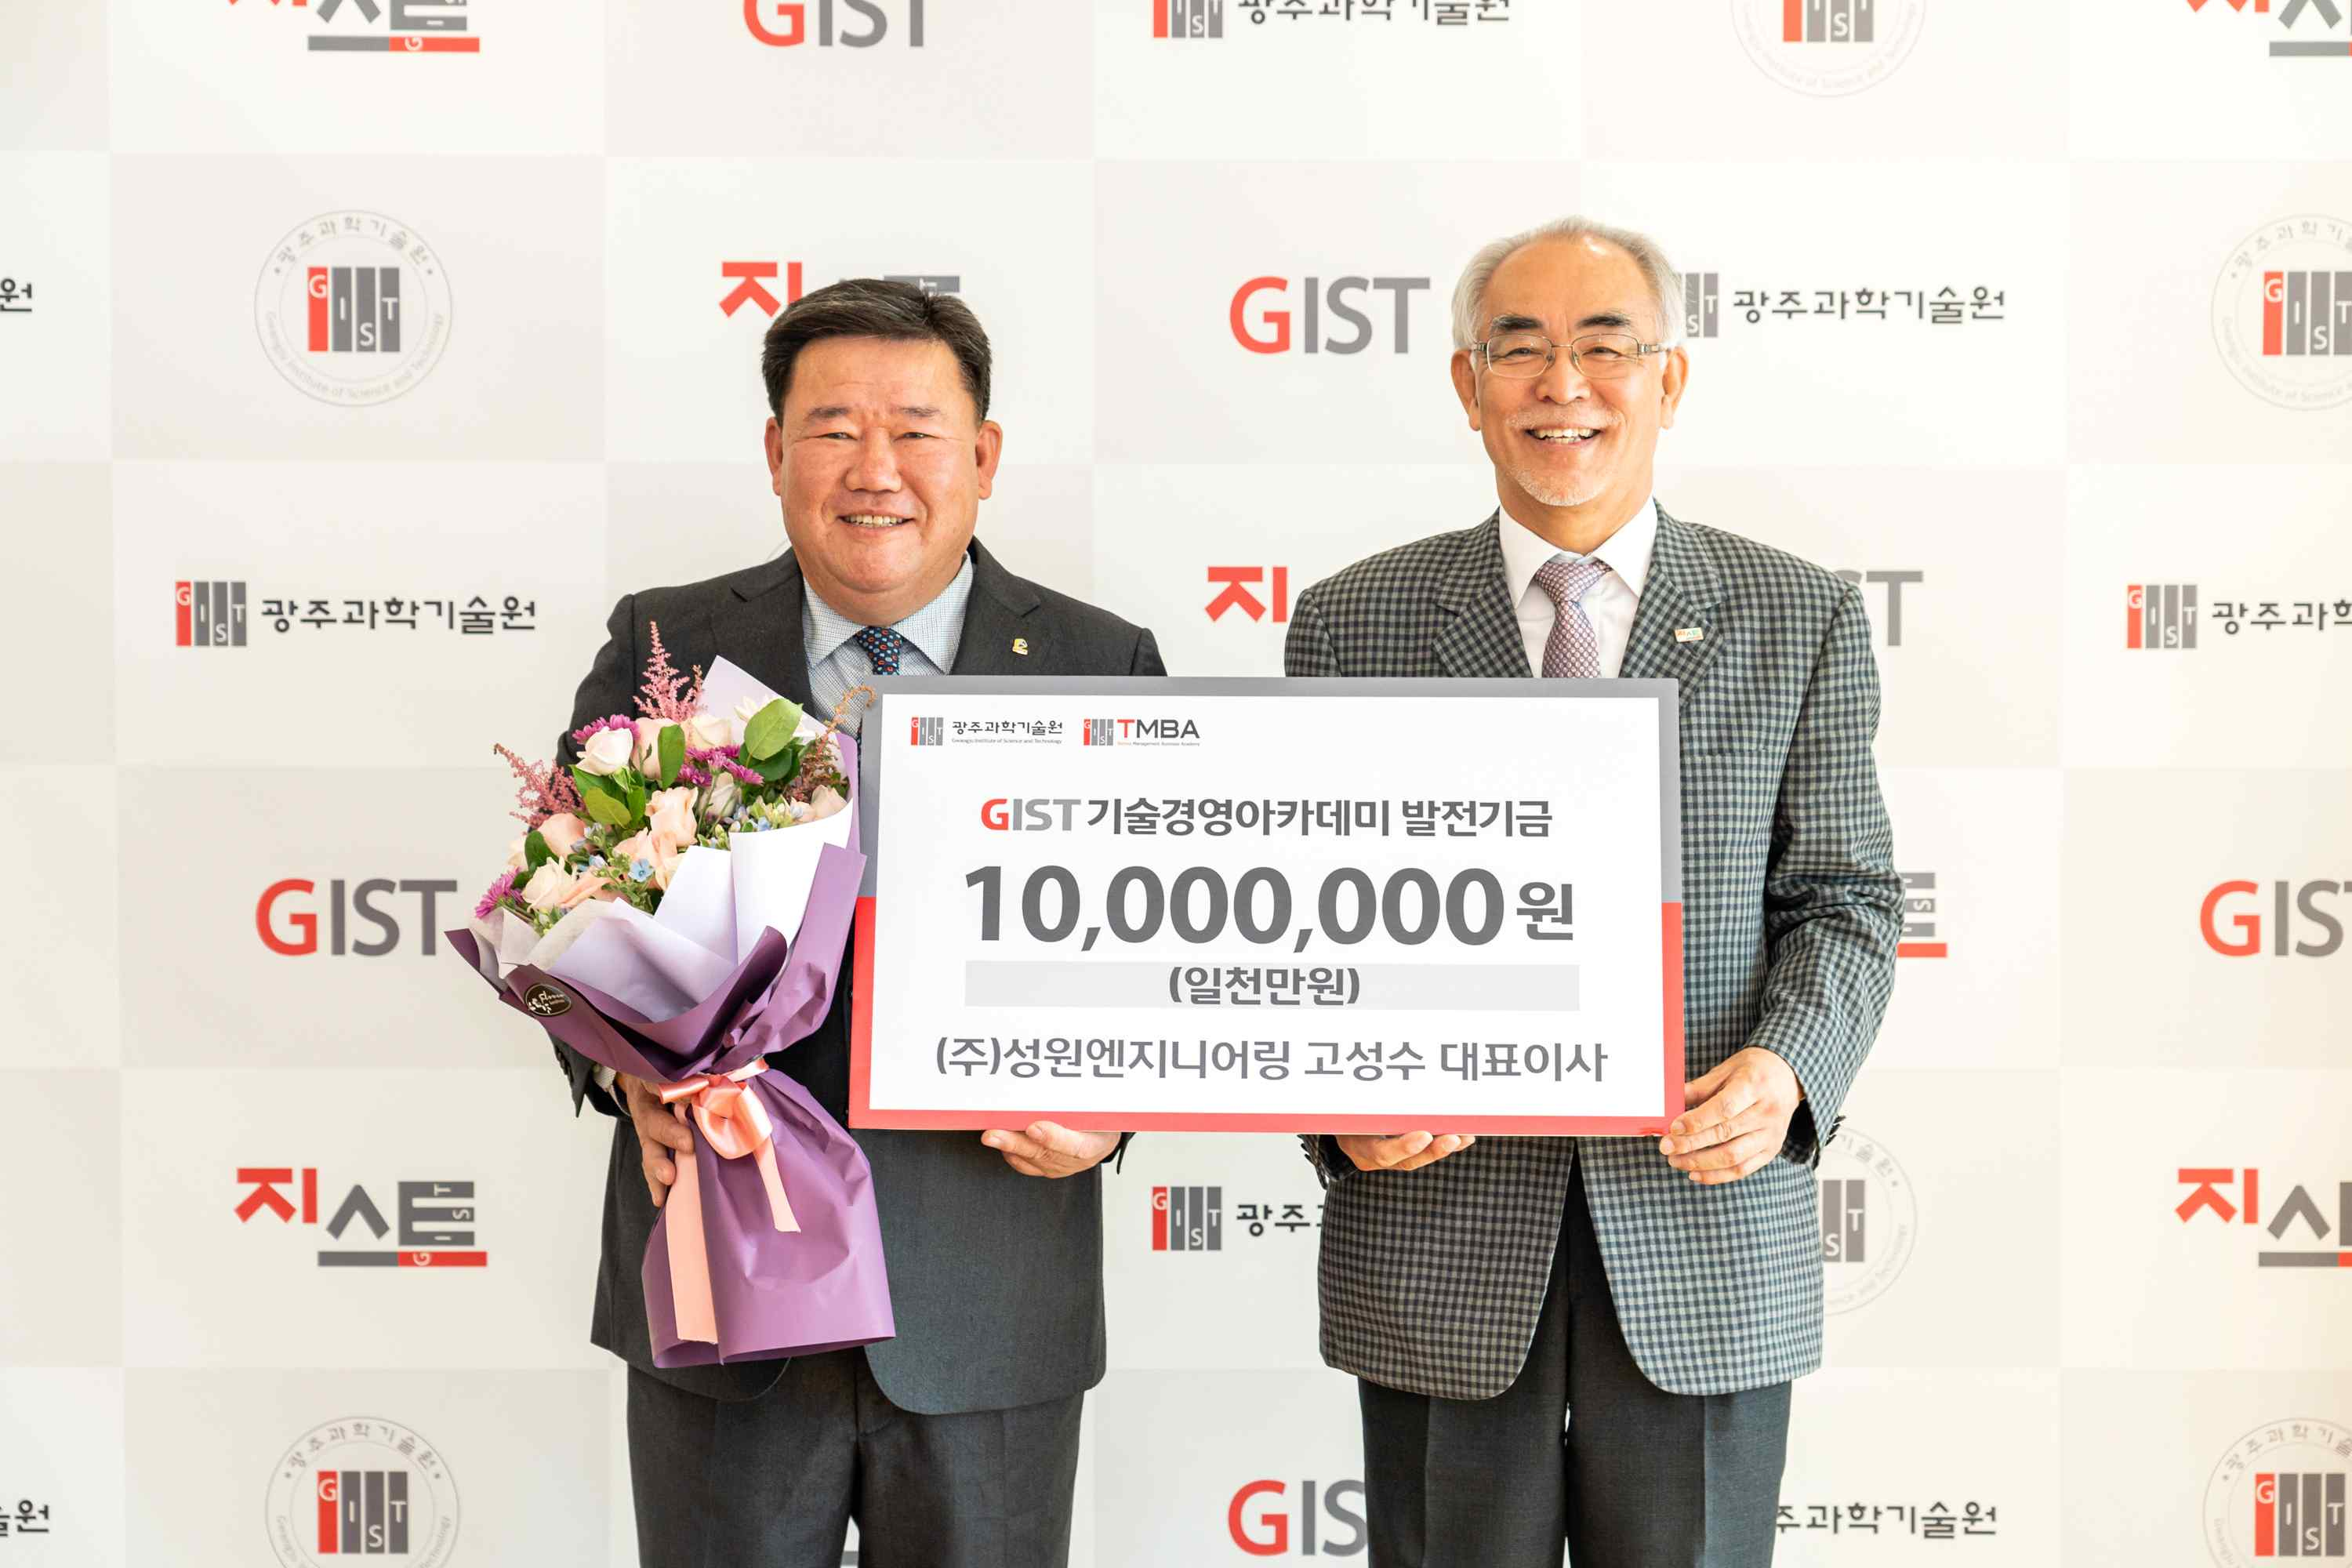
▲ GIST Techno Management Business Academy (GTMBA) 10th class member Seong-soo Koh, CEO of Sungwon Engineering Co., Ltd., donated 10 million won to the GIST Development Fund. (From left) Seong-soo Koh, CEO of Sungwon Engineering Co., Ltd. and GIST President Kiseon Kim

GIST Techno Management Business Academy (GTMBA) alumnus (10th class) Sungwon Engineering Co., Ltd. CEO Seong-soo Koh 10 million won to the GIST Development Fund (Gwangju Institute of Science and Technology, President Kiseon Kim).

Established in 1995, Sungwon Engineering Co., Ltd. develops aluminum windows that can be disassembled and assembled in line with the carbon-neutral era and produces low-carbon, high-efficiency energy products. It has supplied products to educational and research facilities, public facilities, and residential facilities.

For the past 37 years, CEO Seong-soo Koh has contributed to the improvement of construction quality based on his outstanding technology. While serving as the chairman of the Jeonnam Provincial Association of Korea Professional Construction Association, he was praised for his contributions to improving the construction industry system and strengthening national competitiveness, such as joint contracting with main contractors and expansion of professional construction orders.

Since 2003, as a model entrepreneur in the region, he has received awards such as the Jeollanam-do Governor's Citation, the Ministry of Land, Infrastructure and Transport's Citation, and the Model Taxpayer Citation, and in August of this year, he was awarded the Silver Tower Order of Industrial Service Merit.

CEO Seong-soo Koh said, "As a member of the 10th class of GTMBA, I pay attention to the positive impact of GIST's remarkable development and growth on the local economy, and to the Gwangju and Jeonnam regions and the country. Furthermore, I decided to donate the fund in the hope that GIST will produce many excellent science and technology specialists who will be responsible for the future of the world. Please use it to improve the research environment and nurture experts to enhance GIST's research competitiveness."

GIST President Kiseon Kim said, "Thank you for your warm heart despite the difficult economic times. We will make active efforts so that GIST can take a leap forward as an educational and research institute, nurture science and technology specialists who contribute to the community and the country, and lead regional development."



