Inauguration of MSL Chairman Hae-myeong Kim as the new chairman of the GIST Development Foundation

– On the afternoon of the 29th (Tuesday), the inauguration ceremony for the GIST chairman of was held... Jung-joo Ko, the third chairman of KBI Hanam, has resigned

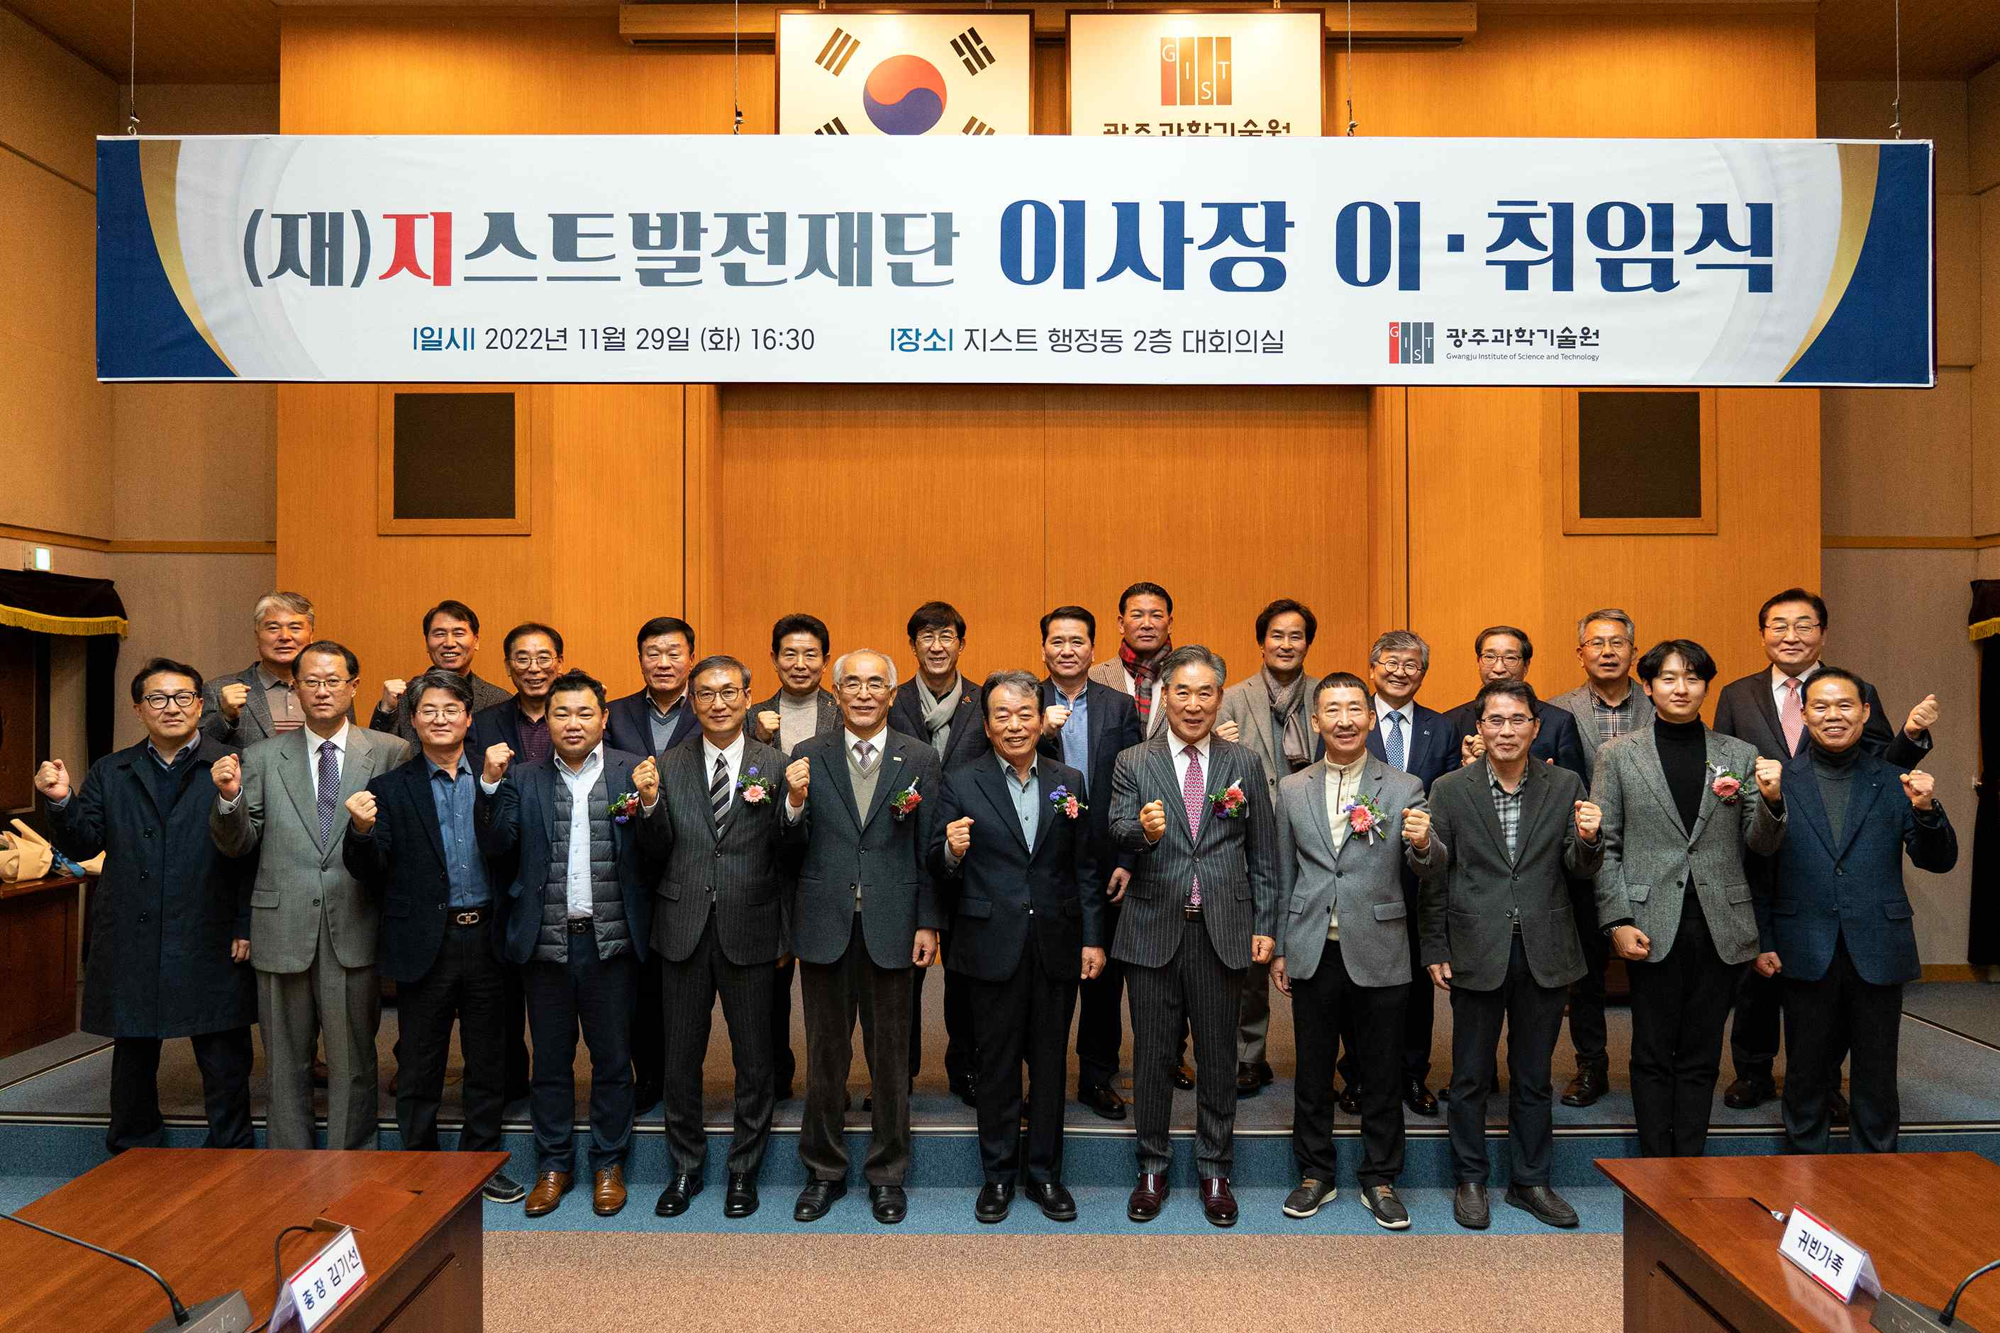
▲ The inauguration ceremony for the chairman of the GIST Development Foundation was held on the afternoon of November 29th (Tuesday) at the GIST Administration Building meeting room.

GIST (Gwangju Institute of Science and Technology, President Kiseon Kim) announced on the 30th that MSL Chairman Hae-myeong Kim was inaugurated as the 4th Chairman of the GIST Development Foundation.

The GIST Development Foundation was established in 2016 and promotes the development of science and technology in Korea and solves local issues together by supporting educational and research activities of GIST, including training high-quality science and technology talent, mid- to long-term R&D, and conducting basic and applied research.

On the afternoon of November 29th (Tuesday), the inauguration ceremony for the chairman was held in the GIST administrative building's large meeting room, with GIST President Kiseon Kim, International and Public Affairs Dean Chang-Duk Jun, the GIST Development Foundation borad of directors, past alumni presidents of the GIST Techno Management Business Academy (GTMBA), local entrepreneurs, GIST professors, and officials.

In his inaugural address as the new chairman, Hae-myeong Kim said, "GIST, which celebrates its 30th anniversary next year, has developed with the interest and love of local residents. As the fourth chairman of the Development Foundation, I will do my best as the chairman so that I can share my thoughts with the members of GIST and think about and help the development of the country and region together. I promise to do my best as the chairman for the development of GIST and national science and technology, development of creative science and technology talents, and contribute to the local community."

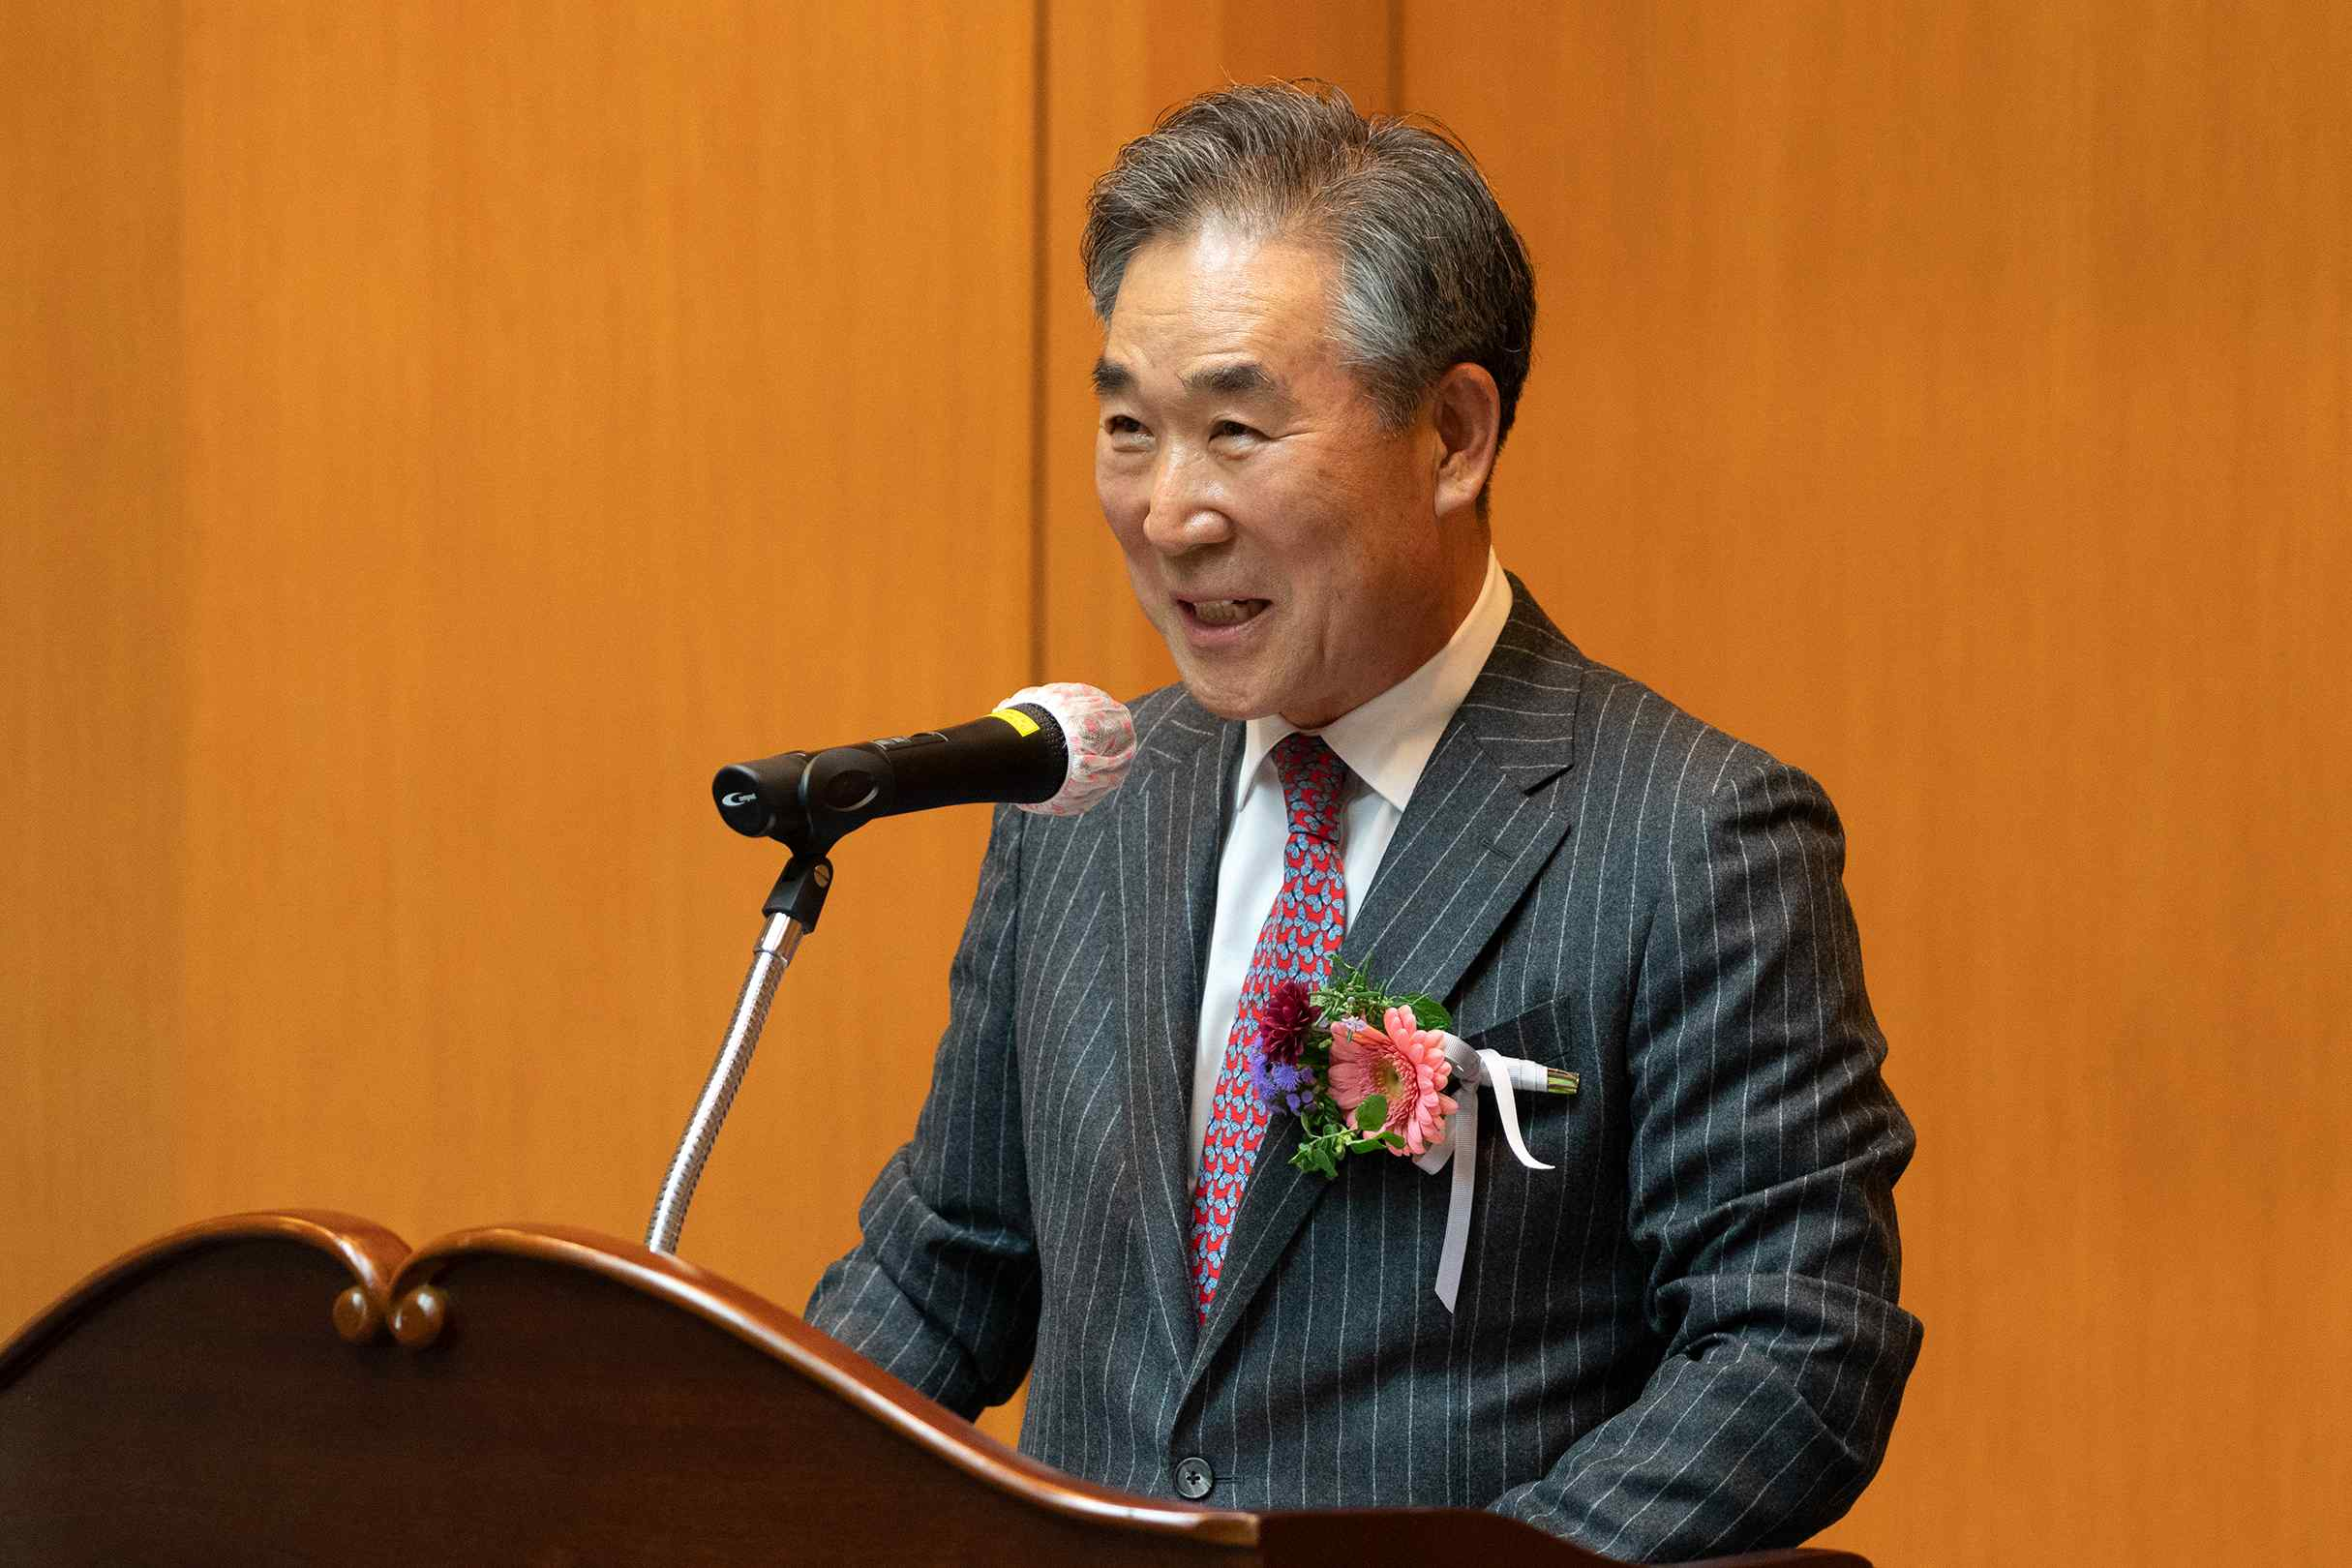
▲ Hae-myeong Kim, chairman of MSL Co., Ltd., who was inaugurated as the 4th chairman of the GIST Development Foundation, is giving his inauguration speech.

Chairman Kim Hae-myung is managing MSL, MST, and Seasun, and served as the Korea Productivity Headquarters Honam Exchange Chairman and the Small and Medium Business Technology Innovation Association Gwangju/Jeonnam Senior Vice Chairman. He is a businessman who has donated for the development of the cultural world, such as the Gwangju Cultural Foundation and the Design Biennale.

In a congratulatory speech, GIST President Kiseon Kim said , "I would like to express my gratitude to Chairman Jeong-joo Ko for his hard work for the remarkable development of GIST and the GIST Development Foundation, and I congratulate the new Chairman Hae-myeong Kim with expectations that he will play an important role for the development of the GIST Development Foundation and GIST in the future."

Jung-joo Ko, who served as the 3rd chairman of the board for the past three years, said, "Thank you to the directors of the GIST Development Foundation for being with us and to the GIST officials who have given us courage. We will always support the continued change and innovation thanks to the new chairman Hae-myeong Kim, who is full of outstanding ability and passion."



